DL 6 Page Brochures
Design Briefing Notes
Billy Lids Indoor Play Centre


www.billylids.com

Page 1 (outside right – when folded it is front page) content

Business Name: Billy Lids Indoor Play Centre & Cafe

Picture:

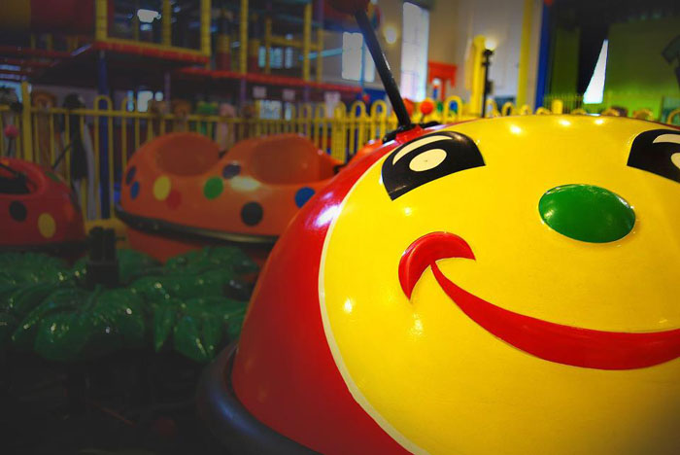

Text: An Iconic Children’s Indoor Play and Party Venue that holds many lovely memories for local families within the Hawthorn Community

Address: 86 Lynch Street, Hawthorn, Vic 3122

Phone: 03 9818 2225

Email: info@billylids.com

Web: www.billylids.com

Like us on Facebook (with Icon): https://www.facebook.com/billylidshawthorn

Text: Subscribe to our Newsletter (from our Website or via Facebook page) and stay up to date with what is happening at Billy Lids!

Page 2 (outside middle – when folded it is back page) content

Map (from Google)

General entry price

Monday to Friday: $10
Saturday and Sunday: $11

Adults and Children under 12 months are free,

EFTPOS available, surcharge applies on Credit Cards Transactions

Trading Hour

Sunday – Friday: 9 a.m. to 5 p.m.
Saturday: 9 a.m. to 6 p.m.
Closed on all public holidays and Christmas, New Year period

 Available at the Centre (Stamp Me is a smart phone app)
Can we add any other info here? i.e carousel, Kelly, etc?
Page 3 (outside left – when folded it is inside behind page 1) content

About Us

Billy Lids is an exceptional indoor children’s play centre located in a Heritage Listed Building that has been entertaining children in Hawthorn since 2001.

Activity Room, Ball pit, Jumping Castle, Flying Fox, Slides and Tunnels and our famous Billy Bugs Ride are just a few fun things for the kids.

We have an onsite Café which offers the best food you will find in a Play Centre, our fresh scones and muffins as well as toasted pides, sandwiches, salads and more are made daily by our professional cooks!

We cater for Birthday parties, Private Functions, or Parties for any occasions. With an after hour’s Liquor License also.

Furthermore, during school terms, we organise free or small cost activities throughout the week for non-school age children. During school holiday, we often have list of exciting shows and activities for everyone to enjoy!

Add some pictures (files attached separately, below is just preview)

Page 4 (Inside right – when open it is the right side page) content

Private Functions

Looking for a party with a difference?

Billy Lids can offer a fantastic Private Functions during the evenings, where you have exclusive use of the whole centre.

We cater for a minimum of 25 children. Billy Lids Private Functions are great for birthdays, christenings, family get-togethers and Christmas parties – enjoy the benefits of exclusive use of the centre and become the ultimate party host! Call us to discuss pricing options, tailored to your needs.

Cafe and Main Centre Hire

Suitable for family or work functions with children. Exclusive use of all play equipment and Cafe space.

Flix Room (Also known as Manresa Room) Hire

Suitable for Teenage Discos and Adult Birthday Parties. Features a Bar, Huge Screen for Movies or Slide Show Projection and Music.

The Manresa Room is also available on weekdays as a Conference space, great for creative workshops, team building exercises or planning meetings.

Add some pictures (files attached separately, below is just preview)

Page 5 (Inside middle – when open it is the middle page) content

Kids Parties - BILLY’S BONANZA PARTY $24.00 per child

Entry for the whole day
Exclusive party space for 1.5 hours
Themed Party Host
Invitations
Homemade Sausage Rolls
Mini Frankfurts
Fairy Bread
Popcorn
French Fries
Fresh Fruit
Unlimited Cordial and Water
Lolly Bags

Add a helium balloon each for just $1.5 extra per child

Add some pictures (files attached separately, below is just preview)

Please note minimum 10 children must attend weekend parties.
Minimum 6 children must attend weekday parties.
If weekday party number is under 10 children, no party host is supplied.

Carousel ice-cream cake is available at Billy Lids

Page 6 (Inside left – when open it is the left side page) content

Kids Parties - FLIX DISCO & GAMES PARTY – $28.50 per child

Invitations
Coloured hairspray (optional)
Glow Sticks
Homemade Pizzas
Homemade Sausage Rolls
Fresh Fruit
Popcorn
Fairy Bread
Lolly Boxes
Soft Drink
Party Hosts

Helium Balloon available at additional costs

Our exclusive Disco party venue offers fantastic interactive parties perfect for children aged between 6 – 12 years! Parties are tailored to your child’s needs, with a wide range of music, games and dancing.

For parents we offer a fully stocked bar, café and great adult platters too!

All Flix Parties run for 1 & 1/2 Hours. We require a minimum of 15 children

Add some pictures (files attached separately, below is just preview)

