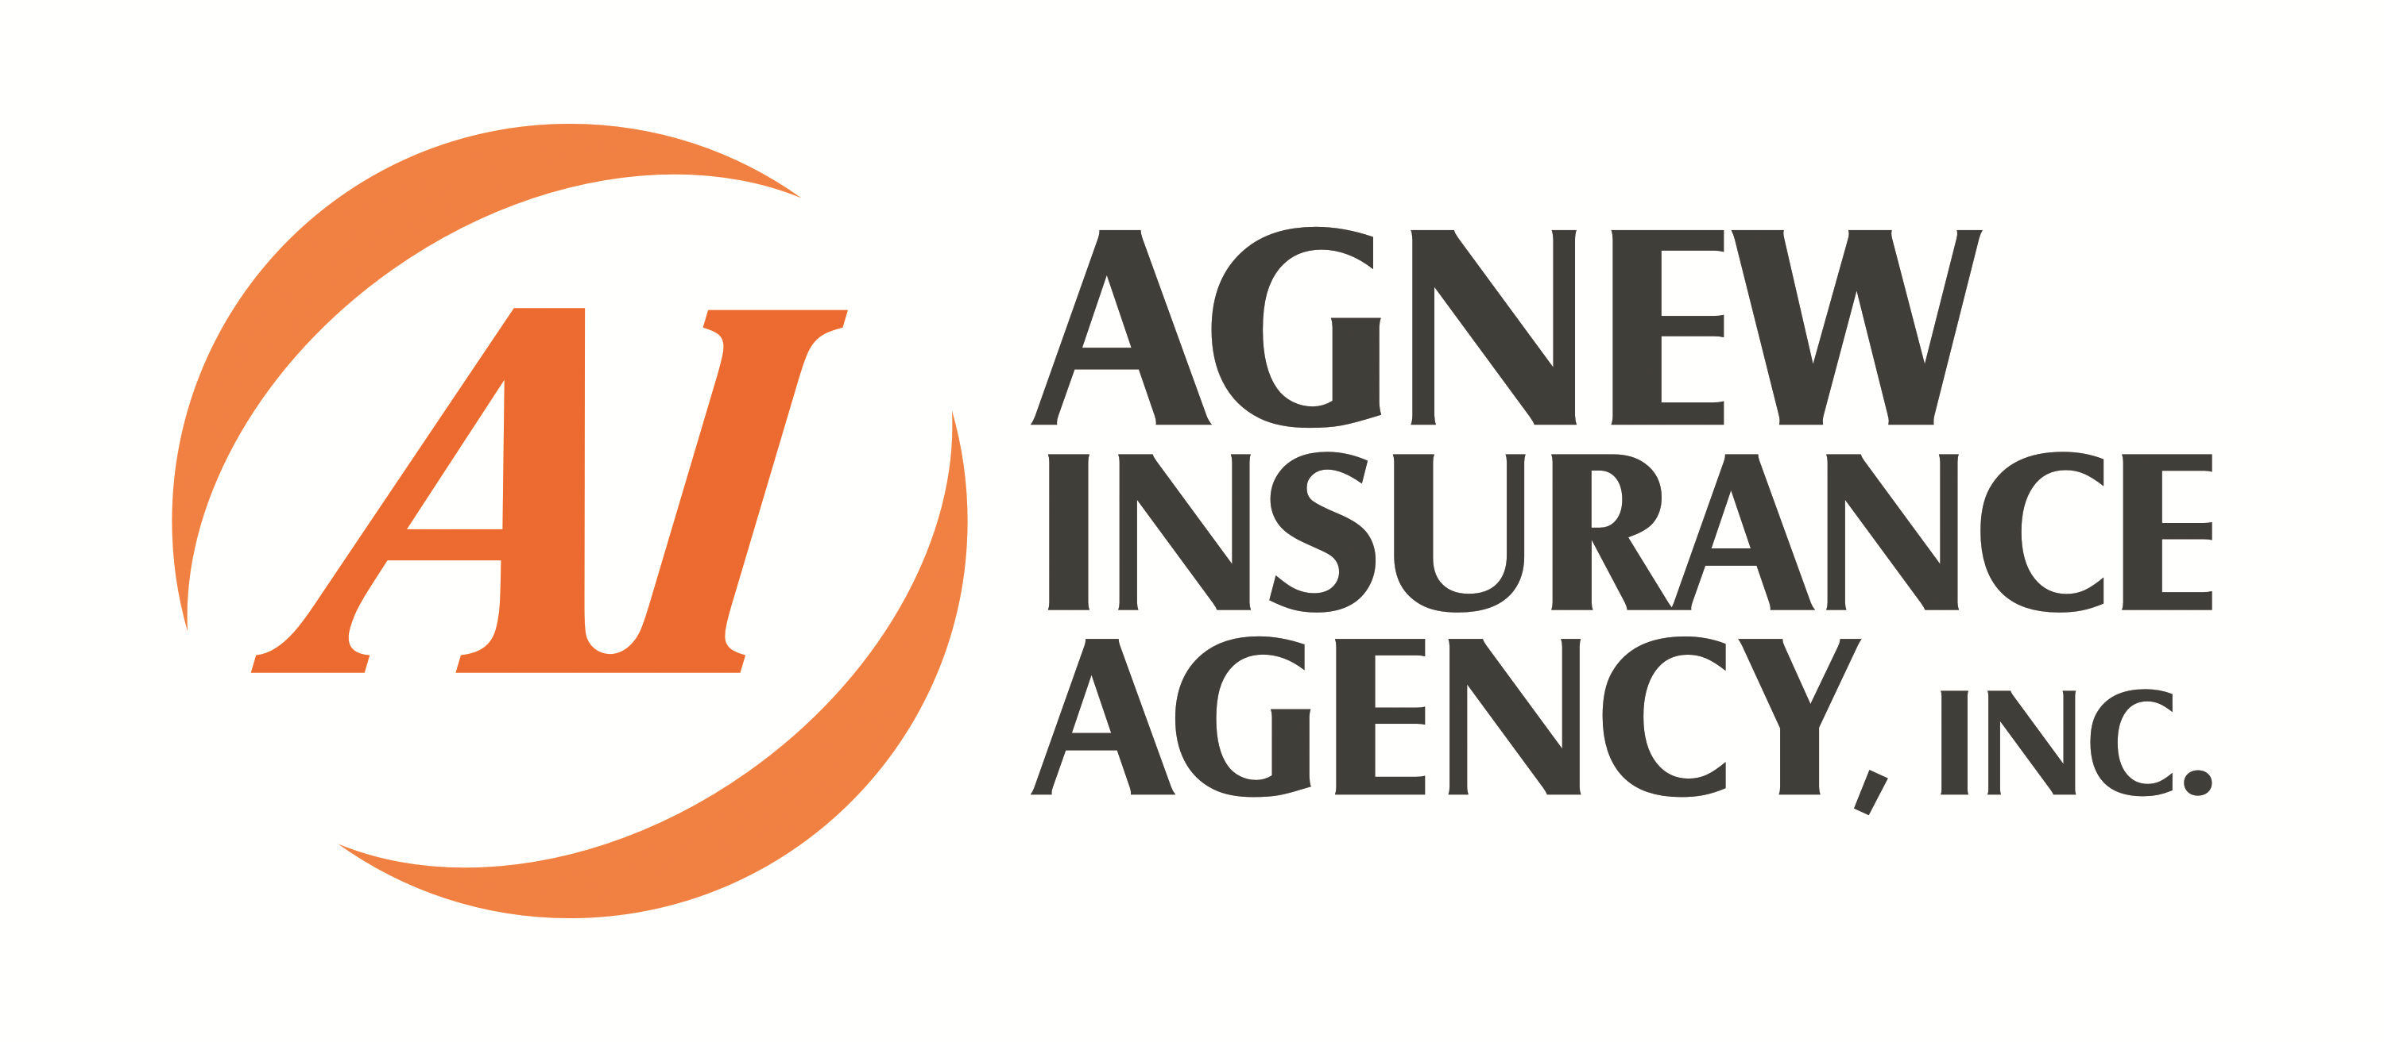
When was your last Check-Up?


WEB
www.check-my-insurance.com
Phone
269-488-5907
Stop in
Agnew Insurance Agency, Inc.
5955 W. Main St.
Kalamazoo, MI 49009

To set up your Commitment Free Agnew ICU:
During the Commitment Free Agnew ICU, we will check for:
- Accuracy – The items currently listed are still in your possession and are accurately depicted in the policy.
- Correct Values – The items currently listed are valued correctly according to the current market.
- Limits – Are the limits on items properly listed so there is coverage to fully replace items in the event of a loss?
- Liability – Is there coverage in place to give the client coverage in the case of lawsuits or legal action?
- Deductibles – Is the client willing to take on more risk in order to reduce premium or would they like to lean on the insurance company more for a higher premium?
- Rates – Is the clients premiums in line with the current marketplace or are they paying too much?????
At Agnew Insurance Agency, we offer our Commitment Free Agnew ICU (Insurance Check-Up)!!!
Many people today are unaware of their insurance coverage. They may be Under-Insured (not enough insurance to cover their valuables in the event of a loss) or they may be Over-Insured (paying for more coverage then they need). If you haven’t had your insurance looked at in a while, it may be time for a Check-Up….

