Page 2, 3, 4 – Inside pages Portrait (separate word doc supplied. Watermark of water behind it?)
Text/Diagram: Athlete Development Pathway
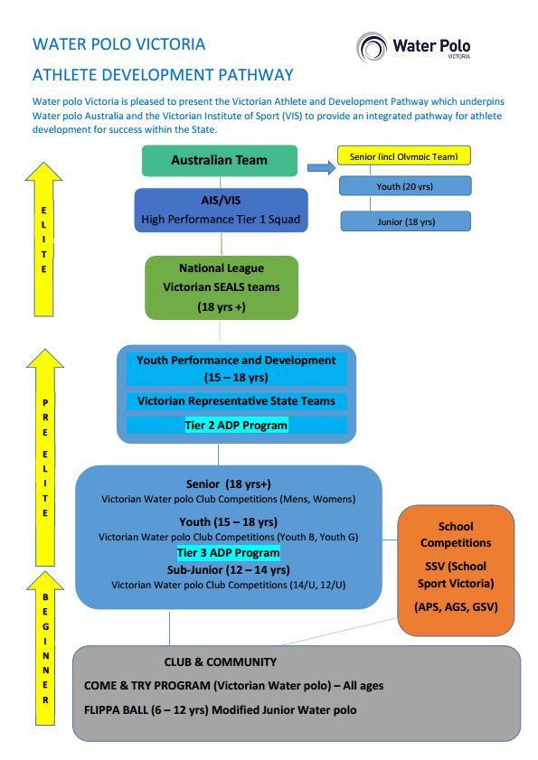
Water polo is a fun and fast paced aquatic team sport for all ages and stages; social through to elite. It’s a sport for life! Become a part of it today!
(text box somewhere on this page)

Along the bottom strip of the portrait page – strip photo of Melbourne Collegians Under 14 team. 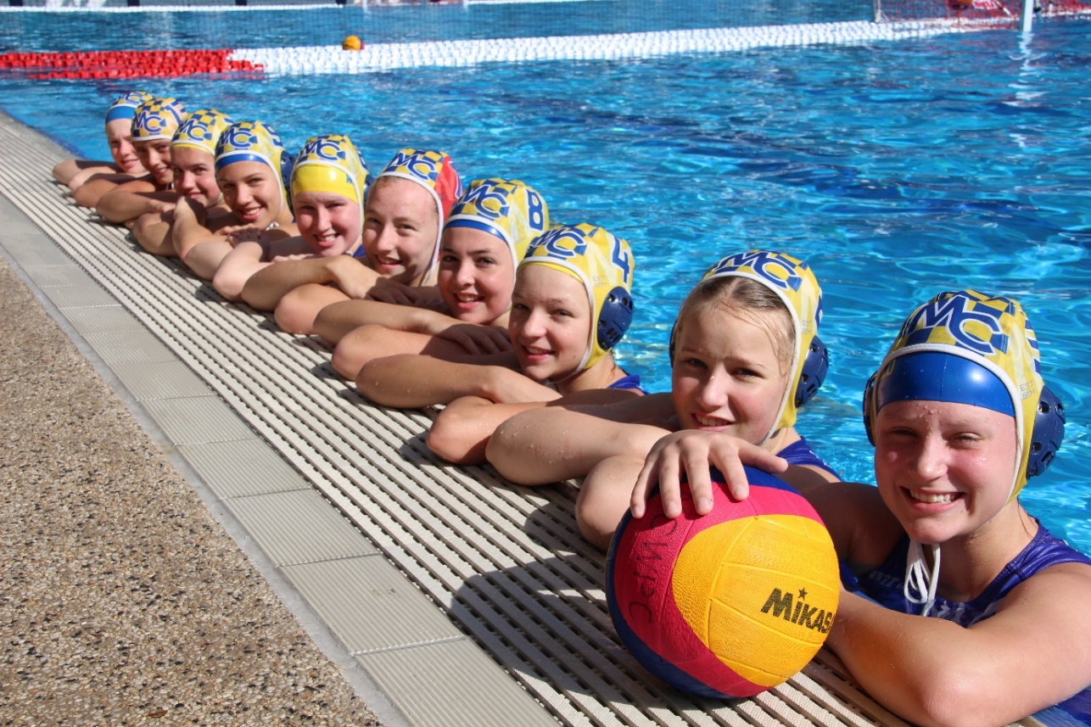
Melbourne Collegians Water Polo Club 14/U Girls Team

