Page 6 – back Cover
Text: ‘Reach new heights….’
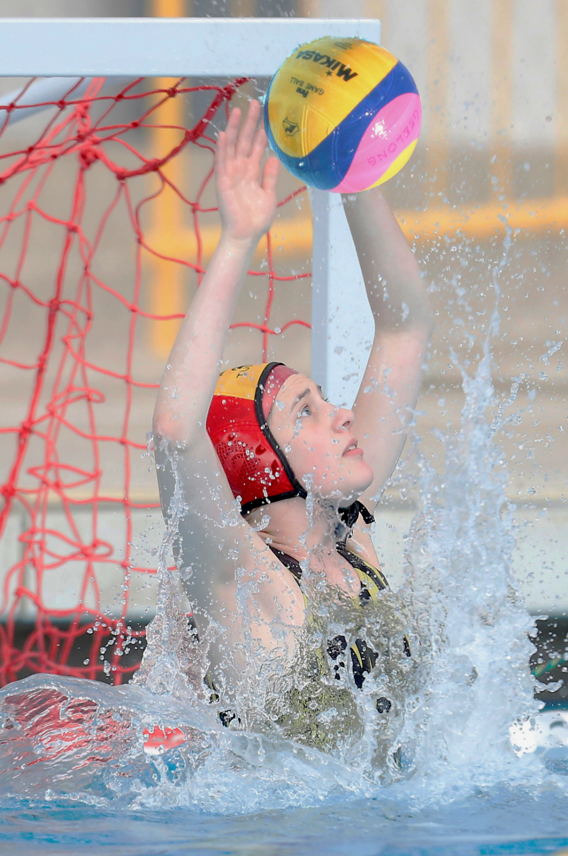
Tejan (TJ) Keller Goalie - Richmond Water polo Club

For more information on how to begin your water polo journey, please contact the Water Polo Victoria office.

 Proud Supporter of Victorian Water polo is
Box 11, MSAC proudly supported by

Aughtie Drive

Albert Park Vic. 3206
T: 03 9926 1552   
F: 03 9926 1657
E: info@vicwaterpolo.com.au
www.vicwaterpolo.com.au

