Page 5 – back LH side page: WHY PLAY WATER POLO?
Focus on four water polo players: Photo in a circle + text
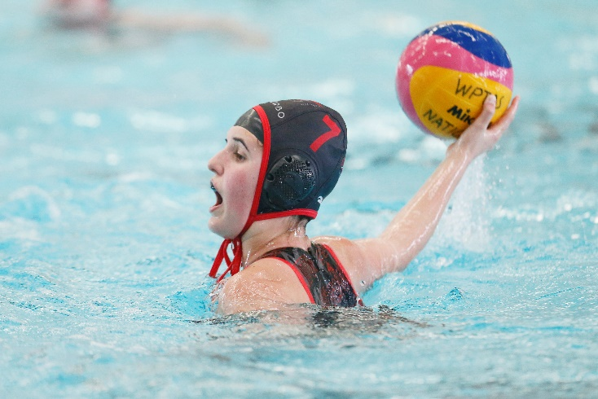
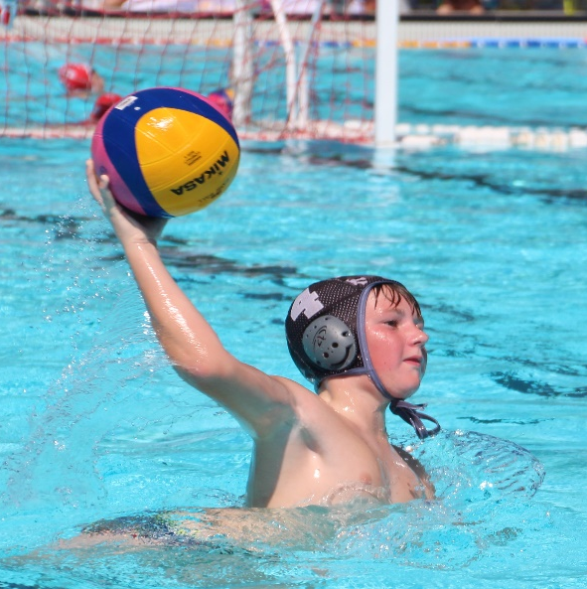
Samuel
Club Pool Pirates Water Polo
14/U Boys
“Water polo is fun and different and I like it because not many athletes play it. It’s great because it includes swimming, ball skills and is a fantastic team sport.”

Lily
Clubs Bendigo & Essendon 14/U, 16/U, SL2, SL1
Team Captain 2014 14/U Victorian State Team
Tier 2 Athlete Development Program
“Water polo isn’t just a sport for me, when I play, nothing else
matters but the game, and the great people I get to play it with,
the rest of the world just melts away.”

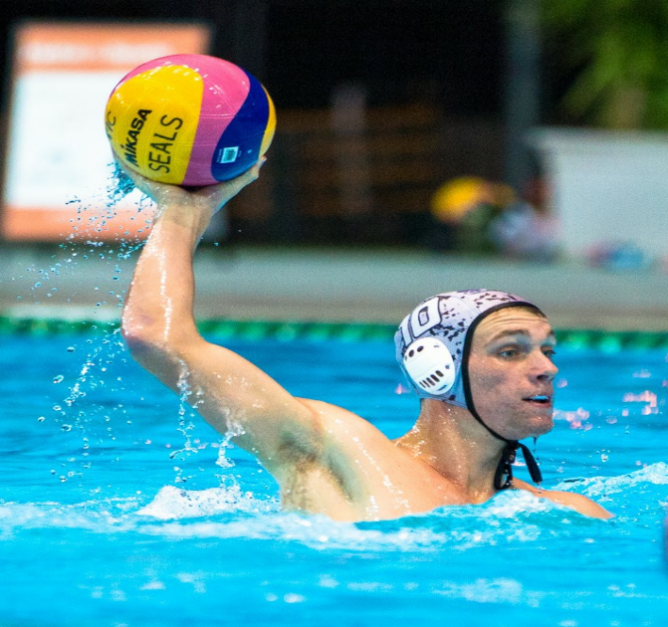

Leo
Club - Melbourne Collegians
Victorian NWPL SEAL
AUS Junior Men’s team
NWPL Mens All Stars Team 2015
Transferred from swimming & football
“I liked playing for my school and discovered that the combination of physicality and skill really suited me. It is such a unique team sport.”

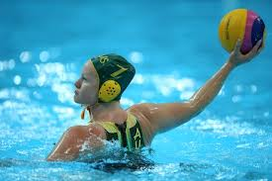

Rowena Webster
Club – Richmond SL1 team, Victorian NWPL SEAL
Australian Olympic Team (London 2012)
“I feel free when I play water polo, there’s
something in me that just lets go of everything. It incorporates skills that we would utilise in other sports, however when thrown in a deep pool, they become so much more challenging to execute.”

