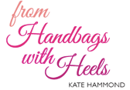

Style Analysis Report

Client : Steph
Body Shape: The Brick, shorter waist.
Main characteristics:
- Broad shoulders
- Hips inline with shoulders
- No shapely waist line
- Possibly larger (ish) thighs
Main goals in dressing ‘The Brick’:
- Create curves using shapely, flowing pieces
- Look for curved edges on garments
- Sweetheart necklines will instantly create a more shapely start to your upper body
- Use patterns to accentuate your best areas and detract from others.
- Use stripes of varying sizes, to create a shapely illusion
- For accessories look for curvy jewelry and handbags
Styles to avoid:
- Square cut or boxed edge jackets
- Short skirts (mini) or shorts which will cut you off mid thigh
- Box pleats or pleats at the front of trousers
- Look for shoes that add to the flow of your garment, nothing too solid, or chunky
Celebrity ‘Bricks’: Kim Cattrall, Natalie Portman, Cameron Diaz

Notes from your styling session
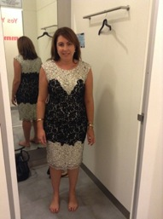
This really is a beautiful dress. The black lace section is the main part of the dress that catches your eye, making your waist look longer and giving you a curvier silhouette. The round neckline works in this instance, thanks to the black V-section across the bust giving that illusion of a longer décolletage , which is what you want to create. This length is perfect; it makes your legs look fantastic. Pair this with some great black heels, your hair up and introduce a coloured clutch, would look amazing.

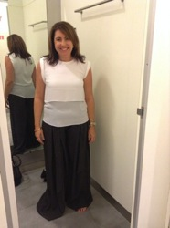
Ok, so these palazzo trousers were terrible and we realised that the pleats are a no go! The fabric is great for you; the softer more ‘flowy’ material gives you a shapelier look. The colour and the pattern (small, fine, beige spot) look great on you and very sophisticated. The top is a great colour of white; I think it looks more ‘vintage’ white, instead of famous ‘Hollywood star teeth’ white, giving you a more polished look. The cuffed sleeve works really well for your arm section, giving a bit of something different to what could be a plain white top. If it didn’t have that layered section in the middle I think it would work even better, as this cuts you off mid section and it does so in-line with your elbows, creating a boxy look to your torso. Not the look you’re trying to achieve! If it had been all one length it would be a great top.

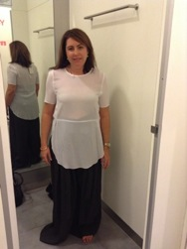
Ok, I ‘ll be short and sweet! Terrible! The sleeves do nothing for the tops of your arms, the seam across the middle of your waist is cutting you in two and the length of the top does nothing but draw attention to your crotch…thank goodness we put this one back on the hanger!

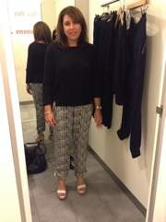
Sophistication in a pair of heels! This outfit is so chic and elegant; it could be transformed from a work outfit to a daytime outfit, to a nighttime outfit, by changing up accessories. A jacket (eg, denim jacket or smart blazer) to a fabulous pairs of heels or a wedge! These trousers are great, look at how long and slender they make your legs look. They sit perfectly on your hips and then don’t cling anywhere. The straight/bootleg cut works really well for you. This outfit has to be a massive winner!

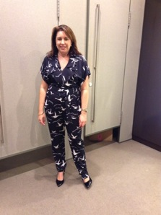
Now, I know you weren’t 100% with this jumpsuit, but I was really impressed by it. Not so much the price tag, but that’s a different story. The pattern is lovely and the waterfall edge of the V-neck works well to elongate your neck and create a flowing top section. The trouser section works well, by skimming over your hips and falling beautifully to your ankles. My only suggestion with this outfit would be to look at having the sleeve section altered (taken in and tapered) as it currently creates a bit of bulk in your arms. The matching belt (which you cant see) clinches in at your waist to give a great ‘curve’ to your silhouette. Would look great with wedges or heels depending on the look you were wanting!

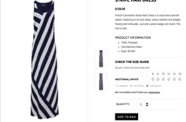
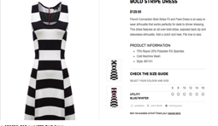
I’ve also had quick surf on the net to see if there was anything worth looking at, or even just for you to use as a guide. I looked through French connection, Witchery and Jag. These are just a few examples

