EPM Partners New Web Site

Overview
The EPM Partners new web site, need to look clean and modern, it has to give the feel of a professional IT consulting firm (something like white / clean background), the design need to be influenced by this site: http://www.phocassoftware.com/ .
The whole site is a one page, plus a link to a blog site, with the following sections:
- Menu
- Main Area
- Our Company
- Services graph
- What we do
- Our Clients
- Our People
- Events
- Contact Us
The new web site will be hosted on WordPress

Design Requirements

Site Menu

- The logo font can be re-designed to be more like the following: (Note the circles and their colours to stay as they are)

- The menu links: (Our Company, What we do, Our Clients, Our People, Events, Blog and Contact Us) are just links to places on the same page.

Main Area
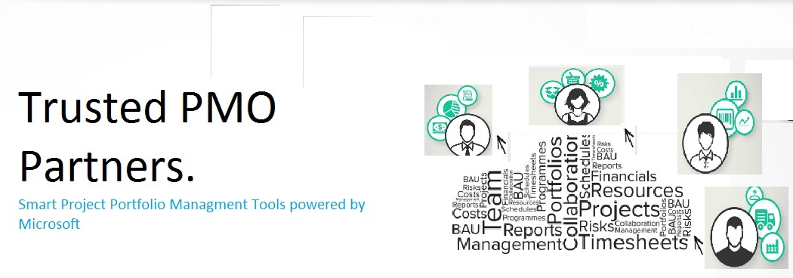
- The font of the text to be changed to align with the overall design (and colours)
- The image of the cloud to be redone, maybe need to be more colourful (using the colours of the three circles in the logo? Or something else), the terms to be used to make up the cloud shape are (Project, Portfolio, Program, Resources, Risks, Issues, Collaboration, BAU, Tasks, Financial, Timesheets, Governance, Workflow) then there should be people icons with arrows into and out of the cloud, the icons need to represent:
  - Reports or dashboards (out)
  - Documents (in)
  - Devices (in/out)
  - Money
  - Time
  - Risks
  - Issues
  - Tasks
- The image should have some shadows or other effects to give it more wow factor (again see site http://www.phocassoftware.com/).

Our Company
Should be ike this site: http://www.kloud.com.au/ , the actual text is:
“EPM Partners is a specialist consulting company that focuses solely on the design, configuration, deployment, user-training and support of Enterprise Project Management (EPM) solutions based upon Microsoft Project Server and its supporting technologies.
EPM Partners offers a true, end-to-end set of services for any organisation implementing an EPM solution within their business - to cover the lifecycle of that system.

This 100% focus on Microsoft EPM systems means that the company has an in-depth of knowledge and experience that is unique in the Australian marketplace. Whether it's a complete implementation project, a hosted solution option, or on-going support for an existing system, EPM Partners have the services to meet its customers' needs.

The team come from a diverse range of backgrounds including Engineering (Civil, Chemical and Systems), Project Management, and Software Development. A number have worked with Microsoft and Microsoft Consulting Services directly. EPM Partners continues to work closely with Microsoft to ensure awareness of latest product developments”

Services Graph
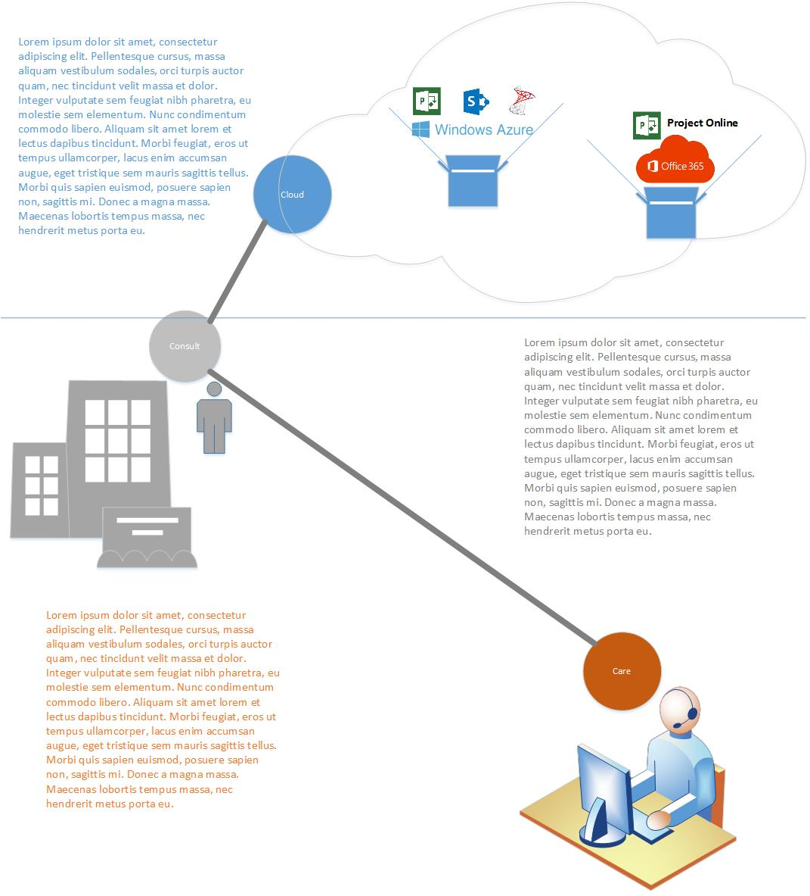
- The conceptual design to be exactly as it is (three dots representing the services Cloud | Consult | Care linked
- The concept of the images to remain the same as follows:
  - First layer is a cloud on the right and an area for text on the left, the cloud to have boxes that have things bursting out, these things are:
    - The first box:
      - Windows Azure (the base)
      - Microsoft Project logo (first one on the left)
      - Microsoft SharePoint logo (the one in the middle)
      - Microsoft SQL logo (the one on the left)
    - The second box:
      - Microsoft Office365 logo (the base)
      - Microsoft Project logo plus a text of “Project Online”
  - Second layer is a building representing the client and an image of a consultant next to it, this to be on the left hand side, while on the right hand side have a place for text.
  - Third layer is a help desk (with many people, not like the picture here) this to be on the right hand side and a place for text on the left hand side.

What we do
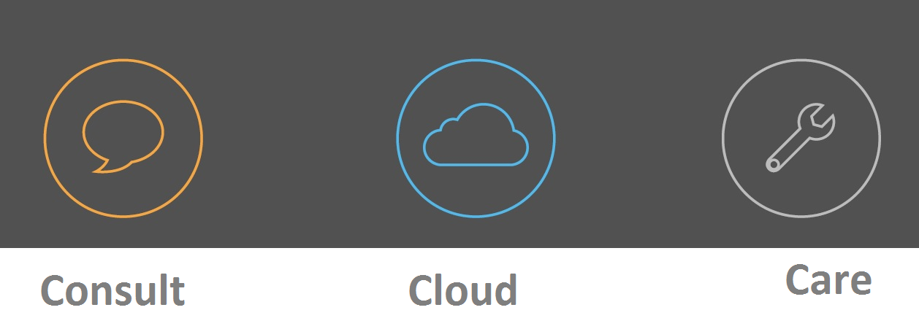
- The icons to be re-arranged to: Cloud | Consult | Care
- The icon colours to be: (from the colours of the three circles in the logo)
  - Blue for Cloud
  - Grey for Consult
  - Orange for Care
- Text, background, etc can change
- The icons themselves to be re-designed, keeping the circle concept (as per the logo), but changing what’s inside
- The name of each service can be placed anywhere (Even within the icon itself if it makes sense from designing perspective)
- Each icon (i.e. circle) is clickable, when clicked in, a section below shows describing the service
- When clicking on a certain service icon, somehow the icon should change to show that it is the current choice that the below section is describing. The behaviour should be similar the site http://www.kloud.com.au/ (look at Infrastructure, Development, Identity, etc)
- The sections describing each service to have a background colour identical to the colour of the service colours, here are few examples:
  - Cloud
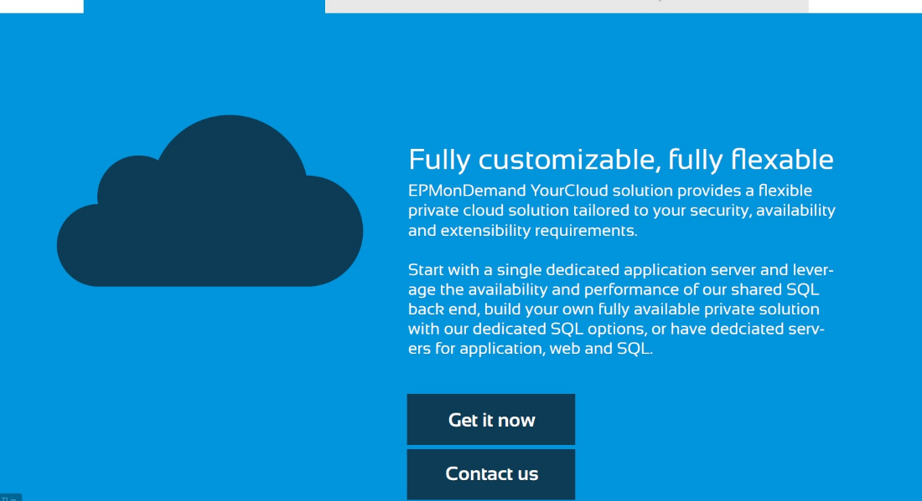
  - Consult
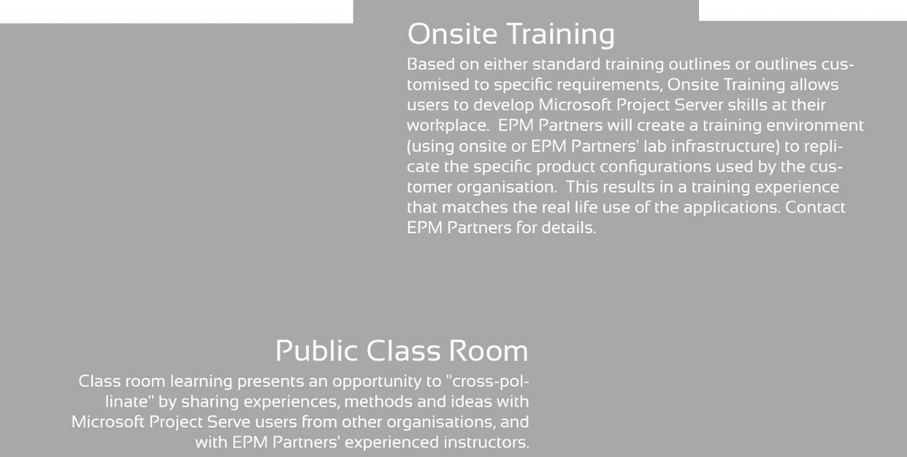
  - Care
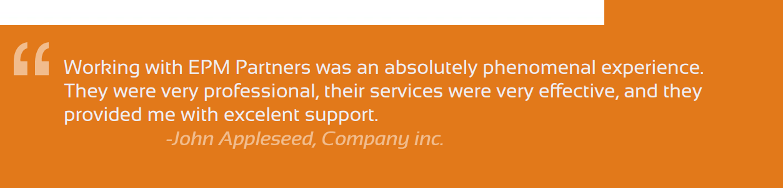

Our Clients

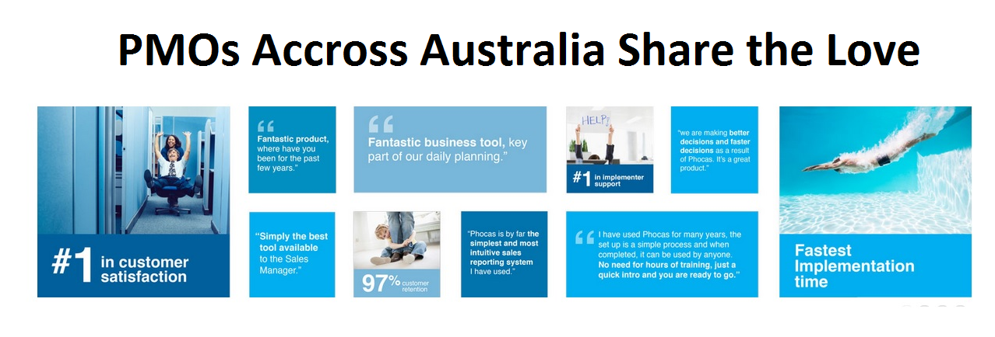

- The entire thing is open for re-design keeping the same concept (i.e. tiles that some have pics)
- The pics to be changed
- The text in the tiles is not ready, so use sample text for now.

Our People
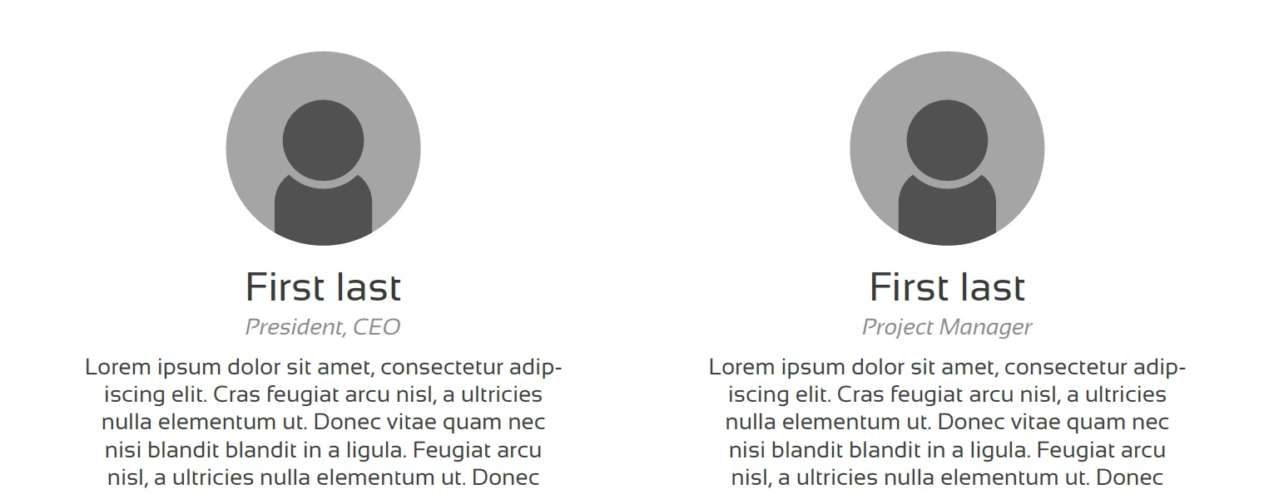

- This section need to allow for at least 12 people
- Colours, design, etc is flexible

Contact Us
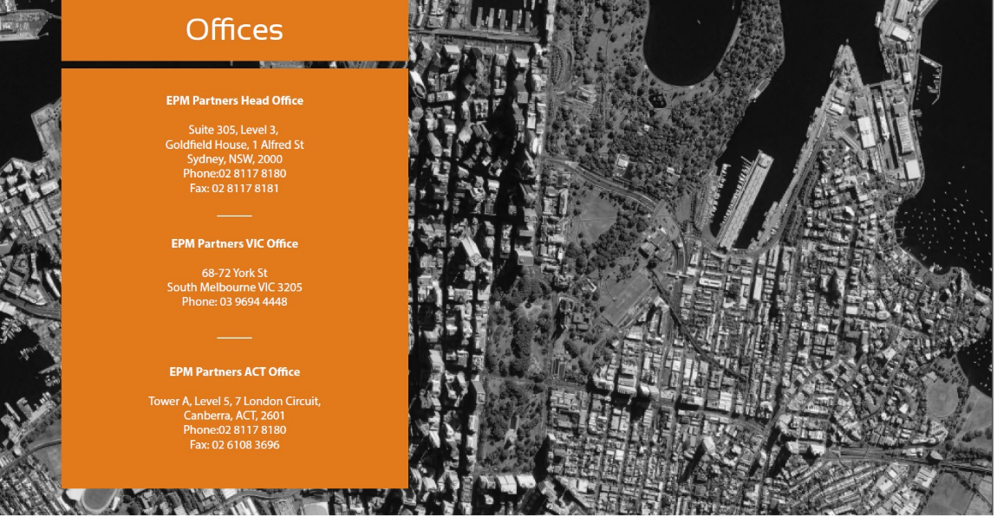
- The background image to be changed but the concept to stay (i.e. eye bird view of Sydney city in black and white)
- The section shouldn’t only list the offices contact details, but also contact us form made of (Name, Email, Message) – but maybe in a separate box?

Events Section
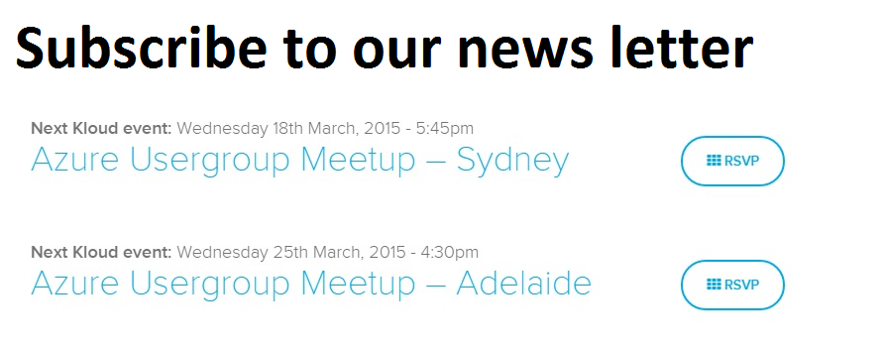
- The whole section can be re-designed to be aligned with over all site design
- The “subscribe to our newsletter” to be distinguishable but integrated with the section design / theme

The Footer
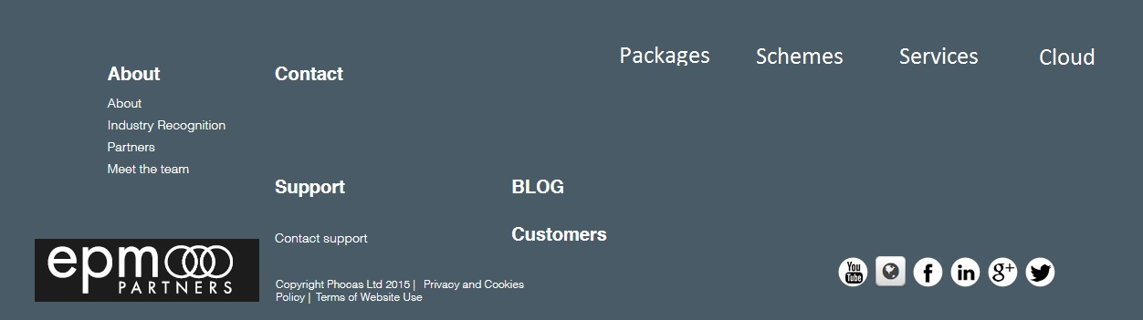

- Colours and overall footer to re-designed to align with the web site design
- Keep the circles (black and white / grey) for social media links
- Re-do the logo to be a cop of the logo on the header (but only white)

