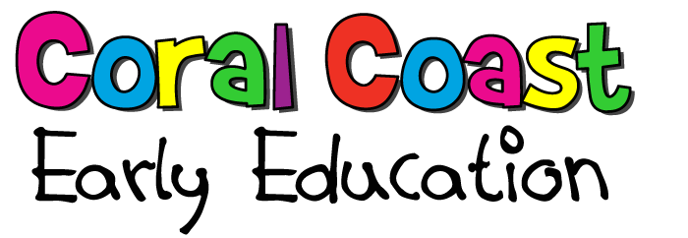
6 weeks to 12 Year Long Day Care
4 y.o. Kindergarten programme  3 y.o. advanced start Kindergarten programme  Before and After School Care  Vacation Care | Individual Tailored education programme  Head Start early education programme  Open 6.30 am – 6.30 pm - 52 weeks a years

Contact us on 07 4154 7511



