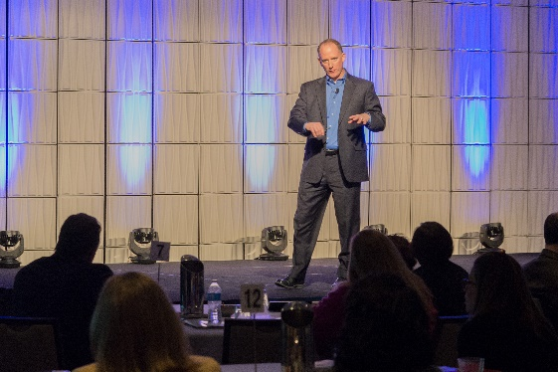
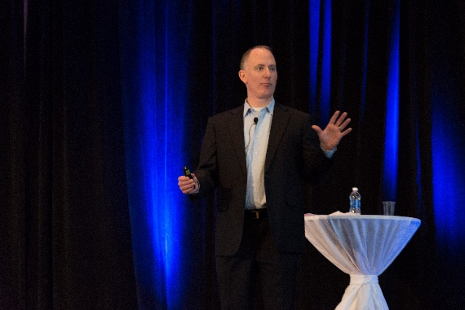
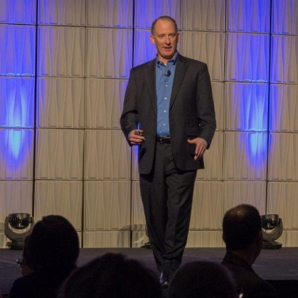

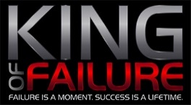

Summary Paragraph about the King of Failure talk and what John brings to this topic.
John Stoiber, the self-proclaimed King of Failure, is an exciting and passionate speaker who helps audiences think differently about failure and setbacks, and shows them how failure is a necessary and critical part of the success process. He instills confidence, courage and motivation in the attendees.
In this one-of-a-kind presentation, John will inspire the audience members to achieve more than they ever thought was possible by using some key techniques to harness fear, overcome failure and accelerate success. Attendees will leave with a new set of beliefs about what is possible in their lives, and what changes they can make to come back from any failure, no matter how epic.
This presentation is powerful for audiences such as students, athletes, sales teams, business executives, entrepreneurs, and more!

Sample Topics included in the King of Failure Presentation (customized based on audience):
- Four Lessons I have Learned from Failure Moments
- 4 Ways to Control Your Fear of Failure
- Why Failure is Good for Success
- Take the Downside Out of Play
- Stop Listening to Other People
- Control Your Emotional Roller Coaster
- Rejection Can Define Your Future
- Fail Like a Kid
- 3 Steps to Recover from Failure
- Live Up to Commitments
- Create Your Own Luck
- Comeback from Setbacks
- Fly with the Eagles
- Avoiding the Mediocrity Trap
- Accelerate Achievement with Positive Self-Talk
- Failure is Merely Learning How to Win
- Maximize Your Motivation through Delayed Gratification
- Fail Successfully – Move Towards What Scares You
- Avoid Multitasking and Get Focused
- Overcoming the Fear of Failure

Samples of the above content can be found on the Speaker’s Blog (http://KingofFailure.com)

Bio – business experience, key expertise
- Over 25 years in business – as an entrepreneur and business executive
- Expertise in business strategy, market positioning, business development strategy, performance improvement, business plan development, product portfolio analysis, turnarounds
- Built teams of 200+
- Worked in Fortune 500, middle market and start-up companies
- Pioneer in developing social networking concepts
- Founded over 12 companies
- (note: grab other bio information from LinkedIn Profile if needed - www.linkedin.com/in/jstoiber/)

Speaking – I have spoken in corporate settings, Universities (Marquette University and University of WI Madison) and other industry events on these types of topics and a wide range of audiences – hundreds of people:
- Achieve More Than you Thought Was Possible
- The Art of Financial Forecasting
- Customer Communities
- Change Management
- Focus
- Reengineering and Process Improvement
- Strategic Positioning of your business
- New Product Launch Roadshows

Credentials:
- Hold five degrees:
  - MBA, Strategy – Kellogg School of Management, Northwestern University (a Top 10 business school in the nation)
  - MBA, New Ventures, Marquette University
  - MS, Software Engineering, Marquette University
  - BS, Electrical Engineering, Marquette University
  - BS, Biomedical Engineering, Marquette University
- Certified Management Accountant (CMA)

Honors and Awards:
- 2014 Inspiring Leader Award, Association Forum of Chicagoland

- Beta Gamme Sigma – Business honor society
- Tau Beta Pi – Engineering honor society
- Who’s Who Among Students in American Universities and Colleges – Marquette University
- MU Award – for leadership and service to Marquette University
- Scholastic Honors in Biomedical Engineering
Personal:
- Mentor at 1871, a premier Chicago technology incubator
- Youth baseball and football coach
- Wife and three kids, live in Frankfort, IL
- Enjoy playing golf and following the PGA Tour, the NFL and NASCAR.

Booking Contact Information:
John R. Stoiber
312.286.6063
john@kingoffailure.com

At this time there are no customer testimonials.

