
VIP Executive Breakfast Invitation
Add creative which shows people working together in a high speed environment with a driving context
e.g. F1 as shown below




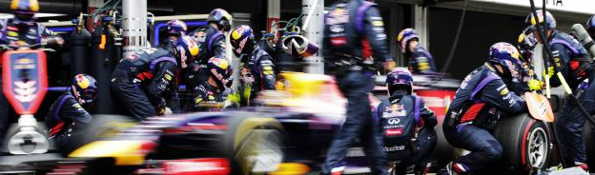
The Driving WorkForce: People-Productivity-Performance-Profitability

GLOBAL LEADERS REVEAL HOW TO DRIVE A THRIVING, COMPETITIVE WORKFORCE CULTURE OF WINNERS!

Dear [FIRST NAME],

What does it take to drive a thriving, competitive workforce culture?
We have assembled a lineup of Global leaders from SAP, Kronos and Concur to find out.

Please accept our invitation to join us for a VIP Executive Breakfast where you will hear from global experts about total workforce management solutions, jam-packed with business value.

Our Agenda:
- 08-30-08:45 Registration
- 08-45-09:00 Presence of IT: The Driving WorkForce
- 09-00-09:20 Kronos: People, Productivity, Performance and Profitability
- 09-20-09:40 SAP: Collaborating in the Cloud
- 09-40-10:00 Concur: Controlling Costs, Claims and Compliance
- 10-00-10:30 Presence of IT: Panel Discussion and Audience Q&A

You will enjoy fine food served throughout the event and have an opportunity to ask questions from a panel of experts. After the event, we’ll send you an executive summary of the discussion.

To RSVP in the following countries:
- [Add Check button] Malaysia – [Add date] @ [Add Location]
- [Add Check button] Singapore – [Add date] @ [Add Location]
- [Add Check button] Thailand – [Add date] @ [Add Location]
- [Add Check button] Indonesia – [Add date] @ [Add Location]

We look forward to seeing you there.

[INSERT NAME]
[INSERT TITLE]

