Overview of Organisation
www.nosellfees.com is a new online classifieds and community website targeting the Caribbean Marketplace. The name of the website pokes fun at the current culture of people taking selfies but in actuality we are encouraging people to make use of their selfie skills to sell unwanted belongings on a FREE classifieds website.

What if we told you that taking selfies could teach you a thing or two about selling? We believe
that selfies and selling have a few similarities. Here are 4 examples:

1. You Have To Know Your Stuff
When it comes to taking a successful selfie, you have to look at yourself. I know this sounds a bit obvious, but looking at yourself is more than just making sure your hair is in the right spot. You have to know the angles you look the best at and the angles that are not so flattering. You have to make sure what you are about to put forth is your best self(ie).
In selling, you need to know what you are selling. You need to know the good, the bad, and the ugly of the product or service. And when you are presenting it to prospective buyers you have to make sure you are presenting the product/service in the best possible light.
2. Look Good, Feel Good
This may sound extremely vain but what I am referring to is how you feel about it. If you are confident in your selfie and believe in how amazing you look, you will be surprised at how positively it affects others viewing it.
The same can be said about selling. If you are confident and passionate about what you are selling to others, they will be able to tell. Think of it this way…if you do not believe in what you are selling, how do you expect the others to?
3.You Are Not Going To Get It In Your First Try
If you have ever taken a selfie, you know that it usually does not happen on the first try (unless you are Beyoncé). You play with the lighting, filters, and angles (sound familiar?) until you get that decent shot, even if it takes 50 tries.
When selling you are probably not going to land your first big sale on your first try or even second, but you learn from them and keep on trucking until you get that deal!
4. Practice makes better.

When it comes to taking selfies know yourself, be confident, and do not be discouraged if it takes more than one try. When it comes to selling know what you’re selling, be confident and passionate about it, and if you fail the first time, get up and try again!

Its all in the NAME
The name of the site says it all NO SELL FEES. Placing classified ads for individuals is completely free and also for companies however companies will be charged small fees on the housing and job categories. classified sections on our website include jobs, housing, personals, for sale, items wanted, services, community, gigs, résumés, and discussion forums.

Target market
The initial target market is the residents of the Caribbean islands of Trinidad and Tobago. Located on the northeastern coast of Venezuela, the Republic of Trinidad and Tobago comprises the two most southerly islands in the West Indies. Tobago, which lies 20 miles northeast of Trinidad, measures only 117 square miles. Trinidad, which has a land mass of 1,865 square miles, is about the size of Delaware. The Republic's capital, Port of Spain, is an important commercial center, producing beer, rum, plastics, lumber, and textiles. Chief exports of Trinidad and Tobago include oil, sugar, citrus fruit, asphalt, and coffee.
Trinidad and Tobago have approximately 1.27 million residents, most of whom live on Trinidad. While the population of Tobago is predominantly black, Trinidad supports several ethnic groups, including Asian Indians (40.3 percent), blacks (39.6 percent), Europeans, Chinese, and Lebanese (one percent). The remaining 18 percent includes individuals of mixed heritage. Roman Catholics (29.4 percent), Hindus (23.8 percent), Protestant Christians (12 percent), Anglicans (10.9 percent), and Muslims (5.8 percent) are the dominant religious groups of the islands.
Trinidadians are known for enjoying life, even in the face of hardship. When curfews were imposed in 1970, they held "Curfew fêtes (festivals)." When the country's economy suffered from falling oil prices in the 1980s, people threw "Recession fêtes."
Another aspect of this casual attitude can be seen in the practice called liming. (This is the counterpart of "hanging out" in the United States.) Trinis are the party people of the world and is the birth place of carnival.
Competitors
Similar websites include:
- www.quickr.com
- www.olx.com
- www.gumtree.com
- www.criagslist.com
However these sites do not have a fun branding campaign that we are looking to develop for our website. Whatever we develop in terms of logo and brand has to FUN and APPEAL to the Trinidadian sense of humor and carefree enjoyment. The brand is poking fun at the modern culture of taking selfies but our poke is like laughing at oneself and not caring what people think. It is an attitude of fun and a care free spirit.
Selfies make sense for young adults and teens. And for the most part, they are simply reflections of their self-exploration and nothing more. “Self captured images allow young adults and teens to express their mood states and share important experiences.
Taking the perfect selfies with a succinct tag line is a true modern pop culture art form. It is a skill and a skill we think our audience can use to sell the things they no longer want.

Project Goals
A website in Australia that has used the selfies culture in its brand identity is www.garagesaletrail.com . Although this is not an online classifieds website but rather a website helping people promote their garage sale in their local area we think they have done an amazing job of using the website users photos to develop a Fun Brand. It features people taking selfies with the things they want to sell. THIS WILL BE A FEATURE OF OUR WEBSITE.
See picture and logo/brand below
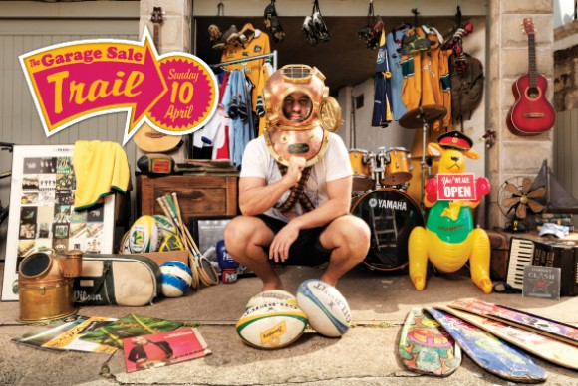
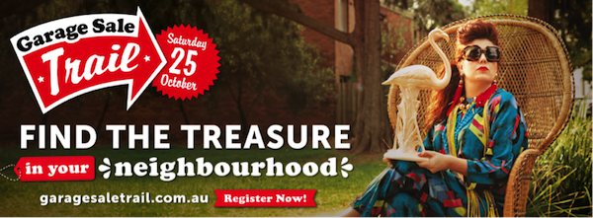

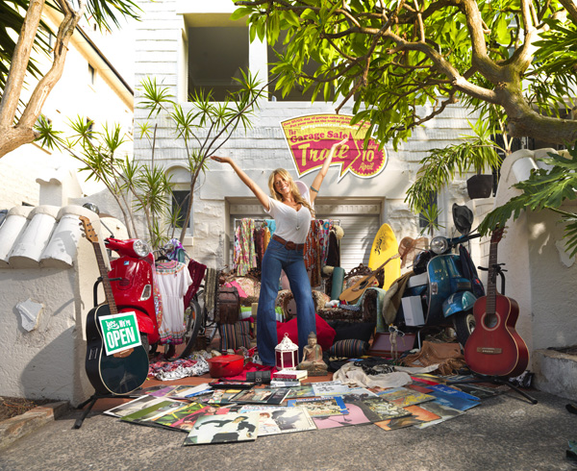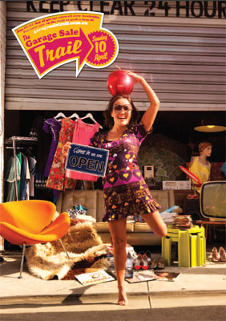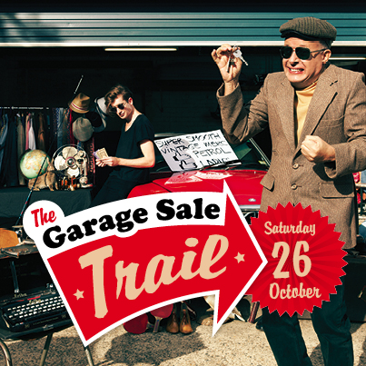
Project Requirements
We are looking for a logo design that can be placed on selife photos submitted by our users. Like the garage sale trail website we want to use these photos to capture the spirit of our users self-exploration and whimsical imagination to sell their possessions and we want to STAMP our logo/brand identity onto these photos.
The NoSellFee logo therefore should be able to be placed on to the selfie photos submitted by our users much like the garage sale trail logo:
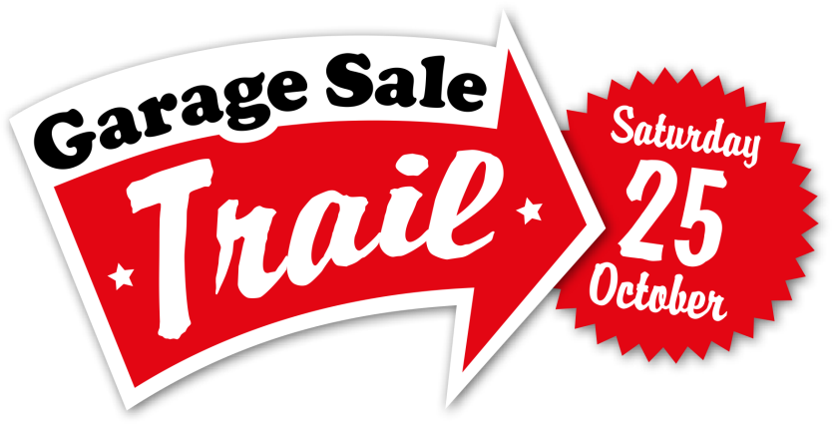

Our ideas:
- Possibly a smart phone imagery making fun of selifies
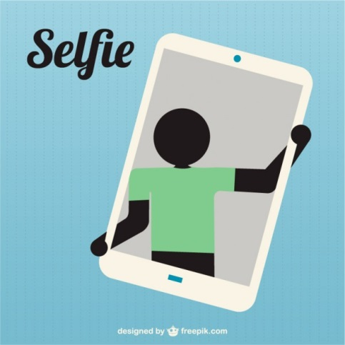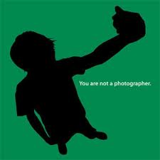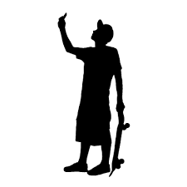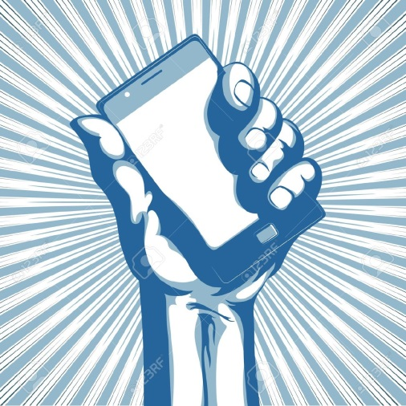
- Something that is trendy, fresh, young but also something retro, iconic so that we can capture the hearts of all age groups

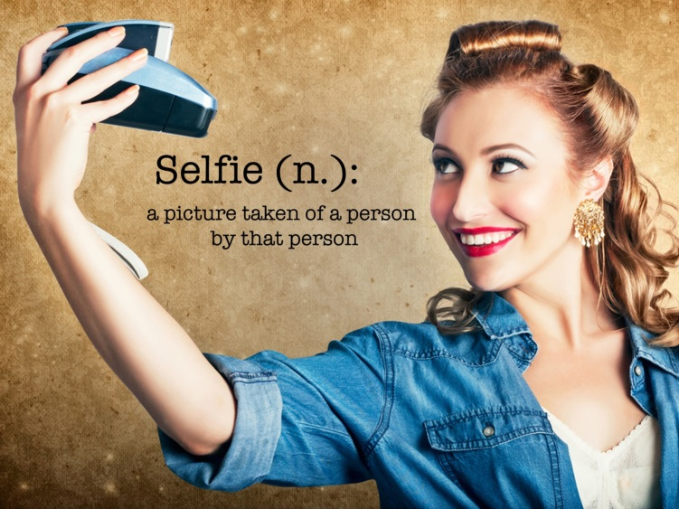
- Something that infers to selling such as a price tag or arrow
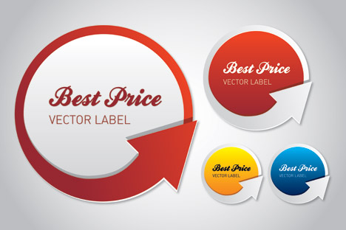

- Something about getting paid
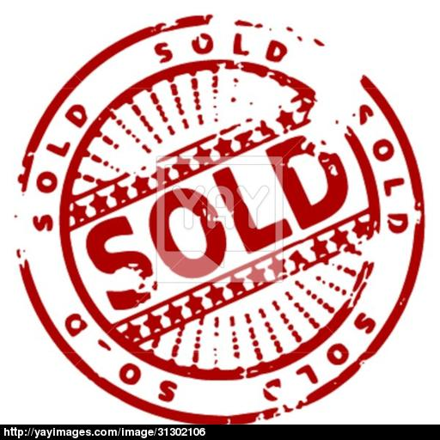
- Smart phone combined with a price tag or classified categories (not much fun though)

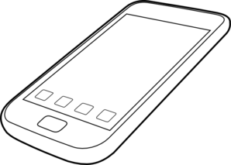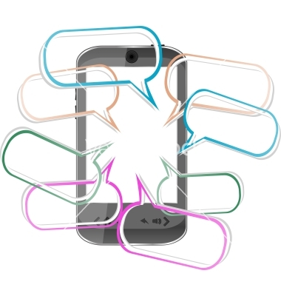

- Much More fun images we like were but we need something that relates to our name and the free selling aspect of our website:
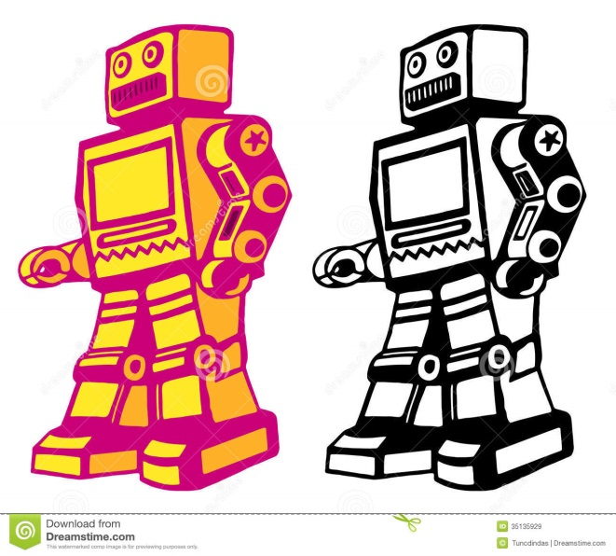
- More fun images we like were these pictures of this black French bull dog taking selfies. We especially like the picture with the headphones:

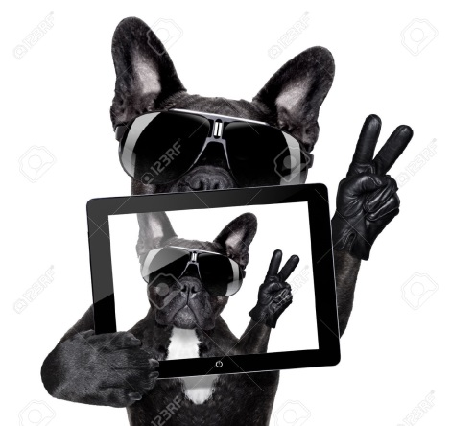
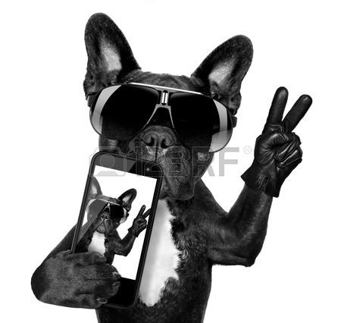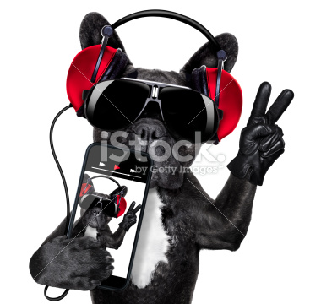


- Logos we like
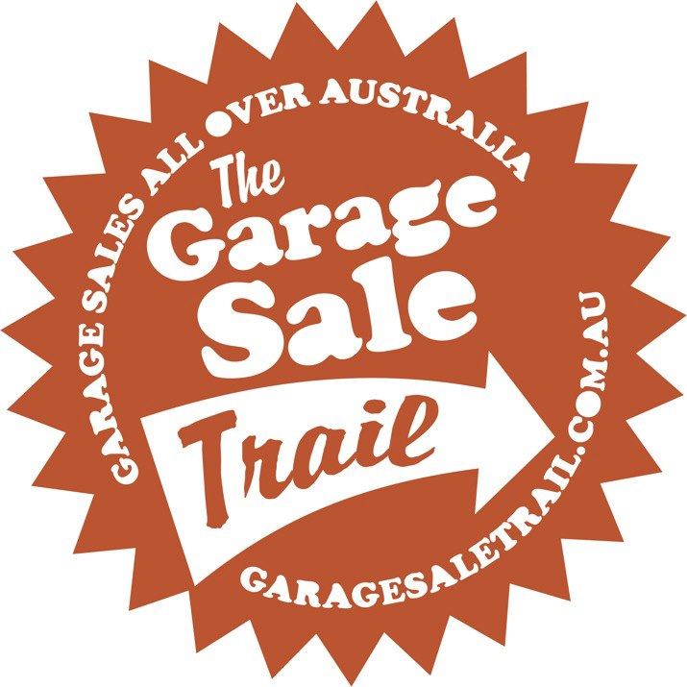
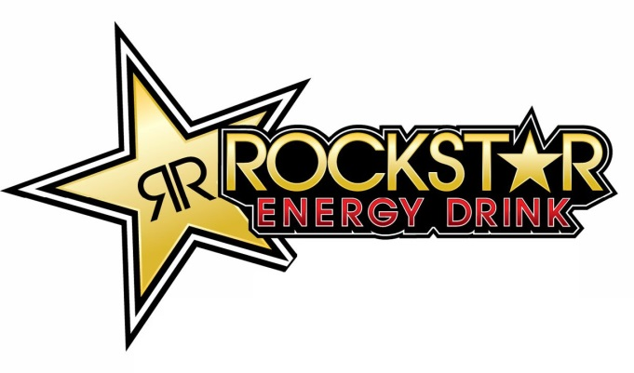

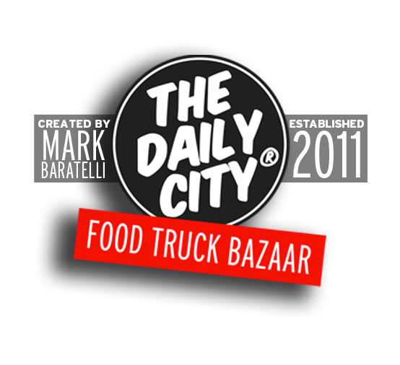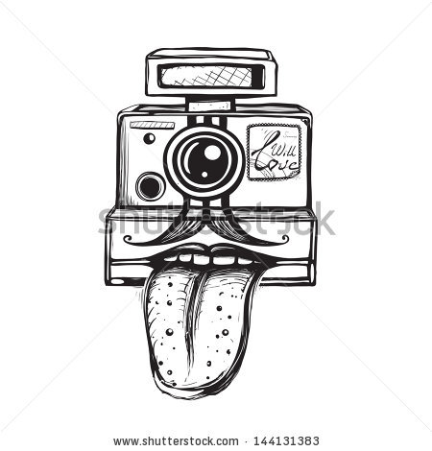

Our final idea: creating a logo that will place the dog in the circle and or name No Sell Fees in the red banner or something like this but we also want to encourage you to be completely free to think outside the box. LOGO NEEDS TO BE – FRESH, RETRO, TRENDY, EASILY IDENTIFIABLE, ABLE TO BE USED TO STAMP PICTURES, PROMOTE THE FREE TO ADVERTISE CULTURE OF OUR WEBSITE.
LOGO Colors RED WHITE and BLACK

+

Logo design
No Sell fees – the name is key and needs to instantly recognizable and easy to read. This will drive new users to the site.
Our Straplines
Our logo will be used with a strapline to convey the spirit of the website
- Love it or list it
- You got sold
- Selfie to wealthy
- A Self occupation that PAYS
- Selfie made man
- The spirit of Trinidad – all kina freeness
- It’s not all about me – it’s also about getting paid
- I’m getting paid
- Let’s make money
- Believe in your selfie
- Cashified ads
- Putting the Sell into selfies
- Note to one selfie – sell it and take the cash
- You only win if you cash in

What ever logo design is developed we want to try it on the picture below to see if it works.


And compare how it looks with the logo and brand on this picture.

