LOGO IDEAS
We are looking for a logo design that can be placed on selife photos submitted by our users. Like the garage sale trail website we want to use these photos to capture the spirit of our users self-exploration and whimsical imagination to sell their possessions and we want to STAMP our logo/brand identity onto these photos.
The NoSellFee logo therefore should be able to be placed on to the selfie photos submitted by our users much like the garage sale trail logo:
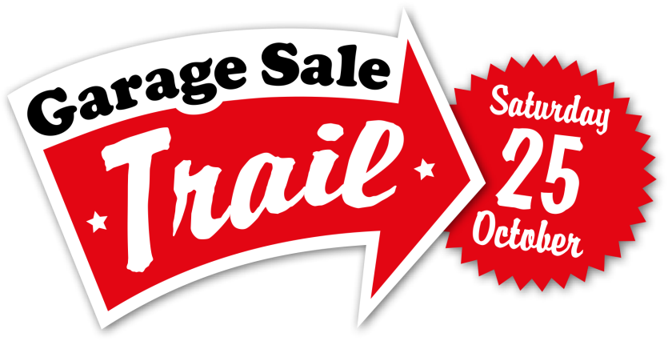

Our ideas:
- Possibly a smart phone imagery making fun of selifies
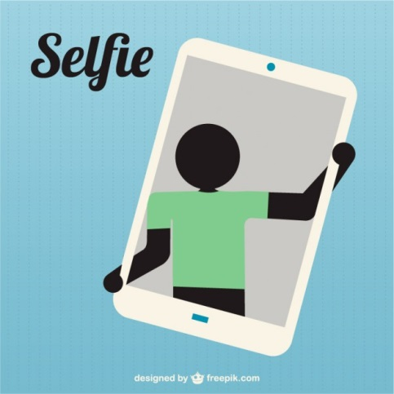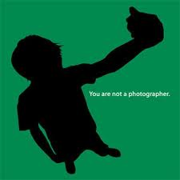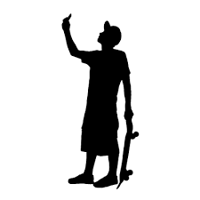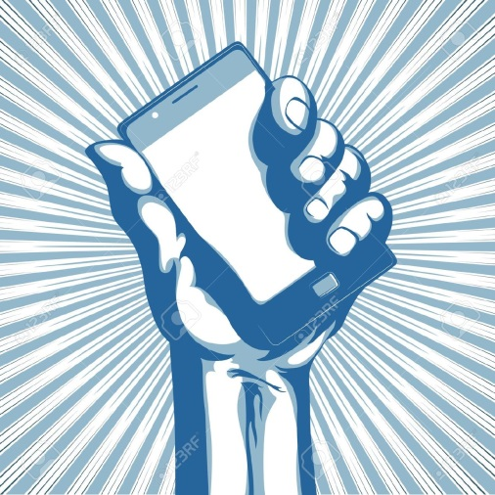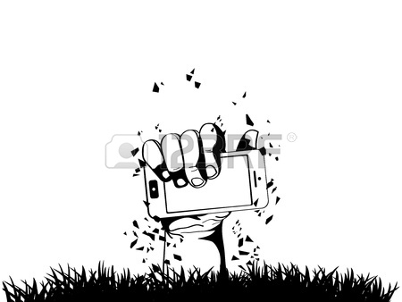
- Something that is trendy, fresh, young but also something retro, iconic so that we can capture the hearts of all age groups
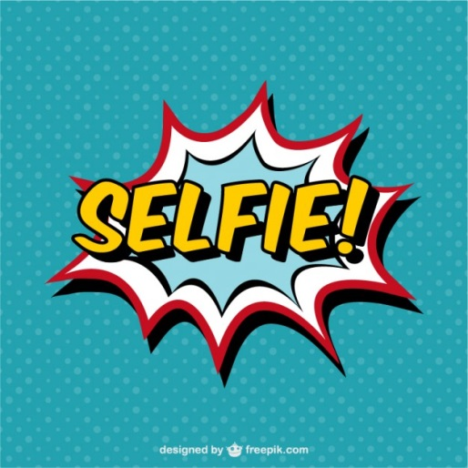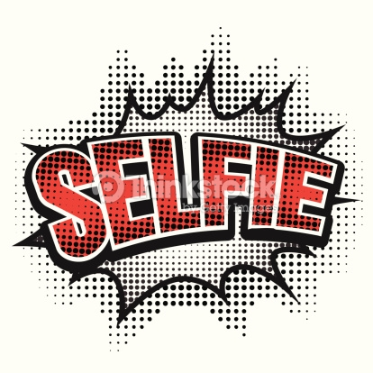
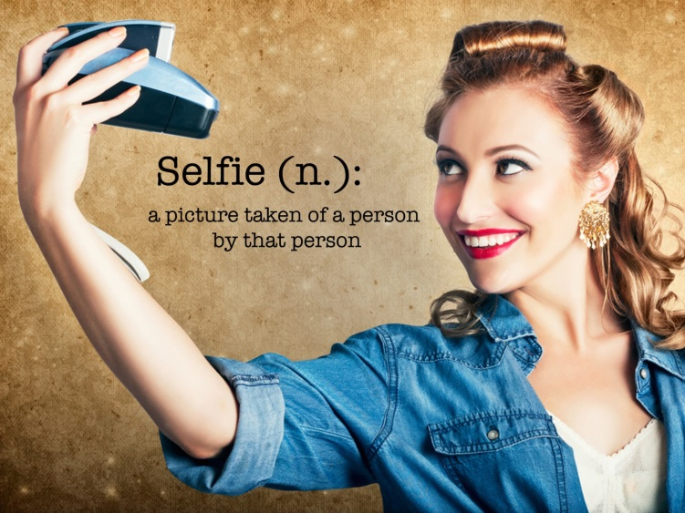
- Something that infers to selling such as a price tag or arrow
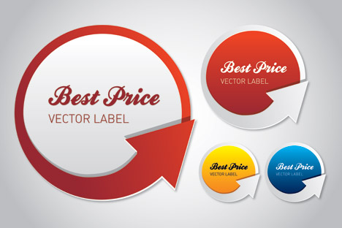

- Something about getting paid
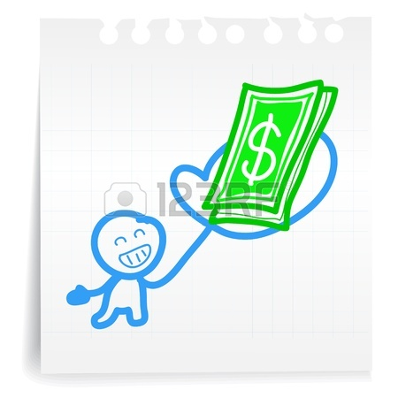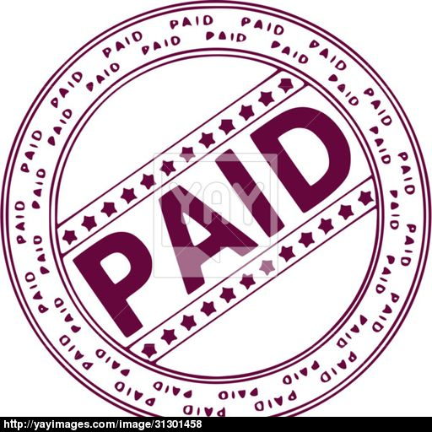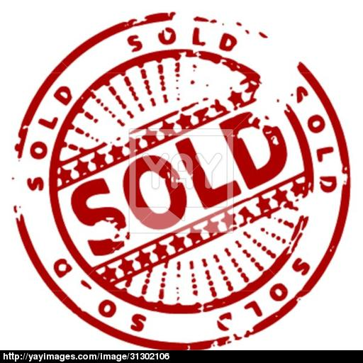
- Smart phone combined with a price tag or classified categories (not much fun though)

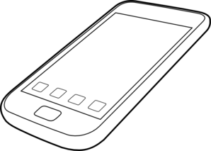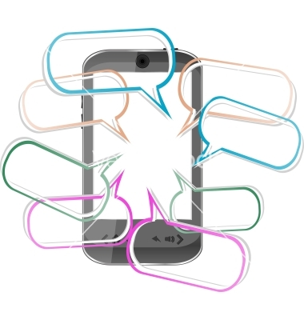

- Much More fun images we like were but we need something that relates to our name and the free selling aspect of our website:
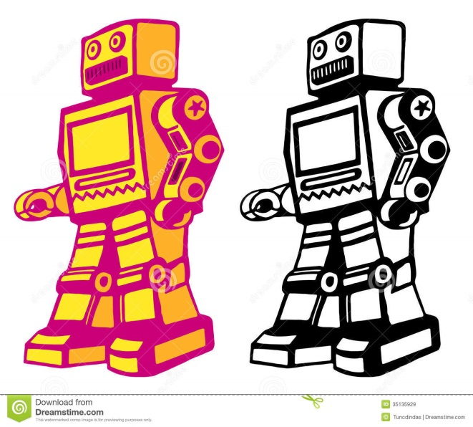
- More fun images we like were these pictures of this black French bull dog taking selfies. We especially like the picture with the headphones:

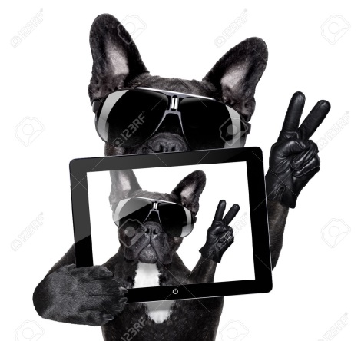
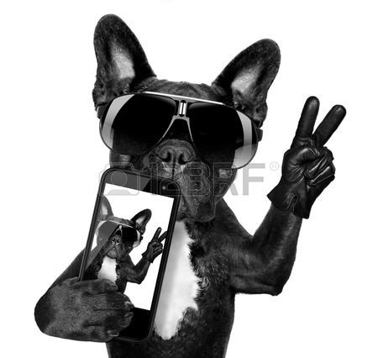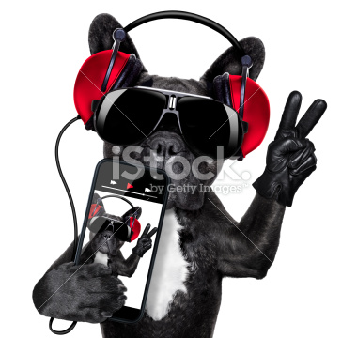


- Logos we like
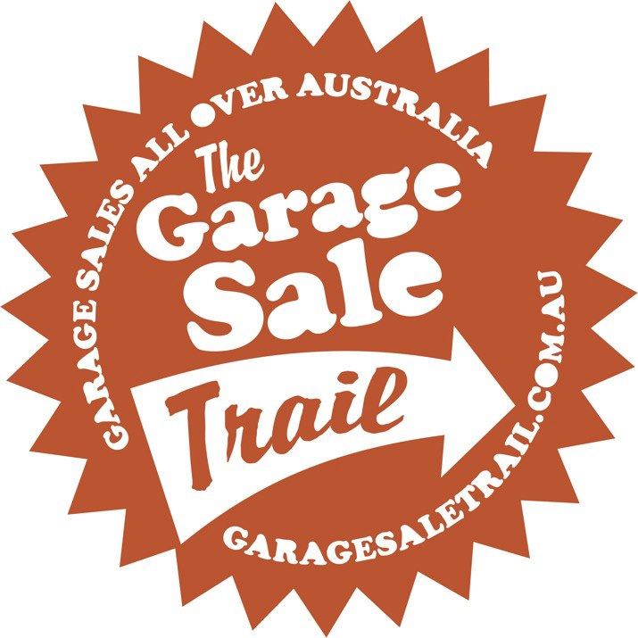
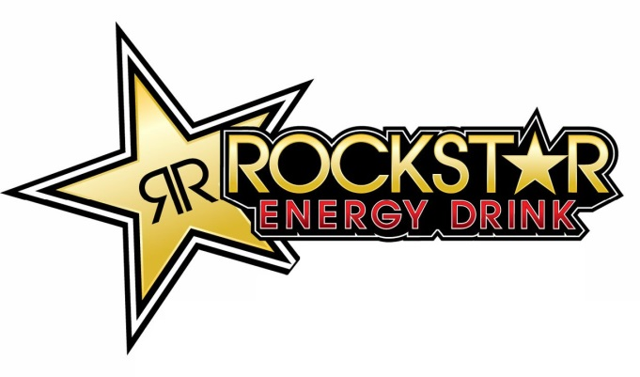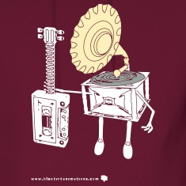
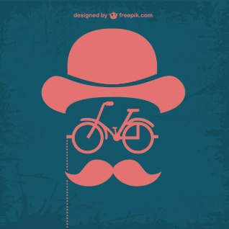
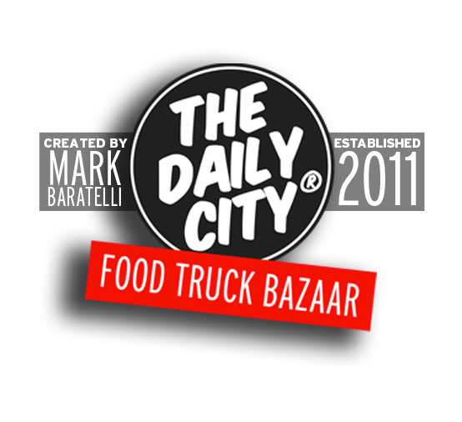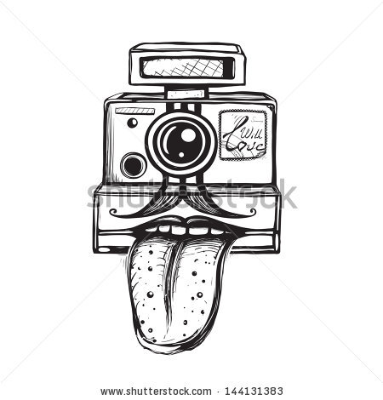

Our final idea: creating a logo that will place the dog in the circle and or name No Sell Fees in the red banner or something like this but we also want to encourage you to be completely free to think outside the box. LOGO NEEDS TO BE – FRESH, RETRO, TRENDY, EASILY IDENTIFIABLE, ABLE TO BE USED TO STAMP PICTURES, PROMOTE THE FREE TO ADVERTISE CULTURE OF OUR WEBSITE.
LOGO Colors RED WHITE and BLACK

+

Logo design
No Sell fees – the name is key and needs to instantly recognizable and easy to read. This will drive new users to the site.
Our Straplines
Our logo will be used with a strapline to convey the spirit of the website
- Love it or list it
- You got sold
- Selfie to wealthy
- A Self occupation that PAYS
- Selfie made man
- The spirit of Trinidad – all kina freeness
- It’s not all about me – it’s also about getting paid
- I’m getting paid
- Let’s make money
- Believe in your selfie
- Cashified ads
- Putting the Sell into selfies
- Note to one selfie – sell it and take the cash
- You only win if you cash in

What ever logo design is developed we want to try it on the picture below to see if it works.

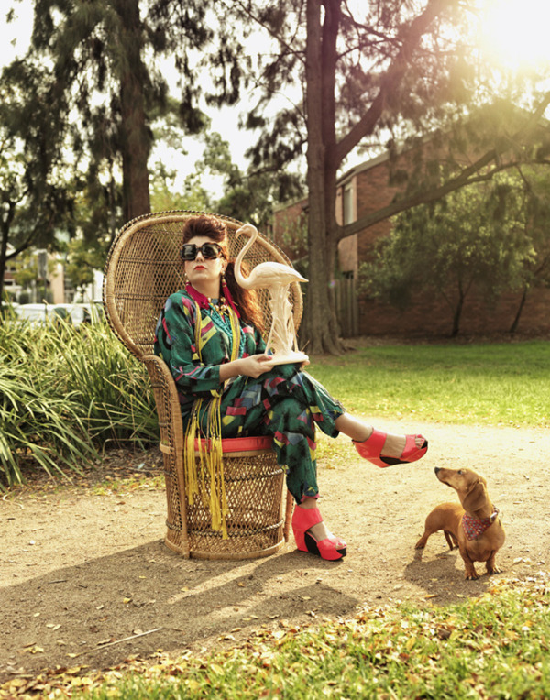
And compare how it looks with the logo and brand on this picture.
