Please use google for more pictures of sugar cane, barramundi and mud crabs.

SUGAR CANE PICTURES
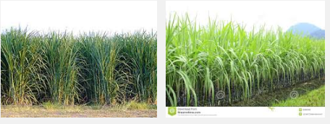
HARVESTING SUGAR CANE BRAHAM CATTLE
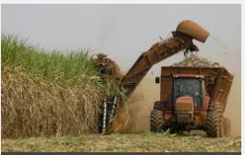
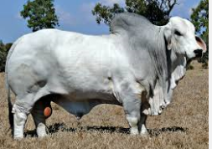
BARRAMUNDI
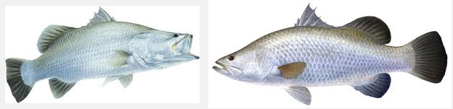
MUD CRABS
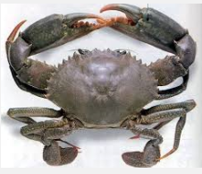
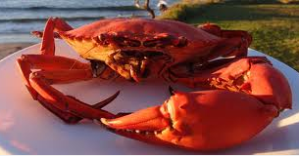
Uncooked crab Cooked crab (goes orange when cooked)

