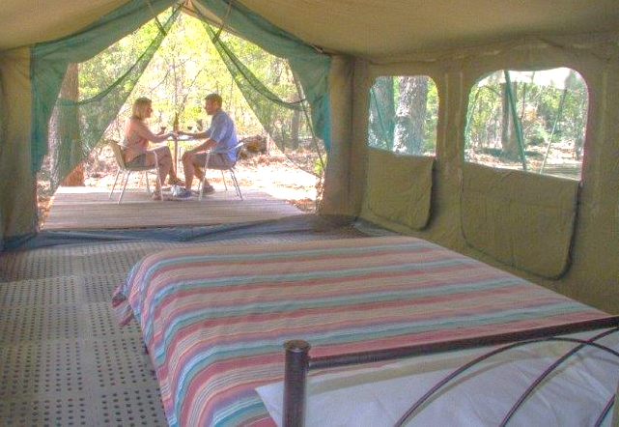
A ‘quintessentially Australian’ nature based experience in Margaret River which doesn’t cost the earth

Front cover
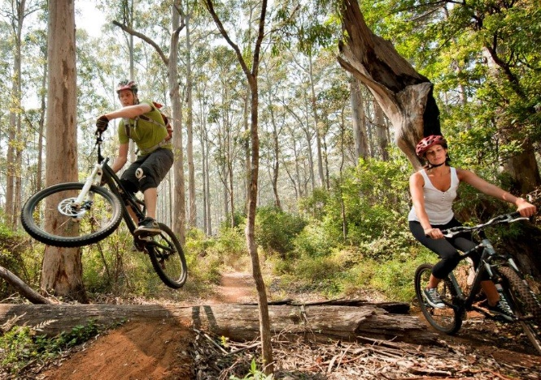
e: stay@wharncliffemill.com.au tel: 08 9758 8227 Carters Road, Margaret River www.wharncliffemill.com.au
- Nestled in the forest – walk or ride to Margaret River town centre or the river
- Rustic simplicity and loads of charm
- Aussie style bush retreat with campfires and a starlit sky
Surrounded by a myriad of walking trails and sensational mountain bike trails, just two kms from the Margaret River town centre, Wharncliffe Mill offers a beautiful nature based eco-experience with a range of attractions and activities on the doorstep.
We generate our own power, harvest rain water and have state of the art waste water treatment facilities to ensure we minimise our impact and educate guests about the natural environment, whilst they experience best practice sustainable living.
e: stay@wharncliffemill.com.au www.wharncliffemill.com.au
tel: 08 9758 8227 Carters Road, Margaret River

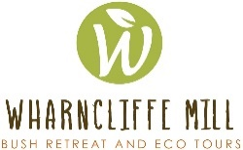

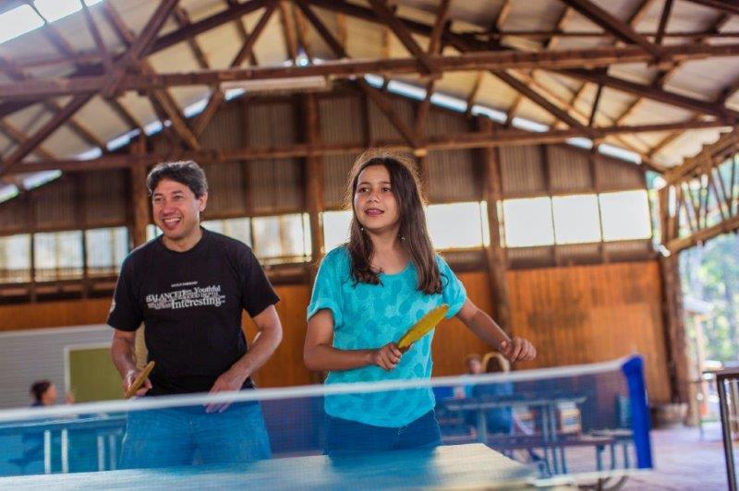
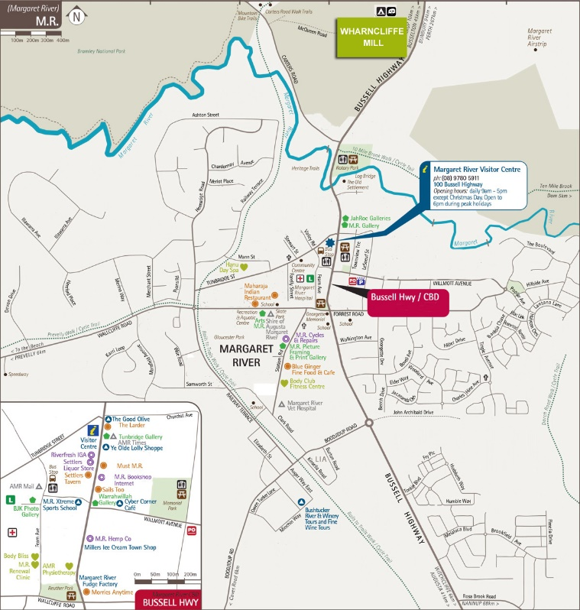
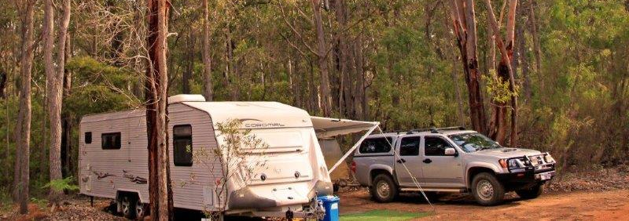
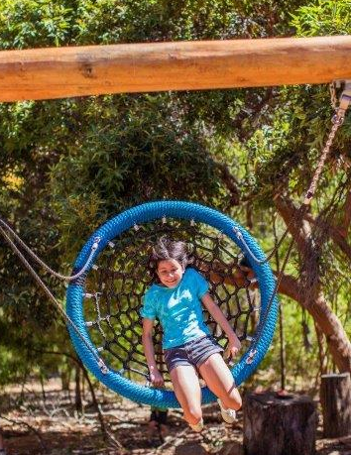
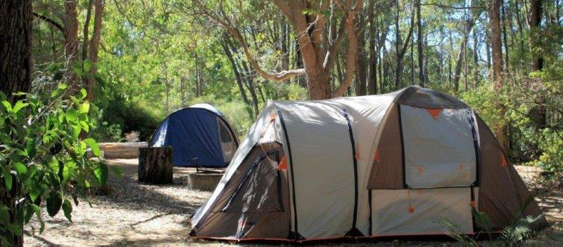
Stay amidst the forest in a safari tent, cabin or eco lodge…
or bring your own caravan or tent…
Booking conditions: Cancellation fee of $50 AUD per room if more than 14 day notice, no refunds if less than 14 days. Full payment on booking. Book online for best available rates.

A mecca for mountain bikers & hikers
A unique eco camp in Margaret River

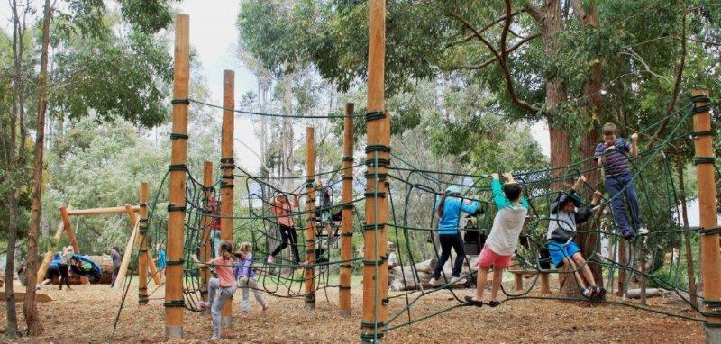SITUATED IN AN AMAZING LOCATION
Wharncliffe Mill is hidden amidst the tall timber of the Bramley National Park, less than two kilometres from the Margaret River town centre.
The region is home to world-class bush trails, cave systems, beaches, surf breaks and wineries. Bramley National Park is the northern gateway to Margaret River and is known for its spectacular biodiversity and natural beauty. The river runs along the southern boundary and a network of world class walk and off road cycle trails is being further developed to the north.
Facilities:
Kiosk/Cafe, hot showers, huge undercover area, camp fires (subject to fire restrictions), camp kitchen, BBQ’s, free Wi-Fi at reception/café, laundry
Onsite activities: Mountain Bike Hire, Self-Guided Forest Walks, Eco Ed, Night Walks, Aboriginal Tours, Table Tennis, Our nature play space incorporates a huge nest swing and a ‘climbing forest’ to inspire children to interact with nature.

Tours & nearby activities: Kayaking, surf lessons, awesome beaches, wine tours, rock climbing, abseiling, cave tours & more…
Ride the world class cycle trails…. Swim, surf or snorkel on stunning beaches Enjoy gastronomic delights …

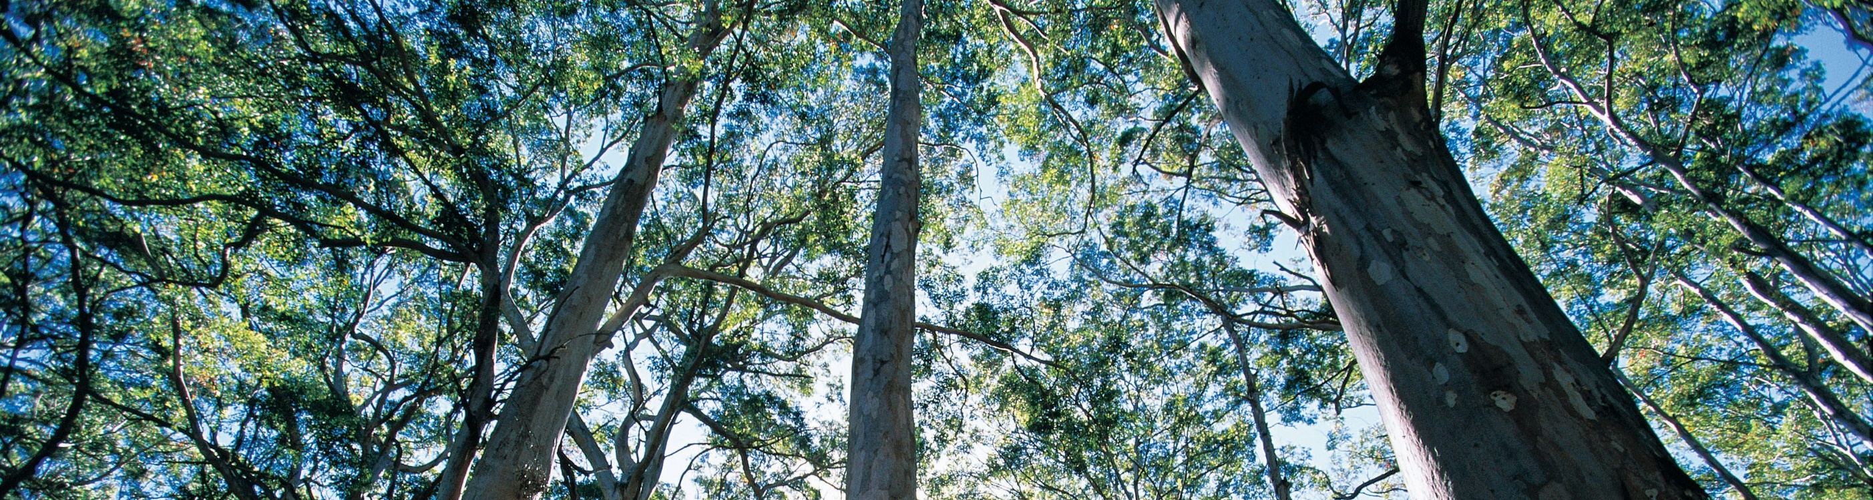

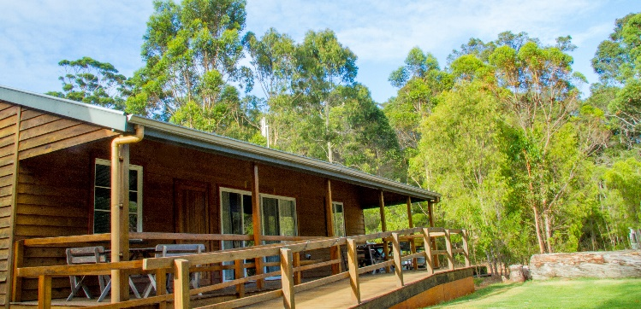
SIMPLE ECO ACCOMMODATION
- The eco lodge has four individually keyed bedrooms with two bathrooms and a kitchen. Each room has a double and a single bed (or trundle/bunk) to sleep up to 3 people (or 12 in the whole lodge).
- Two bedroom en-suite cabins sleep 6 with a queen bed in one room and two sets of bunk beds in the other.
The lodge & cabins have a log fire, balcony, BBQ and kitchen. There is solar powered air-con in the lounge/ dining room which keeps it cool when the sun is shining!

- Basic safari tents are perfect for a first time camping experience or those that don’t have their own tent – each has a double bed and a set of bunk beds to sleep up to 4 people.
- Small dorm rooms sleep up to 5 people and the two large dorm rooms have capacity for up to 12 or 24 people respectively.
- 40 well-spaced bush campsites are suitable for tents or caravans. Most hug the forest and have access to power and water.

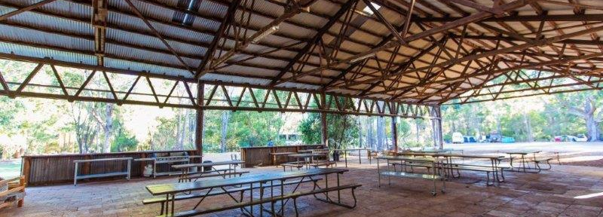GENERATING ENERGY FROM THE SUN
Wharncliffe Mill showcases a range of best practice sustainability technologies and practices. The 32 kW solar power system on the roof of the old mill generates 50,000 units of power per year.

HARVESTING RAINWATER
The 525 square meter mill building roof area yields over 575,000 litres of rainwater per year (based on the average annual rainfall of 1,100mm per year in Margaret River).

REUSING WASTE WATER FOR RETICULATION
The waste water from the toilets, kitchens and showers in our four bedroom eco lodge and our cabins is all treated by an anaerobic and aerobic treatment unit making it suitable for subsurface irrigation for our lawns. This not only minimises our water use, it also deals with our wastewater in an environmentally responsible way.
INTERPRETING NATURE & CULTURE
The Bush Amphitheatre features a Mia Mia (Noongar Aboriginal shelter) and a fire pit to watch cultural tours and performances. It is also a popular spot for yoga and meditation.
Self-guided trail notes, interpretive information, mountain bike hire and a range of tour options has opened up access to a plethora of nature-based adventures.
Explore the wonderful trails in the surrounding national park, or just relax under the trees with a book from our library.

