
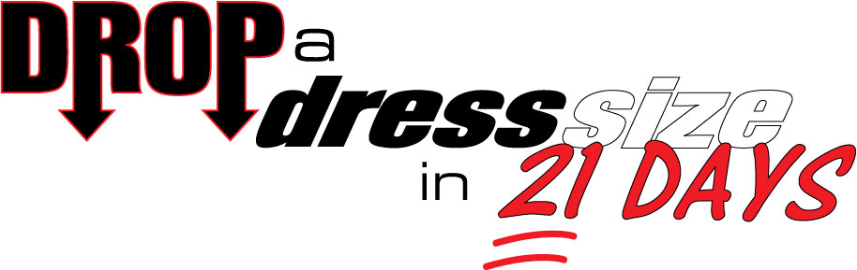

Are you tired of all the health clubs and fitness centers that tell you exactly what you want to hear to get you to join, but once you’re a member they forget about you and don’t teach you anything about how to get results?

Are you frustrated by all the gimmicks; the pills, powders, shakes and gadgets sold on late night TV that are nothing more than empty promises and slick marketing?

If so, then this amazing offer is perfect for you…
Here’s what you get:

- Three weeks worth of Fat Burning Workouts with a Certified Personal Trainer to make sure that you don’t spend one minute exercising that doesn’t produce results.
- 21 Days of Fat Burning Meal Plans designed by a Registered Dietician to ensure that you reach your goals as quickly as possible.
- Nutrition Coaching Session to answer all your questions and set you up for success
- 21 Days of Lessons to keep you on track to achieving your goal of dropping a dress size

…You get all this – a $327 Value - for ONLY $97!

HURRY! SPACE IS LIMITED LADIES!!
Starts April 6th 2015
CLAIM YOUR SPOT NOW – www.Kinetafitbootcamps.com
Call 303-503-9344
WINNER GETS $100 Cash, A NEW DRESS (Up to $100 Value)
AND A FREE PHOTO SHOOT! ($150 Value)

