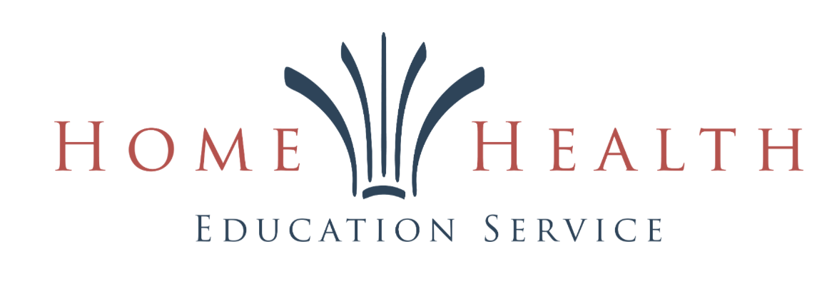
HHES GCC
RESTRUCTURING
PROPOSAL
Options for Conference Partnerships and
Literature Ministry Development

November 2026

HHES GCC Restructuring Proposal
In light of changes in the Southern Union literature ministry landscape and the desire of some conferences to withdraw from the HHES partnership, the following two options are presented for consideration.

Option 1
At the end of 2026, as outlined on page 3 of the HHES GCC Memorandum of Understanding (MOU), total reserve fund balance would be calculated in cash and inventory, minus obligations. The following are rough estimates for the three conferences based on September 30, 2026 figures; final figures would most likely be higher.
Conference | Estimated total equity | Estimated cash | Estimated inventory
Carolina Conference | ~$700,000 | ~$350,000 | ~$350,000  (about 50 skids/pallets)
Gulf States Conference | ~$330,000 | ~$165,000 | ~$165,000  (about 23 skids/pallets)
Kentucky-Tennessee Conference | ~$475,000 | ~$237,500 | ~$237,500  (about 33 skids/pallets)

Planning note: Bad debt expense is not included in these estimates. No separate rebate payment would be made for 2026. Cash and inventory may need to be distributed in installments to minimize disruption of HHES operations.

Option 2
For the three conferences in question, all regular subsidies to HHES GCC would stop on December 31, 2026. At year-end, total equity would be calculated for each conference, and a proposed 30% would be returned to each conference in cash. The following are rough estimates based on September 30, 2026 figures; final figures would most likely be higher.
Conference | Estimated total equity | Proposed 30% cash return
Carolina Conference | ~$700,000 | ~$210,000
Gulf States Conference | ~$330,000 | ~$99,000
Kentucky-Tennessee Conference | ~$475,000 | ~$142,500

Starting January 1, 2027, HHES GCC could continue to provide the following support for the student Magabook ministry:
- Purchasing, warehousing, and shipping inventory
- Providing computers and accounting software
- Issuing scholarship checks to leaders and students
- Maintaining the website
- Providing accounting services, including issuing 1099s and maintaining bank accounts and merchant payment services
- Providing work tools, such as bags, receipt pads, and communication equipment (radios)
- Handling bad checks and damaged or lost books
- Shipping books to and from program locations

Annual conference fee: Each participating conference would continue to be invoiced $40,000 per year. This is the amount currently allocated to each conference by the Southern Union office. Any additional services requested by a conference would be provided on a pay-as-you-go basis, based on the literature ministry initiatives it considers best suited to its field. (See the following pages for optional add-ons.)

Rationale for Option 2: Investing in a More Flexible and Effective Literature Ministry
- Most administrators believe in the power of God’s Word to transform lives, but they do not see the current big-book model as providing the best return on investment for the funding it receives.
- Different fields have different needs and realities. Offering a variety of methods for sharing God’s Word may lead to a greater impact in these last days.
- Leaving behind the remaining 70% of each conference’s equity with HHES would give it the time and resources to improve the effectiveness and profitability of current programs and develop new systems and initiatives.

HHES GCC
Literature Evangelism
À la Carte

The following services are in different stages of development. The goal is to enhance current programs while also seeking to develop new initiatives. Some programs have been successfully implemented in other fields but would need to be adapted. HHES is committed to developing new initiatives to proclaim God’s Word in these last days. We believe that thousands will soon be converted in a single day. For such a great harvest to take place, however, we believe effective sowing must happen now through three avenues: (1) the work of professional literature evangelists; (2) youth canvassing programs; and (3) the free distribution of literature by every willing church member.
The initiatives and services outlined below also provide opportunities for conferences across North America that do not currently operate a literature evangelism program to partner with us in ministry. As someone once said, “God’s work is not finished anywhere until it is finished everywhere.” (Please note that many of the images are AI-generated and are included for illustrative purposes only.)
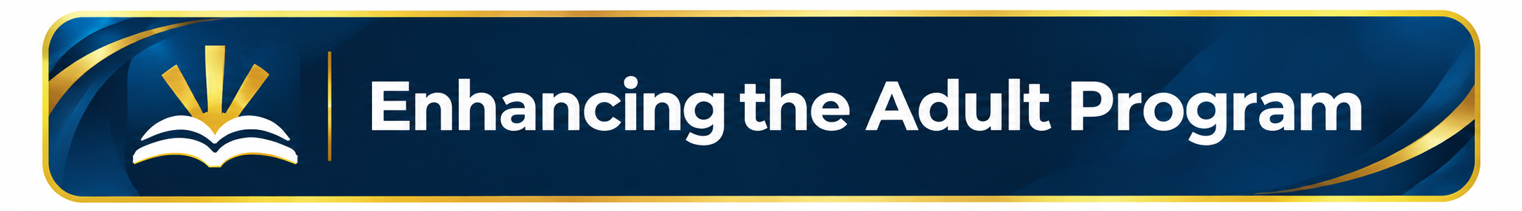

HHES Big-Book Benefits
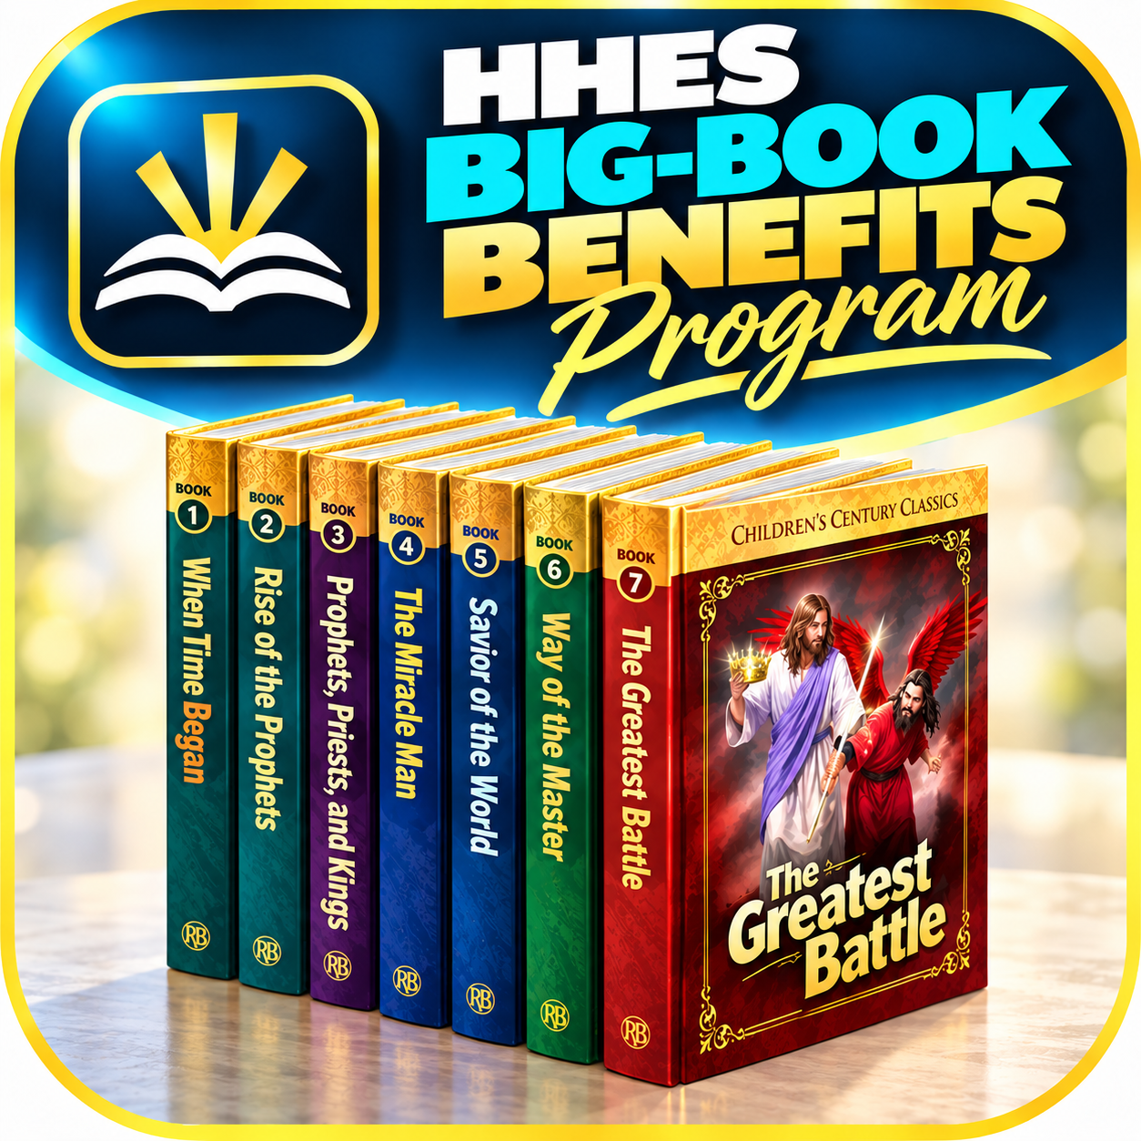
Beginning January 1, 2027, if Option 2 is selected, HHES GCC would continue administering customer contracts for all current and new literature evangelists outside the Georgia-Cumberland Conference (GCC). If a conference chooses to provide bonuses to its literature evangelists, HHES GCC would invoice the conference quarterly for the bonus amount, plus a 2% administrative fee. Each conference would decide whether to offer bonuses and would be responsible for covering the associated costs.

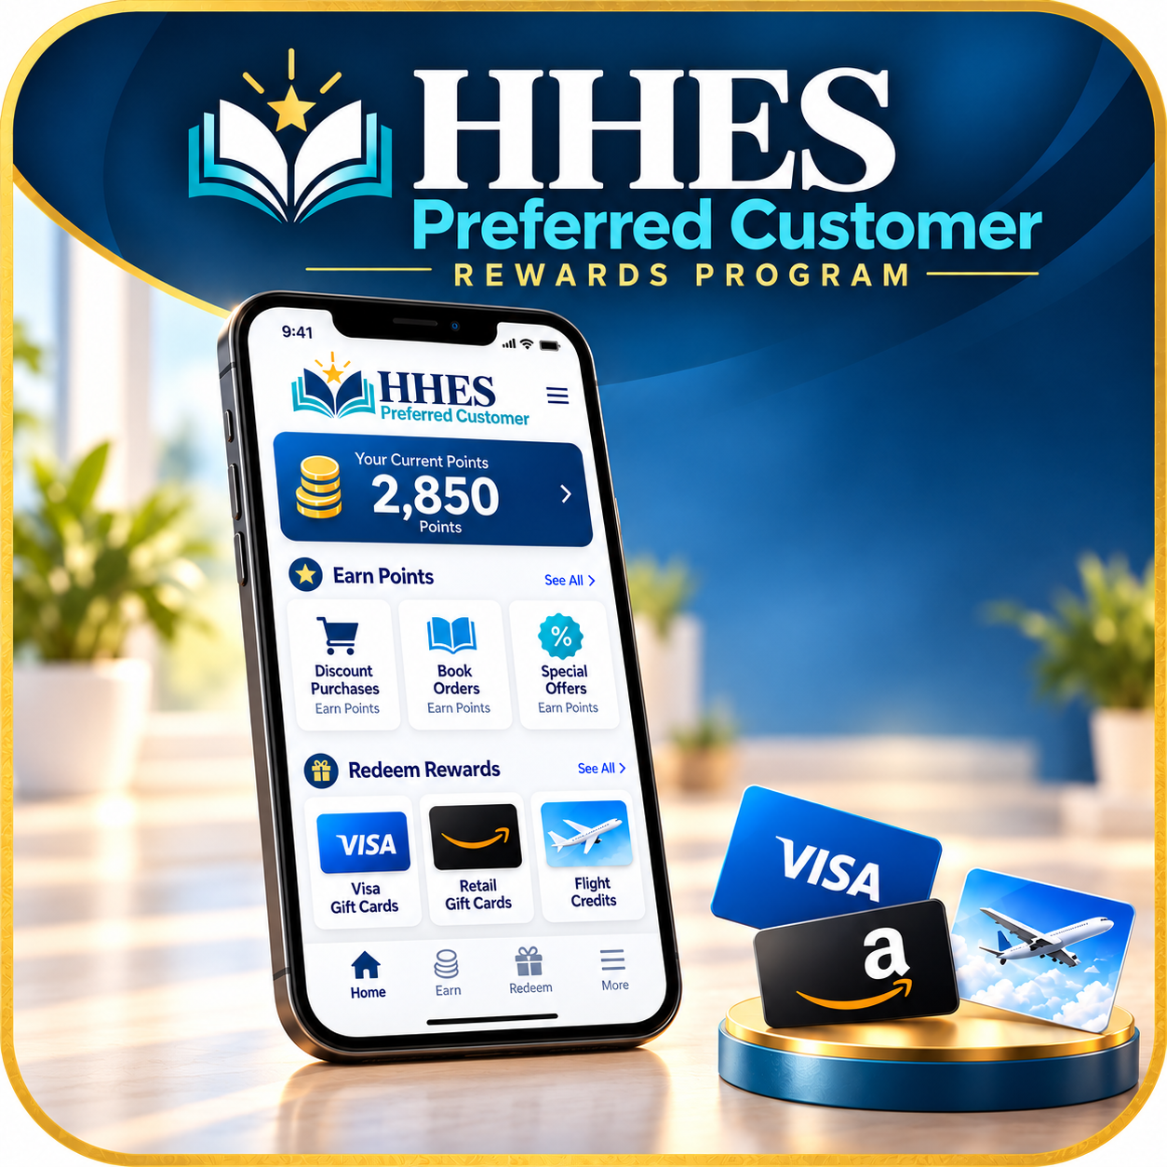
HHES Preferred Customer
Many individuals are currently purchasing books from HHES at discounted prices. We would like to expand this market by either developing our own rewards program or partnering with an established rewards company. Customers would be able to accumulate points through their purchases and redeem them for Visa gift cards (or other retail gift cards – eg. Amazon). This program would also provide an alternative incentive for individuals whose informal distribution methods don’t necessitate issuing of a W-2 or 1099.

Legacy of Light Program

This program offers an enhanced approach to the current Children’s Century Classics distribution method, designed to bring back “good old-fashioned” family values through a creative and engaging approach. Whether at fairs or for door-to-door, this program is geared for older church members to become actively involved in outreach by dressing in period costumes from the late 1800s and interacting with people in character. Families would have opportunities to take pictures with these representatives, participate in simple activities, and receive small, old-fashioned keepsakes. By combining nostalgia, and personal interaction, the goal is also to create memorable experiences that open doors for spiritual conversations and distribution of the CCC and/or other resources.

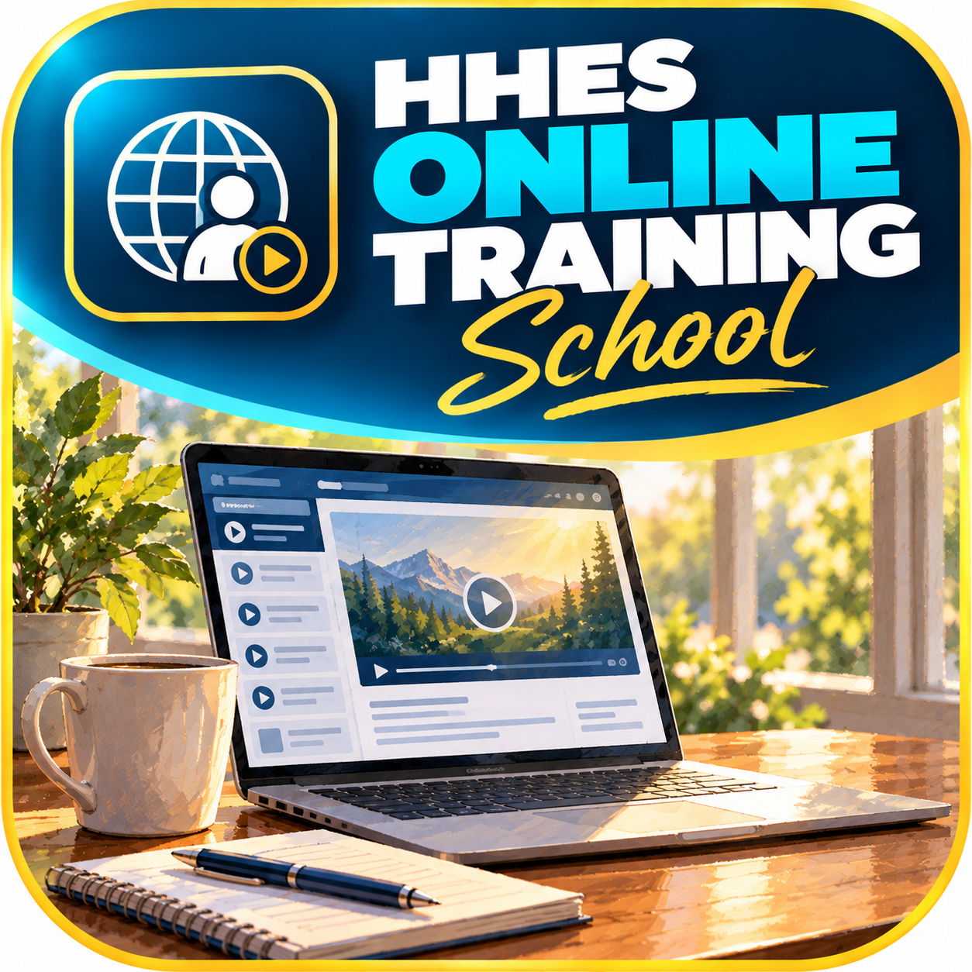
HHES Online Training School
A course has already been produced to train literature evangelists through an online portal. It does not replace in-the-field training, but it allows a foundation to be laid for students and regular LEs—especially those who may not have a structured program close to them. The goal is to inspire and train workers in different methods. The course would need to be updated and contextualized to the South. Modules would also need to be developed for regular church members who simply want to share printed literature without engaging in sales. (See the section below, “Enhancing the Every Member Program.”) This group could also serve as a pool of potential workers who may eventually become involved in more structured forms of literature evangelism.

Coaching Certification – iHeal / BreakFree


Comprehensive health coaching certification programs are already available, including iHeal, which can be completed entirely online, and BreakFree, which offers in-person training. These programs can be combined with other health initiatives to equip literature evangelists (LEs) with the knowledge and skills needed to more effectively promote and sell books addressing physical, mental, and spiritual health. For more information about the iHeal program, visit www.ihealschool.org.

Pop-Up Bookstores (Living Well/Hope Books)
A concept modeled after the pop-up bookstores currently operating in Australia and New Zealand. These portable bookstores are set up at shopping malls, community fairs, schools, etc. where large numbers of people gather. HHES could provide training, materials, and ongoing support to help literature evangelists operate these bookstores. Besides generating sales, the goal would be to create opportunities for meaningful conversations, build relationships, and introduce people to spiritual resources and local churches.
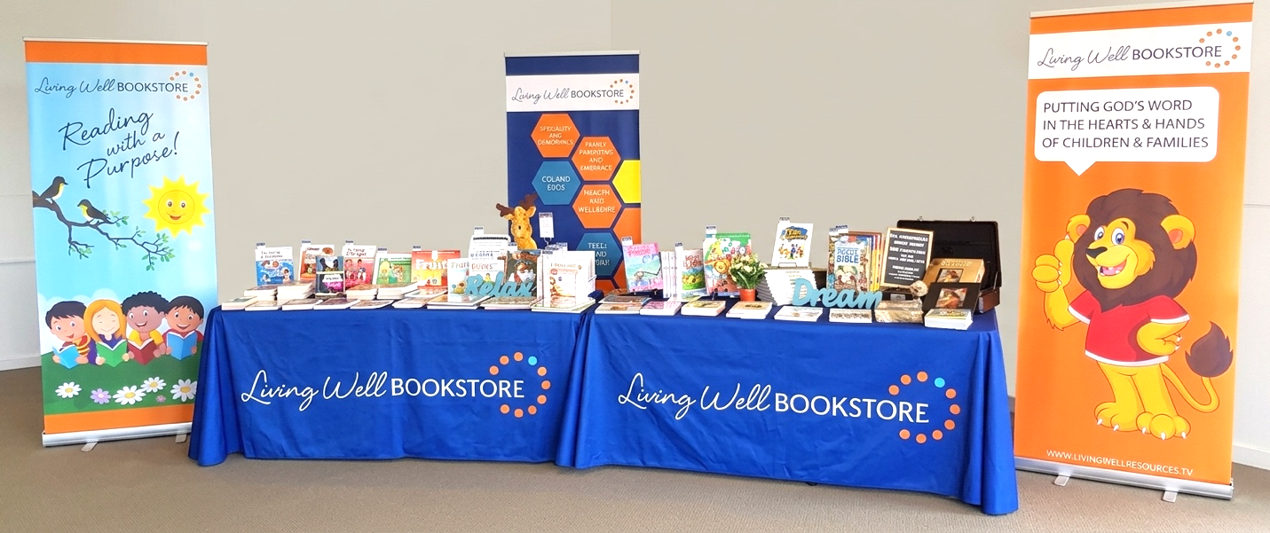

Care Package Program

Nearly one in two Americans will develop cancer during their lifetime. Cancer can be a deeply emotional subject, and conversations about it can create opportunities for meaningful connection. Cancer care packages have been developed to offer guidance and comfort during a difficult time.
(See www.ihealcare.org)
One approach follows a model similar to the Listen/Winner Magazine program: hospitals would let the LE know how many care packages they need, and community businesses would be solicited to donate toward the cost.
Another approach is to canvass the community directly using surveys. People are asked how their lives have been affected by cancer. Those who wish to can purchase care packages, while others can simply donate to the program. The tax-deductible donations help provide packages at no cost to people in the community who may not be able to afford them.
For people with whom meaningful connections have been made, sharing more in-depth spiritual books or inviting them to a small group or Bible study is a natural next step. Diabetes care packages are also in development.

Spiritual Revival and Growth for Literature Evangelists
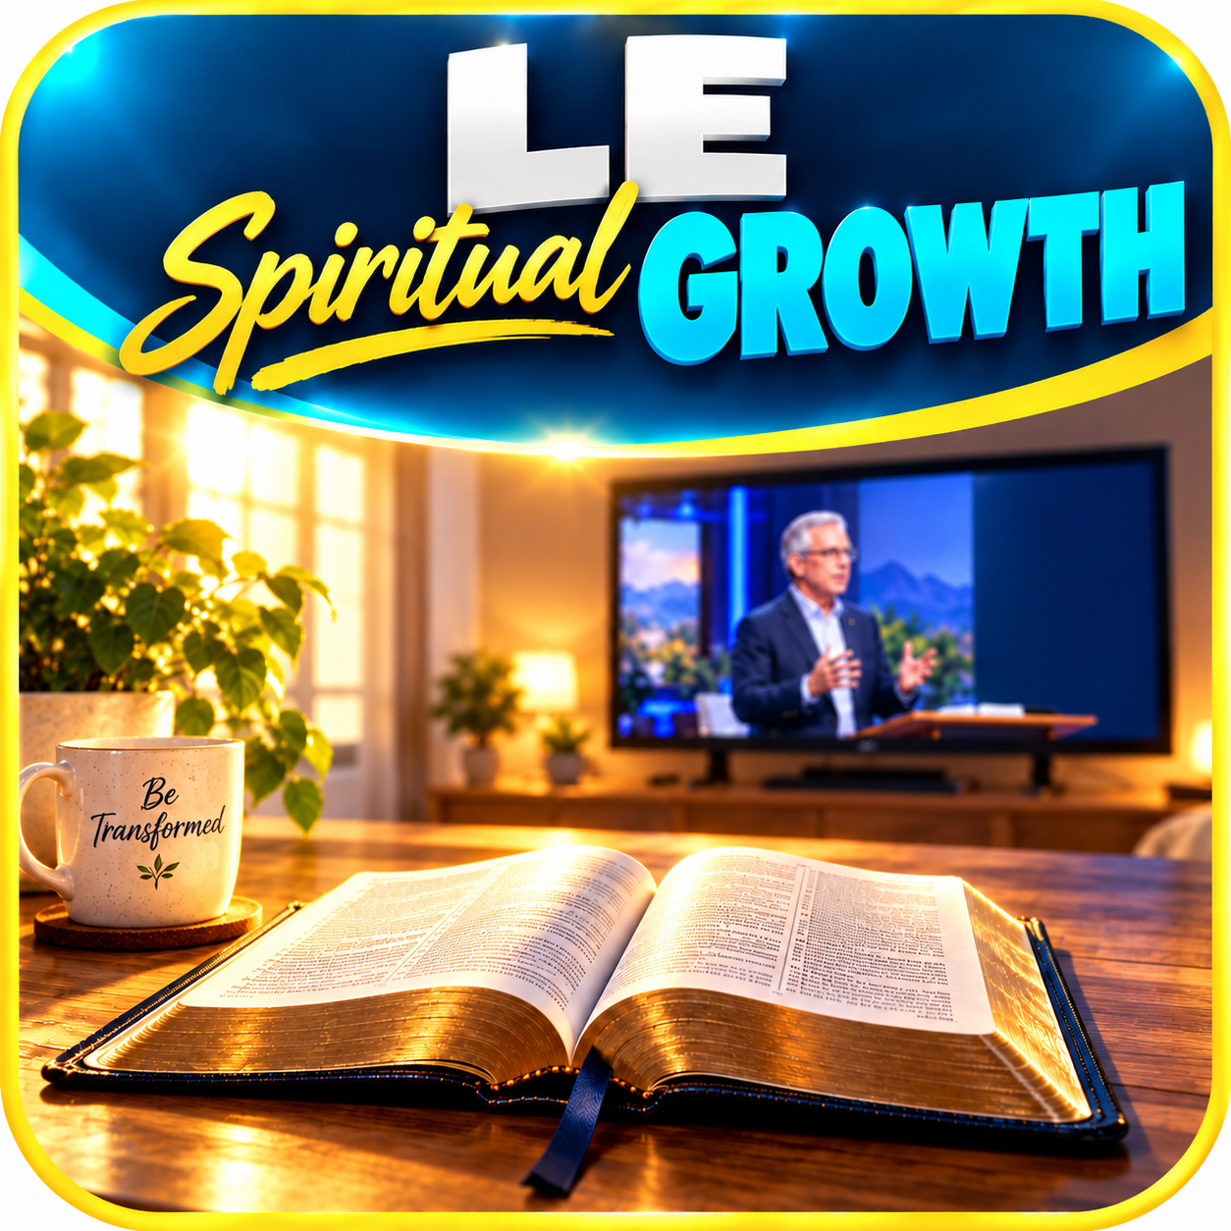
Literature evangelism is first and foremost a spiritual work, yet amid the demands of daily ministry, it can be easy to lose sight of this truth. As time and resources allow, HHES would seek to develop events, training opportunities, and resources specifically designed to nurture the spiritual lives of both new and experienced literature evangelists. The goal would be to encourage personal revival, deepen their relationship with Christ, and help them recognize their work as a divine calling rather than simply a means of distributing or selling books. Initiatives could include annual LE retreats, inspirational books, and modules through the online training platform.



Literature evangelism is one of the few organized ministries within the church that consistently combines sharing God’s Word with a personal touch. We believe the potential to activate more members and impact more people through the power of God’s Word is limitless. We may only be able to try a few methods to start with as we seek the initiatives that will gain the most traction in sharing the three angels’ messages. Some outreach initiatives may fail, or at least not produce major results, but we won’t know until we try. And as the saying goes, nothing ventured, nothing gained.

GLOW Evangelism Program
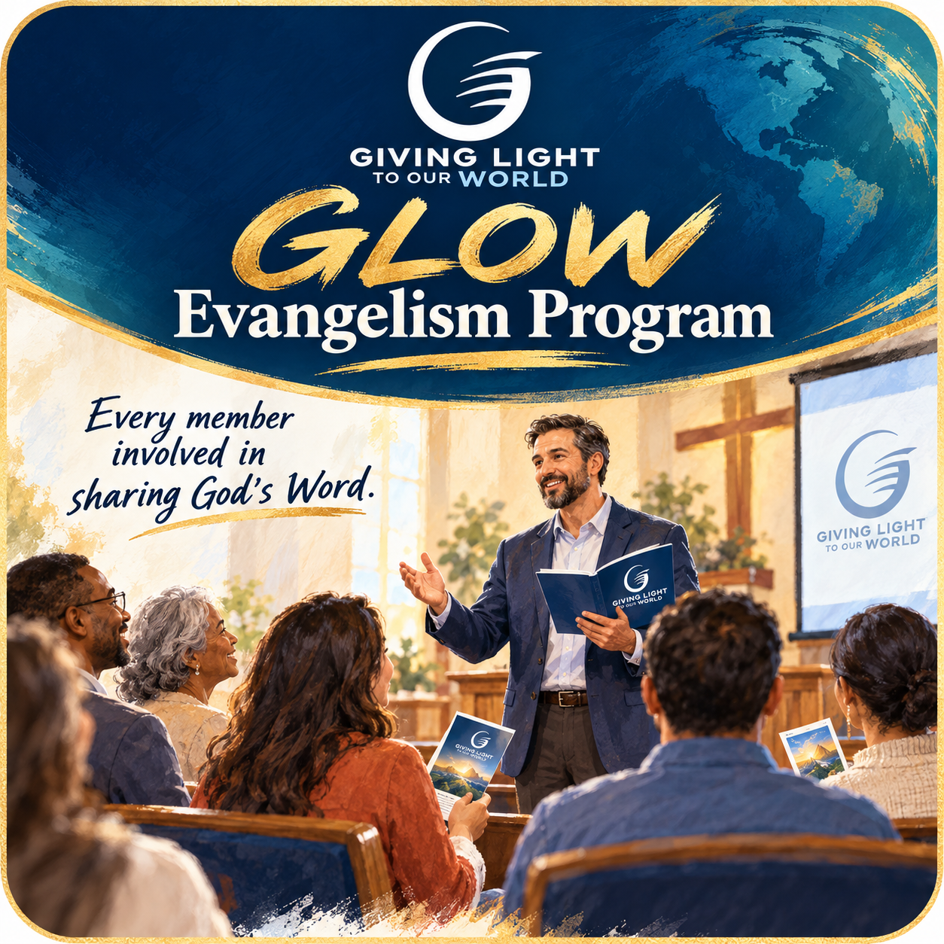
This has been one of the most effective ways to get “every member” involved in sharing God’s Word. There’s even an option for the shy person who doesn’t want to talk to anyone. The program centers on a trained presenter who gives a sermon at a church. The sermon inspires people to recognize the power of God’s Word, and participants receive a concise manual with simple steps for sharing: iForget, iFish, and iTouch. The sermon and the manual share stories and tips on how to make literature distribution a part of their everyday lives. Access to literature is provided at the end of the sermon. Most of these Sabbath rallies result in the sharing of 20,000–50,000 tracts within the following weeks. Personal revival is the best outcome as members turn everyday errands into opportunities to touch people’s lives through personal contact and God’s word.

Booklight Cart Program
Similar in concept to the Jehovah’s Witness literature cart program, but with a more interactive approach. Passersby would be invited to scan a QR code to participate in a fun health quiz or challenge and receive a free book. The books would be small (4" × 6") and divided into three categories: physical, mental, and spiritual health. Additional features would encourage further literature distribution and help generate Bible study leads. Branded apparel could be provided to participants who sign an agreement outlining expectations and allowing for greater structure, training, and ongoing support.
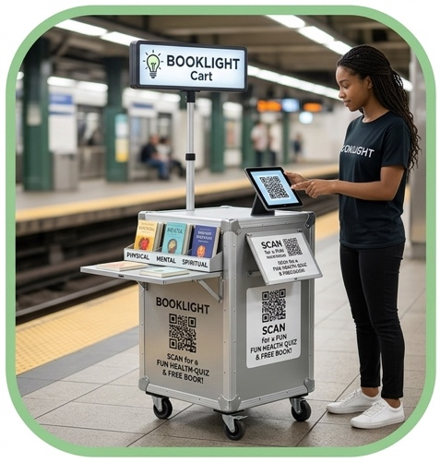
The name “Booklight” is a play on the word “Booklet”. It combines the concept of a small book with the idea of sharing light.
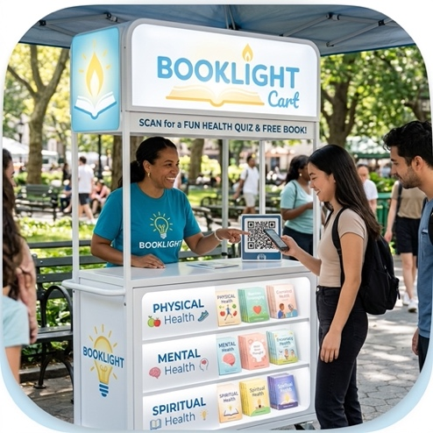

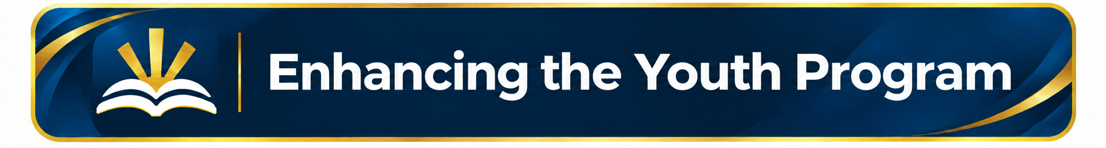

Pathfinder Club/School Fundraising


HHES would provide training, guidance, and the necessary materials to help a local Pathfinder club or school raise funds for a specific need or project. The canvassing would be organized as a structured fundraising initiative, with a clearly defined purpose, financial goal, and established start and end dates. In addition to raising funds for the designated project, the program would provide young people with practical experience in teamwork, and sharing their faith with others. In most cases, the initiative would satisfy the corresponding requirements for LE related Pathfinder honours.


Youth Summit Experience for Teens
This program runs for about four weeks and is designed for teens who may not want to commit to a full summer or feel ready for that level of commitment. It has a different structure, with a male dean and a female dean, with two teens canvassing together at the same door. This structure is intended to address concerns some parents may have about their children participating in the regular program, which includes liability concerns and the longer duration.

Pastoral Ministry Student Sponsorship
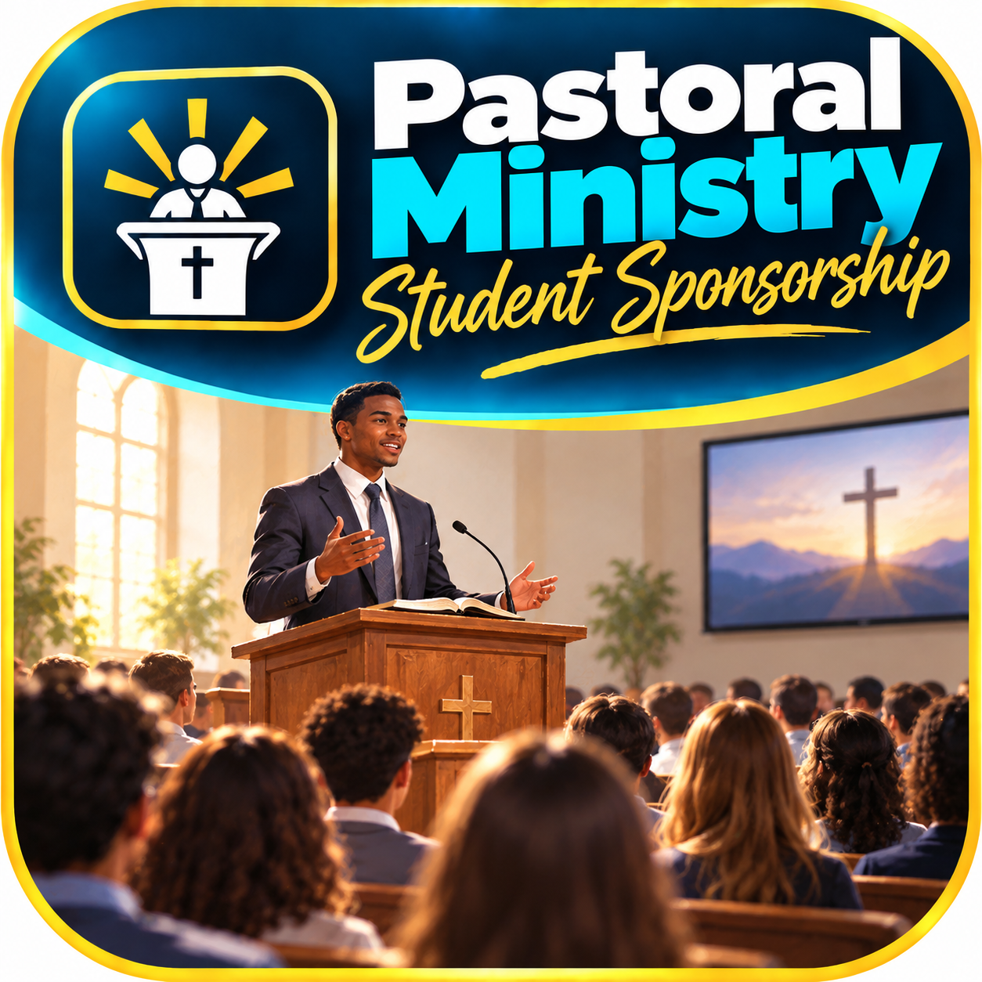
In the North American Division, many young pastors leave ministry within their first few years. One contributing factor is a lack of resilience. Canvassing can help build resilience while also developing the tact and communication skills needed to speak with perfect strangers about your faith. It also teaches you how to deal with rejection and learn to love people in spite of their attitudes.
A local conference can establish a financial partnership with HHES to support a local young person who wants to study for the ministry. Bonus scholarship earnings would be added as a match for whatever the student canvasser earns that summer. In return, the conference and the student could sign an MOU, agreeing that if a position is available after graduation, the student would return to serve in that conference.

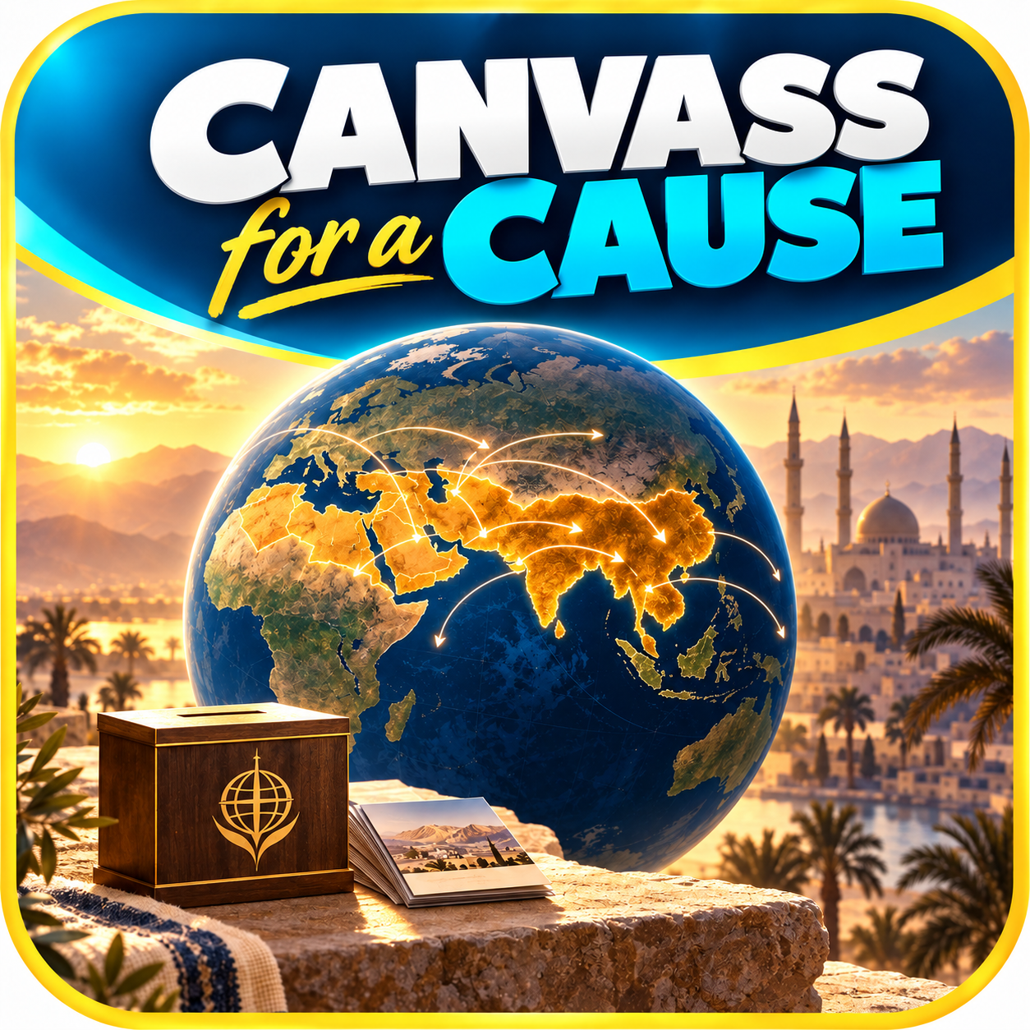
Canvass for a Cause
During a summer program, certain teams have made a decision to dedicate one day’s earnings to a select cause, such as overseas mission (10/40 window). The conference (and maybe even office personnel) would help match the amount raised, increasing the kids’ motivation and impact of their efforts.

Literature Evangelism Academy (LEA)

A one-week convention and training program for Pathfinders and homeschooled children. Families would attend together for a week of inspiration, worship, games, practical training, and hands-on experience in literature evangelism. During the week, participants would have opportunities to go out two by two and put what they have learned into practice. Families could then purchase additional books to distribute in their home states, allowing them to continue their outreach efforts beyond the convention. The books would be smaller than traditional Magabooks (only 4" × 6"), making them easier to carry and share. Youth could also receive training in the Booklight Cart program, equipping them with another practical method of reaching people in their communities.

Full Summer Package

Although this service may not be available for some time, the goal is to give conferences without a publishing director the opportunity to sponsor a complete summer literature evangelism program. HHES would recruit, organize, train, and oversee the program. One option for making this possible would be to hire a full-time recruiter to serve the entire union.
Several conferences without a publishing director have expressed interest in hosting programs, particularly to prepare for fall evangelistic series. Costs would depend on factors such as the number of students, the program’s duration, the distance from HHES, and other considerations. These details would need to be discussed and agreed upon in advance.

