KAJO Australia Brief

1. Brand Guidelines
Key things the identity needs to achieve:

To link to brand foundations and messaging DOC

Create a distinctive and recognisable KAJO Australia identity that stands out in the Australian market and is easily recognisable for new and existing customers.

Maintain a clear connection to KAJO GmbH and the German-manufactured products, without simply copying the existing German visual style as we don’t love all elements of the KAJO German brand & want to have our own style

Create a consistent and practical identity that works across print and digital and can be used confidently by KAJO Australia team as well as dealers and stockists.
**** the plan is to work on brand identity and guidelines first then once you are working through this process (with the idea of how this would all visually align on our website and social platforms) we will work through our thoughts for the website.

2. Existing Brand Assets
- KAJO Australia logo (main & food & bio range logos)- multiple formats (adapted to include ‘Australia’) File
- Biodegradable & food grade logo (we were thinking of potentially adding some form of text so customers recognise the that the green indicates biodegradable products etc.) already been created –
- Existing colour scheme & fonts
- KAJO swirl / graphic elements lots going on here possibly too many to know which ones to use for which applications on print / digital platforms
- Product pack shots
- Sample industry icons (haven’t been implemented on web as we aren’t 100% happy open to fresh ideas) 9 industries- Food & Beverage
- Food & Beverage
- Industrial
- Automotive
- Agriculture
- Forestry
- Rail
- Marine
- Construction & Civil
- Mining
- Sample grease colour icons (haven’t been implemented on web as we aren’t 100% happy open to fresh ideas, for context some customers identify which type of grease they require via visually seeing the colour of the grease i.e. Blue, black, golden etc.)
- Industry Page Images (we do have some options as seen on our industry page HERE but open to suggestions for alternatives or alternative ways to highlight our industry potentially through icons)

What we like:
- We like having a visual link between KAJO Australia and KAJO GmbH, so customers can connect the two and understand that we are the Australian division of the manufacturer, not just another reseller.
- At the same time, we’d like KAJO Australia to have its own unique look and feel. We don’t love all aspects of the current KAJO GmbH branding, so we’re open to ideas on how we can improve our own branding while still keeping that recognisable connection- the blue and white KAJO logo must stay the same as its trademarked, however our supporting ones BIO & food grade can be variations.
- The branding needs to work across our five customer types – retail/end users, bulk customers, dealers/stockists, private label/OEM and custom formulations.
- We also want a clear difference between our product ranges – the core/high-performance range (currently blue), Biodegradable (currently green) and Food Grade (currently orange), while still making it obvious that they all belong to KAJO.
What we don't like / want to change:
- We don’t love the KAJO Gmbh web branding/ style

3. KAJO Germany Relationship
What needs to stay recognisably connected to KAJO Germany / the manufacturer?

As mentioned above customers should be able to see the connection between KAJO Australia and KAJO Germany and recognise that we are the Australian division of the manufacturer, not just a reseller.

Would like to highlight as much as possible that these products are created in Germany, as some current assumptions from customers are that it is a Chinese brand, how can we incorporate this? Apart from as already mentioned in the foundations. Potentially a version of a German flag?

Keep enough familiarity between the branding and products so that someone who has seen KAJO GmbH products or packaging can recognise the connection when they see KAJO Australia.

The KAJO name and existing recognisable brand elements are important to that connection.

What don't we want to carry across from the German style?

We don't love the overall look and feel of the current KAJO GmbH branding and don't want KAJO Australia to simply copy it.

We don't want the German branding to limit what KAJO Australia can become visually.

We would like something that feels more unique, eye-catching and suited to the Australian market, while still clearly being KAJO

4. Visual Direction
We like:
- Lubex: Best Inspo for graphic design on logos, industry icons catalogues etc. nice modern & sleek look. https://www.lubricon.com.au/catalogue-library/
- Whitmore Whitmore | Product Lines Index -American company - Good inspo for website set up for different customer types
- Harrison – clear colour palette, modern branding & UI & clearly manufacturer
- Hi Tec Oils https://hi-tecoils.com.au/ nice website, branding and graphics
- Tri tech lubricants https://tritechlubricants.com/ Nice website & branding
More industry sites (not as powerful)
• Castrol
• FUCHS
• Caltex
Sample Style ideas that we like in folder

5. . Brand Guidelines - What We Think We Need Covered
- Colour palette & usage
- Typography Hierarchy
- Our provided Logo variations usage guidance
- Exclusion zone / clear space
- Placement
- Thumbnail / small-use mark
- Logo on photographs
- Pattern / graphic language
- Iconography
- Photography – if you have any stock banks or similar industry type images we could use until we build up the basics
- Brand in use Print examples
- Brand in use Digital examples basic social templates etc
- Dealer / stockist use

Breakdown of requirements:

6. Logo System
We have the following: Primary KAJO Australia logo (signifies High-performance)
Secondary Biodegradable & Food Grade versions ( Bio is green as is the product range and Food Grade orange)
- Were hoping for a breakdown or suggestions of best practice for these & if advice on whether we need different versions of each
- Simplified / small-use version
- Thumbnail / profile mark
- Vector files
- Logo placement on photography/ print /digital assets

7. Logo Usage Guidelines
- Correct logo use
- Clear space / exclusion zone
- Minimum size
- Logo placement
- Incorrect logo use
- Logo on coloured backgrounds e.g.
- Logo on photographs
- Small / thumbnail use
Notes:

8. Colour
- Core KAJO Australia palette
- Biodegradable colour
- Food Grade colour
- Supporting / neutral colours
- Print colour specifications- we have had issues with different shades of blue/ green/ orange being printed on our materials
- Digital colour specifications
- Notes / preferences:

9. Typography
- Primary typeface (we like the idea of this matching the KAJO in logo)
- Secondary / supporting typeface
- Tertiary
- Headings
- Body copy
- Technical / product information
- Fonts practical for internal / Canva use
Notes:
If you could create a typography hierarchy for print / digital assets so we can maintain consistency and ensure we use the correct font for area/ position across digital and print as per Mildura Example HERE
Can you please supply the downloaded fonts once confirmed as we will be creating some assets via canva and adobe in house also.

10. Grease Colour / Product Recognition
Some customers identify products by the actual physical colour of the grease. We want to consider how this can be accommodated in the visual system. Our own efforts of this &details within this brochure
Products / grease colours to consider:
• 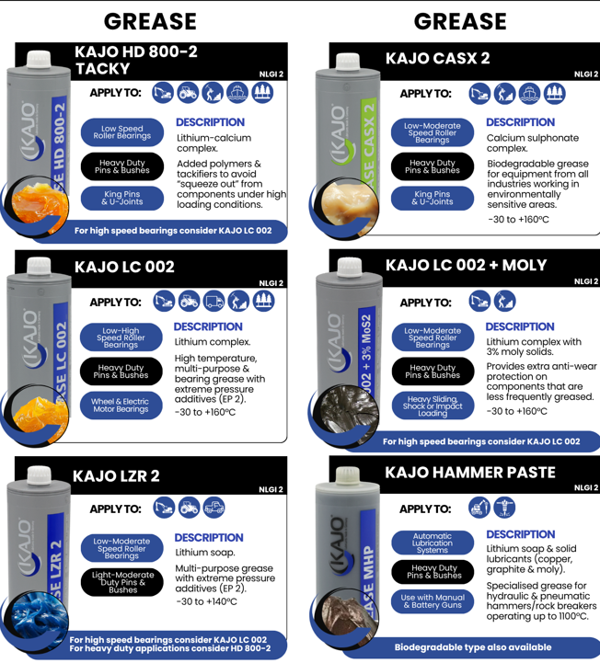

11. Graphic Style
- KAJO swirl &/or ideas on this
- Patterns / supporting graphics
- Shapes / graphic devices
- Icon style
- Technical / product graphics

13. Iconography by Industry & Application
Industry Icons:
- Food Grade
- Industrial
- Agriculture
- Forestry
- Construction & Civil
- Mining
- Rail
- Marine
- Automotive
Potential Equipment Icons & Application Icons
Product / technical features
Icon ideas for applications not set
Also, potential icons to highlight 500g screw cap tube as this our unique KSP in comparison to competitors, and ox rock adapter,500g in manual guns etc our efforts for visual ref

14. Print Requirements
- Business cards
- Letterhead
TBC ignore for now:
- Full product Catalogue (2-3 months before we will be able to provide the info)
- Dealer / stockist material/ brochure
- Posters e.g. grease comparison chart
- A4 Brochures Industry Specific- Food and Beverage, Bio, Rail & Mining
- Private label / OEM material- Possibly brochure/ flyer introducing our capabilities and KSP’s Brochures / flyers template
- Product sheets / technical data presentation
- Branded Company Cover Page & doc for Brand Consistency that we can use on any documents e.g 30 Day Account/Stockist Forms
- Signage potentially for trade shows &/or stockist displays

15. Digital Requirements
Website
- Social media templates
- Social media profile / thumbnail mark
- Email signature
- Email / newsletter graphics
- Canva templates
- Presentation / document templates
- icons

TBC:
- Digital product sheets
- Digital advertisements
- Website industry/ application graphics
- Dealer / stockist digital assets

16. Files & Handover
- Master logo files (Low, med/web res, high res)
- Print-ready files
- Digital / web files
- Colour specifications
- Font information/ files
- Icon files
- Graphic / pattern assets
- Canva-ready assets / templates
- Brand guideline document

16. Dealer / Stockist Use – TBC just ideas, please ignore for now
Once Brand guidelines locked in we could supply to stockists
The Below is tbc for later down the line but kept in mind:
Print promotional material for stockists
Possibly brochure/ flyer
Rules for third-party use

18. Photography & Imagery TBC – TBC just ideas, please ignore for now
- Product photography
- Application / machinery photography
- Industry photography
- People / customer imagery
- German manufacturing / engineering imagery
- Stock imagery guidance
- Logo placement on photography

19. Reference Material
KAJO material supplied:
- • Full KAJO Australia Folder

20. Supporting Documents
- KAJO Australia - Brand Foundations & Messaging
- KAJO Germany material
- KAJO Australia Website
- KAJO Gmbh Website - Not the best website to use for inspo but gives us an idea of all their/our products.

