Goal: Design a label to be used on a kids motocross playset.

Name of Product: Mini-Moto Playset

Manufactured By: NP Racing

Logo:
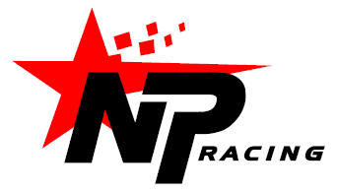

Primary Colors: red / black (as per NP logo), white or light grey background

Dirtbike / Rider Graphic: Please convert to black / white as per example below and use one of the following (center one preferred):

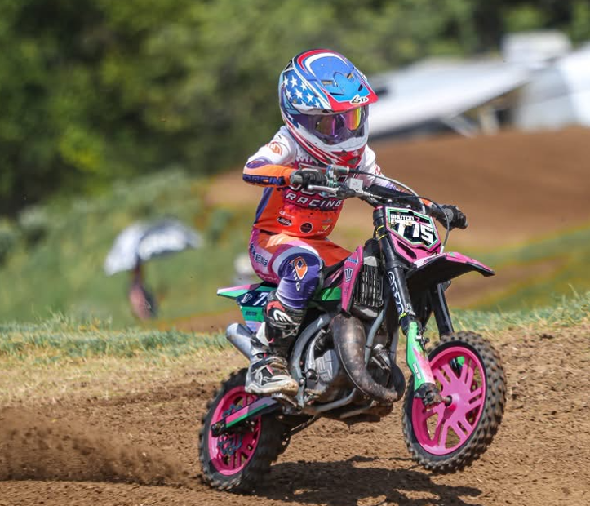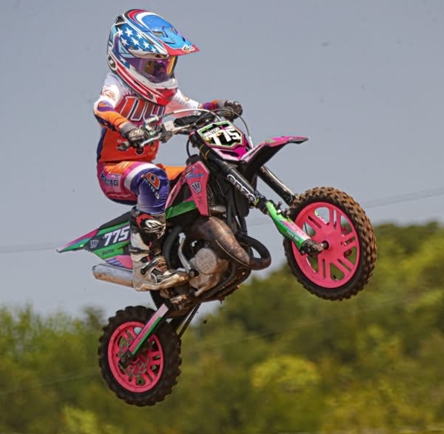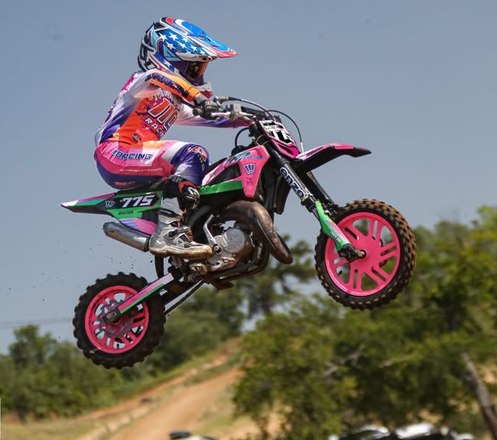

Design Idea References:
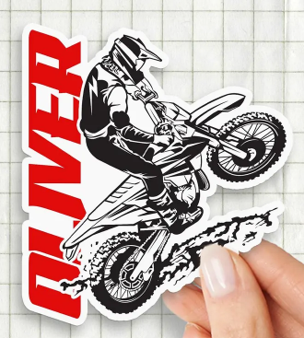
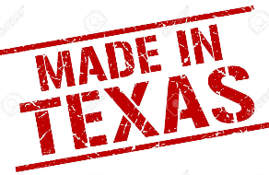
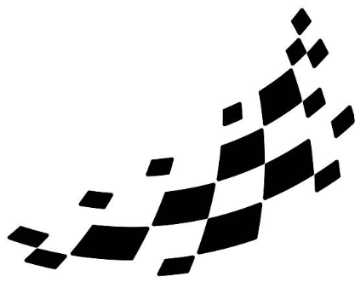

Likes: I like the font used in “Oliver”

My initial idea (open to suggestions, creative concepts, layouts, etc.)
Manufactured By:
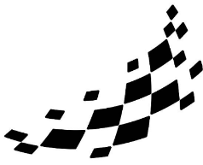
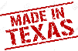
The Race Starts Here!
Mini-Moto Playset

