Do you have concerns about an Elder, maybe you see that they are not taking care of themselves, or family only comes once a month when the Elder has money?  Is an Elder telling you that they are not treated with respect or that someone is bothering them?  These may be signs of Elder abuse, neglect or exploitation.  For help contact:  Your Tribal Social Services or Elders Department:  insert contact information for your tribal services, law enforcement, etc.  The Eldercare Locator for information on Adult Protective Services  1-800-677-1116  If a serious emergency, call 911.  For mental health support for yourself or an Elder, call or text 988  Domestic Violence Hotline  1.800.799.SAFE (7233) |  |  |  | Services for Elders & People Who Care for Them
  Respect for Elders
   | 
  Recipient  Street Address  City, ST ZIP Code | Website  Email
  Company Name  Street Address  City, ST ZIP | Tel Telephone  Fax Fax
  My Mother
  My Father
  My Sister
  My Grandchild
  Myself
  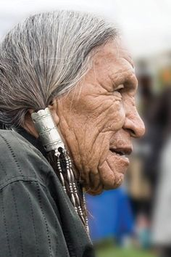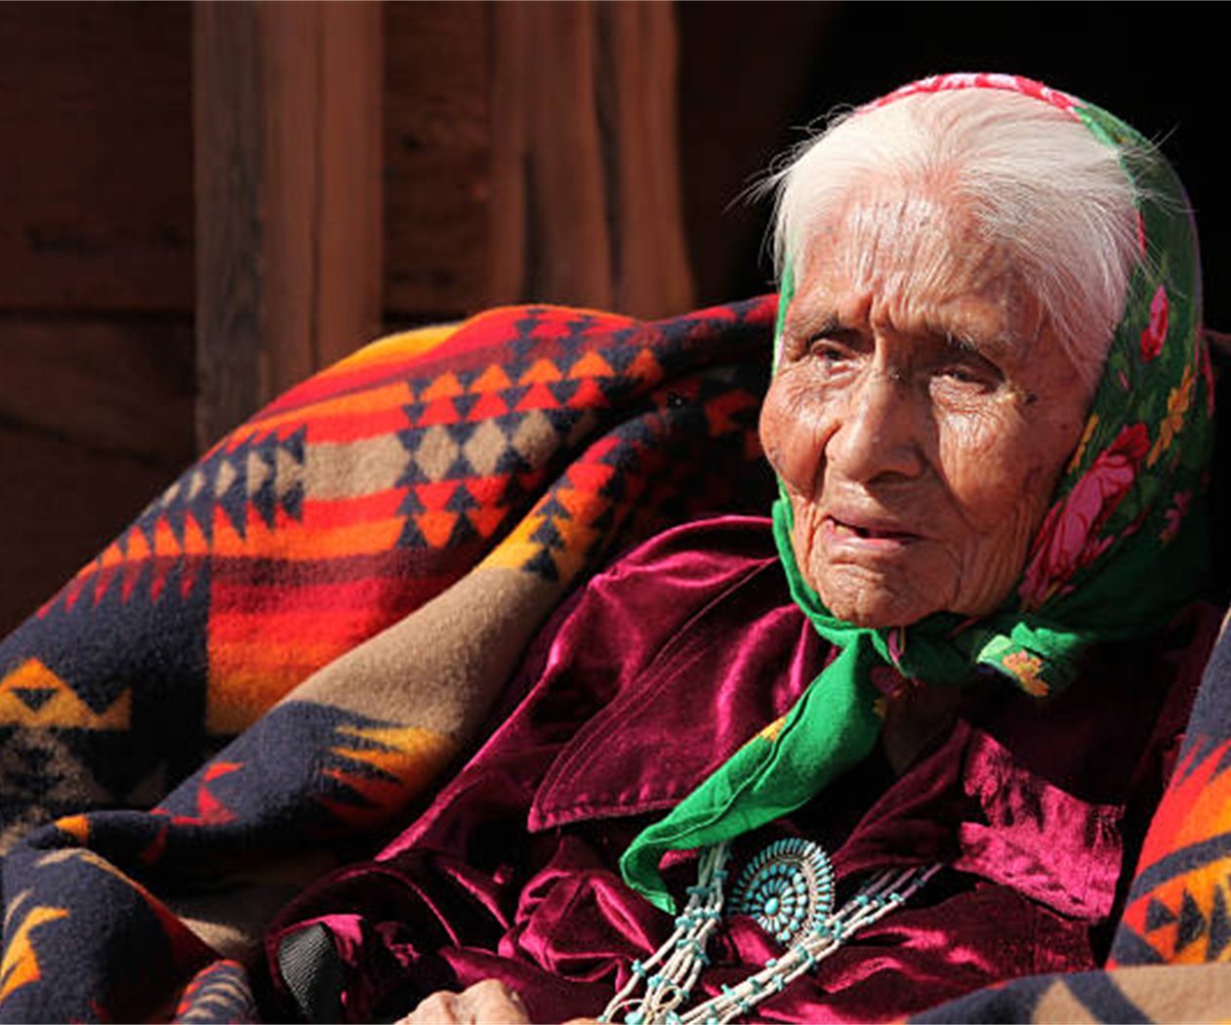
  Are you caring for an Elder or a Grandchild?
  Are you an Elder who needs help staying at home?
  These programs and information can be a helpful resource.
Please delete blank page

Do these stories sound familiar to you?  - My mother gets lost driving home from the store.  - I need help getting groceries and with chores at home.  - My dad wants to sleep all the time; he doesn’t go out with friends anymore. He stopped drumming.  - My sister is raising 3 grandchildren on her own.  - My son is disrespecting me. He only comes to visit when my retirement money arrives. He always asks for money. |  | Resources for Elders  Eldercare Locator  https://eldercare.acl.gov/home  Call or Text: 1-800-677-1116  Email: eldercarelocator@n4a.org  For help finding support. Ask about services to Tribal Elders.  National Alzheimer’s Call Center (24 hours 7 days a week)  Call 1-800-272-3900  For support for people living with dementia, caregivers, families and the public. Connect with a live person who can provide information, local resources, crisis assistance and emotional support.  988 Suicide & Crisis Lifeline  For mental health support, call or text 988.  State & Tribal Hotlines | Native American Elder Justice Initiative  To find local resources within your tribe or state that specialize in elder abuse, neglect or exploitation, visit:  https://iasquared.org/naeji/hotlines-codes/state-tribal-hotlines/  StrongHearts Native Helpline  A 24/7 safe, confidential and anonymous domestic and sexual violence helpline for Native Americans and Alaska Natives.  Call 1-844-762-8483  (1-844-7NATIVE)  https://strongheartshelpline.org/ |  | Resources for Caregivers  Caring for an Older Adult  Eldercare Locator  https://eldercare.acl.gov/home  Call or Text: 1-800-677-1116  Email: eldercarelocator@n4a.org  For help finding support. Ask about services to Tribal Elders.  Dementia Friends | International Association for Indigenous Aging  An interactive educational program to better understand what dementia is and how it affects people.  https://iasquared.org/dementia-friends/  Caring for a Grandchild  Grandparents Raising Grandchildren (Kinship Care)  Grandfamilies.org  An interactive website that seeks to share all relevant publicly available information impacting grandfamilies.  Grandparent Resources | Native American Elder Justice Initiative  A list of resources for grandparents raising grandchildren.  https://iasquared.org/naeji/resource/grandparent-resources/
  Help is available…
  
 |  | Please delete blank page

