 | A-1 VOICE & DATA  CONNECT • PROTECT • EVOLVE
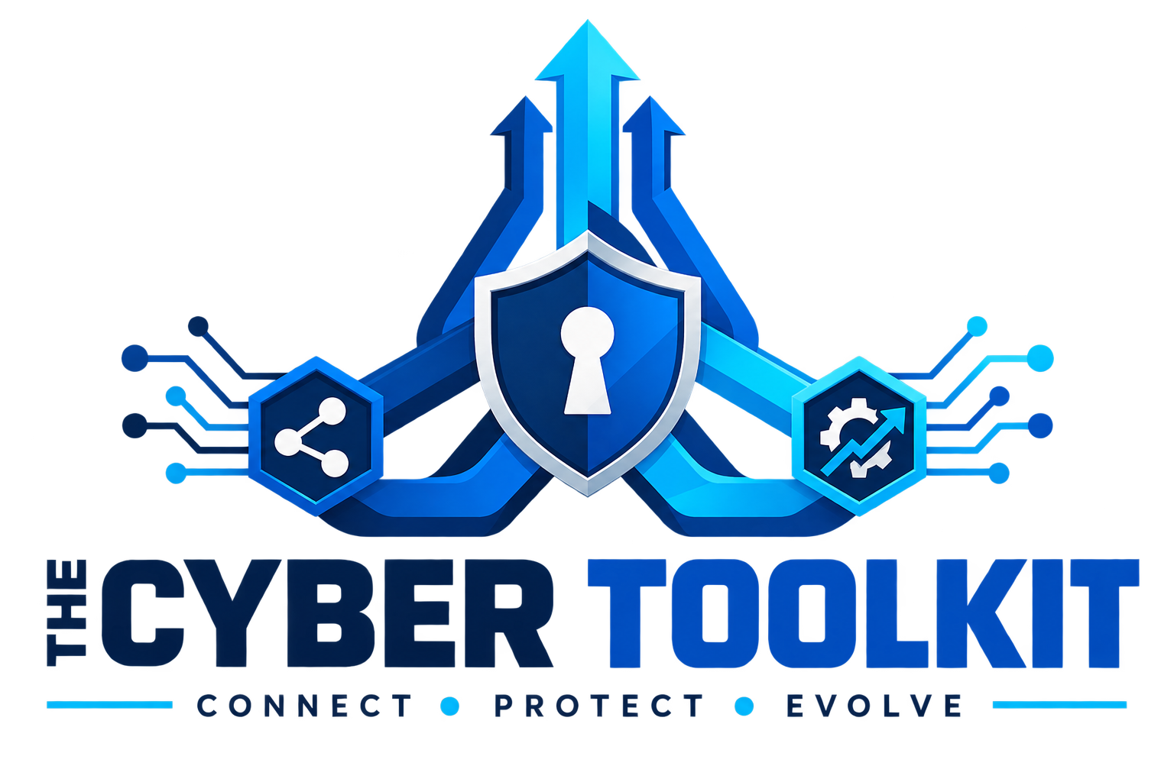

TRAIN SMART. WORK SECURE.
  - A practical, note-ready field guide to the cyber tools your team uses every day.
01  IDENTITY | 02  EMAIL | 03  SUPPORT | 04-05  PASSWORDS + KNOWLEDGE

PREPARED FOR  [CLIENT NAME] | 
EMPLOYEE ________________________________________ DATE ________________
GUIDE

Your training roadmap
  - Five connected tools. One safer, faster way to work with A-1 Voice & Data.

What you will be able to do
Approve legitimate Microsoft 365 sign-ins and reject unexpected MFA prompts.
Read INKY banners, verify suspicious requests, and report questionable email.
Open, track, and update service requests through the A-1 Service Portal.
Use Keeper to create, store, autofill, and share credentials through approved secure workflows.
Use MyGlue to retrieve approved documentation and add personal password records securely.

Training sequence
Module | Tool | Outcome
1 | Microsoft Authenticator | Secure your identity and practice a sign-in.
2 | INKY | Recognize risk banners and report suspicious email.
3 | A-1 Service Portal | Submit a useful ticket and follow its status.
4 | Keeper | Store, use, and share credentials through approved controls.
5 | MyGlue | Find documentation and manage personal password records safely.

Before we begin
PRIVACY RULE Do not write passwords, one-time codes, recovery codes, or confidential client/patient information in this workbook.

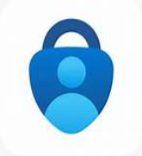
CYBER TOOL 01

Microsoft Authenticator
  - Multi-factor authentication (MFA) protects your account even when a password is stolen.

What MFA does
MFA asks for something you know (your password) and something you have (your registered phone). A prompt should appear only when you are actively signing in.
GOLDEN RULE If you did not initiate the sign-in, do not approve it. Select Deny when available and contact A-1 immediately.

Set up your work account
1 | Install Microsoft Authenticator  Use the Apple App Store or Google Play. Confirm the publisher is Microsoft Corporation.

2 | Open your security information page  On your computer, go to https://mysignins.microsoft.com/security-info and sign in with your work account.

3 | Add the method  Choose Add sign-in method, then Authenticator app. Follow the instructions until a QR code appears.

4 | Scan and test  In the app, tap +, choose Work or school account, scan the QR code, then complete the test. Never photograph or share the QR code.

5 | Add a backup method if permitted  Follow company policy so an unavailable phone does not lock you out.

CYBER TOOL 01A

Using MFA safely every day
  - A real approval connects to a sign-in you just started.

Safe approval check
I started the sign-in myself.
The account, application, location, and number (if shown) make sense.
I am not being rushed by a caller, text message, or email.

Never approve these prompts
A surprise prompt when you are not signing in.
Repeated prompts arriving one after another (MFA fatigue).
A request from anyone asking you to read back an Authenticator code or approve a test for them.
A prompt with details that do not match what you are doing.

If something goes wrong
1 | Deny the request  Do not approve simply to make the notification stop.

2 | Stop interacting  Close suspicious pages and do not call numbers shown in a questionable pop-up or email.

3 | Contact A-1  Call 713-334-2044 or email service@a1voicedatatech.com using a known-good method.

4 | Report a lost or replaced phone immediately  A-1 can help remove the old registration and safely enroll the new device.

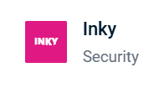
CYBER TOOL 02

INKY email security
  - INKY places a color-coded banner inside email when a message deserves extra attention.

Read the banner before you act
Banner |  | Meaning | Action
RED | Danger |  | High confidence the message is malicious or impersonating someone. | Do not click, open, reply, or forward normally. Report it, then follow company guidance.
YELLOW / ORANGE | Caution |  | Something is unusual: sender, domain, urgency, payment language, or other signals. | Pause. Verify the request through a separate trusted channel before acting.
BLUE | Notice |  | Informational warning, often first-time or external sender. | Read carefully. Stay alert for credentials, money, confidential data, or unusual urgency.
GRAY | Graymail |  | Legitimate bulk mail you may have subscribed to, such as newsletters, promotions, webinar invitations, and routine notifications. | Review when convenient. If it is wanted and should return to the inbox, mark it Not-Graymail or Safe.
GREEN / No warning | Low risk |  | INKY did not identify a warning condition, but no system can guarantee that every message is safe. | Use normal caution. Report the message if the request, sender, link, or attachment still feels wrong.
 | REMEMBER A banner is guidance, not permission. A message without a warning can still be suspicious; use judgment every time.

Common impersonation clues
The display name is familiar, but the actual email address is different.
A lookalike domain swaps letters, adds words, or uses a different ending.
An unexpected request changes payment details, asks for gift cards, credentials, or sensitive data.
The message creates urgency, secrecy, fear, or pressure to bypass normal procedure.

CYBER TOOL 02A

Report and correct INKY classifications
  - Your feedback helps INKY protect the organization and place future mail correctly.

Report a phishing email
1 | Do not interact with the message  Do not click links, open attachments, reply, call listed numbers, scan QR codes, or use an unsubscribe link.

2 | Use the INKY banner  Click Phish, Phish (Block), or Report This Email. If a reporting page opens, choose Phishing. Button wording depends on enabled settings.

3 | Review and confirm  Confirm the classification. Use More Options only when you need comments or an available block-sender choice.

4 | Escalate when appropriate  If you clicked, entered information, approved MFA, or the message involves money or sensitive data, call A-1 at 713-334-2044 immediately.

DO NOT FORWARD NORMALLY Forwarding can strip useful context or expose another employee. Use INKY's reporting control; contact A-1 separately when urgent.

Mark a legitimate email as Safe
1 | Verify it first  Confirm the sender and request through a known-good channel before overriding a warning.

2 | Choose the correction  In the INKY banner select Safe. For a spam false positive, the option may say Not-Spam; use More Options if needed.

3 | Confirm the action  The confirmation page may offer sender allow-list choices if MLD's policy permits them. Do not broadly allow a sender unless you trust it.

WHY THIS MATTERS Marking a message Safe corrects a false positive. Depending on policy, it may also allow future mail from that sender.

CYBER TOOL 02B

Graymail: what it is and how to manage it
  - Graymail is usually legitimate bulk email - distracting, but not the same as spam or phishing.

Common Graymail examples
Newsletters, webinar invitations, industry alerts, vendor marketing, promotions, social-media notifications, and routine software updates.
Mail you subscribed to directly or indirectly, but do not need to see immediately.
Messages INKY may move to a dedicated Graymail folder so you can review them later without inbox interruptions.
STILL INSPECT IT Criminals can imitate newsletters and promotions. A gray banner does not mean you should ignore suspicious links, sender addresses, or requests.

Mark a message as Not-Graymail
1 | Open the wanted message  Confirm it is legitimate and that you want similar messages treated as normal inbox mail.

2 | Use the banner correction  Select Not-Graymail. If that choice is not displayed, choose Safe or More Options / Report This Email and correct the classification.

3 | Confirm  INKY records the correction. Safe also clears the Graymail classification when enabled.

4 | Move or restore if needed  If the message is in the Graymail folder, move it to the Inbox after correcting it. Future handling depends on MLD's policy and enabled rules.

Mark normal mail as Graymail
For a clean external message that should be treated as low-priority bulk mail, choose Graymail in the banner, then confirm. This option appears only when Graymail detection and the applicable inbox rules are enabled.

CYBER TOOL 02C

Encrypted email and quarantine
  - Encryption protects sensitive outbound content; quarantine holds messages that require additional review.

Send an INKY-encrypted email
1 | Compose the message normally  Address the correct recipient and attach only approved information.

2 | Add the encryption trigger  Begin the subject with [ENCRYPT] followed by a space, then the subject. Example: [ENCRYPT] Requested Documents.

3 | Send and verify  Send the email. INKY may provide a sender confirmation. If expected confirmation does not appear, contact A-1 before resending sensitive content.

4 | Recipient experience  The recipient selects View Encrypted Message, authenticates with Microsoft, Google, or an email verification link, and replies inside the secure portal.

AUTHORIZED USE ONLY Encryption protects delivery but does not replace MLD privacy, HIPAA, minimum-necessary, recipient-verification, or record-handling requirements.



Log in to the Microsoft quarantine portal
1 | Open the portal safely  Go directly to https://security.microsoft.com/quarantine or use the approved bookmark - not a link in a suspicious email.

2 | Sign in  Use your MLD Microsoft 365 work account and MFA.

3 | Review the held message  Check sender, subject, date, and quarantine reason. Use Preview only if allowed; do not follow links or open attachments from the preview.

4 | Choose the permitted action  Use Release or Request Release only when you independently recognize and expect the message. Phishing or malware may require administrator approval.

5 | When uncertain  Leave the message quarantined and contact A-1. INKY adds banner protection to released messages, but you must still review the banner.

WHERE QUARANTINE LIVES INKY supplies routing instructions, but MLD users manage held Microsoft 365 messages in Microsoft's quarantine portal. Available actions depend on MLD's quarantine policy.

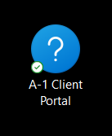
CYBER TOOL 03

A-1 Service Client Portal
  - Use the portal for clear, trackable support requests and updates.

First-time access
1 | Find the A-1 welcome email  Use the activation link. Check junk/spam if it is not in your inbox.

2 | Create your password  Use a unique password and do not reuse your Microsoft 365 password.

3 | Complete MFA enrollment  Follow the on-screen Authenticator steps. If already enrolled, use the + button to add the portal account when requested.

4 | Save the portal address safely  Bookmark it in your browser. Do not store the password in this workbook.

Submit a ticket that speeds up the fix
What happened? Include the exact error message or symptom.
Where is it happening? Identify the site, room, device, or system.
Who is affected? One person, a group, or the whole office?
When did it start, and is it still happening?
What changed just before it started?
Add a screenshot when appropriate - but exclude passwords, MFA codes, patient data, and other sensitive information.
TICKET EXAMPLE Good: “Front-office internet stopped at 9:20 a.m. Three workstations and desk phones are affected.” Avoid: “It’s broken.”

CYBER TOOL 03A

Track requests and escalate correctly
  - Keep one issue in one thread so the complete history stays together.

After you submit
You receive a confirmation with a ticket number.
A technician is assigned and updates are recorded on the ticket.
Reply to the confirmation email or update the existing portal ticket - do not open duplicates for the same issue.
When the issue is resolved, confirm the outcome and keep any approved instructions for future reference.

Portal or phone?
USE THE PORTAL | CALL A-1: 713-334-2044
A device or application is not working normally | The whole office or a critical business function is down
A non-urgent question or service request | You cannot access email or the portal
A request that benefits from screenshots or written detail | There is a suspected cyber incident, unexpected MFA approval, or urgent security concern

Guided practice
Sign in to the portal.
Locate open and past requests.
Draft a training ticket using the details above (submit only if your trainer instructs you).
Portal URL / approved bookmark location (do not write credentials)


CYBER TOOL 04

Keeper Password Manager
  - Keeper protects work credentials in an encrypted vault and reduces unsafe password reuse.

What Keeper does
Stores usernames, passwords, secure notes, payment cards, and approved confidential records in one protected vault.
Generates strong, unique passwords so one compromised account does not expose other systems.
Uses KeeperFill to enter approved credentials without placing passwords in email, chat, tickets, or paper notes.
Supports controlled shared folders and time-limited sharing when company policy permits it.

Install and activate Keeper
Install Keeper Password Manager from the Apple App Store or Google Play, or use the company-approved desktop/browser installation.
Sign in with your assigned work email and complete the invitation or single sign-on process provided by your organization.
Create or enter your Keeper master password if prompted. Make it unique and never reuse your Microsoft 365 password.
Complete MFA enrollment and enable Face ID or fingerprint access only on your assigned, secured device.
CYBER TOOL 04A

Use your Keeper vault every day
  - Search, save, and autofill records without exposing the password to other people or systems.

Find and use an existing login
Open Keeper and unlock the vault with your approved sign-in method.
Use Search or browse the appropriate folder to locate the correct record.
Confirm the record title and website before copying or autofilling credentials.
Use KeeperFill or the approved browser extension when available. Lock Keeper when you finish or step away.

Add a new login
Select + or Create New Record, then choose the appropriate record type.
Enter a clear title, username, website address, and any approved notes or custom fields.
Generate a strong password in Keeper when creating or changing the account password.
Save the record in your personal vault or the approved shared folder. Verify the saved website before using autofill.
Never place passwords, recovery codes, MFA secrets, or security answers in ordinary notes outside Keeper.
CYBER TOOL 04B

Share and autofill safely
  - Sharing permissions should match the recipient, purpose, and required length of access.

Shared folders
Create or open the approved shared folder and confirm the correct team or recipient.
Add the login record to that folder only when the record is intended for everyone who can access it.
Grant the least privilege required: View Only, Can Edit, or Can Share, according to company policy.
Remove access or relocate the record when the business need ends. Do not create duplicate uncontrolled copies.

One-Time Share
Use One-Time Share only when authorized. Set the shortest practical expiration and verify the recipient through a trusted channel before sending the secure link. Do not send a reusable password in ordinary email or text.

KeeperFill setup
Mobile: In the device password/autofill settings, enable Keeper as the approved autofill provider.
Desktop: Install the approved Keeper browser extension, sign in, and confirm KeeperFill is enabled.
Always confirm the real website domain before autofill. A password manager does not make a phishing page safe.

Guided practice
Locate one assigned record, create one training record, and demonstrate safe autofill without writing down the password.
Identify which sharing method and permission level would be appropriate for a trainer-provided scenario.
CYBER TOOL 05

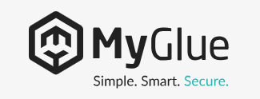
MyGlue secure documentation
  - Think of MyGlue as your company's authorized, online IT binder.

What you may find
Shared passwords you are authorized to view.
IT procedures, reference documents, and self-service instructions.
Vendor, network, equipment, and key-contact information made available to your role.
Live information shared between your organization and A-1 Voice & Data.
ACCESS IS ROLE-BASED Seeing less than a coworker may be intentional. Never use another person's account or ask them to reveal information outside your authorization.

First-time access
1 | Open the MyGlue welcome email  Use the invitation link before it expires. Check junk/spam if needed.

2 | Create your unique password  Use an approved password manager when available. Do not reuse work, portal, or personal passwords.

3 | Enroll in MFA  Follow the QR-code flow with Microsoft Authenticator.

4 | Confirm your access  Review the available areas and tell the trainer if required content is missing; do not request broader access than your job needs.

View approved information
1 | Search or browse  Use the relevant Passwords, Documents, Organizations, or other area shown to you.

2 | Open the correct item  Check the title, owner, and last-updated information when available.

3 | Reveal only when needed  Password access may be logged. Keep the screen private and never paste secrets into email, chat, or a ticket.

4 | Report incorrect or outdated information  Contact A-1 or the designated internal owner; do not create conflicting copies.

CYBER TOOL 05B

Add a personal password in MyGlue
  - Personal records are visible only to you unless you intentionally change the security assignment.
From the MyGlue Dashboard, select your Organization.
Choose Passwords from the navigation menu, then select the Personal tab.
Select + New. Choose Folder to organize related records, or Password to create a credential record.
Enter a clear name, category, username, password, one-time password information if applicable, website URL, and approved notes.
Save the record, then review the Security section on the record details page.
For a private record, confirm Specific groups and/or users is selected and MyGlue Users shows Only Me. Do not select a broader group unless the password is intended to be shared.
Reopen the record and verify the title, website, and access assignment. Report incorrect access immediately.

Important distinctions
Use the Personal tab for credentials intended only for you. Use Shared only for approved records that others are authorized to access.
Saving a password in MyGlue does not automatically make it appropriate to share. Confirm the security assignment every time.
When Keeper is your organization's primary password manager, follow your company policy for which system is the official source of record and avoid unnecessary duplicates.
Never copy passwords from MyGlue into email, chat, ticket notes, spreadsheets, or this workbook.
CYBER TOOL 05A

Use MyGlue responsibly
  - Secure access depends on good habits after you sign in.

Do
Lock your computer whenever you step away.
Use only your assigned account and approved device.
Confirm you are opening the correct record before revealing or copying information.
Close the browser or sign out when using a shared or temporary workstation.
Report access that seems too broad, missing, or incorrect.

Do not
Do not write passwords on paper or in this workbook.
Do not email, text, or place passwords in ordinary ticket notes.
Do not save exported documentation to unapproved personal storage.
Do not install a browser extension or mobile app unless your organization approves it.
Do not share your MFA approval, recovery code, or account with anyone - including IT.

Guided practice
Sign in using your assigned account and MFA.
Locate one document or instruction assigned by the trainer.
Locate one authorized password record without copying it into your notes.
Identify how to report an outdated record.
MyGlue notes / content I need access to

CYBER TOOL 06

Quick reference & personal action plan
  - Use this page after training when you need a fast reminder.
WHEN | DO THIS | NEVER DO THIS
Unexpected MFA prompt | Deny it and contact A-1 using a known number. | Approve it to stop repeated prompts.
Red INKY banner | Do not interact; report it as Phish in the INKY banner. | Click, open, reply, or forward normally.
Yellow/Orange INKY banner | Pause and verify sensitive or unusual requests separately. | Trust the display name alone.
Gray INKY banner | Review later; use Not-Graymail or Safe if legitimate mail was misclassified. | Assume Graymail is encrypted or automatically trustworthy.
Send sensitive email | Use [ENCRYPT] plus a space at the start of the subject when authorized. | Send protected information in ordinary email.
Quarantined message | Use the Microsoft quarantine portal; release only after independent verification. | Release a message merely because you recognize the display name.
Routine support issue | Open one detailed portal ticket and continue in that thread. | Create duplicate tickets for updates.
Office-wide outage or suspected breach | Call A-1 at 713-334-2044 immediately. | Wait for a routine portal response.
Need a password, login, or document | Use Keeper for saved logins or MyGlue for approved records. | Put secrets in email, chat, paper notes, or tickets.

My post-training checklist
Authenticator is installed and my work account test succeeded.
I know how to deny and report an unexpected MFA prompt.
I can interpret INKY banner colors and report a suspicious email.
My A-1 Service Portal login works and I can locate existing tickets.
My Keeper login works and I can locate, save, and autofill an approved record.
My MyGlue login works, my access matches my role, and I can add a personal password securely.
I saved the A-1 support phone and email using approved contact information.

FIELD NOTES

Training notes
  - Write process reminders here - never passwords, MFA codes, recovery codes, or sensitive information.
1

2

3

4

5

6

7

Trainer follow-up: _________________________________________________________________________________
Prepared by A-1 Voice & Data | Connect • Protect • Evolve

