OVERALL:
Please remove “data story XX” titles from all these graphics for final delivery. Thank you.

Drug types and ambulance callouts
Rename the entire page to: Drug type trends
Previous title: Drug Types and ambulance attendances
Subtitle: The drug types most frequently involved in unintentional deaths.
Bottom of Page:
- Remove “drug-type categories are not mutually exclusive and should be summed” from bottom of page
- Remove “ambulance attendance data excludes Victoria etc.” from bottom of page

Data Story 7
  - Change text on bottom of the page
Current Text: “categories can overlap and should not be summed” Change to: “most deaths involve more than one drug type”
  - Remove “#1 opioid type” (sounds like an achievement). Keep the rest of the text the same (488 Deaths involved Heroin) Capitalise the ‘D’ please.
  - Enlarge font size for the ‘names of the optiods/ types if possible. It’s a little hard to read.
Data Story 9
  - Change text on bottom of the page
Current Text “drug-type categories overlap”
Change to: “most deaths involve more than one drug type”
  - Replace “lead” with “drive harms”
  - If possible we would much prefer a bit less space between drug types and a bit larger font. Making them easier to view.

Data Story 10
DELETE ENTIRE Section.
Drug Story 12C
  - “record peaks” should be “recorded peaks”
  - Remove “Navy = 2001 Colour = 2024 record”
  - Move “5x / 4.8x / 14.6x” above the columns, make this text larger

Growth and historic highs
- Data Story 2
  - Remove the word “population” from top right.
  - Remove the word ‘Death’(Leave the % numbers)
  - Remove “19,274,700 à 27,194,300” below columns,
  - Align “+113.2%” above 2024, so it looks similar to the population graphic
  - Replace “grew” in title with “have grown”

- Data Story 12A and 12B
  - Move to the top of the page.
  - On the bottom of 12A change numbers to:
    - "2001: 981 --> 2024: 2091" (remove all other text)
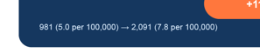

- 12B should have "2001: 5.1 --> 2024: 7.6". Followed by: Highest Annual rate recorded since 2001.
  - In each case, add “unintentional” before deaths eg “unintentional deaths in 2024”, “unintentional deaths per 100,000 people”
  - Also add “unintentional” to “The national death rate reached a new high…”
- Remove this from the bottom of page

Causes of death
Data Story 13
  - Please delete completely
Data Story 14, 15, 16
- Delete “Accidental drug/alcohol poisoning ranks…” in tiny font at bottom of each graphic
- Bottom of page, remove this text

People and place
Data Story 12D
  - Change text:
Current Text: “Four states set new annual record counts”
Change to “Four states set new records for unintentional deaths”
  - Revise “highest annual totals since 2001” to “highest annual totals in time series”
  - Remove “All figures are unintentional deaths in 2024” from below columns
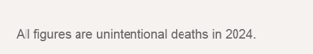
Data Story 11
  - Fix text overlap
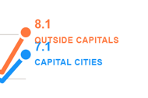
- Remove this please:
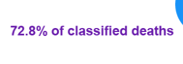
- Change this to communicate which numbers are deaths, and which numbers are rates. Also, specify these are for 2024.
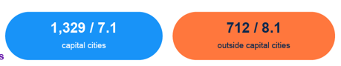
- Remove this from bottom of page

Total death + breakdown
Data Story 3
  - Specify 2024 here eg “more deaths than road toll in 2024”
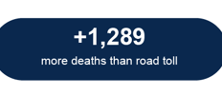
  - Change to “all drug-induced deaths”
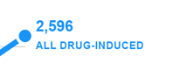
  - Remove “number of deaths” under the chart here
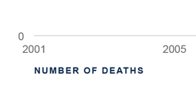
Data Story 4
  - Change title to “Men represent nearly three-quarters of unintentional deaths”
Data Story 8
  - Change title to “Almost 7 in 10 unintentional deaths in 2020-2024 involved multiple drug types”
  - Remove the “total deaths section”
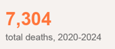
  - Remove all numbers, only use percentages, provided here (it’s a loooooong story but trust me, just use the percentages please):
    - Single drug type 32.2%
    - Two drug types 18.3%
    - Three or more drug types 49.4%
- Remove this from bottom of page

