DESIGN BRIEF: Data & Visualisation concepts

List of Data that needs to be visualised

# | Dataset Topic | Primary Focus / Key Message
1 | Total Deaths (2,596) | Number of overdose deaths in Australia in 2024
2 | Overdose vs. Population | Unintentional overdose deaths compared with population growth 2001 – 2024  Overdose grew 2.7x faster than population.
3 | Overdose vs. Road Toll | Overdose deaths compared with the road toll 2001 - 2024
4 | Gender Breakdown | Gender split of unintentional overdose deaths 2001 – 2024  Males represent 73% of deaths.
5 | Age Distribution | Percent of unintentional overdose deaths by age group  Ages 40–59 represent >50% of fatalities.
6 | Indigenous Disparity | Overdose death rates for Indigenous and non-Indigenous Australians  Indigenous rate is 4.4x higher.
7 | Opioid Types | Deaths by opioid types  Heroin is the single largest opioid driver.
8 | Polydrug vs. Single | Polydrug vs single drug deaths 2020-2024  68% of deaths involve multiple drugs.
9 | Deaths by Drug Type | Unintentional deaths by drug type  Opioids, Amphetamines, and Benzos lead overall.
10 | Ambulance Attendances | Ambulance attendances and  Cannabinoids and Amphetamines drive ER visits.
11 | Regional vs. Metro | Regional deaths compared with city deaths  Major cities account for the majority of deaths.
12a | 2024 Historic Highs | Most unintentional drug-induced deaths  2001 v 2024
12b | 2024 Historic Highs | Highest rate of unintentional drug-induced deaths per-100,000 population
12c | 2024 Historic Highs
  Most unintentional heroin deaths
  Most unintentional amphetamine-type stimulant deaths
  Most unintentional cocaine deaths
12d | 2024 Historic Highs
  Most unintentional drug-induced deaths in VIC
  Most unintentional drug-induced deaths in QLD
  Most unintentional drug-induced deaths in WA
  Most unintentional drug-induced deaths in SA
13 | Causes of Death (20–59) | Leading causes of death aged 20 - 59  Overdose is the #3 killer for young/middle adults.
14 | Deaths by State | NSW and VIC lead national volume.
15 | Cocaine Death Trend | Cocaine trends from 2001
16 | Cocaine Death Trend | Single Call out – Usage is up +403% since 2001

Graph Type per Data Set

Please note – these are ideas only for what type of graph/chart/infographic it can be – this is just a guide. If you can find a better way to show the data please feel free to give it ago. We just want the data to be communicated in the best, clearest possible way.
We would like a range of different graph types to make the data interesting as can be – but the most important thing is to show the data in the clearest way.

1. Total Death (2,595) – Number of overdose deaths in Australia in 2024

Graph/Visual Example taken from previous years report.

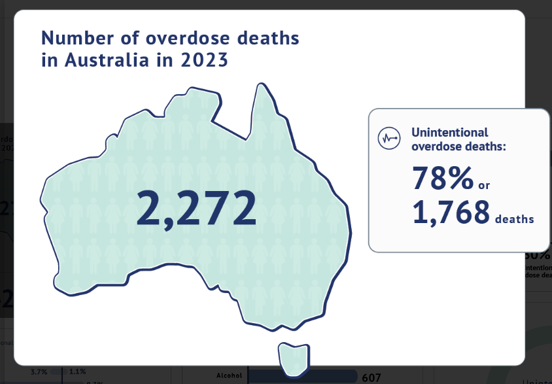

2. Overdose vs. Population - Unintentional overdose deaths compared with population growth 2001 – 2024
Graph/Visual Example taken from previous years report.

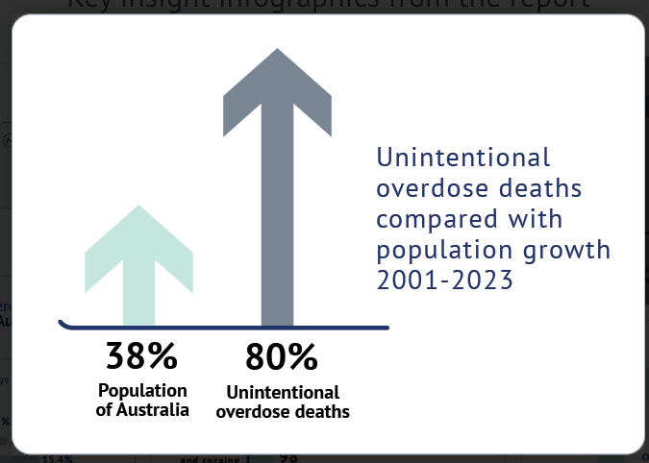

3. Overdose vs. Road Toll - Overdose deaths compared with the road toll 2001 – 2024

Graph/Visual Example taken from previous years report.
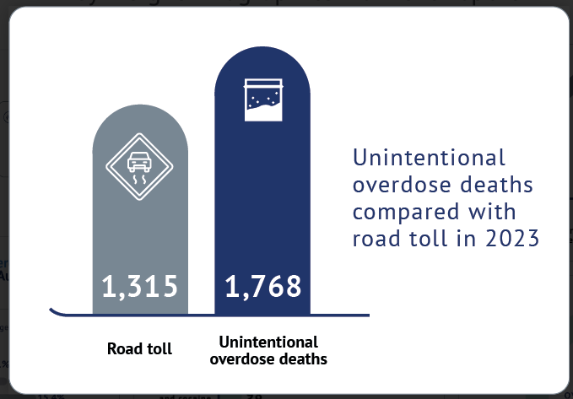
4. Gender Breakdown - Gender split of unintentional overdose deaths 2001 – 2024

Graph/Visual Example taken from previous years report.
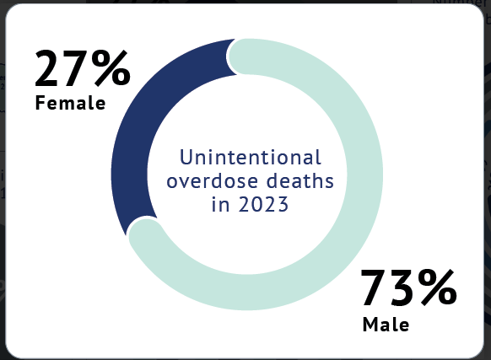

5. Age Distribution - Percent of unintentional overdose deaths by age group Infographic Example:
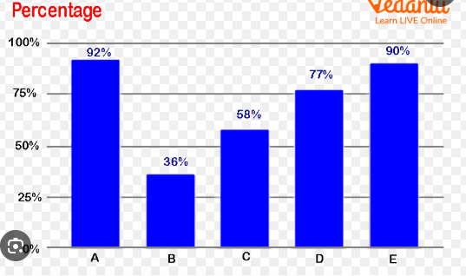
6. Indigenous Disparity - Overdose death rates for Indigenous and non-Indigenous Australians

Infographic Example - Two-Line Gap Chart
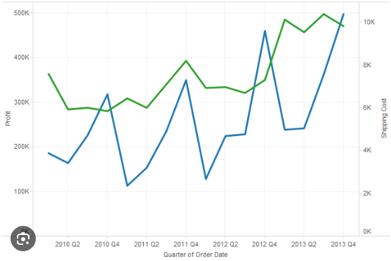

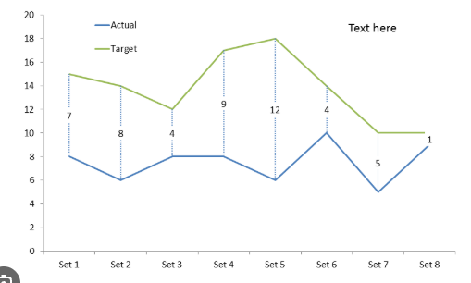

7. Opioid Types - Deaths by opioid types
Graph/Visual Example taken from previous years report.

Horizontal Bar Chart or Circle –

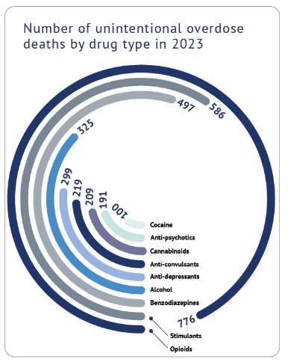
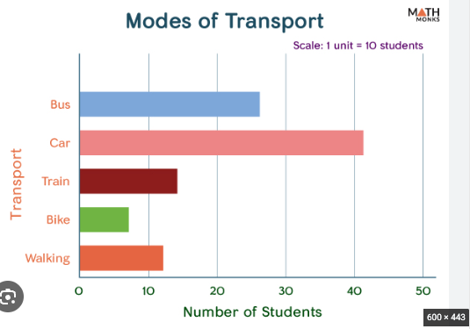

8. Polydrug vs. Single - Polydrug vs single drug deaths 2020-2024
Graph/Visual Example taken from previous years report.

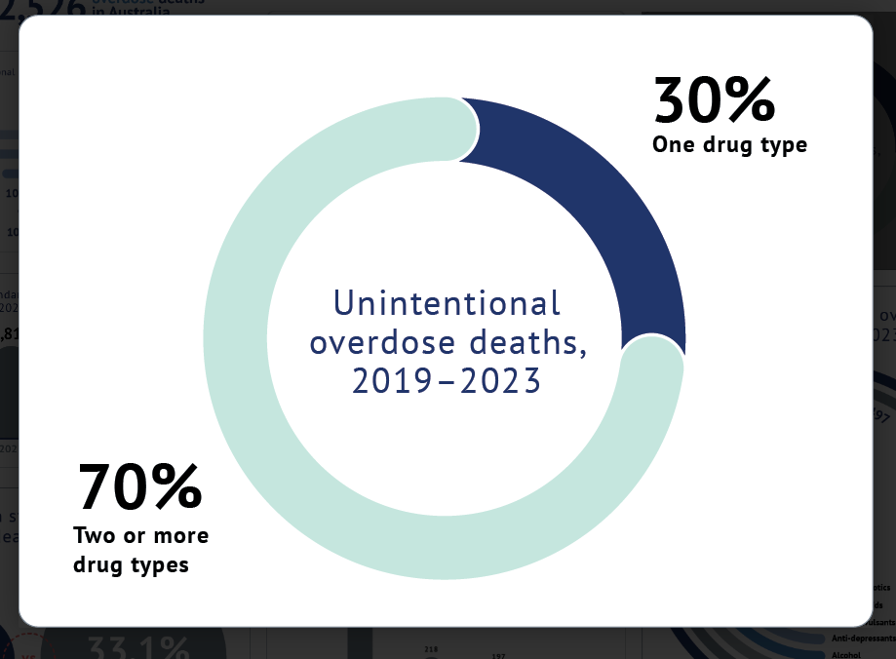

9. Deaths by Drug Type - Unintentional deaths by drug type

Infographic Example - Ranked Horizontal Bar:

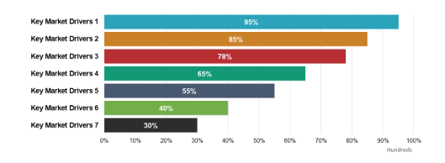

10. Ambulance Attendances - Ambulance attendances and
Cannabinoids and Amphetamines drive ER visits.

Infographic Example: Same as Above

11. Regional vs. Metro - Regional deaths compared with city deaths

Infographic Example:
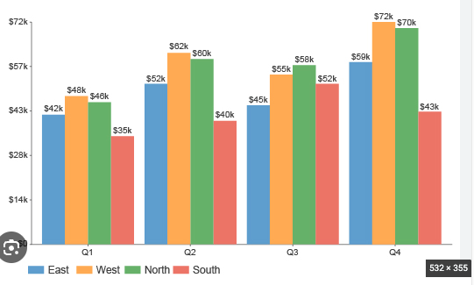

12A. Most unintentional drug-induced deaths 2001 v 2024

Infographic Example: Designer to choose.

12B. Highest rate of unintentional drug-induced deaths per-100,000 population

Infographic Example: Designer to choose.

12C - Most unintentional heroin, amphetamine-type stimulant, cocaine deaths

Infographic Example: Designer to choose.

12D - Most unintentional deaths in Vic, QLD, WA, SA

Infographic Example: Designer to choose.

13 – Causes of Death (20-59) - Leading causes of death aged 20 - 59

Infographic Example: Designer to choose.

14. Deaths by State - NSW and VIC lead national volume.

Infographic Example: Designer to choose.

15 – Cocaine Death Trend -
Infographic Example: Designer to choose.

16 – Cocaine Single Call out

Graph/Visual Example taken from previous years report.

