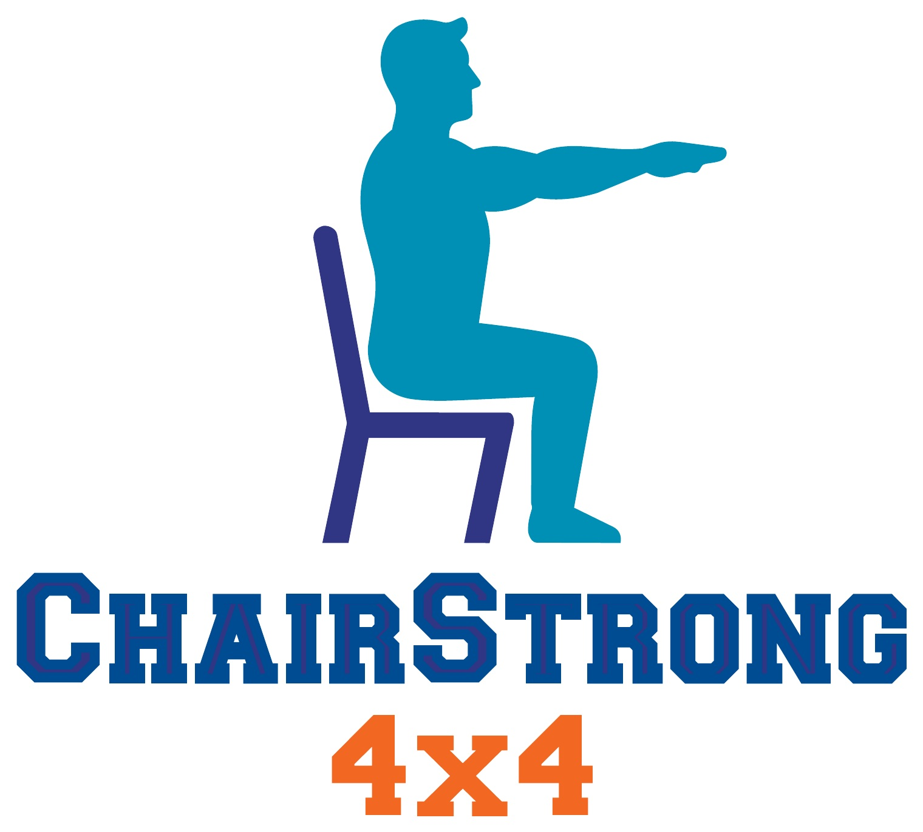
BUSINESS DESCRIPTION
& BRAND MESSAGING
ChairStrong 4×4 | Internal Brand Reference | July 2026
Brand essence
Approachable comeback. Visible progress. Active longevity.
Four Days. Four Weeks. A Stronger You.
Every journey begins with a single step. The journey is the adventure.

1. Purpose of this guide
This is the internal source of truth for describing ChairStrong, expressing its value, and creating consistent marketing. It is grounded in the Demographics document’s audience insight: capable adults who have become deconditioned and want an approachable, joint-conscious way back to strength and active living.
How to use it
Choose the description length that fits the channel, then build the message from the approved hierarchy, voice, pillars, and claims guardrails below.

2. Business description

Master description
ChairStrong is an active-longevity fitness brand created for adults who want to return to exercise, rebuild strength, stamina, balance, and mobility, and remain active for the life ahead. Its foundational program, ChairStrong 4×4, combines four workouts per week with four progressive four-week phases, using a sturdy chair to make the return to movement more approachable and joint-conscious. Customers receive clear video instruction, illustrated guides, easier and more challenging modifiers, an online calendar, and a progress journal that turns each completed workout into visible evidence of accomplishment. ChairStrong is not random internet exercise, a clinical rehabilitation program, or a diminished version of traditional fitness. It is a structured, legitimate comeback journey designed around real bodies, real schedules, and the goal of living a longer, more active, engaged life.

Concise description
ChairStrong is a progressive, chair-supported fitness brand that helps adults return to exercise and rebuild strength, stamina, balance, mobility, and everyday confidence. Through structured workouts, clear modifications, video instruction, illustrated guides, and progress tools, ChairStrong makes the first step approachable and provides a path toward an active, independent life.

One-sentence description
Approved
ChairStrong helps capable adults make an approachable, progressive return to fitness so they can keep participating in the people, activities, and years that matter.

Short profile description
ChairStrong helps adults return to fitness through progressive, chair-supported workouts designed to build strength, stamina, mobility, balance, confidence, and active longevity.

3. Brand platform
Brand element | Approved definition
Category | Progressive comeback fitness and active-longevity education.
Primary customer | Formerly active adults, generally 52–70, who still feel capable but recognize a loss of stamina, strength, flexibility, balance, or confidence.
Customer problem | They know they need to move again, but traditional fitness feels too abrupt, hard on the joints, inconvenient, intimidating, or disconnected from their current starting point.
Brand promise | Make returning to exercise feel possible today and meaningful for the years ahead.
Method | Four days per week, four progressive phases, chair-supported movement, clear instruction, easier and harder modifiers, video guidance, illustrated plans, and visible progress tools.
Functional outcome | Build greater strength, stamina, balance, mobility, and everyday physical confidence.
Emotional outcome | Replace hesitation and discouragement with momentum, pride, and belief in what is still possible.
Long-term aspiration | Help customers keep participating in family, travel, hobbies, independence, and the life they want to continue living.
Differentiator | A legitimate, structured comeback path built for capable adults and real schedules—not random exercises, shame-based fitness, or subscription tricks.

4. Messaging hierarchy
Priority | Approved language
Brand name | ChairStrong 4×4
Primary tagline | Four Days. Four Weeks. A Stronger You.
Brand essence | Approachable comeback. Visible progress. Active longevity.
Journey message | Every journey begins with a single step. The journey is the adventure.
Chair positioning | The chair isn’t where you stop. It’s where you start.
Category statement | A structured comeback for capable adults.
Core benefit | Rebuild strength, stamina, mobility, balance, and confidence through a progressive, chair-supported program.
Life benefit | More capacity for grandchildren, travel, stairs, hobbies, independence, and the years ahead.
Habit message | One workout. One win. One step forward.
Primary call to action | Start Your Journey

5. Brand voice
Voice principle | Say / do | Avoid
Encouraging, not hyped | Use credible optimism and achievable next steps. | Avoid miracle language, urgency tricks, and exaggerated transformations.
Respectful of capability | Speak to an adult making a comeback. | Avoid elderly, frail, weak, helpless, or patronizing language.
Clear and legitimate | Explain the structure, progression, support, and value. | Avoid vague claims, hidden conditions, and fitness jargon.
Human and relatable | Connect movement to family, travel, hobbies, and independence. | Avoid clinical distance and generic stock-fitness language.
Progress over perfection | Celebrate completion, consistency, and restarting. | Avoid shame, punishment, “no excuses,” and all-or-nothing rules.
Joint-conscious, not clinical | Say approachable, low impact, supported, and mindful of joints. | Do not diagnose, prescribe treatment, or promise pain relief.

6. Audience-derived messaging pillars
Approachable reentry: Starting again can feel manageable. The chair reduces the psychological and physical barrier to taking the first step.
Joint-conscious movement: Low-impact, supported movement respects the customer’s concern about knees and other vulnerable joints without defining the customer by limitation.
Visible progression: Four progressive phases and clear modifiers show a path forward. The customer is not trapped at one level.
Real-life capability: Strength matters because life still asks things of the customer: keeping up with grandchildren, climbing stairs, traveling, working, and enjoying hobbies.
Active longevity: The deeper goal is not simply finishing a workout. It is remaining active, capable, independent, and engaged for more years.
Fits real schedules: Four workouts per week and flexible timing make the program compatible with a full life. Missing a planned day is a rescheduling issue, not a failure.
Legitimate and transparent: Clear inclusions, demonstrations, modifications, lifetime access, and honest expectations distinguish ChairStrong from low-value internet programs.
Habit and accomplishment: Every completed workout is proof of progress. Calendars, journaling, and positive reinforcement help customers see themselves becoming active again.

7. Approved message bank
- Four Days. Four Weeks. A Stronger You.
- The chair isn’t where you stop. It’s where you start.
- Every journey begins with a single step.
- The journey is the adventure.
- One workout. One win. One step forward.
- The goal is not perfection. It is returning.
- Progress you can see. Confidence you can feel.
- You’re not looking for a senior workout. You’re looking for a way back.
- Start where you are. Build toward the life you want to keep living.
- A structured comeback for capable adults.
- Rebuild strength without punishing your joints.
- No crowded gym. No floor exercises. No guesswork.
- Strength for the life that still needs you.
- Train for the years ahead.
- More life in your years.

8. Product and customer journey
Stage | Offer | Role
Stage 1 | ChairStrong 4×4 | The foundational return-to-exercise program. Establish consistency and rebuild baseline capacity through four progressive phases.
Stage 2 | ChairStrong 4×4 Momentum | The next level for customers ready to continue progressing with more challenge and stronger results.
Stage 3 | ChairStrong 4×4: Beyond the Chair | An optional transition toward more intensive movement with less reliance on chair support.
Commercial strategy
Show customers that a complete journey exists, but sell the one appropriate next step. Introduce Momentum and Beyond the Chair after trust and progress have been earned rather than presenting all three as a Good-Better-Best choice.

9. Channel-ready copy

Standard public boilerplate
ChairStrong 4×4 is a four-day, four-week progressive fitness program created for adults ready to become active again. Using a sturdy chair, low-impact movement, clear modifications, illustrated guides, and guided video workouts, ChairStrong helps make the return to exercise approachable while building toward greater strength, stamina, balance, mobility, and everyday confidence. Every journey begins with a single step. Start yours at www.chairstrong.com.

Website hero
Headline: Four Days. Four Weeks. A Stronger You.
Supporting copy: A progressive, chair-supported comeback program for capable adults ready to rebuild strength, stamina, mobility, balance, and confidence.
Call to action: Start Your Journey

Social bio
A progressive, chair-supported way back to strength, stamina, mobility, balance, and confidence. Four Days. Four Weeks. A Stronger You.

Partner or affiliate description
ChairStrong 4×4 helps adults return to fitness with four weekly workouts, four progressive phases, clear video instruction, illustrated guides, and modifications for different starting points. The program is built for real schedules and designed to support a stronger, more active life.

Call-to-action options
- Start Your Journey
- Take Your First Step
- See How ChairStrong Works
- Begin Your Comeback
- Choose Your Starting Point

10. Brand and claims guardrails

Approved claim territory
- Designed to help customers build strength, stamina, mobility, balance, and confidence.
- Low-impact and chair-supported movements can make returning to exercise feel more approachable.
- Clear modifiers let customers choose an easier or more challenging version.
- A structured four-day, four-week progression supports consistency and visible accomplishment.
- The program is designed around busy schedules and different energy levels.

Do not claim
- That the program treats, cures, prevents, or rehabilitates a medical condition.
- That it heals knees, eliminates pain, prevents falls, reverses aging, or is safe for everyone.
- Guaranteed weight loss, fixed physical results, or guaranteed habit formation within a set number of days.
- That a customer should ignore pain, medical advice, dizziness, shortness of breath, or other warning signs.
- That using a chair means the customer is frail, elderly, weak, or incapable.
Quotation and attribution rule
Use “Every journey begins with a single step” and “The journey is the adventure” as ChairStrong journey language without attributing either phrase to Steve Jobs. Do not imply celebrity endorsement.

11. Brand review checklist
- Does the message speak to a capable adult making a comeback?
- Is the chair positioned as a starting tool and source of support—not a symbol of limitation?
- Does the message connect exercise to a meaningful life benefit?
- Is progression visible and are different starting points respected?
- Does the language encourage without shaming, patronizing, or overpromising?
- Are knee, joint, safety, and health claims restrained and nonmedical?
- Is the offer specific, transparent, and easy to understand?
- Does the call to action invite one clear next step?
- Does the work sound like ChairStrong: approachable, credible, optimistic, and purposeful?
- Would the target customer think, “This was made for someone like me”?
Final brand test
ChairStrong should leave the customer feeling understood—not diminished; encouraged—not pressured; and ready to believe that the next chapter of an active life can begin with one approachable step.

