

INTERCHANGE LIMITED STRATEGY OVERVIEW PURCHASE 29% OF PRIMA


Interchange Limited i

Table of Contents
Executive Summary 1
Overview 1
Investment strategy 5
Benefits 5
Increased Capacity 6
Value growth 7
Benefits & Solution 7
Cost synergies 8
Increased dividends 9
Why increased dividends 9

Proposed new structure 10
New Ownership Structure options 10
Market opportunity 11
Primary versus secondary 11
Financing the buyout 13
Loan debt 13
Projected cashflows 16
Threats of the LEO satellites 13
Starlink 13
Other LEO's 16

CONFIDENTIAL - DO NOT DISSEMINATE. This business plan contains confidential, trade-secret information and is shared only with the understanding that you will not share its contents or ideas with third parties without the express written consent of the plan author.

Interchange Limited ii
Alternatives to Prima 13
Funds including IFC 13
Recommendations 14
Implementation 14
Due diligence 15
Timeline 15
Appendix (A) Budget 16
2029 versus 2039 Ten year projected figures 16

CONFIDENTIAL - DO NOT DISSEMINATE. This business plan contains confidential, trade-secret information and is shared only with the understanding that you will not share its contents or ideas with third parties without the express written consent of the plan author.

Interchange Limited 1

Executive Summary

Overview

Interchange Limited (ICL) proposes to acquire the remaining 29% of Prima from the Fletcher Family Trust for USD 10 million and absorb Prima into ICL under a consolidated holding and management structure.

This acquisition secures full operational control of the Tamtam submarine cable and establishes Tamtam as Vanuatu’s primary international route, relegating ICN1 to a secondary/standby role. The shift avoids an estimated USD 15 – 20 million replacement capital expenditure for ICN1 and eliminates the current USD 50,000 per month reserve, freeing approximately USD 600,000 annually to support Prima debt service and growth initiatives for the Tamtam cable.

Ownership of Tamtam immediately captures contracted IRU and presale revenues and internalizes recurring lease income. The transaction accelerates commercialization of the data-centre market and IPLC expansion. This improves and enables bundled offering including protected circuits, hosting and O&M that enhance ARPU and customer retention while strengthening competitiveness against LEO players such as Starlink. Operational integration under a single board and executive team will eliminate duplicated commercial, legal and O&M costs, leverage vendor economies (ASN), improve decision making which will be materially boosting EBITDA and balance-sheet collateral.

Recommended funding is a USD 10 million bank term loan with discussions commenced with VNPF who have communicated the funds potentially available from the NBV. Pre-close conditions include novation of IRUs/O&M contracts to ICL and formalized seller deliverables. Immediate integration priorities are consolidated technical operations, commercial bundling, centralized finance and targeted anchor sales to realize synergies, improve national redundancy, and drive sustainable revenue growth. These are details in this document with detailed revenue forecasts up to 2039.

CONFIDENTIAL - DO NOT DISSEMINATE. This business plan contains confidential, trade-secret information and is shared only with the understanding that you will not share its contents or ideas with third parties without the express written consent of the plan author.

Interchange Limited 2

STRATEGIC INTENT 2039
To be a US$20 million revenue entity in 2039 while enabling improved redundancy routes and improved diverse business revenues to ensure improved competitiveness against LEO’s like Starlink who have currently 3,600 active users in Vanuatu.

SHAREHOLDER EXPECTATIONS FOR THE CONSOLIDATED ICL-PRIMA BUSINESS
- Improved financial performance through continual EDITDA growth with quick payback of acquisition.
- Cashflow and dividend growth with a positive operating cashflow from Year 3.
- Avoid unnecessary Capex expenditure through Tamtam primary routing strategy.
- Improved governance with single board with defined KPIs, reserved matters, and clear reporting.

Ownership & Structure
Company Number: 30698

Date of Incorporation: 2nd of May 2004

Directors:

- Jean Marie Duffau – (Chairperson)
- James Willie
- Shirley Abraham
- George Manuiri
- Roan Lester
- John Jack
- Gillian Attapattu
- Albert Williams
- Simon Fletcher

Shareholders 2026:

37.5% - Vanuatu National Provident Fund 37.5% - Government of Vanuatu
12.5% - Vanuatu Post Limited 12.5% - Fidelity Pacific

Accountant: Steve Adams and Associates Auditor: Ernst & Young 2026

CONFIDENTIAL - DO NOT DISSEMINATE. This business plan contains confidential, trade-secret information and is shared only with the understanding that you will not share its contents or ideas with third parties without the express written consent of the plan author.

Interchange Limited 3
Consolidated growth in USD 000,000
25
20
15
10
5
0
2029 2030 2031 2032 2033 2034 2035 2036 2037 2038 2039
Ten-year 2029 - 2039
ICL
Prima
Consolidated
Linear (Consolidated)

Major Growth for next ten years – 2029 versus 2039

 | Year-end Dec 2029 |  |  |  | Year-end Dec 2039
 | ICL (forecast) | Prima (estimated) | Consolidated |  | ICL (forecast) | Prima (estimated) | Consolidated
P&L | USD (m) | USD (m) | USD (m) |  | USD (m) | USD (m) | USD (m)
Revenue | 9,158 | 3,500 | 12,658 |  | 11,209 | 12,108 | 23,317
Profit | 2,365 | 750 | 3,115 |  | 2,853 | 4,843 | 7,696
Additional Profit from Branching | 524 |  | 524 |  | 905 |  | 905
Dividend Income | 290 |  | 290 |  | 1,740 |  | 1,740
Net Income | 3,179 | 750 | 3,929 |  | 5,498 | 4,843 | 10,341

Major USD Growth for ten years
USD dollars

Improved Revenues

This acquisition of Prima with the domestic fiber investment will deliver national resilience, rapid capacity growth over the next ten years up to 60G additional wholesale international data, diversified revenue streams and a compelling enterprise alternative to LEO satellite options such as Starlink.

CONFIDENTIAL - DO NOT DISSEMINATE. This business plan contains confidential, trade-secret information and is shared only with the understanding that you will not share its contents or ideas with third parties without the express written consent of the plan author.

Interchange Limited 4
P&L Outline numbers
12

10

8

6

4

2

0
2026
2027 2028 2029 2030 2031 2032
Axis Title
2033 2034 2035 2036
Operating Profit
Net Profit
EBITDA
Dividends
Linear (Net Profit)

P&L outline numbers for the next ten years
US dollars USD

FY29 to FY39 forecasts strong predicting good growth by secure, long-term contracts in place with the two MNO (mobile network operators) customers as the capacity is expected to increase by all players with the consolidated company offering a robust redundant path for their international data capacity with two separate routes and two landing stations in different locations.

- Providing customers with a better service offering and SLA’s through two sea-cables therefore improved customer service confidence and relationships going forward.

- Value capture & synergies by eliminating duplicated O&M and overhead costs.

- Increased revenue projections with increased IPLC (International Protected Lease circuits) sales and data-centre provision.

- Avoiding heavy capex spending through Tamtam primary routing strategy.

- One board for faster and direct decision making with one coherent strategy.

CONFIDENTIAL - DO NOT DISSEMINATE. This business plan contains confidential, trade-secret information and is shared only with the understanding that you will not share its contents or ideas with third parties without the express written consent of the plan author.

Interchange Limited 5
Total Mbps Monthly
70

60

50

40

30

20

10

0
2024
2025
2026
2027
2028
2029
2030
Annual Growth per month December

Total number of Mbps consumed monthly December
000 Mbps

Roadmap

The acquisition roadmap will commence with ICL Board approval on the ICL/Prima on August 4th, 2026. These details have been provided by management to agree to proceed forward with the consensus to purchase Prima from Fletcher holdings for the sum of 10 million USD, 29% of Prima. This will be followed by structuring and securing USD $10 million for the transaction. This funding will start with NDA’s to be signed with several lenders in the Pacific (BSP, ANZ, BRED, NBV). Design a new draft of the shareholders agreement to accommodate the proposed new ownership structure. Focus during this period will be on securing the USD $10 million term loan facility. Once the finance is confirmed a proposed term-sheet and shareholders agreement will be presented to the seller in Q1 2027 after all EIC funding is secured from the Prima side. This term sheet will detail that this sale will proceed with the aim of being closed once the Tamtam comes online and Prima has delivered the project on time and on budget. Interchange will pay the seller a deposit in Q1 2027 that is fully refundable on signing of the agreement to sell the 29% of Prima to Interchange at the agreed price dependent on banking covenants. The final sale of Prima to interchange is targeted to be completed in Q1 2028 with Tamtam live and all technical acceptance tests signed off with supplier ASN. During this period in 2027 – Interchange will secure full finance of 10 million USD, have shareholders agree a new shareholders agreement and new structure with shareholding percentages of the new entity agreed and in place with all regulatory approvals and business plans for integration all signed off. Therefore the expansion is ready to roll out on completing the transaction with Prima in Q1 2028.

CONFIDENTIAL - DO NOT DISSEMINATE. This business plan contains confidential, trade-secret information and is shared only with the understanding that you will not share its contents or ideas with third parties without the express written consent of the plan author.

Interchange Limited 6

Investment Strategy

Overall Benefits

The $US 10 million offers exceptional value for four core reasons:
  - Infrastructure access: $US 53 million cable for $US 10 million (19% cost ratio)
  - Strategic position: 29% ownership in growing regional infrastructure
  - Revenue diversification: Multiple new revenue streams – data centre etc.
  - Future proofing: 20-year extension of critical infrastructure, primary versus secondary routes.

Strategic Benefits

These are beneficial to all shareholders

  - Asset Enhancement: Immediate $US 10 million balance sheet increase
  - No replacement cost for ICN1: Using Tamtam as primary route and ICN1 as secondary route – cost to replace ICN1 in 2039 is estimated to be $US15 million
  - Network Redundancy: Establishes dual-cable system with Tamtam and ICN1.
  - Market Expansion: Domestic branching gives access to more customers to fibre connectivity to the three Islands of Tanna, Santo and Malakula with a population of 120,000 people.

Revenue Benefits

The P&L for both companies increase with improved revenues through more competitive services

  - Data Centre Opportunities: Potential of $US600K - $US1.2 million annual revenue from international data centres estimated to grow to $US100k per month.
  - Geographic Expansion: Revenue diversification across three additional major Islands.
  - Synergy Value: Enhanced service capabilities through ICL - Prima integration.

Government benefits

  - Enhanced connectivity and Digital inclusion – Improved internet quality for 120,000 citizens across three populous islands which were previously underserved.
  - Economic Development: Enhanced digital infrastructure supporting business growth and education. Ownsership of new entity gives sovereign control and access to decision-making.

Benefits to financing partners (ADB / EIB)

  - Diversified Ownership: Additional equity partner reduces concentration risk
  - Revenue Stability: Expanded market and access to MNO’s revenues improves debt serving
  - Local Partnership: Same owners and shareholders with experience with sea-cable assets.

CONFIDENTIAL - DO NOT DISSEMINATE. This business plan contains confidential, trade-secret information and is shared only with the understanding that you will not share its contents or ideas with third parties without the express written consent of the plan author.

Interchange Limited 7

Capacity Increase

By consolidating ICL and Prima ownership, internalizing IRUs, deploying branching and commercializing underutilized data-centre capacity, the merged ICL–Prima entity creates materially more sellable bandwidth and a product range that meets enterprise/regional demand that will grow strongly over the next decade. Subsea cables provide the latency, capacity scale and SLA guarantees that high-value customers require. These items detailed below highlight how that will sustain and expand demand despite LEO competition.

Why the consolidated ICL–Prima will deliver more capacity and why demand will grow over the next 10 years:

- How the merger increases usable capacity
  - Combined physical infrastructure: Ownership of Tamtam plus ICN1 creates two independent submarine routes and additional branching to Santo, Tanna and Malakula, immediately increasing routable international capacity and geographic reach.
  - Domestic branching: Tamtam branching and planned domestic fiber reduce last-mile constraints so capacity can be aggregated and marketed as larger, contiguous IPLC and wholesale pipes (target technical growth to 60 G over the decade to 2039 – see chart below.
  - Avoiding replacement capex: Making Tamtam primary avoids a $15–20M ICN1 replacement and frees reserves (~$600k p.a.), allowing capital to be invested in potential capacity upgrades and further branching instead of duplicative replacement spending.

- Why demand for this capacity will grow (drivers, 2029–2039).
  - Cloud, SaaS and enterprise migration: Regional enterprises, data sovereignty needs, and cloud adoption will drive demand for high-capacity, low-latency international links and onshore hosting.
  - Mobile data growth: MNOs expanding 4G/5G services increase IPLC and backhaul demand; two separate cables reduce risk for MNO SLAs and stimulate larger, multi-year contracts.
  - Data centre hosting market: Vanuatu’s favorable tax regime and new data centre supply will attract international hosting, gaming, fintech and CDN (Content delivery network) customers that demand sustained bandwidth.
  - Regional connectivity & hub positioning: An ICL/ Prima merger with one entity markets Vanuatu as a Pacific gateway, demand from neighboring islands and regional carriers for redundancy and lower-latency routes will increase over the coming decade.
  - Replacement of aging assets: Other regional cables reaching end-of-life should create switching demand to newer Tamtam capacity by 2039.

CONFIDENTIAL - DO NOT DISSEMINATE. This business plan contains confidential, trade-secret information and is shared only with the understanding that you will not share its contents or ideas with third parties without the express written consent of the plan author.

Interchange Limited 8

Capacity growth by year, 2029–2039

Customer | Details | 2024 | 2025 | 2026 | 2027 | 2028 | 2029 | 2030 | 2031 | 2032 | 2033 | 2034 | 2035 | 2036 | 2037 | 2038 | 2039
Customer | Details | Monthly | Monthly | Monthly | Monthly | Monthly | Monthly | Monthly | Monthly | Monthly | Monthly | Monthly | Monthly | Monthly | Monthly | Monthly | Monthly
Digicel | Rate | 45 | 45 | 33 | 18 | 16.0 | 15.0 | 14.0 | 14.0 | 14.0 | 14.0 | 14.0 | 14.0 | 14.0 | 14.0 | 14.0 | 14.0
 | Mbps | 7,000 | 7,000 | 10,000 | 20,000 | 25,000 | 30,000 | 35,000 | 36,250 | 37,500 | 38,750 | 40,000 | 40,000 | 40,000 | 40,000 | 40,000 | 40,000
 | Revenue | 315,000 | 315,000 | 330,000 | 360,000 | 400,000 | 450,000 | 490,000 | 507,500 | 525,000 | 542,500 | 560,000 | 560,000 | 560,000 | 560,000 | 560,000 | 560,000
Vodafone | Rate | 33 | 18 | 18 | 18 | 16.0 | 15.0 | 14.0 | 14.0 | 14.0 | 14.0 | 14.0 | 14.0 | 14.0 | 14.0 | 14.0 | 14.0
 | Mbps | 10,000 | 20,000 | 20,000 | 20,000 | 25,000 | 30,000 | 35,000 | 36,250 | 37,500 | 38,750 | 40,000 | 40,000 | 40,000 | 40,000 | 40,000 | 40,000
 | Revenue | 330,000 | 360,000 | 360,000 | 360,000 | 400,000 | 450,000 | 490,000 | 507,500 | 525,000 | 542,500 | 560,000 | 560,000 | 560,000 | 560,000 | 560,000 | 560,000
Wantok | Rate | 65 | 65 | 65 | 65 | 45 | 45 | 45 | 30 | 30 | 30 | 30 | 30 | 30 | 30 | 30 | 30
 | Mbps | 350 | 350 | 350 | 350 | 450 | 550 | 650 | 675 | 700 | 725 | 750 | 750 | 750 | 750 | 750 | 750
 | Revenue | 22,750 | 22,750 | 22,750 | 22,750 | 20,250 | 24,750 | 29,250 | 20,250 | 21,000 | 21,750 | 22,500 | 22,500 | 22,500 | 22,500 | 22,500 | 22,500
Govt | Rate | 65 | 65 | 13 | 13.09
 | Mbps | 50 | 50 | 3,000 | 3,000
 | Revenue | 3,250 | 3,250 | 39,275 | 39,275
Total Revenue |  | 671,750 | 701,000 | 752,025 | 782,025 | 820,250 | 924,750 | 1,009,250 | 1,035,250 | 1,071,000 | 1,106,750 | 1,142,500 | 1,142,500 | 1,142,500 | 1,142,500 | 1,142,500 | 1,142,500
Total Mbps |  | 17,400 | 27,400 | 33,350 | 43,350 | 50,450 | 60,550 | 70,650 | 73,175 | 75,700 | 78,225 | 80,750 | 80,750 | 80,750 | 80,750 | 80,750 | 80,750

Increased Capacity

What benefits does increased capacity bring

  - The 2029 and 2039 increased capacity will enable further dividend growth and directors’
bonuses.

  - A stronger cashflow will enable ICL to service its increased loans, including for Prima

  - Improved orders from the MNO’s increasing data capacity by customers by 300% by 2039.

  - Allocate funds into future investments including further branching units to other Islands such as Ambae and Api.

CONFIDENTIAL - DO NOT DISSEMINATE. This business plan contains confidential, trade-secret information and is shared only with the understanding that you will not share its contents or ideas with third parties without the express written consent of the plan author.

Interchange Limited 9

Value Growth

Topline growth

Total revenue rising from $US8.1m in 2025 to $US13.6m in 2039 — consistent CAGR (compound annual growth rate) driven by continual capacity leases and new domestic capacity market.

Very high gross margin maintained (est. 95%) as cost of sale remains relatively low so incremental revenue flows to EBITDA.

EBITDA expansion from $US6.45m in 2025 to $US9.88m in 2039. Clear margin driven value accretion even after absorbing new overhead costs.

Improving Net Profit and ROS: net profit and return on sales trend upward (mid-30s % to mid-40s %), reflecting scalable operating leverage.

Debt service manageable: interest expense on Prima purchase loan declines over time reducing pressures on cashflow.

Cash generation supports strategic actions: ability to fund capex expansion and service bank debt.

Value from consolidation: merging ICL & Prima accelerates revenue synergies including cross-selling, bundled offers and increases the high gross-margin base across a larger customer footprint.

Consistent EBITDA growth by year, 2025–2039

CONFIDENTIAL - DO NOT DISSEMINATE. This business plan contains confidential, trade-secret information and is shared only with the understanding that you will not share its contents or ideas with third parties without the express written consent of the plan author.

Interchange Limited 10

How the combined company will bring cost synergies

Interchange and Prima combined would add and improve the purchase going forward of fixed-cost assets such as the ASN cable, PoPs, core routers, certainly reducing unit costs from key suppliers. The combined companies would improve the negotiating power pushing down transit costs and equipment prices. This should improve gross margins. Combining both companies’ products through bundled wholesale and retail offers while cross-selling to Prima customers using ICL backbone infrastructure will increase ARPU and reduce potential churn of customers. The combined infrastructure footprint and capacity will provide redundancy helping bargaining strength against competitors like Starlink. Improving cashflow after 2033 with free cash to support increased debt service, giving this one entity a better capex and strategic reserves for potential further Island domestic connectivity. Also important to note acquiring and agreeing now to purchase Prima in January 2027 will captures better value before full market appreciation by end of 2029.

By combing Prima and ICL many operational costs can be improved across the board such as reducing employee headcount by eliminating the duplication of management, commercial and support roles including saving on ASN support management. This one company will have only one NOC (Network operations centre) and a centralized OSS/BSS (Operating support system and business support system) reducing staffing tools, licensing and facilities costs. Also, one company conducting procurement should bring down future CAPEX costs. Also devising a shared business strategy through sales and marketing activities will bring customers acquisition costs while improving cross-selling opportunities. Also it will have a consolidated billing and administration platform with one collections team and reduced bad -debt risk through a large customer base. By combining the balance sheets this should improve borrowing terms with lower interest rates for the future. Also having one company with combined P&L and balance sheet will be more cost effective to external audit, this also including regulatory compliance easier for one company that two separate ones.

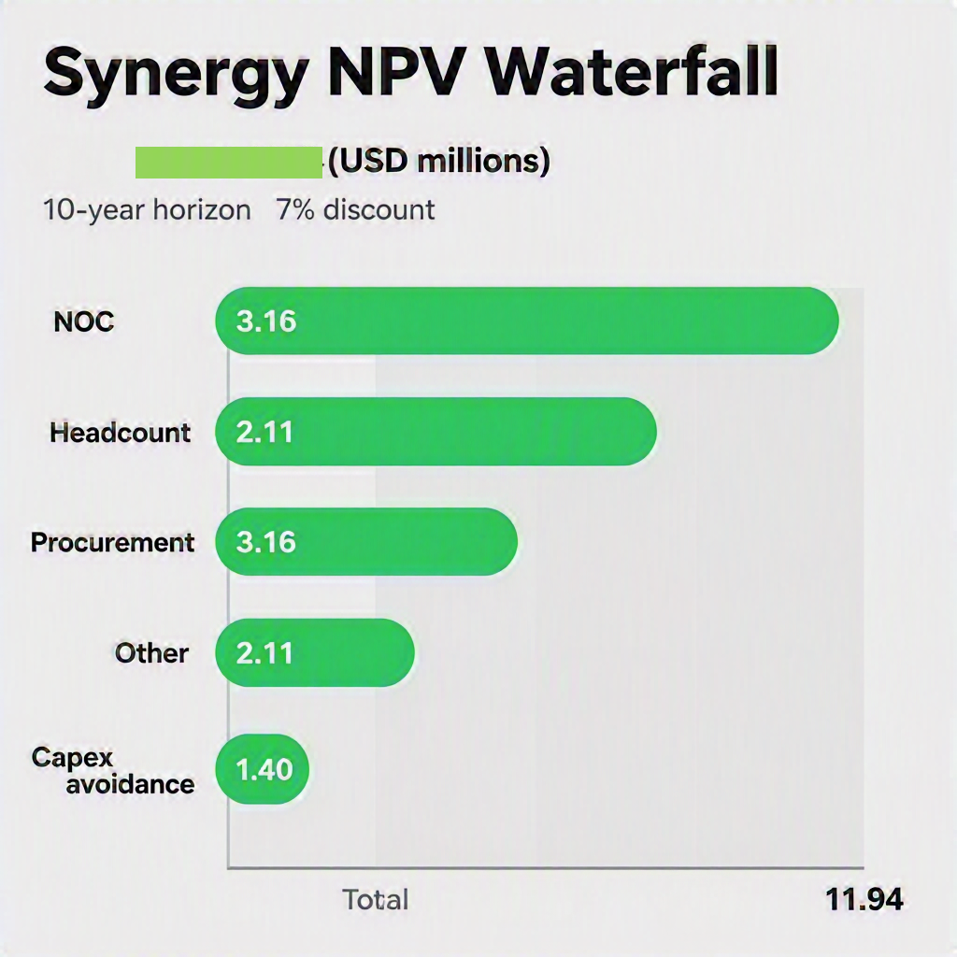

CONFIDENTIAL - DO NOT DISSEMINATE. This business plan contains confidential, trade-secret information and is shared only with the understanding that you will not share its contents or ideas with third parties without the express written consent of the plan author.

Interchange Limited 11

Increased Dividends

Why dividends rise 2029 - 2039
Dividends increase from about US$3 million in 2030 to $US5 million in 2039 supported by rising profits and cash balances.
Primary drivers
Revenue growth (recurring, high-margin) driven by expanding capacity-lease income and incremental site/customers. Revenue is predictable/recurring (leases), so cash conversion is reliable. Very high and stable gross margin (high 90’s %) as most incremental revenue flows to the bottom line. Overheads scale modestly (total overheads rise slower than revenue), so operating profit and ROS increase. EBITDA rises from $US7.5 million to $US9.8 million creating distributable earnings. There is also a decreasing financing burden as debt payments decrease serving the loans therefore creating improved net profit. Interest on Prima purchase loan declines over this period reducing interest expense and improving net profit. Capex and working capital needs are steady and predictable compared with operating cashflow, leaving surplus cash available for distribution to shareholders because of their investments in ICL/Prima. Depreciation is steady (non-cash), so accounting profit rises without equivalent cash outflow. The combination of growing high-margin recurring revenue, operating leverage, declining interest costs from paying down the Prima acquisition loan, and accumulating cash balances produces higher distributable cash — enabling progressive increases in dividends from 2029 through 2039. All these detailed increased dividends payments with need board resolutions to approve the increases.

Consistent Dividend growth by year ICL, 2029–2039 Dividend Growth Combined 2029 - 2039

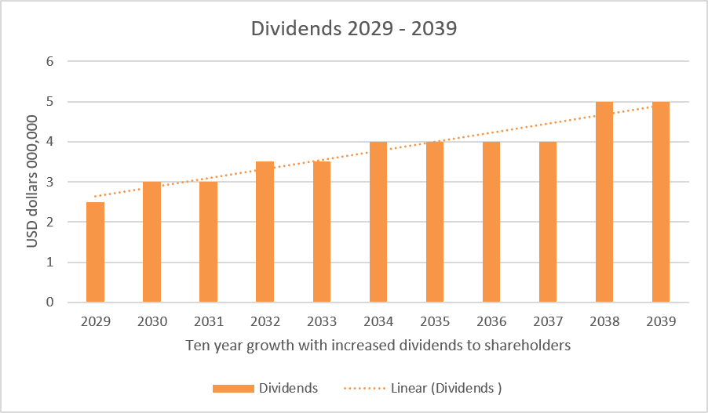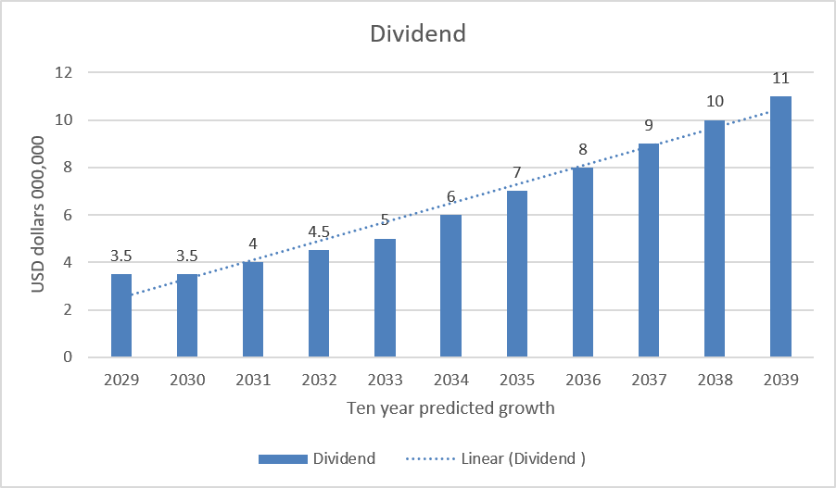

CONFIDENTIAL - DO NOT DISSEMINATE. This business plan contains confidential, trade-secret information and is shared only with the understanding that you will not share its contents or ideas with third parties without the express written consent of the plan author.

Interchange Limited 13

Proposed new shareholder’s structure

Two options with different ownership %

.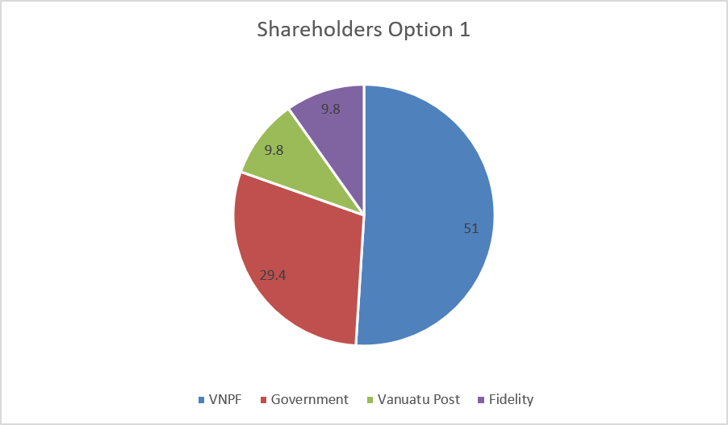 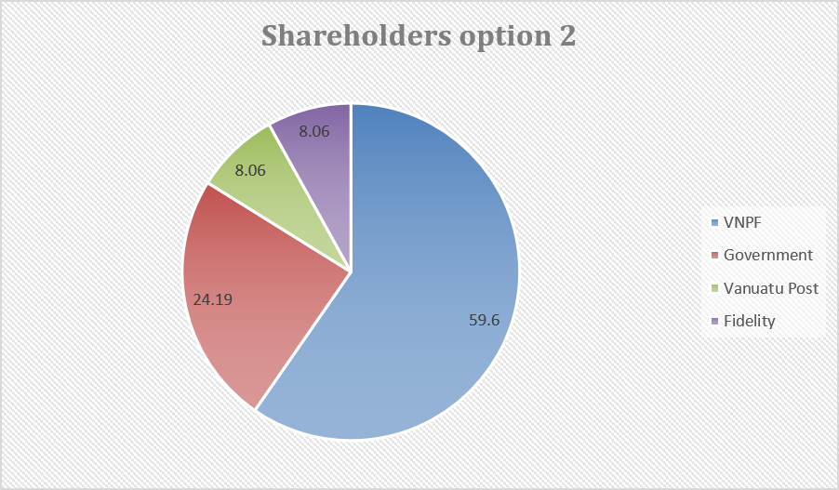

CONFIDENTIAL - DO NOT DISSEMINATE. This business plan contains confidential, trade-secret information and is shared only with the understanding that you will not share its contents or ideas with third parties without the express written consent of the plan author.

Interchange Limited 14

Proposed Structure of new company 2028

🔷 SHAREHOLDERS (OWNERS) 🔷
║
▼
╔═══════════════════════════════════════════════════╗
║ 📋 BOARD OF DIRECTORS (9 SEATS) ║
║ ║
║ 🟦 VNPF: 5 seats ║
║ 🟩 Vanuatu Government: 2 seats ║
║ 🟨 Fidelity Pacific Life: 1 seat ║
║ 🟪 Vanuatu Post: 1 seat ║
╚═══════════════════════════════════════════════════╝
║
▼
╔═══════════════════════════════════════════════════╗
║ CHIEF EXECUTIVE OFFICER (CEO) ║
╚═══════════════════════════════════════════════════╝
║
╔═════════════╩═════════════╗
▼ ▼
╔═══════════════════╗ ╔═══════════════════╗
║ CHIEF FINANCIAL ║ ║ CHIEF TECHNICAL ║
║ OFFICER (CFO) ║ ║ OFFICER (CTO) ║
╚═══════════════════╝ ╚═══════════════════╝
║ ║
╔═══════╩═══════╗ ▼
▼ ▼ ╔═══════════════════╗
╔═══════════════╗ ╔═════════════╗ ║ 🔧 ENGINEERS ║
║ 📁 ADMIN STAFF║ ║ SALES ║ ║ (8 STAFF) ║
║ (3 STAFF) ║ ║ STAFF ║ ║ ║
║ ║ ║ (2 STAFF) ║ ║ 🔹 Engineer 1 ║
║ 🟢 Admin 1 ║ ║ ║ ║ 🔹 Engineer 2 ║
║ 🟢 Admin 2 ║ ║ 🟠 Sales 1 ║ ║ 🔹 Engineer 3 ║
║ 🟢 Admin 3 ║ ║ 🟠 Sales 2 ║ ║ 🔹 Engineer 4 ║
║ ║ ║ ║ ║ 🔹 Engineer 5 ║
╚═══════════════╝ ╚═════════════╝ ║ 🔹 Engineer 6 ║
║ 🔹 Engineer 7 ║
║ 🔹 Engineer 8 ║
╚═══════════════════

CONFIDENTIAL - DO NOT DISSEMINATE. This business plan contains confidential, trade-secret information and is shared only with the understanding that you will not share its contents or ideas with third parties without the express written consent of the plan author.

Interchange Limited 15

Market Opportunity

Primary Versus Secondary

Primary Cable (Tamtam):

Direct southwest connection from Vanuatu to Lifou Island, New Caledonia (main landing point).

Role - Primary traffic route for regional connectivity.

Status: Main operational path.

Originally targeted for replacement around 2040; combined management with the secondary route extends service life to 2058.

Secondary Cable (ICN1):

Route: Southeast from Vanuatu to Fiji (backup path)

Role: Critical redundancy and failover route.

Status: Supports regional backup and resilience.

Aligned with the combined network plan, also extended to 2058 under single-company operation

Key Benefit

The Tamtam serves as the direct, primary link while ICN1 provides essential backup. Operating both routes under one company allows the original 2040 replacement timeline to be deferred, extending overall network longevity to 2058.

Primary and secondary routes for one company
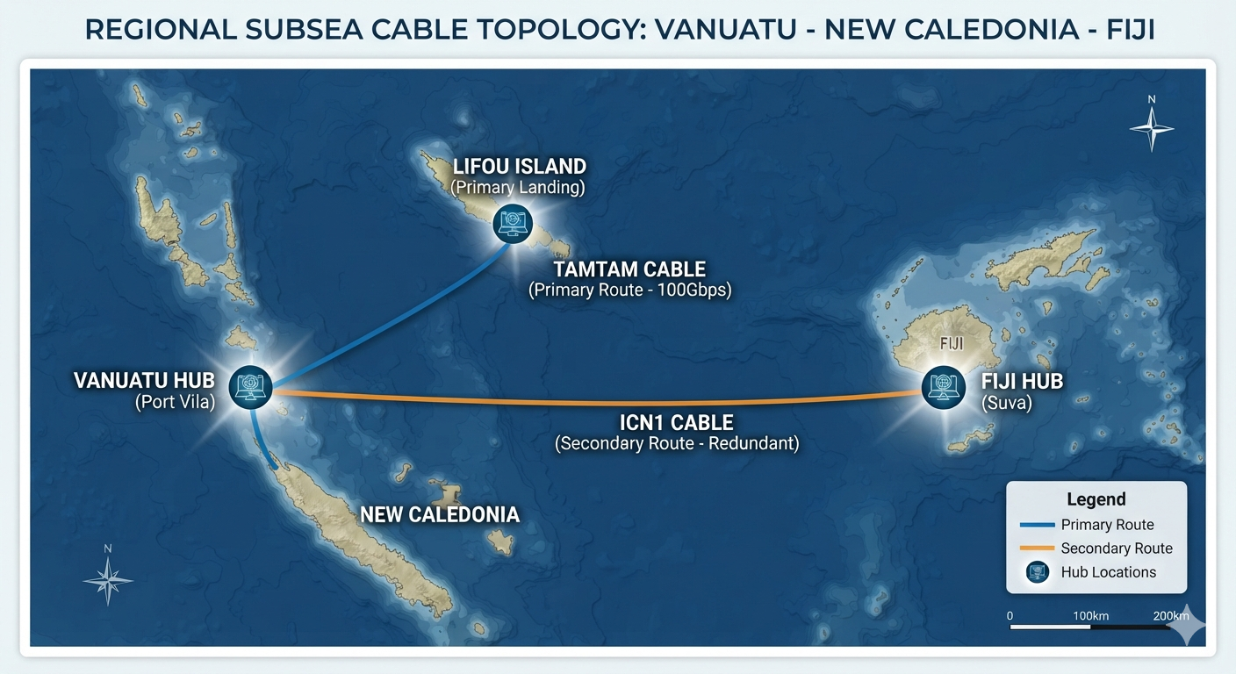

CONFIDENTIAL - DO NOT DISSEMINATE. This business plan contains confidential, trade-secret information and is shared only with the understanding that you will not share its contents or ideas with third parties without the express written consent of the plan author.

Interchange Limited 16

Financing the buyout

Loan debt
In summary, the generated cash flows are more than sufficient to comfortably buy and service the new 10-year private debt while continuing to honour existing obligations and grow overall cash reserves through 2039
- Principle & Interest: The $10 million loan (assumed at 5% interest over a 10-year term) is clearly accounted for in the "Prima purchase Loan repayments" line.
- Repayments commence in FY 2027 with an initial outlay of $US636,000, (deposit amount) From FY 2028 to FY 2037 (a full 10-year period), the annual debt service is a steady $US1.27 million annually
- Capacity to service debt: The projections demonstrate that the company can easily absorb this new debt service requirement due to robust and growing cash generation: Cash movement from P&L grows consistently every year, starting in 2027 and rising steadily to nearly 10 million by FY 2039. Even during the peak loan repayment years (FY 2028 - FY 2037), the closing cash balance remains highly positive and continues to grow. The strong operational inflows easily cover the $US1.27 million annual loan repayments, alongside substantial dividend payouts and other existing financing obligations (which are shown dropping from $US3.5 million in 2025 down to a steady $US1.35 million by 2031.

CONFIDENTIAL - DO NOT DISSEMINATE. This business plan contains confidential, trade-secret information and is shared only with the understanding that you will not share its contents or ideas with third parties without the express written consent of the plan author.

Interchange Limited 17

Threats of the LEO Satellites

Key Technical advancements of LEO’s (Starlink):

Starlink has made major advancements in their technical capabilities since launching in Vanuatu in 2024. Optical inter-satellite links (laser/FSO): lower backbone latency, reduce ground-station dependence, enable global mesh routing, this improves performance with fewer potential outages. Their onboard processing/edge computing is also improving giving vastly improved packet routing, caching, CDN-style services and basic application hosting in space. The satellites since 2026 are now using advanced propulsion and station-keeping. Their ground & user terminals are getting cheaper and more like a plug and play service using lower power, easier to install with multi-beam capability. However, their biggest advancements have come in their integrated direct-to-cell/handset terminals with NB-IoT/5G-compatible satellites and gateways for direct mobile services. This helps massive frequency reuse and carrier aggregation across Ka/Ku/L bands (and L-band for direct-to-cell). This gives them Low-band cellular integration: L-band or S-band links enabling narrowband mobile coverage from space.
They are launching and manufacturing on industrial scale which has been fast tracked since the SpaceX LPO in June 2026 at a massive 2 trillion US dollars. This gives them a massive war-chest to fast track coming into markets quicker than expected with competition ramping up for 2027/28.
Bulk manufacturing and rideshare optimisation reduce per unit costs and faster replenishment. Finally, they are developing their IoT/MCU scale services pushing into massive, small-message connectivity for sensors with low power and cost, a growing market with large revenues for the next decade.
SpaceX has been actively developing direct-to-cell / direct-to-phone capability (often described as “cellular from space” or satellite-to-mobile). Public filings, demonstrations and partnership talks through 2024–2025 indicated tests and pilots of low-band direct-to-handset service and integration plans with terrestrial mobile networks. This has now gone LIVE with T-Mobile in the USA in 2026. Global commercial rollout depends on regulatory approvals, handset compatibility or agreements with phone manufacturers/carriers, spectrum coordination, and successful testing. That means wide consumer availability could be phased (initially for roaming, emergency or narrowband services, then expanded) rather than instantaneous across all markets within five years — though SpaceX has signalled strong intent and active technical progress to have this across the world by 2030.

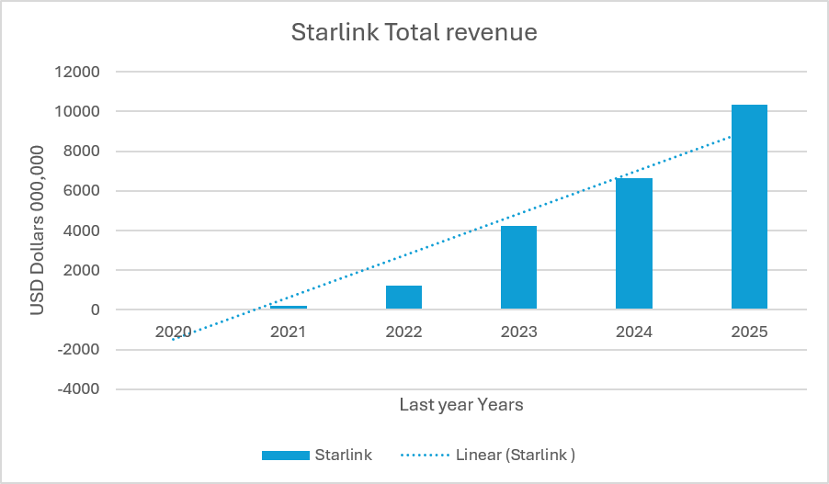

CONFIDENTIAL - DO NOT DISSEMINATE. This business plan contains confidential, trade-secret information and is shared only with the understanding that you will not share its contents or ideas with third parties without the express written consent of the plan author.

Interchange Limited 18

Other LEO Satellites

More players coming to the market:

By 2036, the LEO landscape will transition from basic broadband provision to an integrated, multi-orbit ecosystem connecting everything from enterprise data centers to unmodified smartphones and global IoT sensors.
Key Players in the LEO Market

Project Kuiper (Amazon) Focus: Consumer broadband, enterprise, and government networks. Kuiper will heavily integrate with Amazon Web Services (AWS) to offer seamless edge computing and cloud services from space. Kuiper is developing highly efficient, low-cost customer terminals. They are using laser communications between satellites—to create a space-based mesh network that reduces reliance on ground stations and lowers latency.

Eutelsat Oneweb Focus: Enterprise, aviation, maritime, and telecommunications backhaul. Unlike consumer-focused constellations, OneWeb primarily sells to businesses and telecom operators (B2B). Following its merger with Eutelsat, OneWeb is pioneering. A multi- orbit strategy. They are integrating their LEO constellation with Eutelsat’s Geostationary Orbit (GEO) satellites. This allows them to offer smart routing: using LEO for low-latency tasks (like video calls) and GEO for high-capacity data downloads.

AST SpaceMobile & Lynk Global Focus: Direct-to-Device (D2D) / Direct-to-Cell connectivity. These companies are revolutionizing the market by building satellites that act as cell towers in space. They utilize massive deployable phased array antennas. This technology allows standard, unmodified smartphones on the ground to connect directly to satellites, eliminating cellular dead zones globally.

Chinese (Guowang / Qianfan) Focus; State-backed global internet coverage to ensure strategic independence and offer alternatives to Western constellations. China is focusing on rapid manufacturing, utilizing higher frequency bands (like V-band) to increase data capacity, and incorporating AI into satellite management for autonomous collision avoidance and network optimization.

CONFIDENTIAL - DO NOT DISSEMINATE. This business plan contains confidential, trade-secret information and is shared only with the understanding that you will not share its contents or ideas with third parties without the express written consent of
the plan author.

More players coming to the market Technological advancements driving the next decade:

Laser Communications (OISL’s) Almost all next-generation LEO satellites will use lasers to talk to each other. This creates a secure, high-speed internet backbone in space, minimizing the need to build expensive ground stations in remote or politically unstable regions.

Software-Defined Payloads Satellites will no longer have fixed coverage beams. They will be "re-programmable" in orbit, allowing operators to shift capacity instantly based on weather, demand, or commercial needs.

V-Band and E-Band Utilization as the Ku and Ka radio bands become congested, operators are developing technology to use higher frequency V and E bands, which offer massive increases in data throughput.

Electrotonically steered Antennas on the ground, the physical dish is being replaced by flat panels with no moving parts. These ESAs can track multiple fast-moving LEO satellites simultaneously, drastically reducing the cost and size of user terminals.

Massive revenue growth of all LEO’s to a market of 135 billion USD by 2039
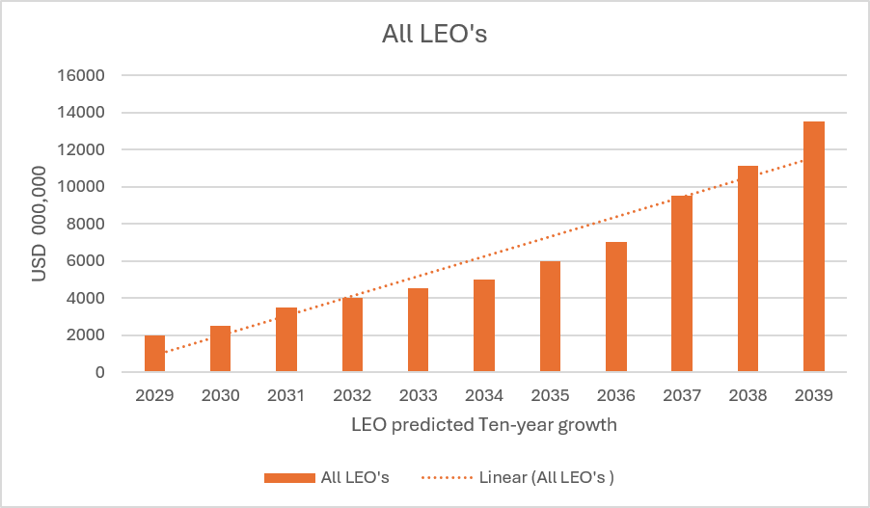

Alternatives to Prima

Funds including IFC:

Following strategy to put funding away for next 12 years to purchase replacement cable from ASN in 2040. This is an estimated cost of $US 15 million USD. ICL have been looking at funds overseas with difficulty due not having an international business with global banking access. CRAIG’s have requested ICL set-up a New Zealand bank account after all due diligence was completed. ICL are liaising with IFC and their digital transformation fund for the developing world. This an expensive alternative with over 100K to be invested from 2030 into this monthly after starting at 50K USD per month in 2026. This will be invested into the fund over 12 years with the sum of close to $US10 million to be then invested into the replacement cable along with some private bank debt to make the shortfall.
The costs for a replacement cable of 1,100 KM’s would be a substantial investment, typically ranging from$US15 million USD to $US35 million.

- This consists of cable manufacturing and Procurement around 30% of the cost. This covers the custom-made fiber optic cable itself, including embedded repeaters (essential for this length to boost signals), branching units, and spare cable.

- Marine Operations; Often the largest expense sometimes of high as 50%. This includes the extremely high daily charter rates for specialized cable-laying vessels, fuel, specialized crew, detailed seabed surveys, and the complex process of deploying, burying, and protecting the cable along the entire 1100 km route.

- Shore end operations (7%) Costs for the land-based Cable Landing Stations (CLSs) at each end, connecting to existing terrestrial networks, and securing the cable from the shore to the CLS.

- Securing necessary permits (2%) from all relevant coastal states and international bodies along the long route, environmental impact assessments, and legal fees.

- Project management, engineering and consulting (10%) The significant overhead for designing, planning, coordinating, and overseeing such a large and complex international project.

- Testing, commissioning & Warranty (3%) Ensuring the newly laid cable meets performance specifications and is ready for service.

- Contingency and Insurance (10%) A crucial budget for unforeseen challenges like bad weather, technical issues, or route complications, along with comprehensive project insurance.

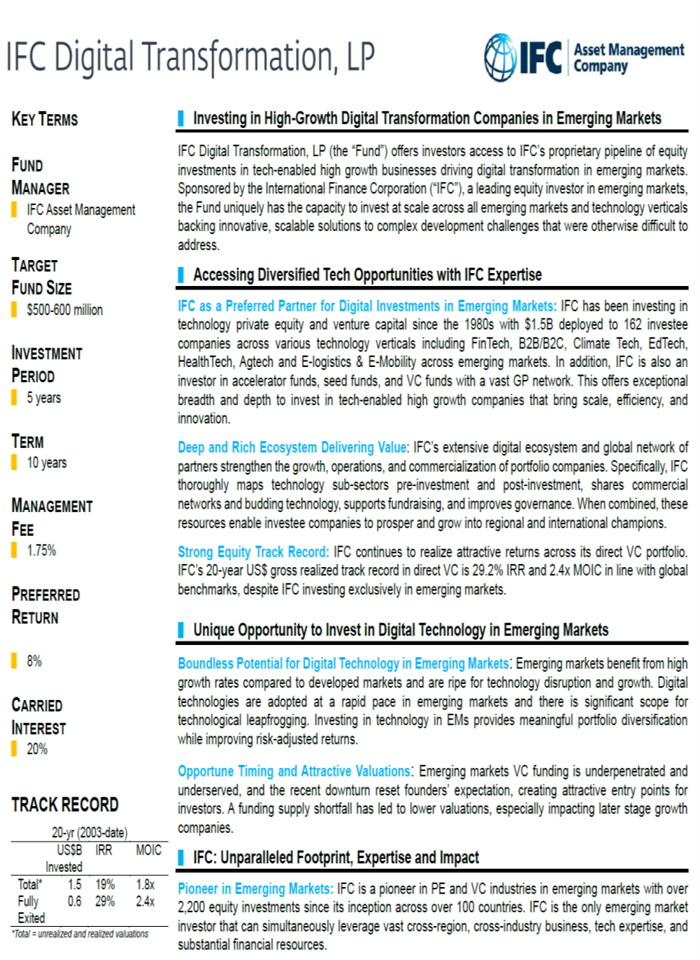

Recommendations

Implementation:

- Agreement: ICL to make an offer through agreeing to make 10 million USD offer for Prima subject to due diligence. This agreement will detail that both parties agree to the sum, this will be signed in Q1 2027 after processes completed and a deposit paid (500K) fully refundable dependent on baking covenants from ADB and EIB.

- Secure Funding: ICL to devise a term-sheet for payment to be made when Tamtam project is delivered by April 2028 and all technical acceptance tests have been signed off. This term-sheet will be approved by the ICL shareholders at the annual AGM in Q1 2027, this will include a shareholder’s agreement also. Aim to postpone AGM till then. This gives ICL time to secure the 10 million funding in debt finance, complete due diligence and design term-sheet and new shareholders agreement.

- Regulatory: ICL will work with the TRBR office over the next 12 months to get a new telecommunications licensing merging the two existing licenses into one and receiving all necessary approvals.

Timelines:

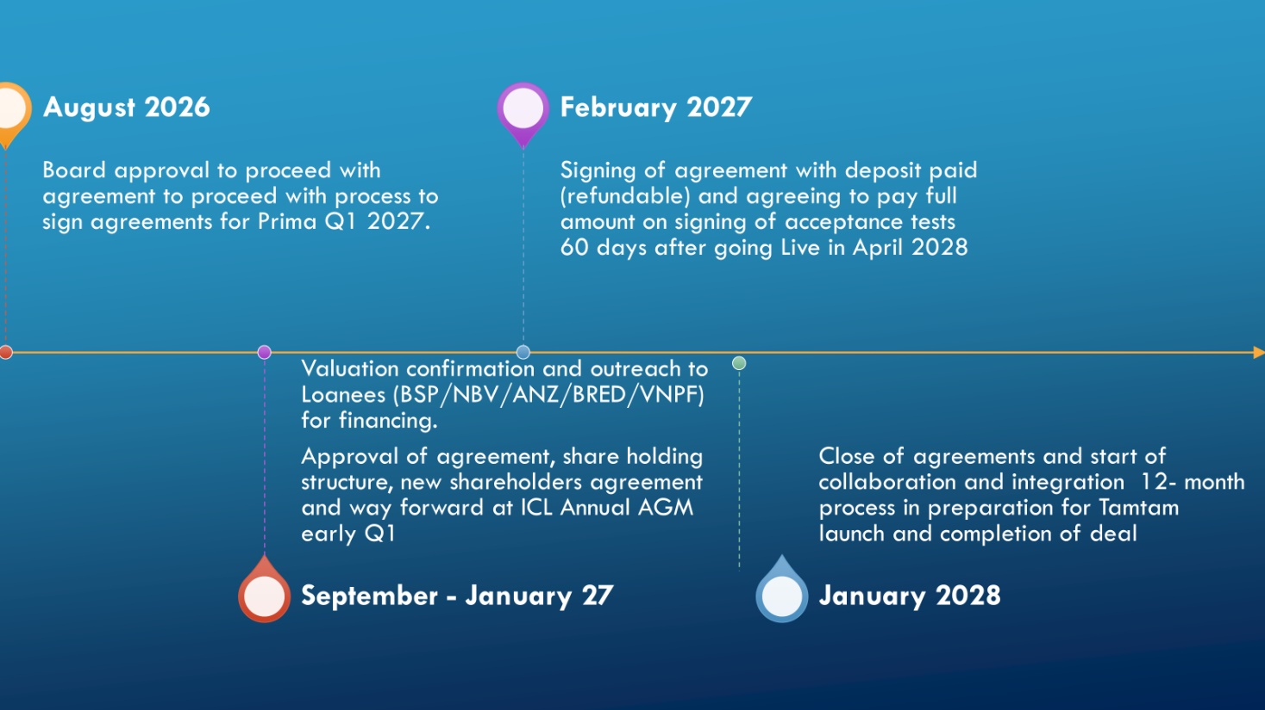

Interchange Limited Appendix (A) 19

CONFIDENTIAL - DO NOT DISSEMINATE. This business plan contains confidential, trade-secret information and is shared only with the understanding that you will not share its contents or ideas with third parties without the express written consent of the plan author.

