The Wig Room – Logo

TWR
THE WIG ROOM
By Jennine Ford

My draft examples generated with AI:
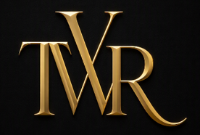
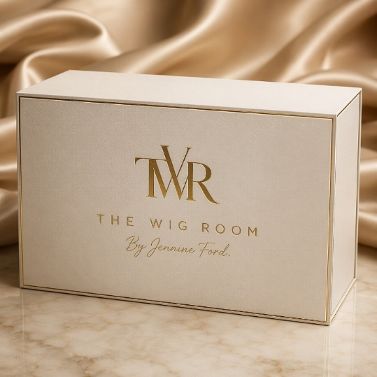
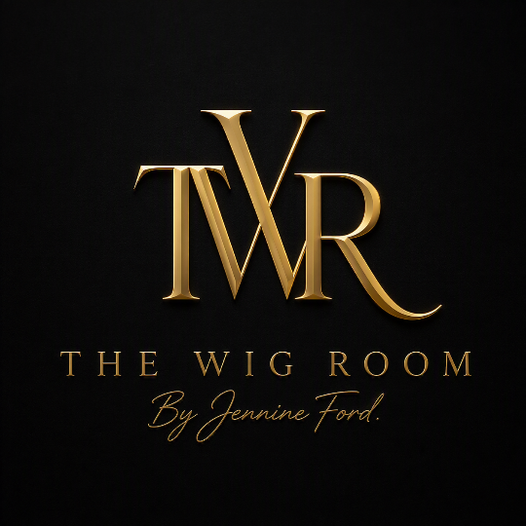

I’d am happy with this design and the colours. Just now want the output files to use on my website, business cards, Insta account etc.

Output requirement:

- Full brand gold on black
- Full brand gold on white
- Full brand gold on transparent
- TWR gold on black
- TWR gold on white
- TWR gold on transparent.

Sized to use on Web, Socials, and Packaging and all appropriate file formats (EPS, JPEG, Transparent PNG, etc).

Also please provide:
- Font names and colour information in HEX, RGB and CMYK codes

