The Story Behind Marsco

- Can we have the tabs on a drop down menu on the left of the page rather than visibly at the top?
- Can you create my website to look like this, the first tab to lay out similar to this with my photo and my logo.

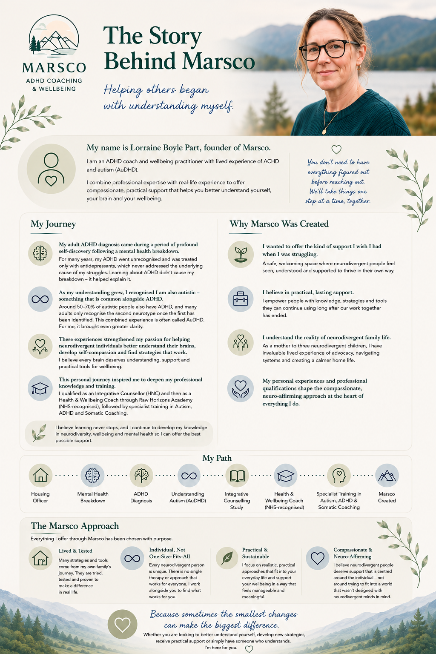

How Marsco can support you

- Please create similar to this and use my logo

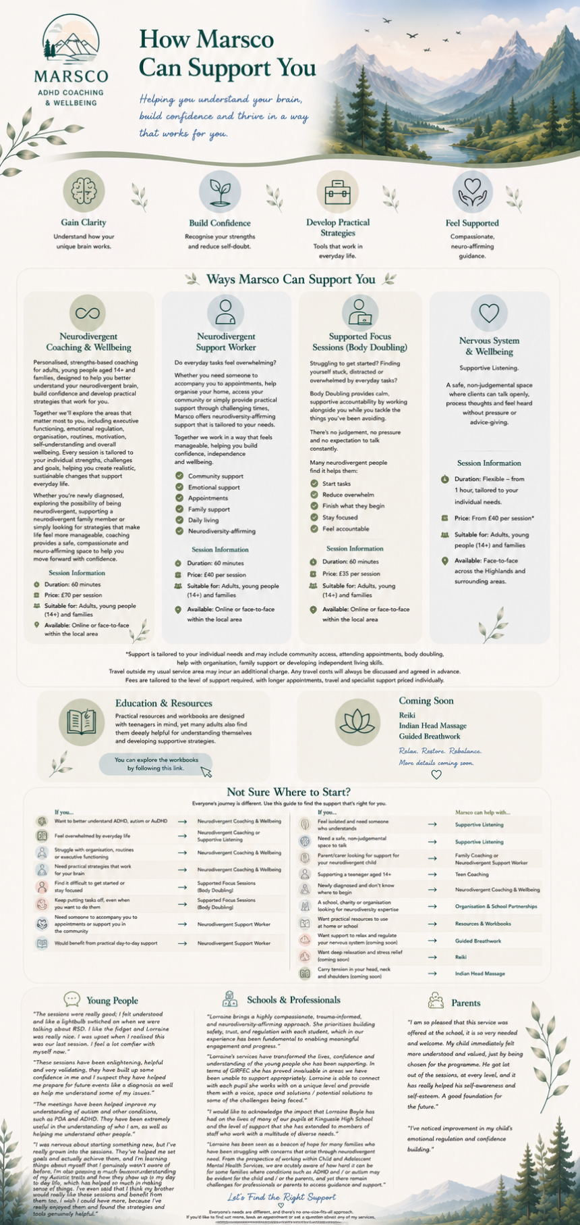

Organisation & Partnership
Use my Logo

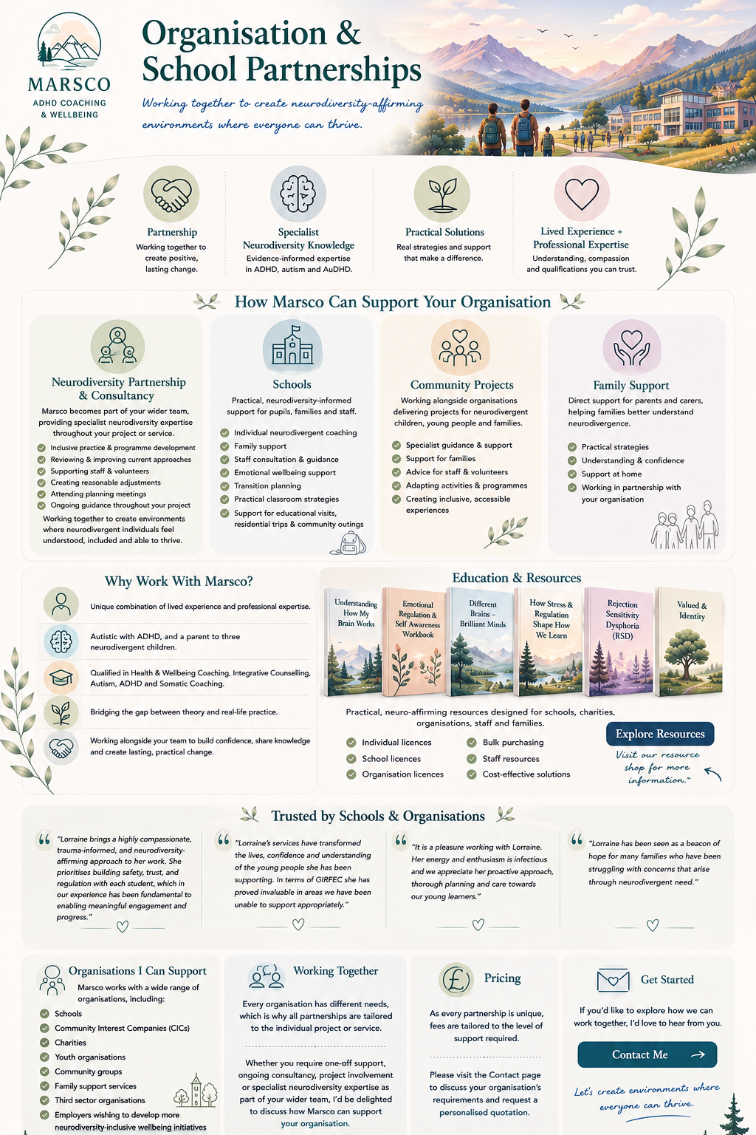

Resources & Workbooks (put in & workbooks to the tab)
Using my logo.

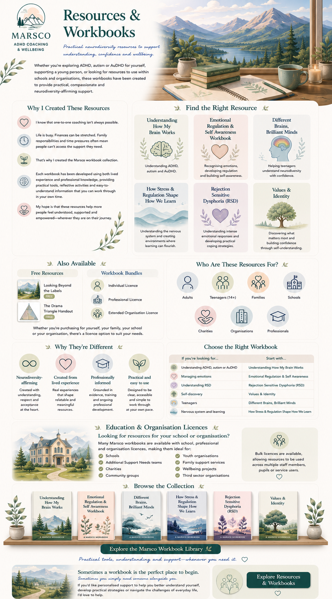

Contact
Use my logo – I know you can’t do the drop down “what are you enquiring about” but please keep this and make sure folk can’t go any further without filling this part in.

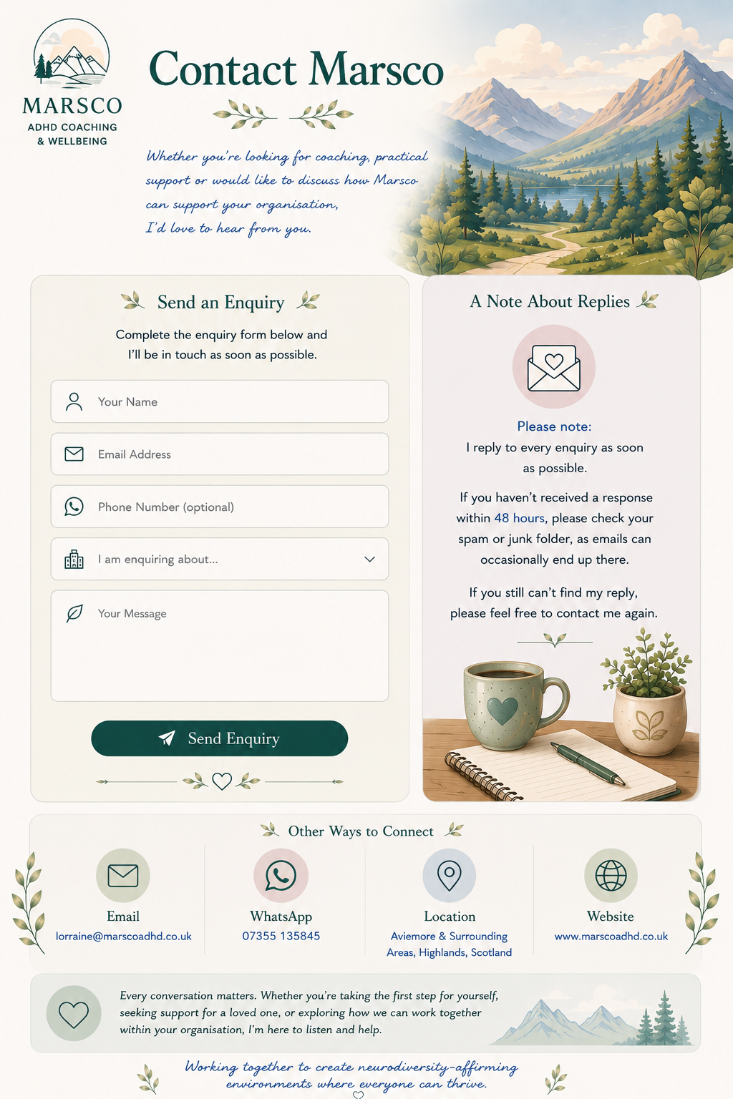

Privacy Policy

Use my Logo

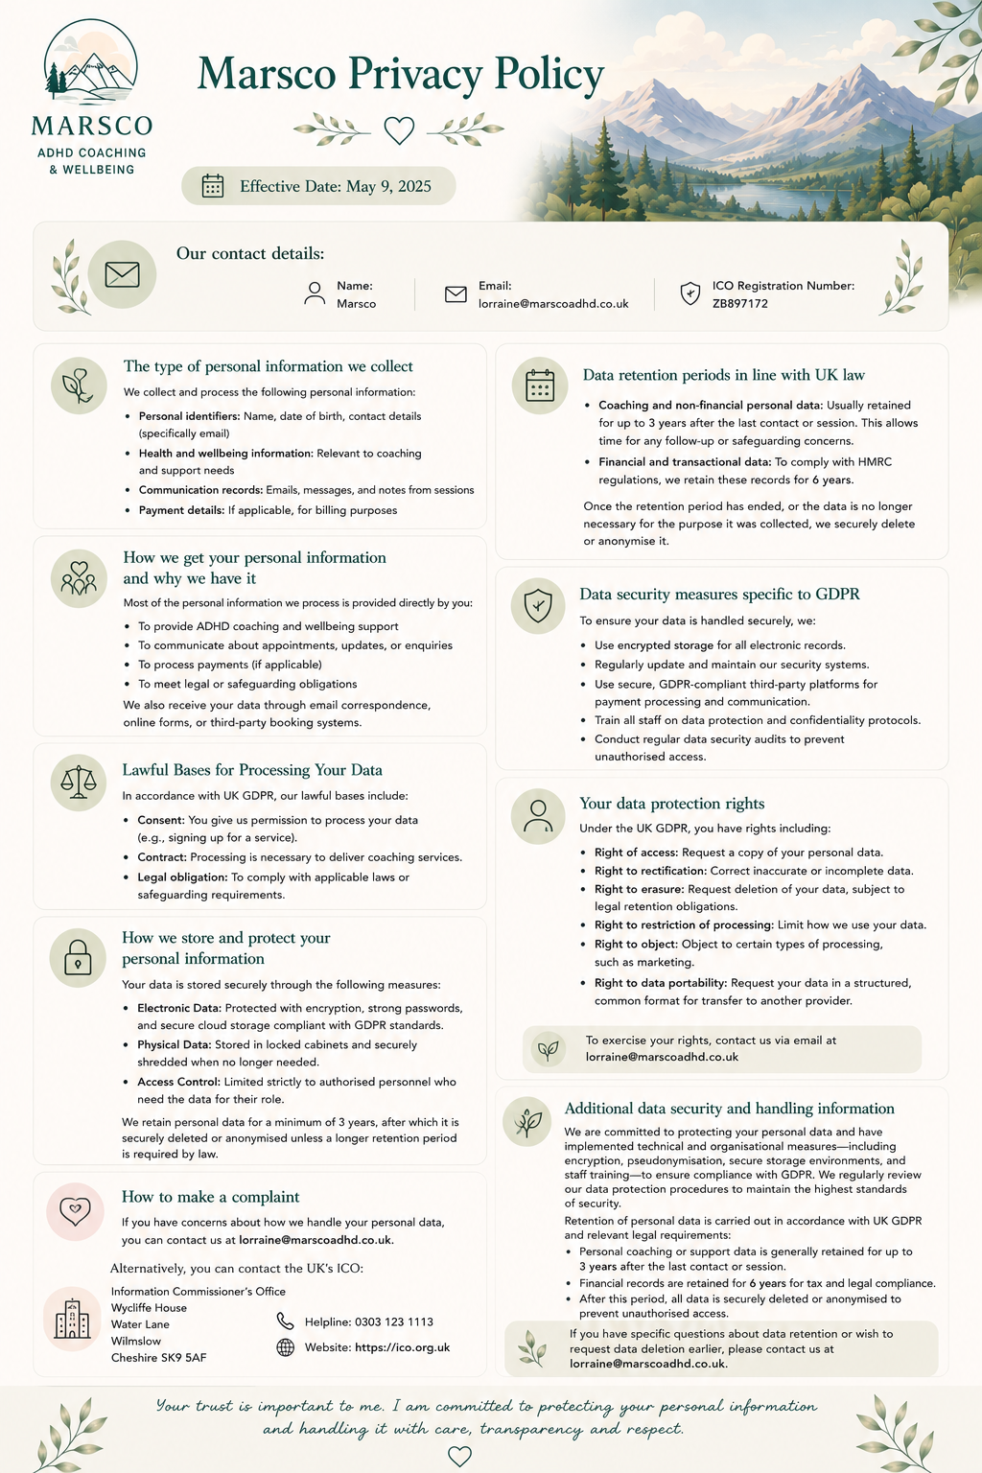

Please put this at the end of Story behind Marsco please. Use my logo

