The Grainer Good Co.
BRAND CORE

Brand Name: The Grainer Good Co.

Tagline: Grain for the greater good.
MISSION, VISION & VALUES

Mission Statement

"To supply, educate, and serve through whole grains — naturally sourced, thoughtfully distributed, and grounded in God’s design — for the health and well-being of others."

Vision Statement
To become the trusted leader in freshly harvested, naturally grown grain products, restoring food to its wholesome roots and building a healthier future through every sack and shipment we deliver or provide to meet the health needs of the generation.

Core Values (7 on purpose)
- Integrity of Source – Partnering with U.S. farmers who prioritize soil health, regenerative practices, and non-GMO integrity.
- Faith-Grounded Stewardship – Guided by biblical principles to operate with humility, provision, and purpose.
- Freshness and Nutrition First – Delivering recently harvested, nutrient-rich grains that nourish homes and communities.
- Educating the Market – Equipping families, bakers, and millers to make informed, confident choices about whole grains.
- Transparency Always – Clear labeling, honest sourcing, and educational packaging that builds trust.
- Pricing Consistency– Price hedging tied to commodity fluctuations, harvest seasons and availability.
- Storing to Provide – Promoting food security through the wisdom of storing up grain for seasons ahead.
POSITIONING STATEMENT
The Grainer Good Co. is a values-driven grain distribution brand supplying high-integrity wheat berries to health-conscious consumers, artisan bakers, and milling partners. We ensure regional traceability, harvest freshness, and ethical sourcing from regenerative U.S. farms.
MESSAGING PILLARS (Distribution-Centric)

1. Fresh-From-Farm Wheat Berries
We source directly from trusted U.S. growers — minimizing storage time and maintaining seed vitality and flavor integrity.

2. Mill-Ready, Bake-Ready
Whether you’re milling at home or running a full-scale baking operation, our berries are cleaned, sorted, and ready to grind or soak.

3. Traceable by Region
Midwest hard red wheat? Southern soft white? We label our sacks with origin and harvest date — so you know exactly what you’re getting.

4. Grains With a Purpose
More than a commodity — our grains support rural farms, healthy soil, and food systems rooted in faith and integrity.

5. Packaging Designed for Distribution
Available in 5lb, 25lb, and 50lb bags — shipped bulk or LTL from central hubs for freshness and affordability.
BRAND APPLICATIONS (Current Phase)
- Wholesale-Friendly Packaging: Durable, breathable kraft paper sacks with moisture-safe liners.
- Labels Focused on Grain Type + Origin: Ex: "Hard Red Winter Wheat – Nebraska – 2025 Harvest"
- Marketing Collateral:
  - “How to Store Wheat Berries” insert
  - Grain sampler kits for bakeries or small co-ops
  - Origin maps for transparency
VISUAL IDENTITY

Logo
Classic circular wheat-emblem logo with strong organic-farm character and grounded text design. Available in single-color and reverse.
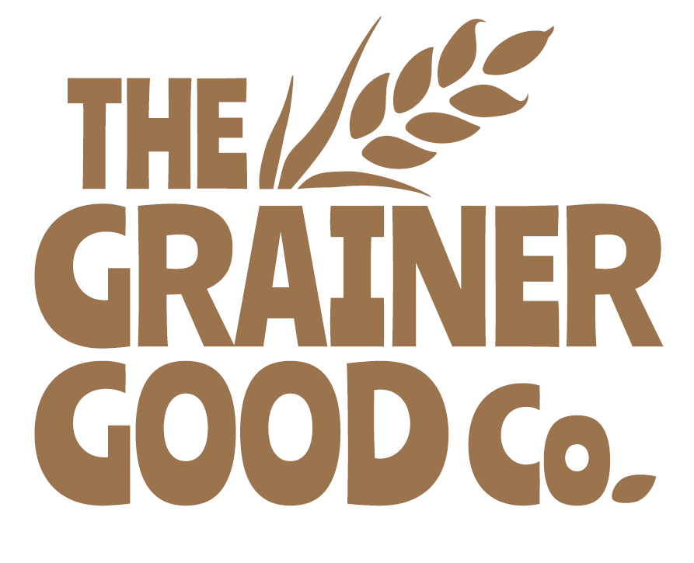

Color Palette
Color Name | Hex | Use Case
Harvest Brown | #9C6B3E | Primary logo, headers, icons
Golden Grain | #F2C87A | Accent color, CTA highlights
Cream Flour | #FAF4EC | Backgrounds, packaging base
Stone Gray | #58595B | Text, neutral balance
Field Orange | #D56217 | Bold buttons, promotions

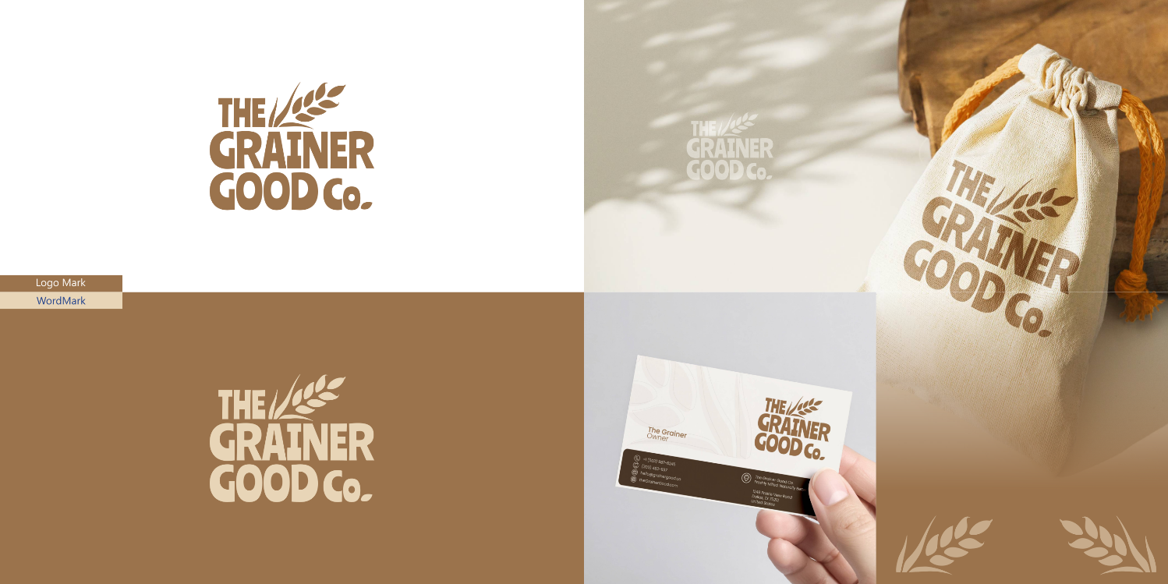

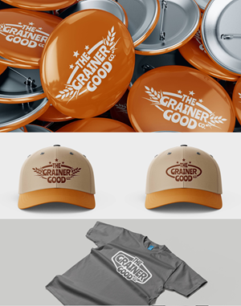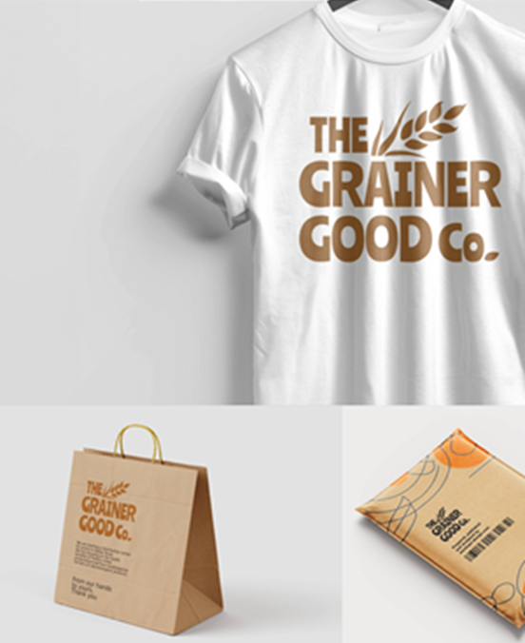
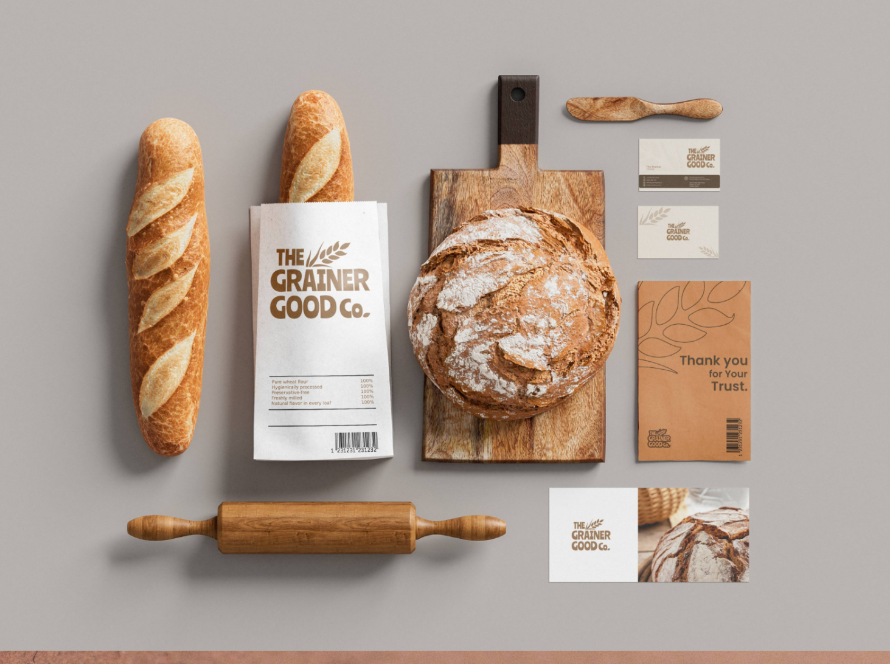

Typography
- Logo / Display: Custom slab serif (e.g., Baloo, ChunkFive)
- Body / Web:
  - Merriweather (warm serif, legible)
  - Work Sans (clean sans-serif)
  - Lora (serif with softness and clarity)

