Feedback on Design #37441164
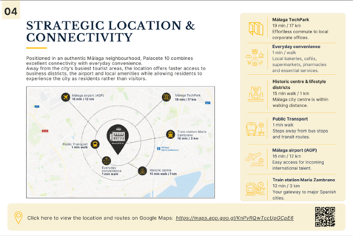

Can you make the mapaccurate, the different items should be placed differently on the map please, meaning:

Left from bottom down: Málaga TechPark
Train station María Zambrano
Málaga airport (AGP)

Right from bottom down:
Public transport
Everyday convenience
Historic centre
Like this – marked in yellow: 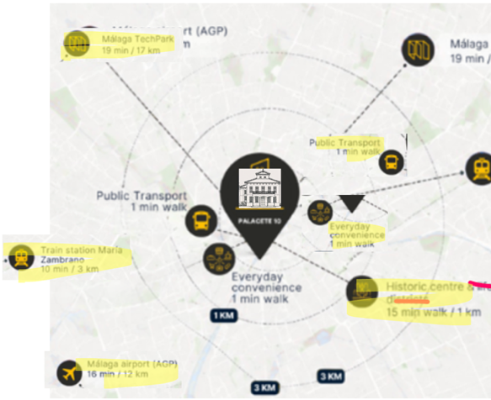

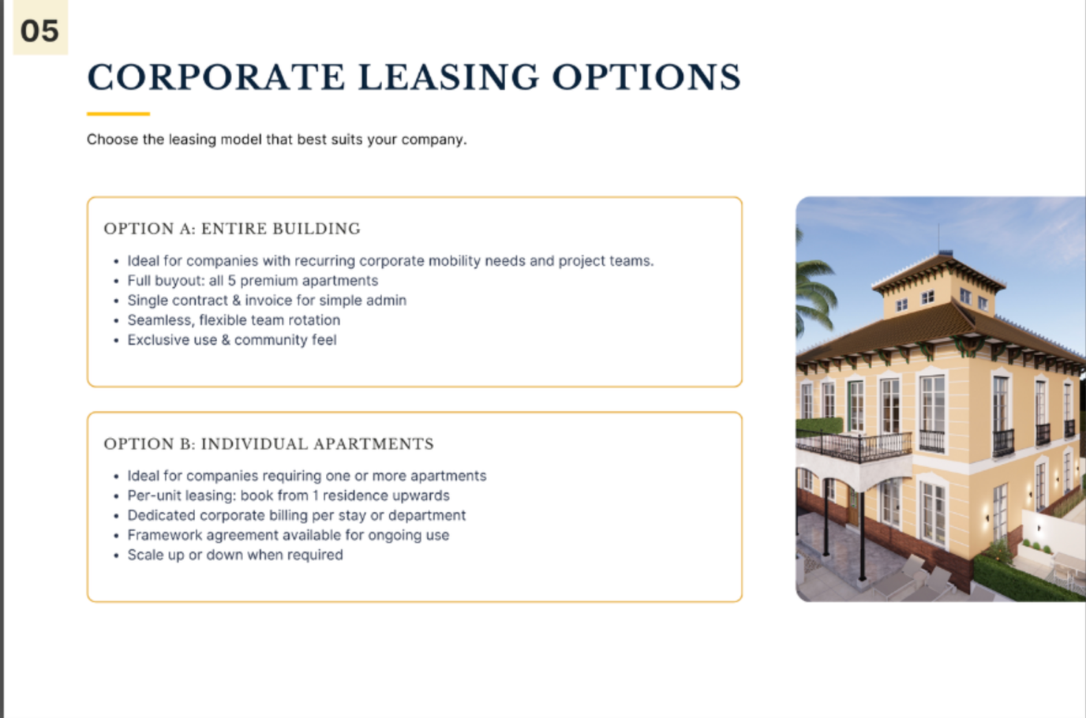
Teams. -> must be teams
(thus end sentence without a .)

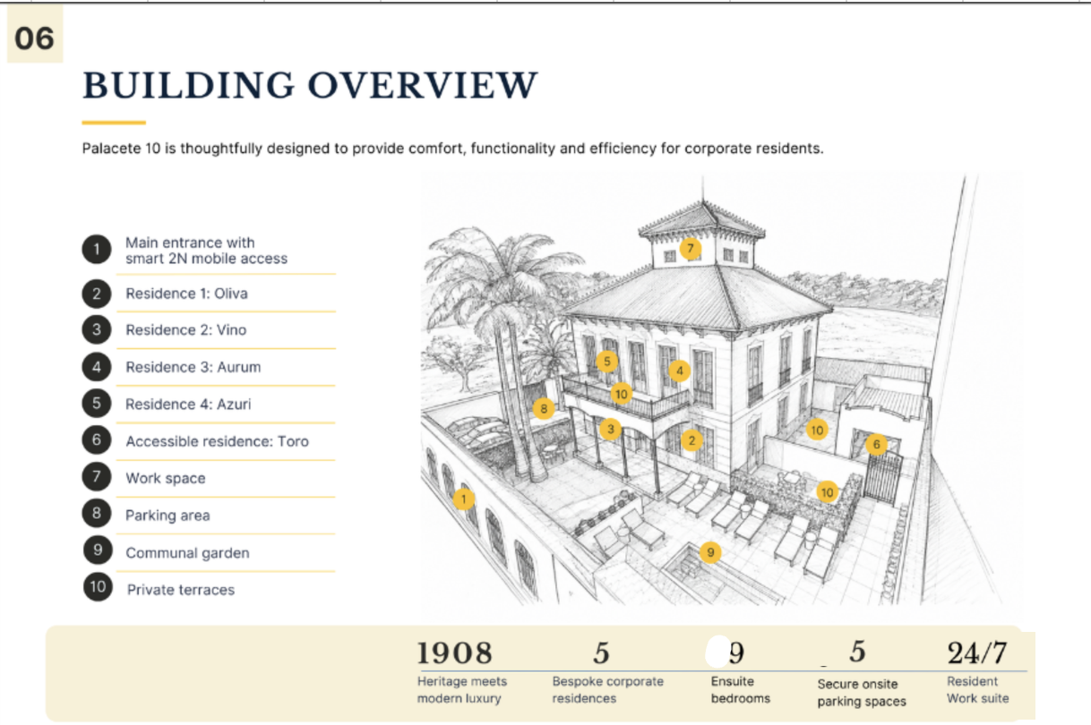

Same remark as before:
The numbers ligned with the drawing above and centered above the tekst they belong with + placed underneath the drawing with empty banner at lef hand side (like my picture above)

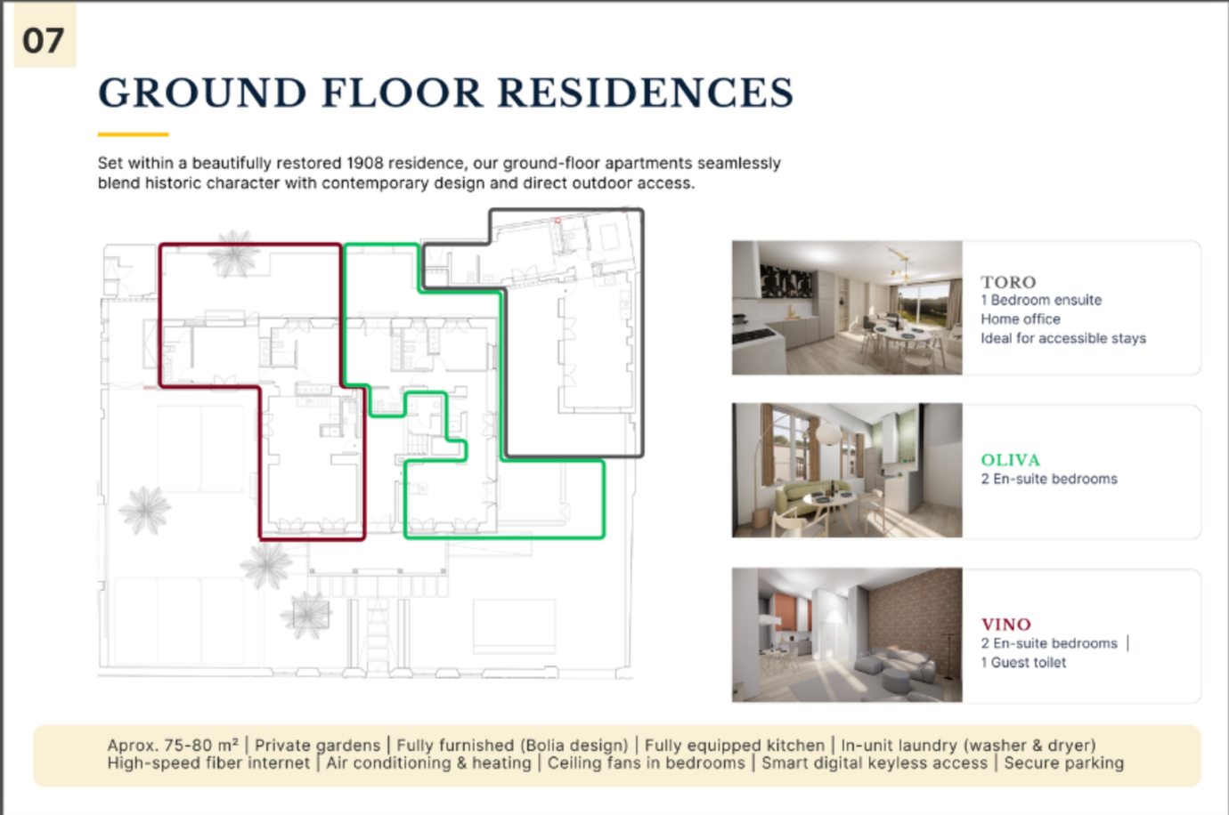

TORO
1 En-suite bedroom

Remove the /

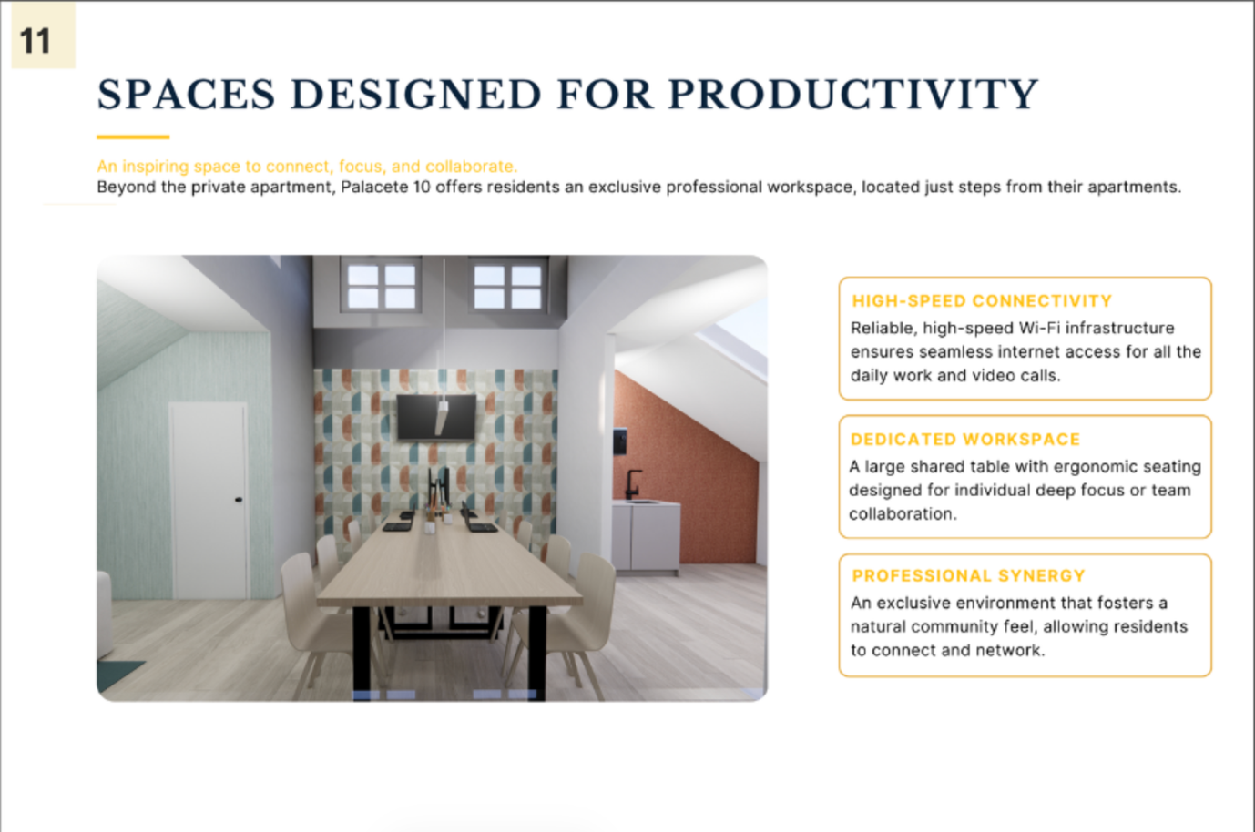

Sorry, I explained badly: the text should start at Palacete 10, please remove “Beyond the private apartment,”

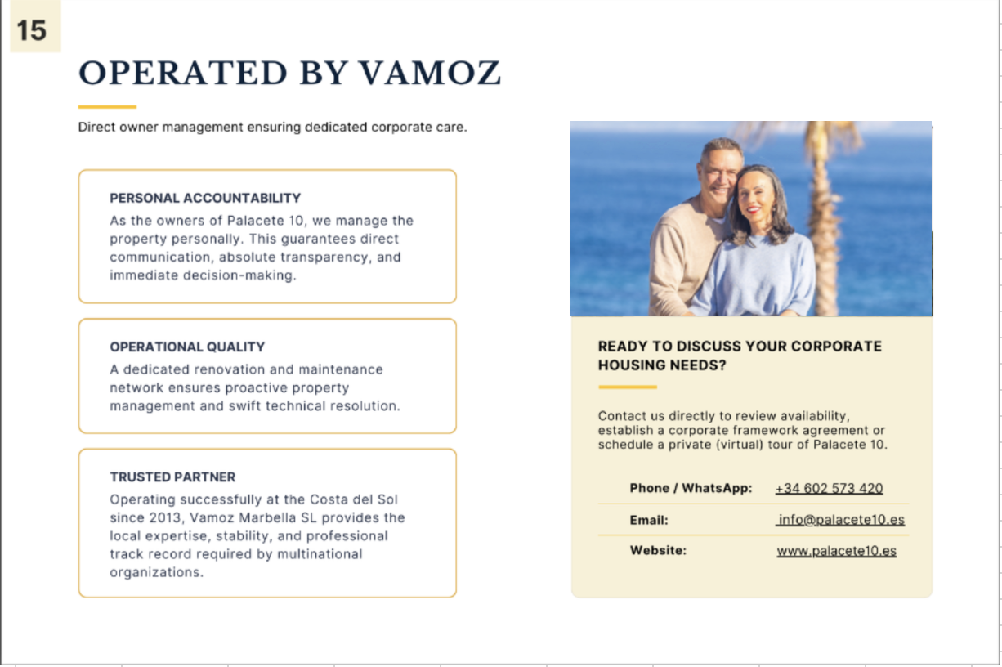
Mail must be .com
Web must be .com

