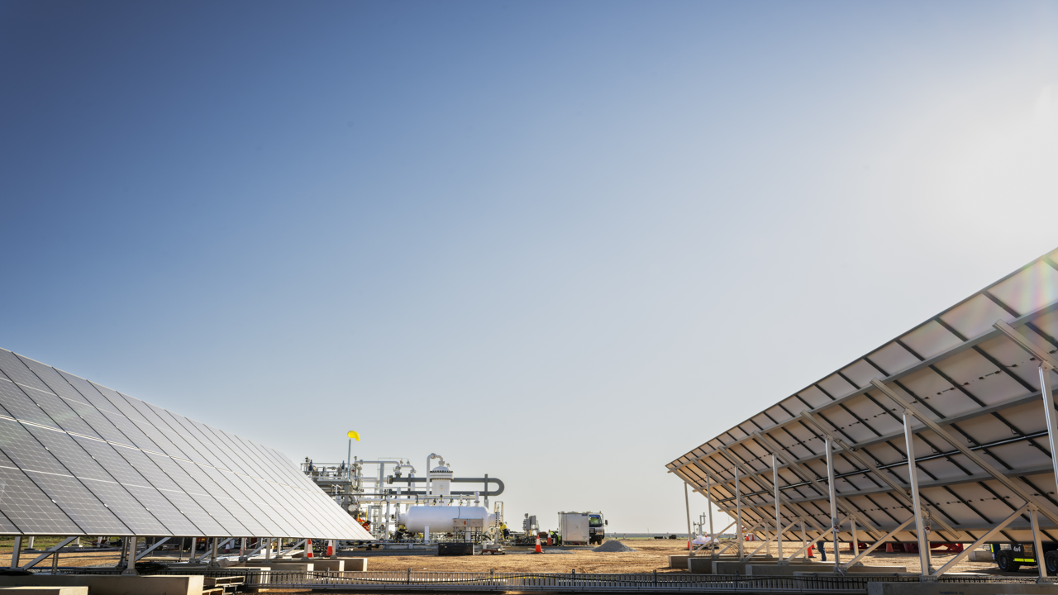


Capability Statement
Simplify Project Execution,
Streamline Operations

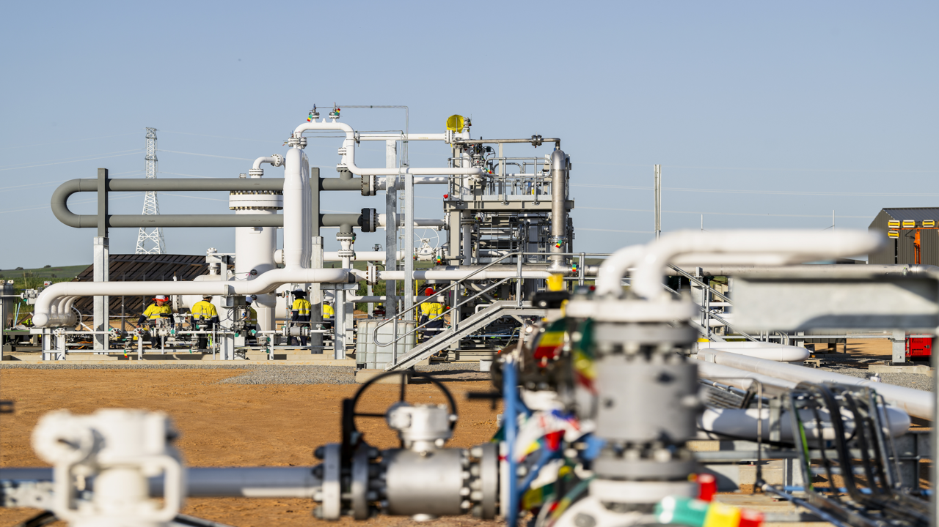

www.simpliphi.com.au

Who are Simpliphi?
Simpliphi are a highly experienced team of Executive, Project, Construction, Commissioning and Operations specialists who combine deep technical knowledge with proven leadership to deliver unique Project Delivery Partner services to organisations in Australia.
Our vision is straightforward:
Simplify Project Execution, Streamline Operations.
What is a Project Delivery Partner?
A Project Delivery Partner (PDP) provides integrated project management along with technical, commercial and delivery support services to help an organisation successfully deliver a project. The PDP acts as the owner’s team while the owner retains accountability and key decision-making authority.
PDP Core Principles:
- Owner controls the project
- PDP enables delivery & provides assurance
- Contractors execute the work

PDP Objective:
Deliver the project safely, on schedule, within budget and ready for operations; providing owner capability throughout the project lifecycle.

PDP Services:
# | Function | Simpliphi Service
1 | Project Management | Planning, Reporting & Delivery Leadership from Concept to Completion
2 | Engineering | Concept Selection, Design Coordination, Technical Assurance & Value Engineering
3 | Procurement | Contracting Strategy, Tender Process & Supplier/Contractor Management
4 | Approvals | Land Access, Regulator Engagement, Safety Case, Permits & Licenses
5 | Cost Control | Budget Development, Forecasting & Management
6 | Scheduling | Master Schedule Development, WBS, Resource Allocation, Monitoring & Updating
7 | Risk Management | Risk Register, Identification, Mitigation & Reporting
8 | Governance | Framework, Stage Gates, Change control, Reporting & Decision Support
9 | Construction | Management & Coordination of Contractor Execution Teams
10 | Commissioning &  Start-up | Lead Commissioning & Start-up, Completions System, Bring the Facility to Steady-State
11 | Operations Readiness | People & Organisation, Process & Procedures, Systems & Technology
12 | Operations & Maintenance | Monitor & Operate Asset, Minimize Downtime, Lowest Possible OPEX for Owner

PDP Roles & Responsibilities:
Owner | Simpliphi Service
Sets Project Objectives | Develops Delivery Plans
Approves Major Decisions | Provides Recommendations
Holds Project Risk | Identifies and Manages Risks
Awards Contracts | Manages Contractor Interfaces
Provides Funding | Monitors Cost and Schedule Performance

PDP Benefits:
- Provides owners with access to experienced project delivery capability
- Improved project controls and governance
- Greater flexibility than traditional EPC delivery
- Enhanced visibility and management of cost, schedule and risk
- Scalable resources aligned with project phases

PDP Challenges:
- Owner retains significant delivery risk
- Requires clear governance and decision-making processes
- Multiple contractor interfaces require strong coordination
- Success depends on collaborative Owner-PDP relationship

For More Information Contact: directors@simpliphi.com.au

Key Simpliphi Personnel
Name: | Kevin Craig | Role: | Executive Director
35yrs Exp: | Shell, Sakhalin Energy, GRPS, Strike Energy
Extensive global energy industry experience, from frontline O&M to the boardroom.
Respected ‘C Suite’ leader with a track record of building high performing teams that deliver outstanding results.

Name: | Gordon Shand | Role: | Technical Director
39yrs Exp: | Shell, Sakhalin Energy, Petroleum Development Oman,  BP, BG Group, QGC, GRPS, Strike Energy
Highly skilled & experienced operations & project management professional with 39 years’ experience in the global oil & gas industry delivering multiple projects and establishing best in class operational assets. Deep knowledge of project management, construction, commissioning & start-up including a global functional assurance role.

Name: | Russell Moyle | Role: | Commercial Director
40yrs Exp: | Woodside, INPEX, BP, GRPS, Strike Energy
Senior Logistics & Supply Chain Manager / Procurement Manager with strong operational, commercial, project management, negotiating & relationship building skills. Experienced in operating complex and diverse logistics operations, significantly improving service levels whilst reducing cost.

Name: | Jon Selkirk | Role: | Operations Director
27yrs Exp: | BP, BG Group, QGC, GRPS, Strike Energy
27 years’ success leading operations, maintenance and commissioning teams on onshore and offshore oil and gas production platforms, FPSOs, gas processing, coal seam gas, refrigeration facilities, and chemical refineries.
Results driven and enthusiastic Leader with a proven track record of delivery.


www.simpliphi.com.au

www.simpliphi.com.au

www.simpliphi.com.au

