References:
https://www.paybackfx.com/brokers/ic-markets/6
https://premium-rebate.com/rebates/tickmill
https://www.forexcashbackcloud.com/brokers/exness
The layout design will include:
1. HERO SECTION (Top of the Page) – Hook Users Within 3 Seconds
Broker Logo & Broker Name (e.g., IC Markets - Leading Global ECN Broker).
Rating & User Counter: 5-star rating system + total active users (e.g., "4.5/5 stars | 10,000+ Active Traders").
Key Benefit / Main Slogan (Large Font): "Get Up To [X]% Spread or $[Y]/Lot Cashback".
Account Connection Widget (Quick Actions):
- Our Referral Code / Partner ID: [Your Code] (With a "Copy" button).
- CTA Button 1: [OPEN NEW ACCOUNT & GET REBATE] (Primary color).
- CTA Button 2: [LINK EXISTING ACCOUNT] (Secondary/Outline style).

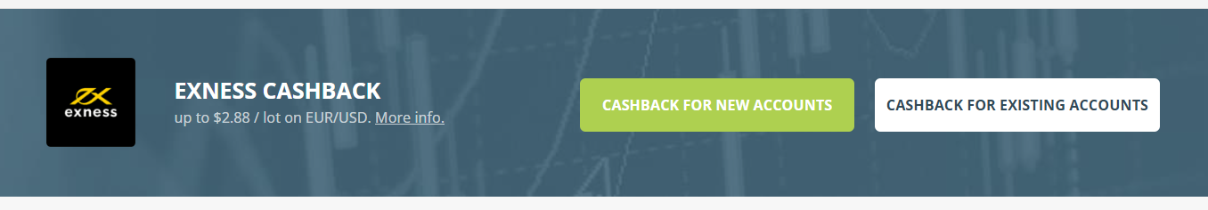
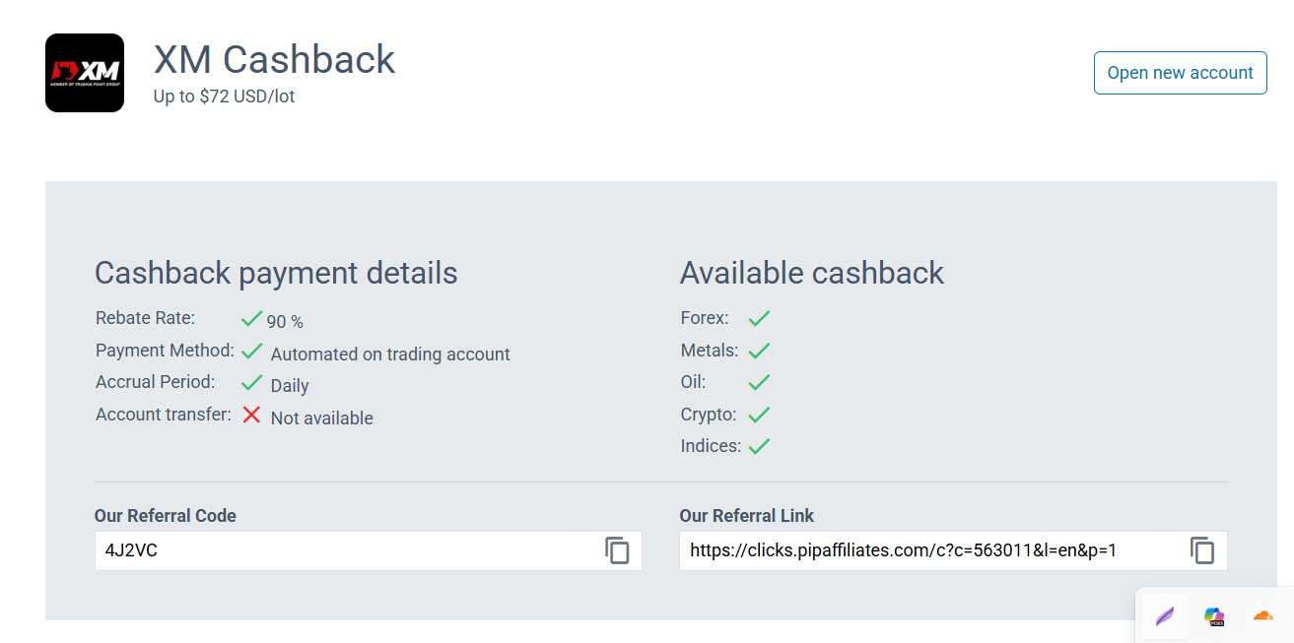

2. REBATE RATES TABLE – Core Value Proposition
A clean, highly scannable grid showing cashback rates broken down by Account Type and Trading Instruments:
Account Type | FX (Currencies) | Metals (Gold/Silver) | Crypto | Indices
Standard (Commission-Free) | $8 / lot | $17 / lot | $0.8 / lot | $2 / lot
Raw Spread / ECN | $2.5 / lot | $5 / lot | $1.7 / lot | $1.7 / lot
Micro / Cent | 13¢ / lot | 17¢ / lot | N/A | N/A

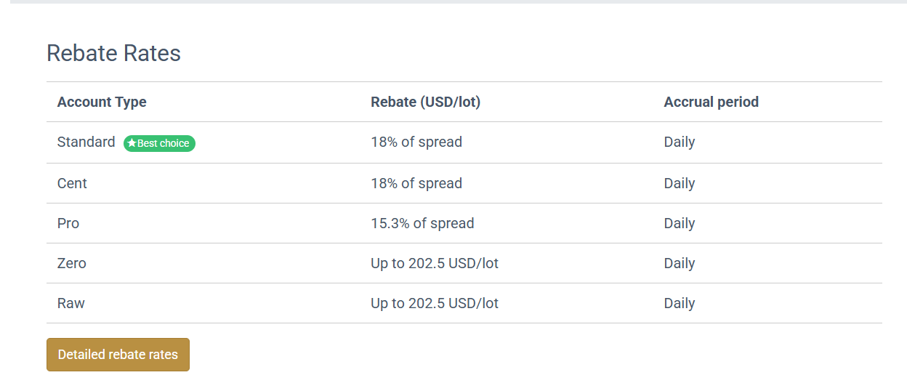

3. REBATE DETAILS & CONDITIONS – Transparency & Rules

4. INTERACTIVE REBATE CALCULATOR – Engagement Tool
- User Input Sliders: * [Daily Trading Volume (Lots)]
  - [Trading Days Per Month]
- Real-time Dynamic Output Display:
  - Extra Monthly Earnings: $367.50
  - Extra Yearly Earnings: $4,410.00
- Designer Note: Make the potential earnings look big, bold, and highly rewarding to boost registrations.

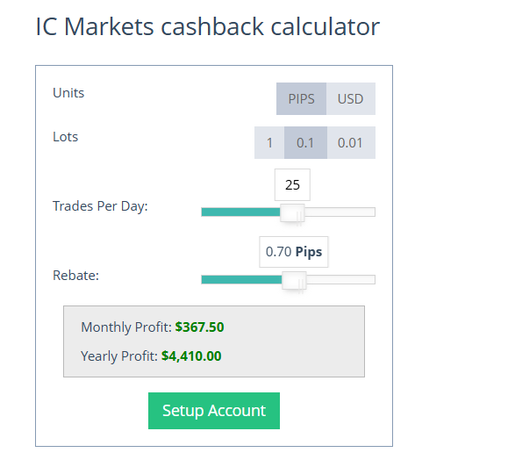
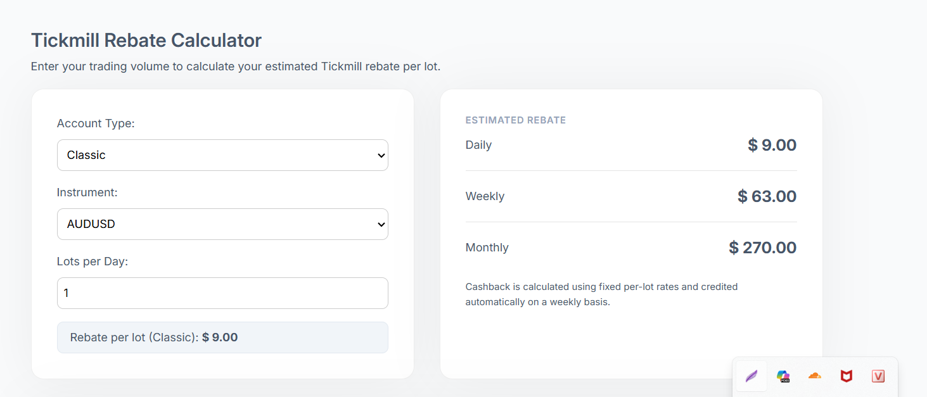
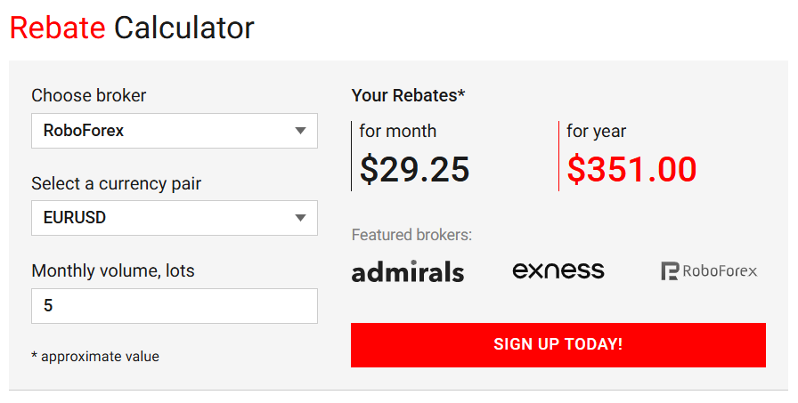

5. BROKER GENERAL INFO & TRADING CONDITIONS – Trust Building
- Regulatory & Safety: Company Name, Founded Year, Headquarters, and Licenses/Regulators (e.g., ASIC, CySEC, FSA).
- Trading Environment Details:
  - Minimum Deposit (e.g., $5 USD).
  - Maximum Leverage (e.g., 1:1000).
  - Trading Platforms (MT4, MT5, cTrader).
  - Allowed Strategies: EA allowed, Scalping allowed, Hedging allowed, Swap-free accounts.
- Deposit/Withdrawal Methods: Icons of supported gateways (Local Internet Banking, Visa/Mastercard, Skrill, Neteller, USDT).
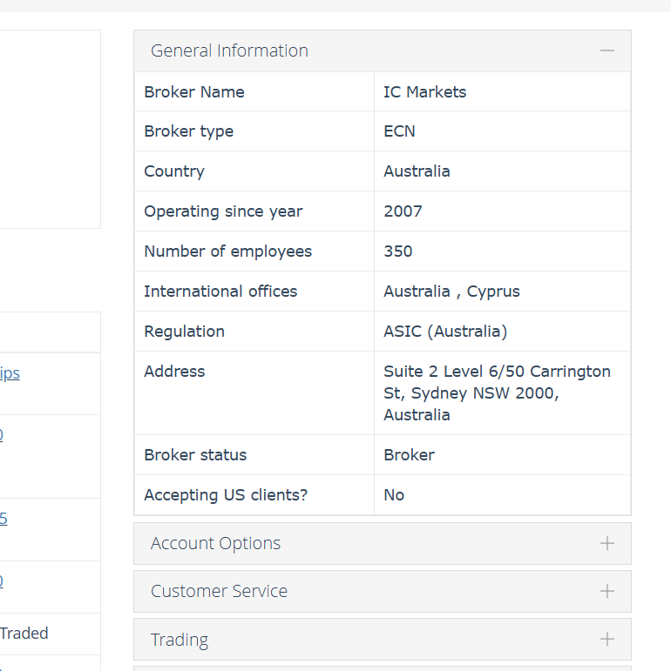

6. "HOW IT WORKS" SECTION – 3 Simple Steps (Onboarding UX)
Use simple step-by-step layouts with clean custom icons or a short video:
- Step 1: Click our referral link to open a new account (or submit an IB transfer request for your existing account).
- Step 2: Add your Trading Account ID into your Personal Dashboard on our website for verification.
- Step 3: Trade as usual and watch your automated cashbacks roll into your account daily/weekly.

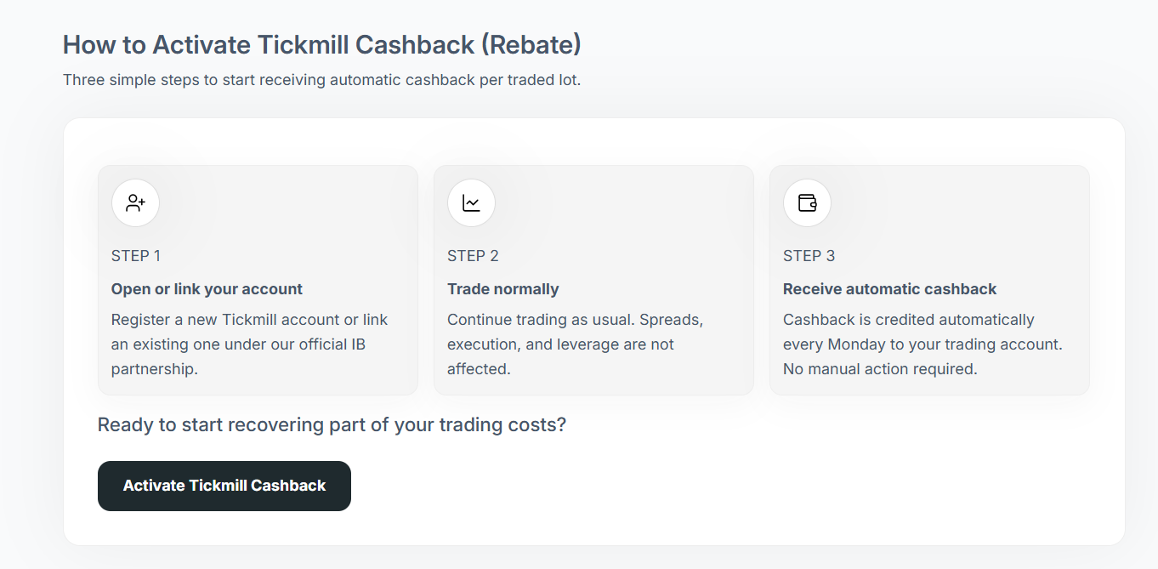

7. FAQ & SUPPORT – Overcoming Objections
- Q1: Does using a cashback service increase my Spreads or Commissions?
  - Answer: Absolutely not. Your trading conditions remain 100% identical to opening directly with the broker. We simply share a piece of the commission the broker pays us back with you.
- Q2: Can I link my existing broker account?
  - Answer: Yes, depending on the broker's policy (Specify which brokers allow IB transfer and which require a new account).
- Sticky Support Widget: Place a sticky Floating Action Button (FAB) for Live Chat, Telegram, or Zalo in the bottom corner labeled: "Need help linking your account? Let us do it for you!"

