







BRAND GUIDELINES 2026


TWOFOLD THC SPIRITS

LOGO
2026

3

COLORS
17

PAGE 2

11

TYPOGRAPHY

SOCIAL
13 PHOTOGRAPHY

19 CONTACT

Content
21

TWOFOLD THC SPIRITS
2026
PAGE 3

Logo

LOGO

Primary Logo
The Twofold logotype consists of a wordmark.

It is our primary logo—a major representation of our brand. It has a vital role in establishing brand awareness therefore should be used in all our communications in proper, approved forms.

TWOFOLD
2026

PAGE 4

DOWNLOAD LOGO FILES

LOGO

Secondary Logo

TWOFOLD
2026

PAGE 5







Our secondary logo is provided to be used internally or in instances where the primary logo is not needed.

DOWNLOAD LOGO FILES





LOGO

Light Option
A light option of the logo
is used when applied on dark backgrounds and images.

TWOFOLD
2026

PRIMARY

SECONDARY
PAGE 6

LOGO

Icon

TWOFOLD
2026

PAGE 7

For optimal use in smaller spaces, an icon is provided. By using the Twofold flower, we maximaize our space and remove any issues relating
to legibility.















LOGO

Exclusion Zone

TWOFOLD
2026

PAGE 8

To ensure the logo maintains a high level of visibility it is important that is surrounded by a minimum amount of clear space. No other graphic elements should encroach within this area. The exclusion zone is equal to the height of the ‘t’ in Twofold. It creates a boundary around the logo.

To preserve the readability of the logo it should never be sized below certain dimensions. The minimum length is 22 mm when used in print and a length of 62 px in digital environments.

22 mm / 62 px

LOGO

Incorrect Usage

TWOFOLD
2026

PAGE 9

The logo must always be reproduced in its original state and according to the guidelines. These examples illustrate modifications that must be avoided.
twofold


Do not alter the color of the logo Do not change the font of the logo Do not stretch, rotate or skew the logo






Do not use the logo as an outline
Do not add any effects on the logo
Do not combine with other elements

LOGO

Social Icon

TWOFOLD
2026

PAGE 10








For optimal use on social channels, a profile icon version of the logo is provided.
twofold
54 834 162
Posts Followers Following
Twofold THC Spirits Raise Your Bar twofoldspirits.com
Edit Profile
New
Mental Efficiency Tracker

By using our icon, we maximize
our space and take away any issues relating to legibility. The clearspace is adjusted to secure maximize impact.






TWOFOLD THC SPIRITS
2026
PAGE 11

Colors

COLOR

Palette
Twofold’s palette starts on the bottle. The gradients on the packaging design translate the feeling Twofold gives you, the lift, the warmth, the easy shift. Each SKU color is pulled from a specific point in that gradient, so the spirit you pour and the color you see come from the same source.
Agave
CMYK RGB
HEX
13 / 42 / 100 / 0
210 / 157 / 66 #D29D42
CMYK RGB
HEX
13 / 29 / 55 / 0
214 / 181 / 135 #D6B587

Use the primary palette for brand-level work. Layer in SKU colors for product-specific creative. Combinations outside this system pull the brand apart, so check approved pairings before going off-script.

TWOFOLD
2026

PAGE 12

Whiskey
CMYK RGB
HEX
28 / 74 / 100 / 21
144 / 83 / 45 #90532D
CMYK
RGB HEX
15 / 70 / 100 / 3
191 / 108 / 56 #BF6C38
Gin
CMYK RGB
HEX
77 / 48 / 93 / 57
42 / 62 / 32 #2A3E20
CMYK RGB
HEX
54 / 33 / 68 / 10
125 / 136 / 103 #7D8867

CMYK 72 / 67 / 65 / 79
Apertif
CMYK RGB
HEX
1 / 83 / 99 / 0
221 / 93 / 53 #DD5D35
CMYK
RGB HEX
5 / 32 / 51 / 0
229 / 182 / 139 #E5B68B
Rum
CMYK RGB
HEX
29 / 90 / 100 / 31
126 / 51 / 34 #7E3322
CMYK
RGB HEX
17 / 84 / 100 / 6
180 / 82 / 51 #B45233
Vodka
CMYK RGB
HEX
100 / 93 / 24 / 10
42 / 53 / 114 #2A3572
CMYK RGB
HEX
65 / 39 / 12 / 0
107 / 137 / 178 #6B89B2
Black
White
RGB 25 / 24 / 24
HEX #191818
CMYK 0 / 0 / 0 / 0
RGB 255 / 255 / 255
HEX #FFFFFF

TWOFOLD THC SPIRITS
2026
PAGE 13

Typography

TYPOGRAPHY

Brand Typeface 01

TWOFOLD
2026

PAGE 14

Our brand typeface is Freight Micro Pro Regular. It’s a strong and unique serif font, making it perfect for all applications.

All headlines should be written in Sentence Case with a tracking of 0pt.

All subheadlines should be written in all caps with a tracking of 60pt.

AaBbCc123 Freight Micro Pro

Freight Micro Pro

ABCDEFGHIJKLMNOPQRSTUVWXYZ ÁÂÄÀÅÆÉÊËÈÍÎÏÌÓÔÖÒØEÚÛÜÙUŸ
abcdefghijklmnopqrstuvwxyz
:;...!?*#\ (){}[]-_"'$+=%@&| 1234567890

TWOFOLD
2026
PAGE 15

TYPOGRAPHY

Brand Typeface 02
Our secondary brand typeface is PP Mori and should be used for all body copy and smaller text.

All body copy or smaller should be written in sentence case with a tracking of 0pt.

Although PP Mori is available in a variety of weights and styles, in order to maintain brand consistency we suggesting using PP Mori in the way we have assembled it.

AaBbCc123 PP Mori

PP Mori

ABCDEFGHIJKLMNOPQRSTUVWXYZ ÁÂÄÀÅÆÉÊËÈÍÎÏÌÓÔÖÒØEÚÛÜÙUŸ
abcdefghijklmnopqrstuvwxyz
:;...!?*#\ (){}[]-_"'$+=%@&| 1234567890

TWOFOLD
2026
PAGE 16

TYPOGRAPHY

Usage
Freight Micro Pro Regular in Title Case is intended for headlines.

Freight Micro Pro Regular in all caps is used for subheadlines.

PP Mori Regular is used for all areas of body copy and smaller text.

Headline Example

Subheadline Example

Body Copy Example

Lorem Ipsum Dolor Sit Amet
LOREM IPSUM DOLOR SIT A MET

Lorem ipsum dolor sit amet etri te factu simmovica; nostion inam prituribus hi, confec tus ia resinequa co converum ubli straed inam tantis intissum forur iam consulviris Mullegerei senam viribus ego pors confirimus post vere intis nos.

TWOFOLD THC SPIRITS
2026
PAGE 17

Photography

PHOTOGRAPHY

Creative Direction

TWOFOLD
2026

PAGE 18

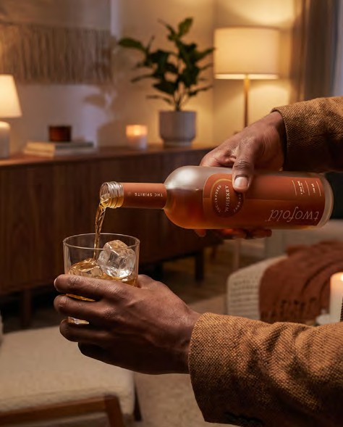
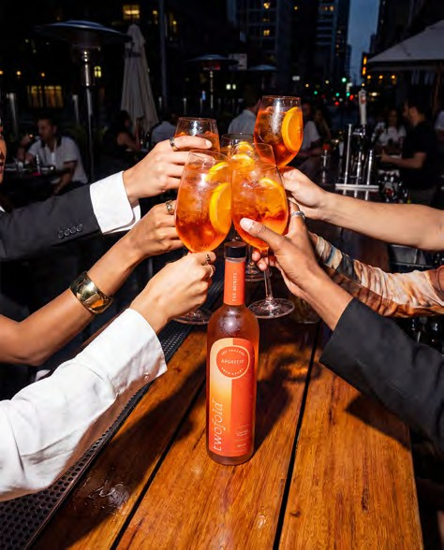
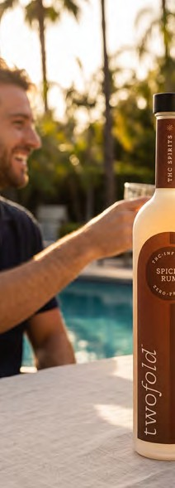
Twofold belongs in the rooms where cocktails are made.
Hospitality settings, bar tops, kitchen counters, golden-hour rooftops. The mood is intentional, never staged. Light should feel warm and lived-in, not commercial. The bottle is always the hero, but the room around it tells the story.

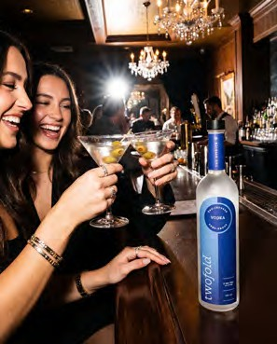
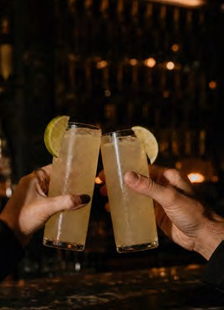
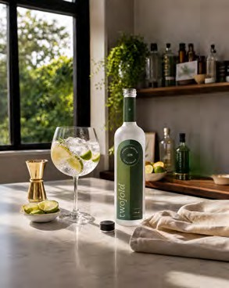
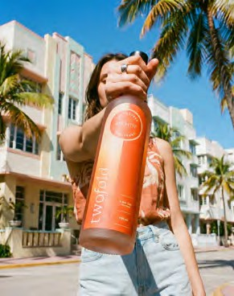
Avoid stock-feeling product shots, harsh studio lighting, and anything that reads as a mocktail.

TWOFOLD THC SPIRITS
2026
PAGE 19

Social

SOCIAL

Digital Examples

TWOFOLD
2026

PAGE 20

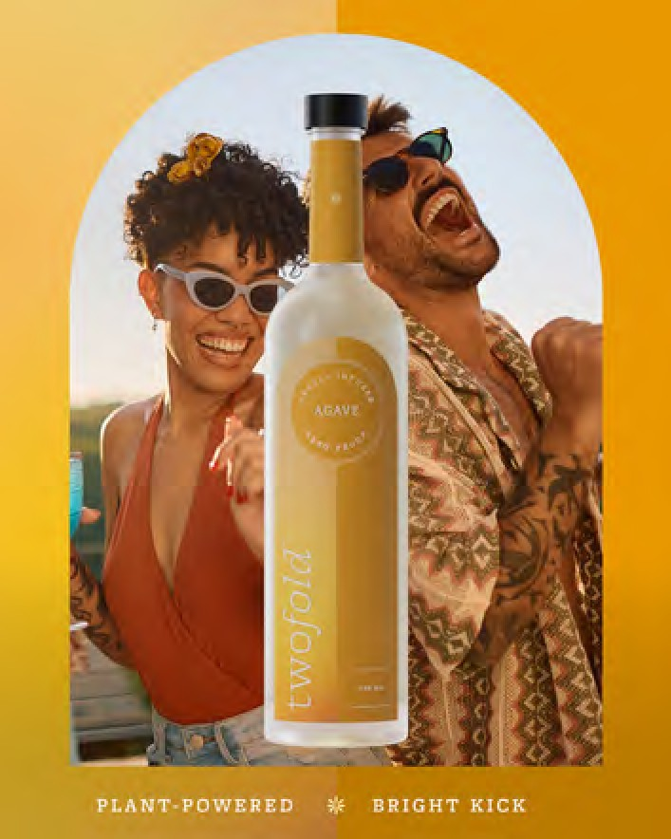
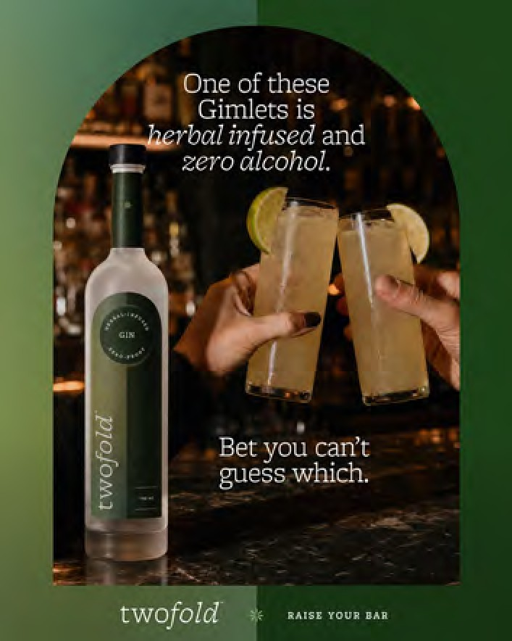
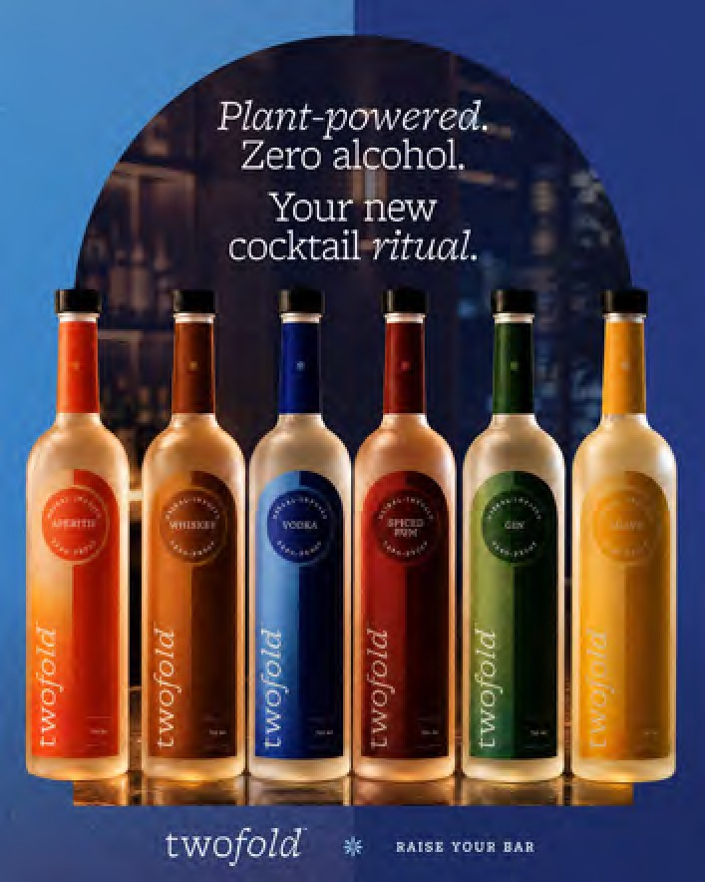
Social is where Twofold meets people in the moment.

Posts should feel native to the feed, not transplanted from a billboard. The arched window is the visual anchor to the packaging design.

Story styling can lean more casual than feed posts, with room for creator content and behind-the-scenes moments.

TWOFOLD

Contact
2026

PAGE 21

If you have any questions, comments
or suggestions regarding our brand guidelines, please contact: arsnlmedia.com

Built by ARSNL Media

