

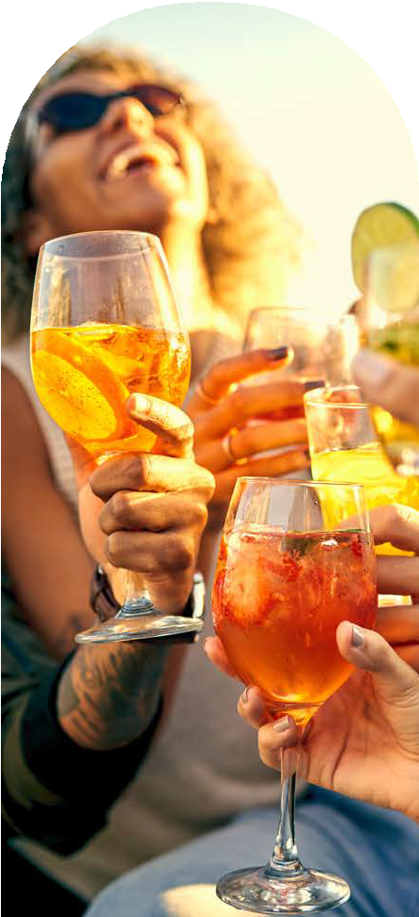
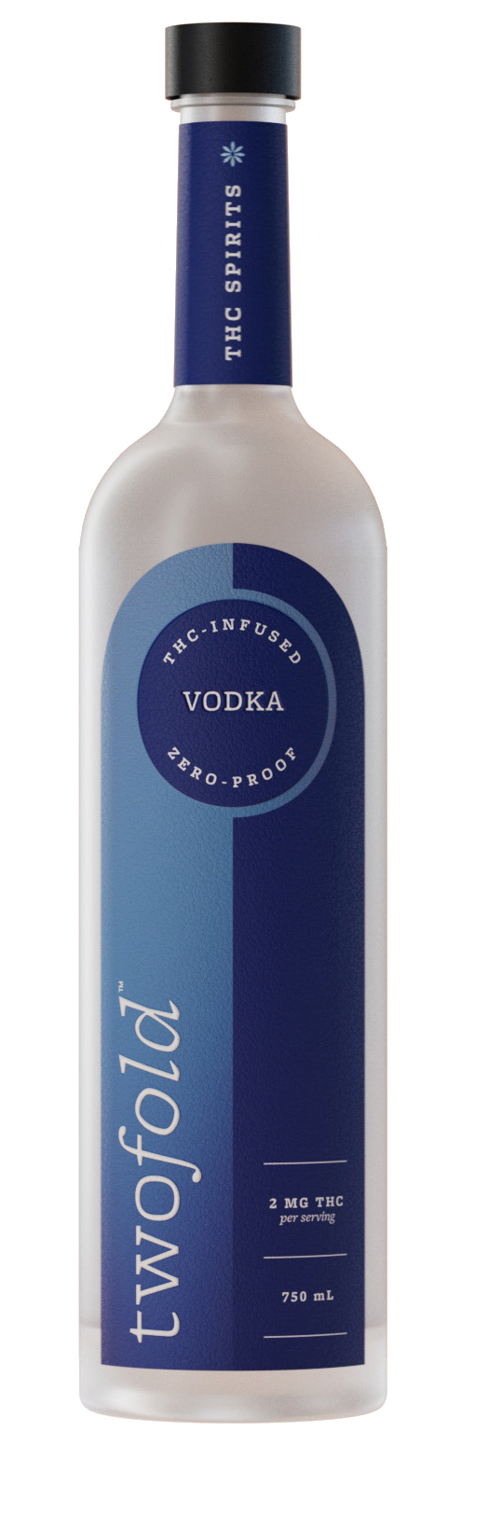
THC

BARTENDER EXPERIENCE
SPIRITS
Vodka,
T
W
O
F
O
L
D
S
P
I
R
I
T
S
.
Reimagined
C
O
M

LOW -DOSE THC SPIRIT FOR COCKT AIL PROGRAMS
A non-alcoholic, hemp-derived THC spirit designed for cocktails and sessionable social drinking.
750 mL bottle
2 mg THC per 1.5 oz serve
17 servings per bottle
Built for highballs and classic cocktails

PRODUCT OVERVIEW
Twofold™ Vodka is a hemp-derived THC spirit designed specifically for hospitality.
Pour-for-pour replacement for vodka
Standard 1.5 oz cocktail format
Integrates into existing cocktail menus
Designed for sessionable social drinking


FLAVOR PROFILE
Neutral and clean with a smooth finish
Designed to carry mixers and highlight cocktail ingredients

No recipe changes required
Standard cocktail format
Familiar guest experience
FORMA T
750 mL frosted glass bottle 17 servings per bottle
SERVING SIZE
1.5 oz (44 mL)
Equivalent to a standard vodka pour (by volume)
THC CONTENT
2 mg hemp-derived THC per serving
34 mg THC per bottle
NON- ALCOHOLIC
Zero-proof (0.0%) ABV

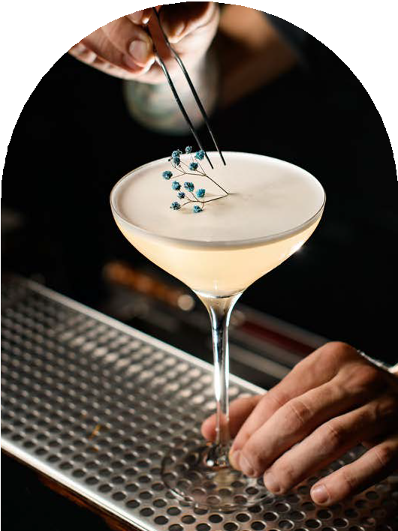
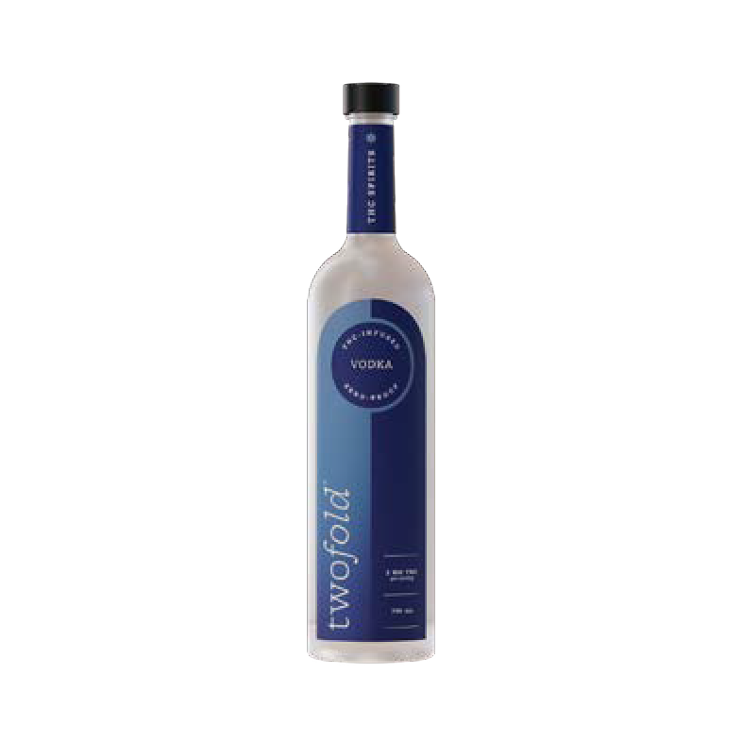
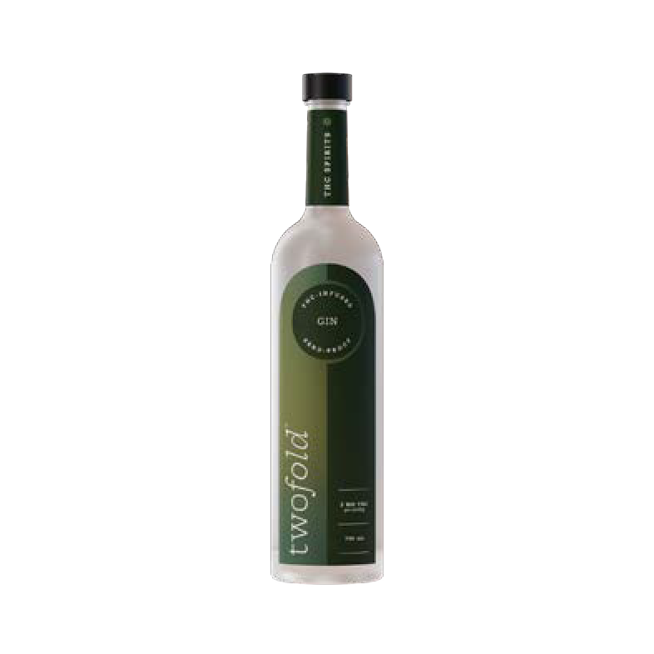
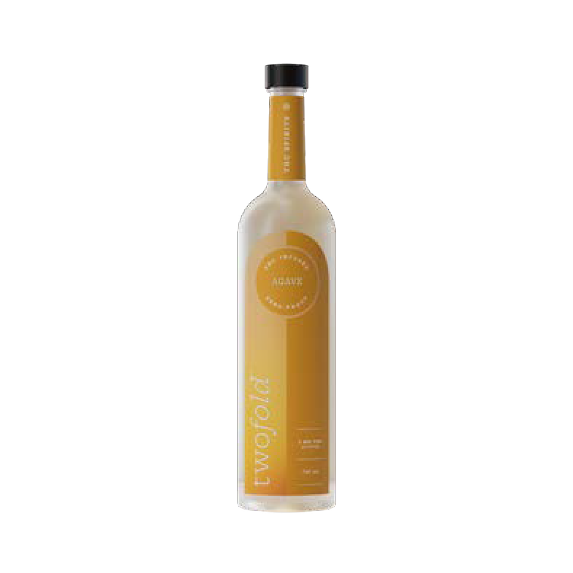
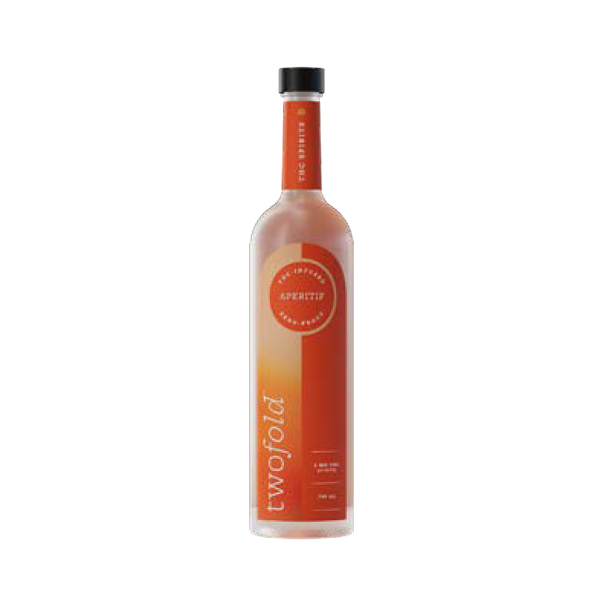
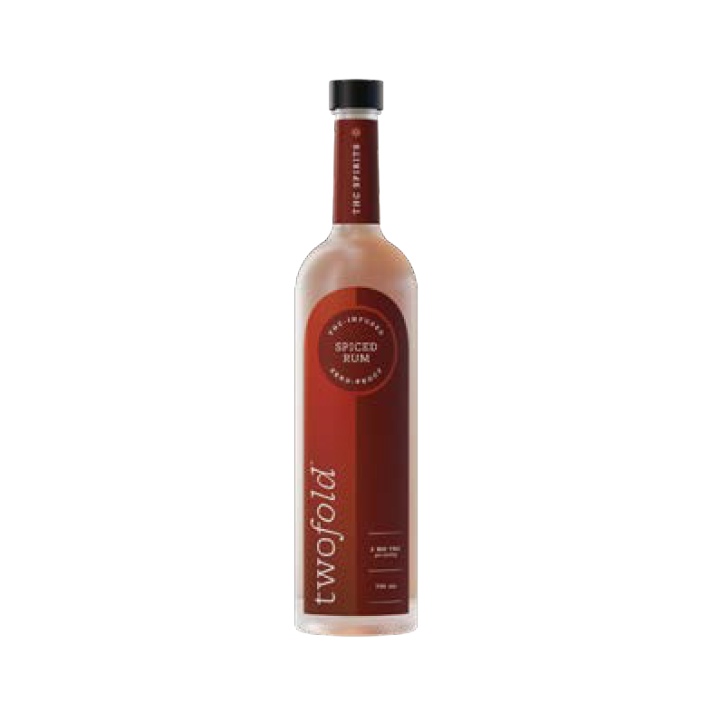
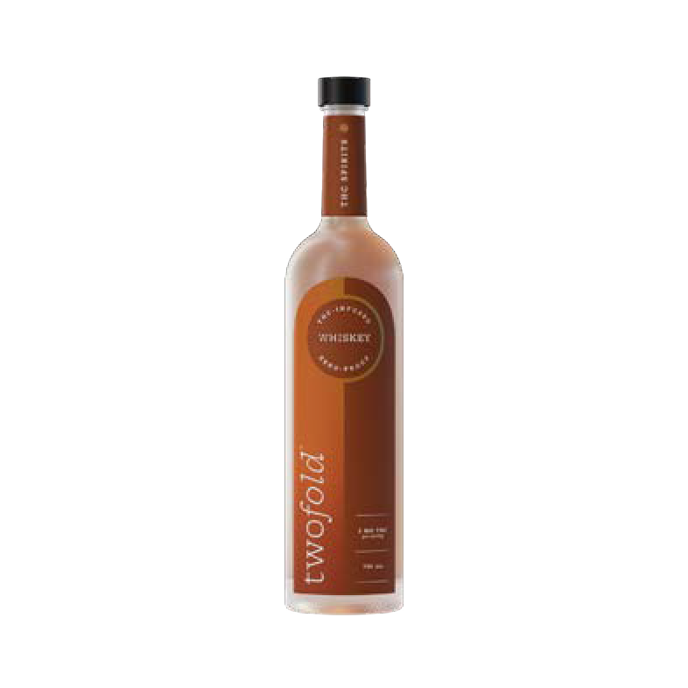
THC
SPIRITS

MENU INTEGRA TION - 1:1 VODKA REPLACEMENT
Twofold™ Vodka is designed to integrate seamlessly into existing cocktail programs.
A simple substitution for traditional spirits, use anywhere vodka is currently served in your existing menu, including:

Moscow Mule Vodka Soda Espresso Martini Cocktail or Highball

NEW REVENUE OPPORTUNIT Y
Twofold™ Vodka delivers high-margin and incremental revenue from occasions where alcohol is not being consumed — without disrupting existing sales.
T
W
O

COST
F
O
L
D
$44.83 per bottle
S
P
I
R
$269 per case (6 x bottles)
I
T
S
.
C

T YPICAL PRICING
O
M
$15–$22 per cocktail / highball
17 servings per bottle = $255–$374

GROSS PROFIT
$210-$329 per bottle
$1,260-$1,974 per case

MARGIN
82%-88%

EDUCA TIONAL RESOURCES
Scan for cocktail recipes, staff training tools, and usage guidance.

SALES INQUIRIES
For further information, please contact your local Twofold™ representative.
Name: Phone:
Email: sales@twofoldspirits.com
Part of the Twofold™
collection.
A spirits-led THC collection designed to live where spirits already live.
VODKA · GIN · AGAVE · APERITIF SPICED RUM · WHISKEY

21+ only. Federally compliant hemp-derived THC. Not intended for pregnant or breastfeeding individuals. Responsible service recommended.

