Avantgarde Technologies
Slogan “Specialised Consulting”
Avantgarde Technologies is a Technology Consulting Company based in Perth, Western Australia, which offers customers tailored technical solutions for a range of products.
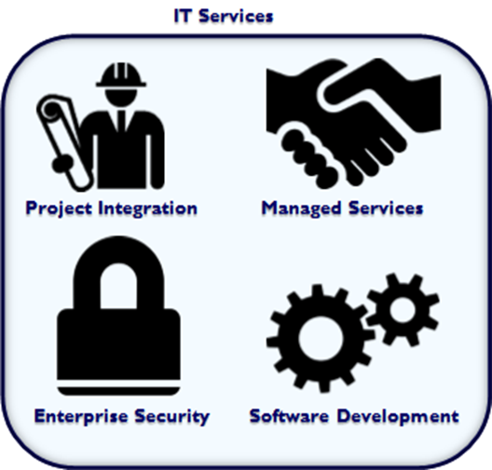
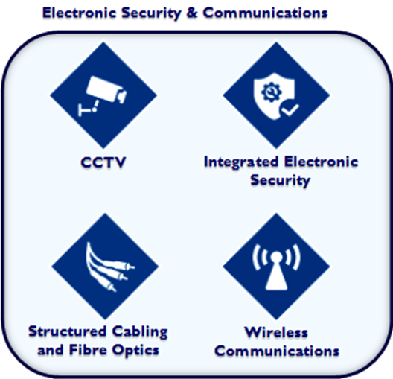
Update the below services overview with something better looking.

Put on the brochure:
“Do it Once, Do it Right”
This can be at the footer, as a backdrop, somewhere large and fancy down the side, middle of the document... Let the designer come up with something.

Our Commitment
Our commitment to you is to do things right the first time while being fair but cost-effective. If you’re looking for the cheapest consultants, Avantgarde may not be the right fit for you.
We are a specialised consultancy firm that offers tailored solutions to government and the enterprise sector with some of Perth's best consultants.
In areas such as cybersecurity and business continuity, it pays to get it done correctly the first time in alignment with vendor best practices. There are many ways of doing things in the technology field, and only after understanding all methods of achieving an outcome can you recommend the best solution in alignment with best practices.

Our Policy
Be Fair
“At Avantgarde we believe that both parties benefit when pricing is fair. If margins are too low, we may sacrifice service quality, and this ultimately harms our brand. If margins are too high, our customers have an incentive to seek alternative providers, and this compromises our growth and damages client relationships.”
Be Cost-Effective
“At Avantgarde we believe that it is possible to deliver both high quality at a fair cost, by providing services that are intelligent and efficient.”

All goods and services provided by Avantgarde are provided in accordance with our Standard Terms and Conditions available at https://www.avantgardetechnologies.com.au/t&c

