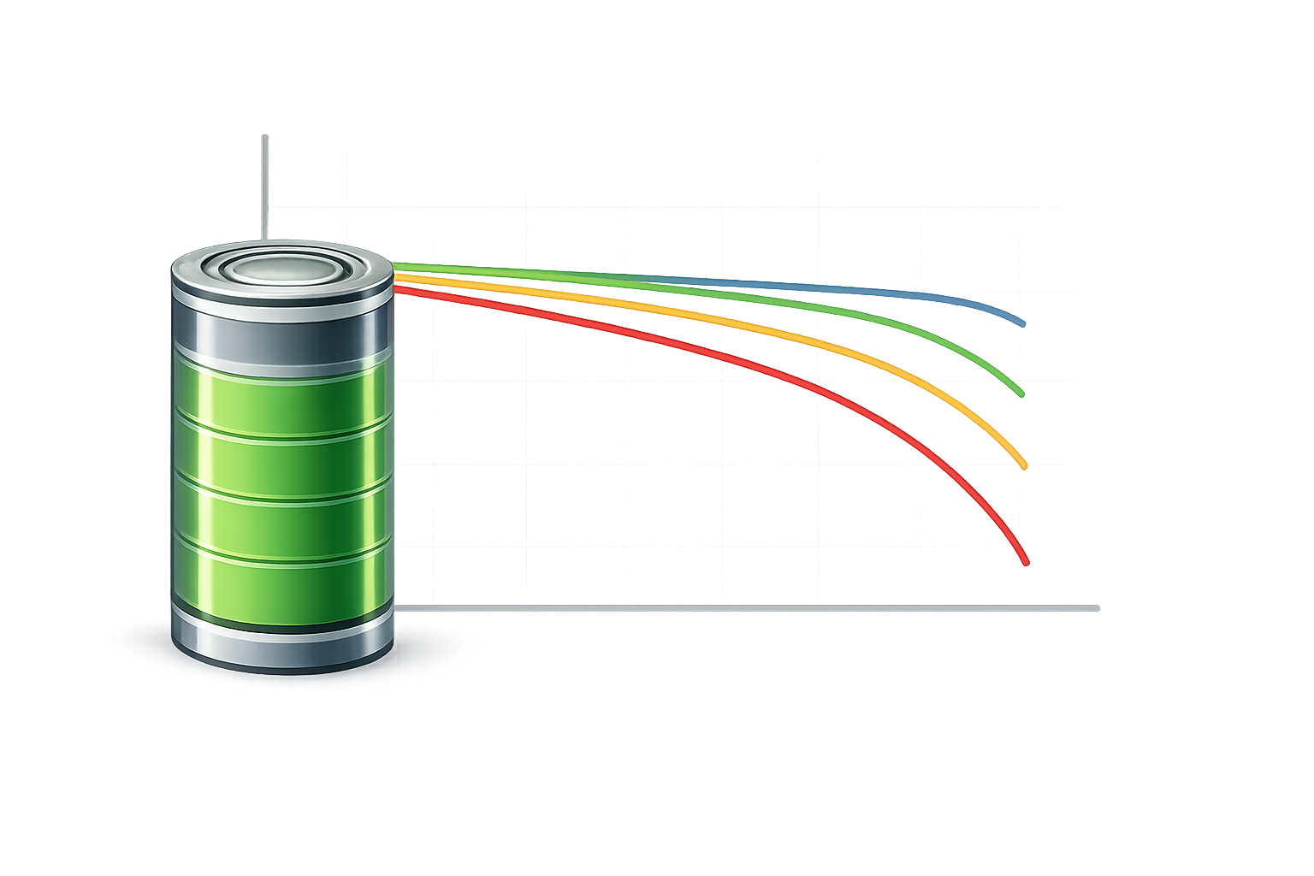  Icon: battery+graph | Battery Modeling. We develop practical battery models and characterization methods that support accurate, efficient, and deployable battery management.
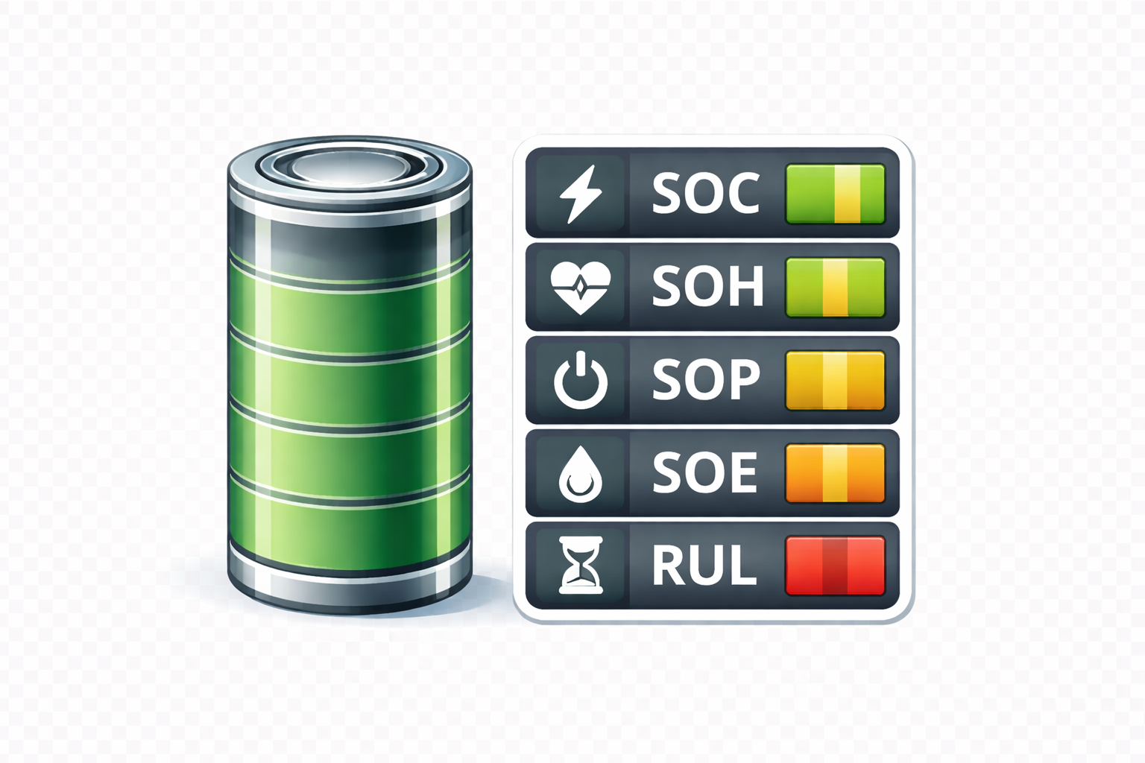  Icon: battery+SOX indicators | Fuel Gauging. We estimate key battery states, including SOC, SOH, SOP, SOE, TTC, TTE, and RUL, under uncertainty and real-world operating conditions.
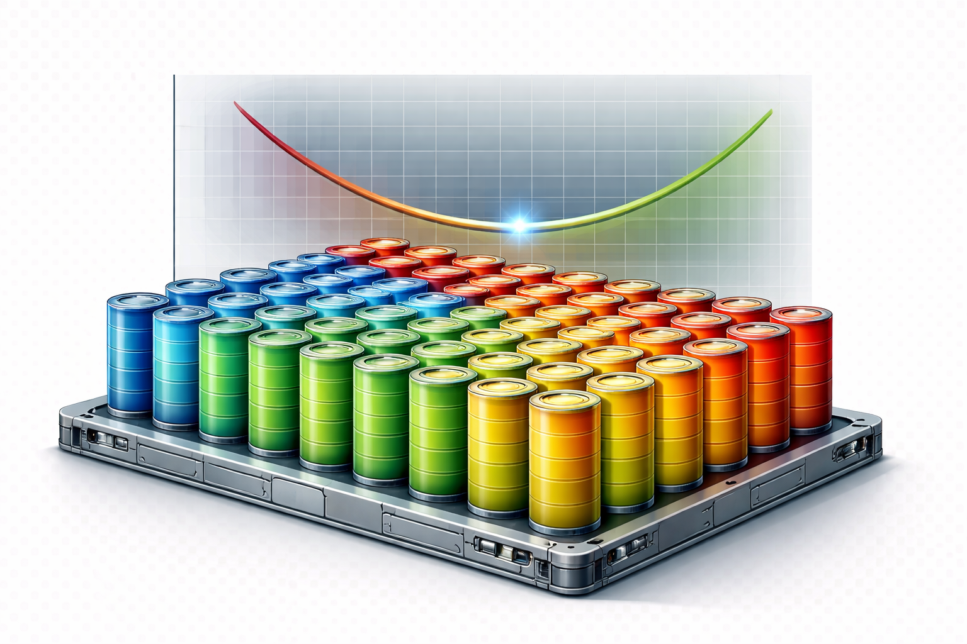  Icon: battery+multimodal grap showing start at optimal point | Pack Optimization. We develop tools for battery pack sizing, thermal design, and mission-aware optimization to meet performance, safety, and cost requirements.
  Icon: battery+heart | Health Diagnostics. We develop diagnostic and prognostic methods to detect degradation, identify faults early, and predict remaining useful life.
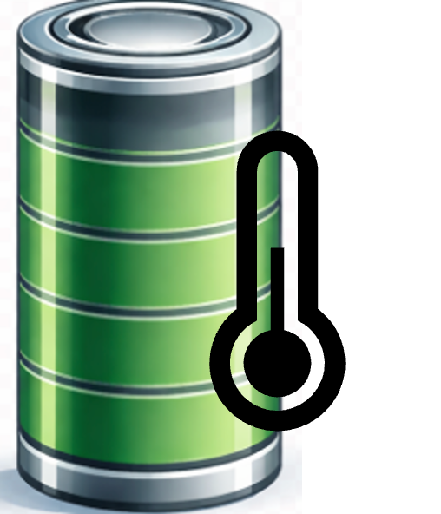  Icon: battery+thermometer | Thermal Management. We model and control battery thermal behavior to improve safety, performance, and reliability under dynamic operating conditions.
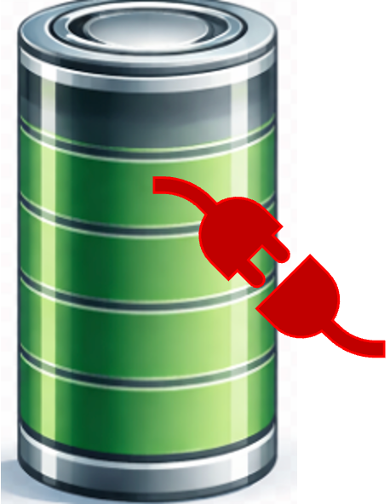  Icon: battery+ plug sign | Smart Charging. We develop intelligent charging strategies that balance charging speed, efficiency, safety, and long-term battery health.
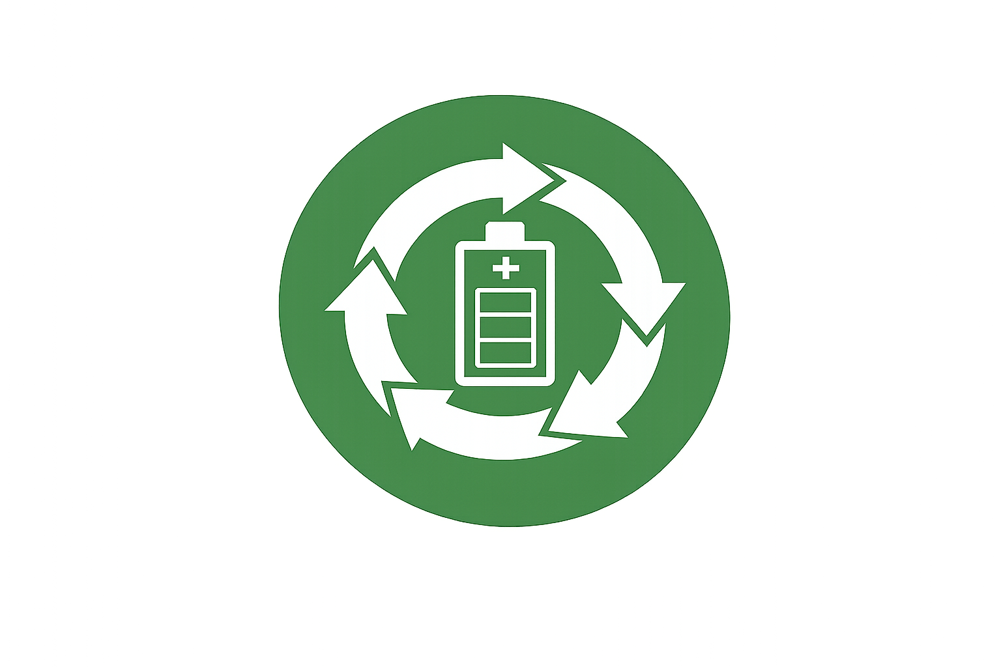  Icon: battery+ circular arrows | Circular Economy. We develop methods to assess, sort, refurbish, and repurpose retired batteries for safe, reliable, and cost-effective reuse.
Icon: battery pack+ test tube | Battery Testing. We design and use experimental platforms to characterize, validate, and evaluate battery cells, modules, and packs under realistic conditions.
Icon: circuit with BMS sign+ scale | BMS Validation. We develop validation and benchmarking methods to evaluate the accuracy, reliability, and robustness of battery management systems.

