MARUNOR
This brand competes will compete with ALO, LULULEMON but Affordable luxury brand
Our products mainly: Unisex Tees, sweatpants, Hoodie, Caps
Real Key pictures from google
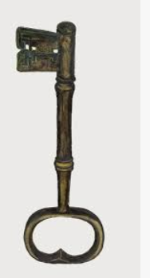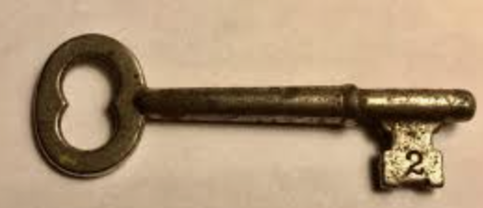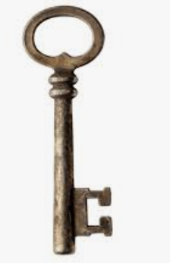

Recommendation from my coach:
- Clean, simple sans-serif wordmark or similar, Simplified key icon that works as a standalone symbol. the key needs to become iconic. One silhouette that reads at 5mm embroidery AND on a billboard. That's the test.
- Possibly a monogram M that doubles as the key head for hats, zippers, hem tabs.
The key should be THE logo.

Styles
I like the zipper for and wish to have my logo as nice as this brand manieredevoir
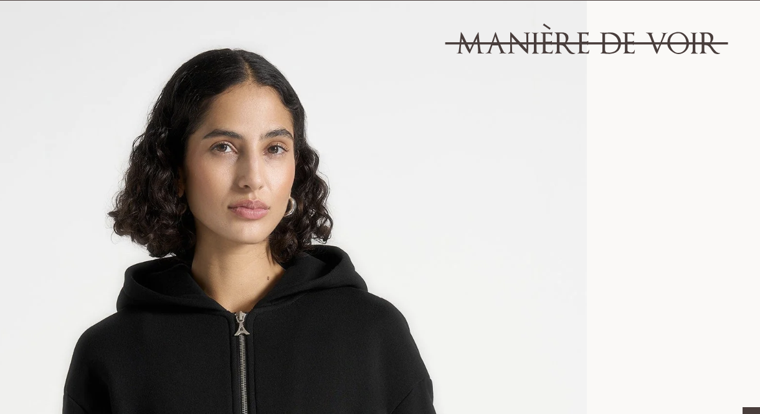
LULULEMON:
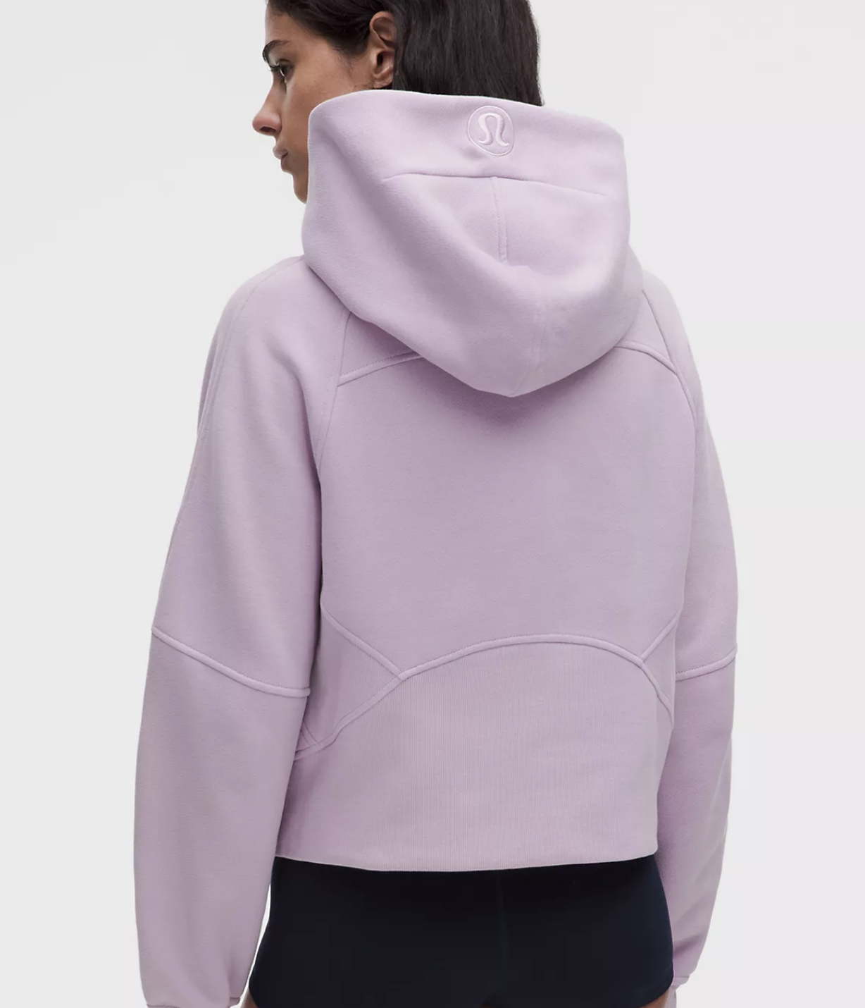
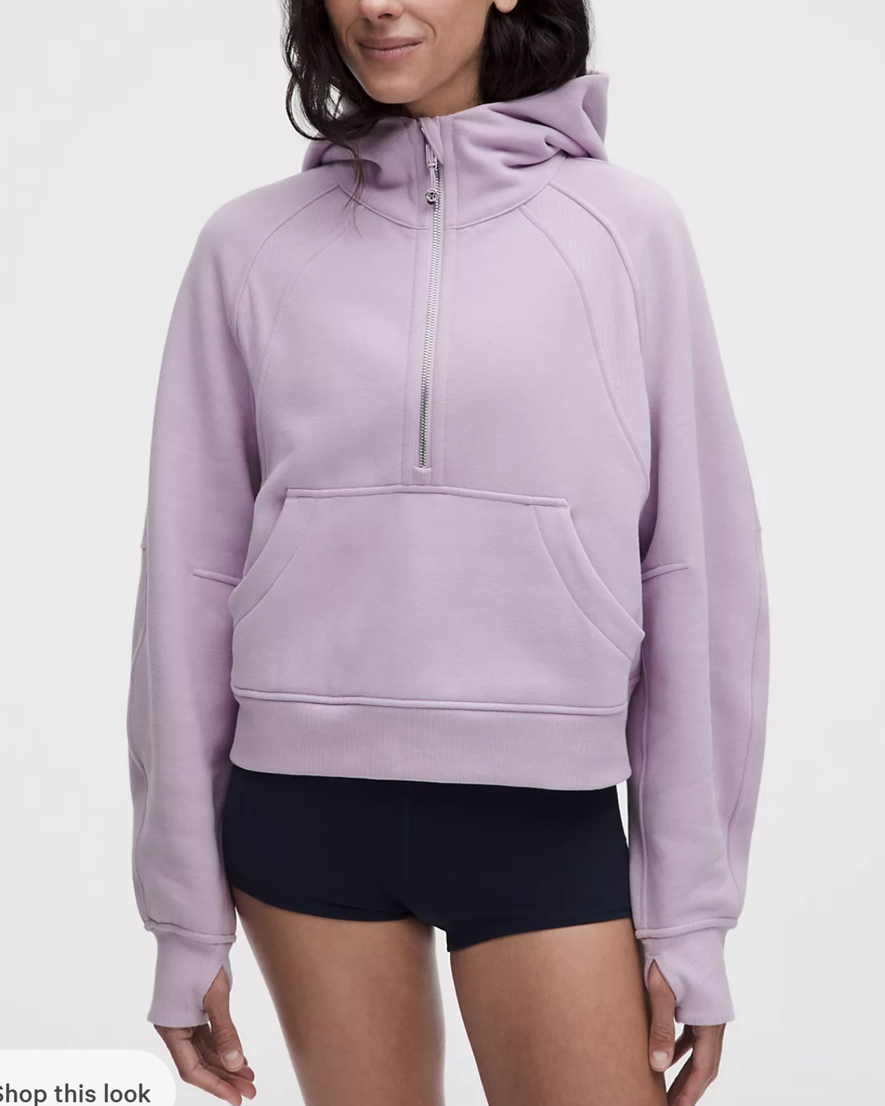

ALO
