LUNCH SPECIALS
2 Slices of Pizza & 20 oz Drink  Choose your drink. Add a slice topping if you'd like. | $8.99
Slice of Pizza & Small Salad & 20 oz Drink  Choice of dressing and drink. | $9.99
Slice of Pizza & 6 Wings & 20 oz Drink  Choose wing sauce and your drink. | $12.99
Any Philly Cheesesteak & 20 oz Drink  Choose your drink. Philly add-ons available. | $10.99
DAILY SPECIALS
Medium Cheese Pizza & 10 Wings  Choose wing style and sauce. | $29.95
Large 16" Cheese Pizza & 20 Wings  Choose wing style and sauce, then add pizza toppings if you'd like. | $39.95
2 Large 16" Pizzas  Add toppings to either pie. | $30.99
18" Cheese Pizza, 24 Wings & 2 Liter Soda  Choose wing style, sauce, soda, and pizza toppings. | $45.99
CALZONES
Traditional Calzone  Mozzarella & Ricotta Cheese | $11.99
NY Supreme Calzone  Pepperoni, Sausage, Mushrooms, Onions, Green Peppers, Mozzarella, & Ricotta Cheese | $14.99
Veggie Calzone  Black Olives, Mushrooms, Onions, Green Peppers, Mozzarella, & Ricotta Cheese | $12.99
Meat Lovers Calzone  Sausage, Pepperoni, Ham, Bacon, Mozzarella, & Ricotta Cheese.  Extra calzone toppings:  $.75 each: Anchovies • Banana Peppers • Black Olives • Green Olives • Extra Cheese • Extra Sauce • Garlic • Green Peppers • Ham • Jalapeños • Meatballs • Mushrooms • Onions • Pepperoni • Pineapple • Salami • Sausage • Spinach • Tomatoes • Bacon • Broccoli  $1.00 each: Artichokes • Bacon • Chicken • Eggplant • Green Olives • Meatball • Ricotta  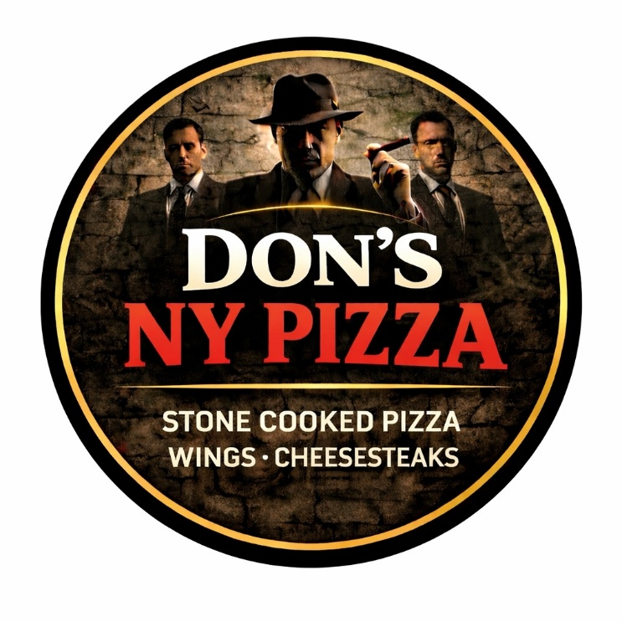 | $14.99

DON'S NY PIZZA
STONE COOKED PIZZA
WINGS • CHEESESTEAKS • CALZONES
★ OWNER'S FAVORITE
The Don's Chicken & Jalapeño
Built for The Don himself.

DRINKS
20 oz Soda  Dr Pepper, Pepsi, Starry, Orange Soda, Diet Pepsi | $1.99
2 Liter Soda  Dr Pepper, Pepsi, Starry, Orange Soda, Diet Pepsi | $2.99

DESSERTS
Cheesecake | $4.99
Tiramisu | $5.50
Cannoli | $4.99

PIZZA ROLLS
Cheese Pizza Roll | $11.49
Pepperoni Pizza Roll  Pepperoni & Cheese | $12.99
Meat Lovers Pizza Roll  Pepperoni, Sausage, Ham, Bacon, & Cheese | $13.99
Veggie Pizza Roll  Mushrooms, Green Peppers, Onions, Black Olives, & Cheese | $13.99
Supreme Pizza Roll  Pepperoni, Sausage, Mushroom, Green Peppers, Onions, & Cheese | $13.99
Buffalo Chicken Pizza Roll  Buffalo Chicken & Cheese | $13.99
Chicken, Bacon, Jalapeños & Ranch Pizza Roll  It is what it says, Plus Cheese | $13.99

SALADS
Garden Salad  Lettuce, Tomatoes, Cucumbers, Olives, Onions, & Pepperoncini | S $4.99  M $5.99  L $8.99
Antipasto  Ham, Salami, Lettuce, Tomatoes, Cucumbers, Olives, Onions, & Pepperoncini. Topped with Mozzarella Cheese. | S $6.99  M $8.99  L $11.99
Bruiser Chicken Salad  Chicken, Parmesan Cheese, Lettuce, Tomatoes, Cucumbers, Olives, Onions, & Pepperoncini | S $6.99  M $8.99  L $11.99
Caesar Salad  Romaine Lettuce, Parmesan Cheese, Croutons - Tossed in Caesar Dressing | S $5.49  M $6.99  L $9.99
Chicken Caesar Salad  Chicken, Romaine Lettuce, Parmesan Cheese, Croutons - Tossed in Caesar Dressing | S $6.99  M $8.99  L $11.99
Dressings: Ranch, Italian, Caesar, Blue Cheese, Balsamic, & Vinaigrette.

APPETIZERS & SIDES
Mozzarella Sticks 6 Piece | $7.99
Mozzarella Sticks 12 Piece | $16.99
4 Piece Chicken Fingers Basket w/Fries | $12.49
Fried Zucchini 12 Piece | $9.99
Fried Zucchini 20 Piece | $12.99
Fried Mushrooms 12 Piece | $9.99
Fried Mushrooms 20 Piece | $16.99
6 Piece Cheese Pizza Log | $11.49
6 Piece Pepperoni & Cheese Log | $12.49
Garlic Knots 6 Piece | $6.99
Garlic Knots 12 Piece | $10.99
Garlic Knots 20 Piece | $16.99
Garlic Bread | $4.75
Garlic Bread w/Mozzarella | $5.25
Garlic Bread w/Mozzarella | $5.25
FRIES
French Fries | $4.75
Queso Fries  They are what you think they are, fries smothered in Queso Cheese. | $5.99
Famous Philly Cheesesteak Fries  French Fries Smothered W/Queso Cheese & Philly Steak Meat | $13.49
Chicken Philly Cheese Fries  French Fries Covered W/Queso Cheese and Philly Chicken Meat | $13.49

WINGS
★ Bone-In Wings  Mild, Medium, Hot, Suicide, BBQ, Garlic Parmigiana, Spicy Asian, Lemon Pepper, Plain | 6 pc $8.99  12 pc $16.99  24 pc $29.99  48 pc $50.99
Boneless Wings  Mild, Medium, Hot, Suicide, BBQ, Garlic Parmigiana, Spicy Asian, Lemon Pepper, Plain | 6 pc $8.99  12 pc $16.99  24 pc $29.99  48 pc $50.99
EXTRA  Extra Dipping Sauce  Marinara, Ranch, Blue Cheese, Mild, Medium, Hot, Suicide, BBQ, Garlic Parmigiana, Spicy Asian, Lemon Pepper | $0.50

SIGNATURE PIZZAS
★ Brooklyn Supreme  Pepperoni, Sausage, Mushroom, Green Peppers, Onions, & Extra Cheese | 14" M $23.95  16" L $25.95  18" XL $27.95
Bronx Meat Lovers  Pepperoni, Sausage, Ham, Bacon, & Extra Cheese | 14" M $23.95  16" L $25.95  18" XL $27.95
Central Park Veggie  Mushrooms, Green Peppers, Onions, Black Olives, & Extra Cheese | 14" M $21.95  16" L $23.95  18" XL $25.95
Buffalo Borough Chicken  Breaded Chicken in Hot Sauce Topped W/Ranch or Blue Cheese | 14" M $22.95  16" L $24.95  18" XL $26.95
Fifth Avenue Bacon Ranch  Breaded Chicken with Bacon and Ranch | 14" M $22.95  16" L $24.95  18" XL $26.95
Harlem BBQ Chicken  Breaded Chicken in BBQ Sauce | 14" M $22.95  16" L $24.95  18" XL $26.95
Little Italy Margarita  Fresh Mozzarella, Basil, & Homemade Sauce | 14" M $21.95  16" L $23.95  18" XL $25.95
The Don's Chicken & Jalapeño  Chicken, Jalapeño, & Extra Cheese  ★ OWNER'S FAVORITE | 14" M $22.95  16" L $24.95  18" XL $26.95
Broadway Bianca  Ricotta, Parmesan, & Garlic - No Sauce | 14" M $21.95  16" L $23.95  18" XL $25.95
Broadway Bianca Deluxe  Ricotta, Mozzarella, Garlic, Spinach, & Tomatoes | 14" M $22.95  16" L $24.95  18" XL $26.95
Burgers
Singe Smash Burger W/Cheese  1/3 LB Burger, Onions, Lettuce, Tomatoes, & American Cheese | $7.99
Double Smash Burger W/Cheese  Two 1/3 LB Burger, Onions, Lettuce, Tomatoes, & American Cheese | $9.99
★ BUILD YOUR OWN NY STYLE PIE
Medium Cheese Pizza 14” $15.50
Large Cheese Pizza 16” $16.95
XL Cheese Pizza 18” $18.50

Whole Pie Toppings
$3.99 each: Anchovies • Banana Peppers • Black Olives • Green Olives • Extra Cheese • Extra Sauce • Garlic • Green Peppers • Ham • Jalapeños • Meatballs • Mushrooms • Onions • Pepperoni • Pineapple • Salami • Sausage • Spinach • Tomatoes • Bacon • Broccoli
$4.99 each: Artichokes • Bacon • Chicken • Eggplant • Green Olives • Meatball • Ricotta
Half Pie Toppings
$2.00 each: Anchovies • Banana Peppers • Black Olives • Green Olives • Extra Cheese • Extra Sauce • Garlic • Green Peppers • Ham • Jalapeños • Meatballs • Mushrooms • Onions • Pepperoni • Pineapple • Salami • Sausage • Spinach • Tomatoes • Bacon • Broccoli
$2.50 each: Artichokes • Bacon • Chicken • Eggplant • Green Olives • Meatball • Ricotta
SUBS
★ Corleone Chicken Sub  Marinated & Cubed Chicken W/ Sautéed Mushrooms, Jalapeños, Bacon, Ranch, Topped W/Melted Pepper Jack, Swiss, Provolone, American, & Parmesan Cheese on an Amoroso Roll. | $12.49
★ Famous Philly Cheesesteak  Sliced Steak, Onions, & American Cheese on an Amoroso Roll. Make it a Hogie (Lettuce & Tomato) for $1.00 | $12.49
Chicken Philly Cheesesteak  Sliced Chicken, Onions, & American Cheese on an Amoroso Roll. Make it Hogie style for an extra $1.00 | $12.49
Mama’s Meatball Sub  Homemade meatballs with ground turkey & Italian sausage, smothered in marinara and finished off with Provolone Cheese on an Amoroso Roll. | $12.49

Popular Philly add-ons include: $.50 - mushrooms, onions, green peppers, jalapeños, banana peppers, black olives, tomatoes, lettuce, marinara, bacon, pepperoni, queso, pepper jack, and provolone
$3.00 – Extra Meat

