🛡️ THE SMART CHOICE: PROTECT YOUR PAINT
Your vehicle’s finish takes a beating every day—UV rays, heat, contaminants, and water spots all slowly damage your paint.
A professional coating is one of the best investments you can make to:
- Preserve your vehicle’s value
- Keep it looking newer, longer
- Reduce maintenance and cleaning time

✅ WHAT ALL PROFESSIONAL COATINGS DO
Whether you choose Ceramic or Graphene, you get:
- ✔ Long-term paint protection
- ✔ Deep gloss & color enhancement
- ✔ Water beading / hydrophobic surface
- ✔ Easier cleaning (less dirt sticks)
- ✔ UV & oxidation protection
- ✔ Chemical resistance (bird droppings, road grime, etc.)
💡 This is a massive upgrade over wax or sealants.

⚖️ CERAMIC vs GRAPHENE
Two Premium Options — Different Strengths
🔷 CERAMIC COATING (SiO₂)
The proven industry standard
What it is:
A hard, glass-like protective layer bonded to your paint.
Strengths:
- ✔ High-gloss, mirror-like finish
- ✔ Strong surface hardness (scratch resistance)
- ✔ Reliable, time-tested performance
- ✔ Excellent protection for daily drivers
Best For:
👉 Customers who want great protection and value

⚫ GRAPHENE COATING (Next-Gen Hybrid)
Advanced performance upgrade
What it is:
A reinforced coating using graphene technology for improved flexibility and performance.
Strengths:
- ✔ More flexible (less micro-cracking over time)
- ✔ Better heat dissipation (runs cooler in sun)
- ✔ Improved water spot resistance
- ✔ Extremely slick surface (stays cleaner longer)
- ✔ Anti-static (less dust attraction)
- Best For:
👉 Customers who want maximum performance and lowest maintenance

- 🔍 KEY DIFFERENCES (SIMPLE VIEW)
Feature | Ceramic Coating | Graphene Coating
Finish | High-gloss | Deep, slick gloss
Durability | 2–5 years | 5–7+ years
Water Behavior | Strong beading | Faster water shedding
Heat Handling | Standard | Improved
Water Spot Resistance | Moderate | Better
Maintenance | Low | Lowest
Investment | $$ | $$$

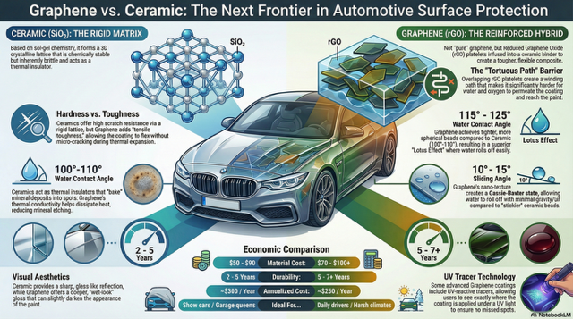

Ceramic ($SiO_2$): The Rigid Matrix
Based on sol-gel chemistry, it forms a 3D crystalline lattice that is chemically stable but can be brittle and lacks thermal conductivity.
Hardness vs. Toughness: Ceramics offer high scratch resistance via a rigid lattice, while Graphene adds "tensile toughness," allowing the coating to flex without micro-cracking during thermal expansion.
Water Contact Angle (the left side 100-110): Ceramics have a higher thermal insulator affect which may not dissipate minerals as well. Graphene's higher thermal conductivity helps dissipate heat more thoroughly which reduces mineral etching.
Visual Aesthetics: Ceramic provides a sharp, gloss-like reflection, while Graphene offers a deeper, "wet-look" gloss.
Graphene (rGO): The Reinforced Hybrid
The Reduced Graphene Oxide (rGO) platelets are infused into a ceramic binder to create a tougher and more flexible composite. Overlapping platelets create a winding path that makes it significantly harder for water and oxygen to permeate the coating and reach the paint.
Water Contact Angle (the right side 115-125)
Graphene achieves tighter, more spherical beads compared to Ceramic which results in a superior "Lotus Effect" where water rolls off more easily.
Sliding Angle: Graphene's nano-texture creates a Cassie-Baxter state, allowing water to roll off with minimal gravity/tilt compared to "stickier" ceramic beads.
UV Tracer Technology: GET RID OF THIS. Replace with:
Anti-Static Properties (Dust Repellency): Because Graphene is a conductive material, it helps dissipate the static charge that builds up on a vehicle's surface. This results in a "self-cleaning" effect where dry dust and pollen are less likely to cling to the surface.
Replace the Economic Comparison with this:
Decision Matrix

Feature | 🔷 Ceramic | 🟢 Graphene
Finish | High Gloss | Deep / Slick
Durability | 2–5 Years | 5–7+ Years
Water Behavior | Beading | Faster Shedding
Heat Resistance | Standard | Improved
Water Spot Resistance | Moderate | Better
Maintenance | Low | Lowest

