“The Purest Democracy”
Iwo Jima Eulogy by Chaplain Rabbi Roland B. Gittelsohn

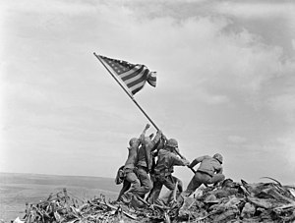
BANNED
Chaplain Mutiny and Conspiracy
The untold story of the first Jewish chaplain to serve in the Marine Corps. Based on discovery of the only known handwritten copy of his “lost” Iwo Jima eulogy.
by Ken Regopoulos

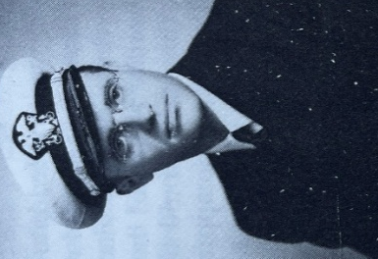

“As the first Jewish chaplain in American history to serve in the United States Marine Corps, during combat on Iwo Jima I witnessed human behavior at its glorious best and ugliest worst. How can such saintly and such beastly conduct emanate from one kind of being? How can men hate, not just the enemy, but each other as they bleed and die in what is hailed as their common cause? How can their religious leaders encourage the nastiest of their prejudice? When – as if by a miracle – a man has survived the most terrifying horrors of hell, what can he do to spare his son and grandson such torment.”

Rabbi Roland B. Gittelsohn

To the reader
This factual historical account is finally being told because of the discovery and research into the only known handwritten copy of Chaplain Rabbi Roland B. Gittelsohn’s “lost” Iwo Jima eulogy. The handwritten eulogy was penned in 1945 by an Army Air Corps CFC gunner on a B-29 super fortress, stationed in Guam during the time of the battle: namely, my father.
Anyone who wants to live in a democratic society should read Rabbi Gittelsohn’s Iwo Jima eulogy: yet most Americans have never heard of the rabbi, his words, or the chaplain mutiny that prevented him from delivering them at the planned interdenominational service to dedicate the 5th Marine Corps Division cemetery on Iwo Jima.
After reading Gittelsohn’s eulogy, we can sense the reasons why, before his death, he looked back on his life wondering where all the hope had gone. The man, his words and story, cannot be forgotten lest we lose the very fabric that makes America. That is why I fell in love with this man, and why I wrote this book.
Ken Regopoulos

“I have often wondered whether anyone would ever have heard of my Iwo sermon had it not been for the bigoted attempt to ban it.”

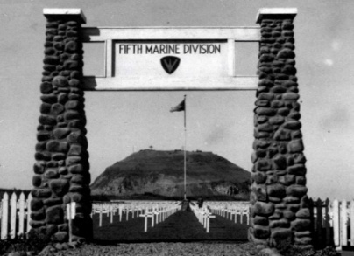
PHOTO: 5th Division Cemetery, Iwo Jima.
(Official United States Marine Corps photo, USMC Archives.)

“The publicity given my cemetery eulogy infuriated the chaplains who had originally objected to my giving it.”

About Rabbi Roland B. Gittelsohn, the first Jewish chaplain to serve in the Marine Corps, and his famous Iwo Jima eulogy, “The Purest Democracy”:

“He would experience dealing with the American military at war… and the impact of racism and bigotry at a time when America appeared to be standing united as a country” - Angela J. Anderson, Director, Marine Corps University Press, in Pacifist to Padre (2021).

“Like hearing Lincoln at Gettysburg” - The Boston Globe, May 29, 2022.

“It is quite a find”- The Jacob Rader Marcus Center of the American Jewish Archives (AJA), email to Ken Regopoulos, April 27, 2022.

“An important document” - National Museum of the Pacific War; Archives and Library, email to Ken Regopoulos, July 6, 2022.

“The import of Gittelsohn’s sermon/eulogy is undeniable” - the National World War II Museum, email to Ken Regopoulos, June 30, 2022.

“Of all the words that aimed to capture the meaning of America’s role in the Second World War and to chart the way for the postwar future, this is the speech for text- books, anthologies, classrooms, recitations, YouTube, memorial ceremonies, and movie scenes” - Donald M. Bishop, “Iwo Jima and The Purest Democracy,” in American Interest, 23 December 2019.

Dedication
“The Purest Democracy” BANNED is dedicated to Rabbi Roland B. Gittelsohn and all military chaplains: be they Christian, Jewish, Muslim, Hindu, Islamic, Sikh, or Lay Person.

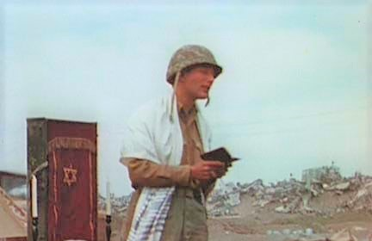
PHOTO: Rabbi Roland B. Gittelsohn on Iwo Jima

After so many died on Iwo Jima, there were many promises and pledges made to the American people to promote truth and justice and mend wrongs. Where have these gone?

Gittelsohn, Here Am I – Harnessed To Hope, New York; Vantage, 1988, 3.
Gittelsohn, Here I Am, 132.
Gittelsohn, Here Am I – Harnessed To Hope, New York; Vantage, 1988, 142.

