Scissor Book Cover Concept Research

Title: Scissor Skills Preschool Activity Book
Price: $3.99
Monthly Sold Units: 6944
Monthly Revenue: $27,707
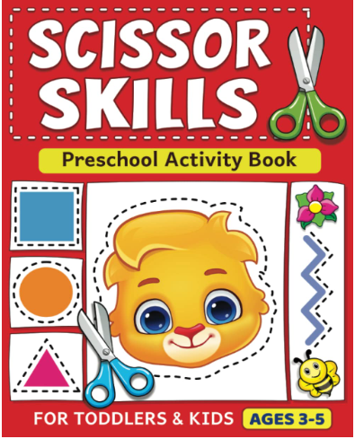

Title: Preschool Cutting and Pasting
Price: $6.50
Monthly Sold Units: 2,222
Monthly Revenue: 14,443
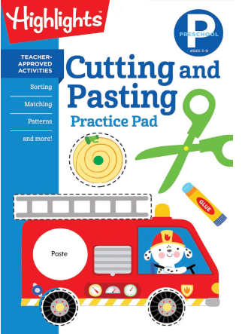

Title: My First Scissor Skills Workbook: Cut-and-Paste Activities to Build Hand-Eye Coordination and Fine Motor Skills (My First Preschool Skills Workbooks)
Price: $5.75
Monthly Sold Units: 1,242
Monthly Revenue: $7,142

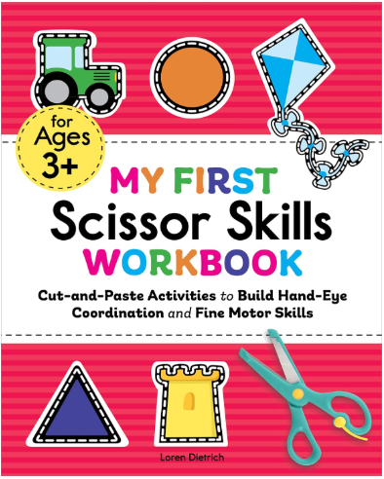

Title: Preschool Paper Crafts: 25 Creative Crafts to Practice Hand-Eye Coordination & Scissor Skills
Price: $5.69
Monthly Sold Units: 1,439
Monthly Revenue: $8,188
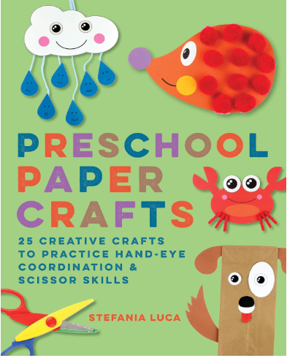

Title: School Zone Cut & Paste Workbook: 32 Pages, Toddler, Preschool, Kindergarten, Learning Activities, Scissor Cutting, Stickers, Counting, Picture Puzzles, Ages 3-5 (Little Hand Helper Book Series)
Price: $4.18
Monthly Sold Units: 817
Monthly Revenue: $3,415
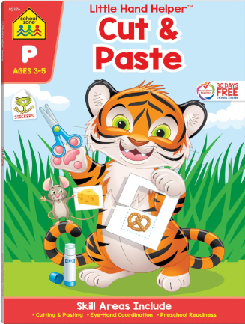

Title: Cut, Paste, and Create Pets: Highlights Activity Book for Kids 3-5 with Scissor Skills Practice, Puzzles, Crafts & Stickers (Highlights Cut, Paste, and Create Activity Books)
Price: $9.31
Monthly Sold Units: 280
Monthly Revenue: 2,607
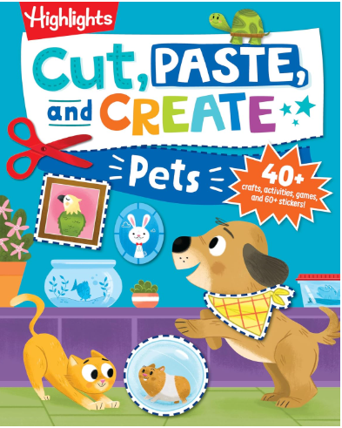

Title: Play Smart Cutting and Pasting Age 2+: Preschool Activity Workbook with Stickers for Toddlers Ages 2, 3, 4: Build Strong Fine Motor Skills: Basic Scissor Skills (Full Color Pages)
Price: $7.95
Monthly Sold Units: 294
Monthly Revenue: $2,337
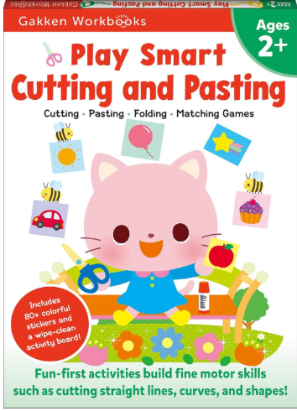

Title: Scissor Skills for Little Girls: A Preschool Cutting and Coloring Activity Workbook for Kids Ages 3-5 (Start Little Learn Big Series Workbook)
Price: $6.99
Monthly Sold Units: 219
Monthly Revenue:$1,531
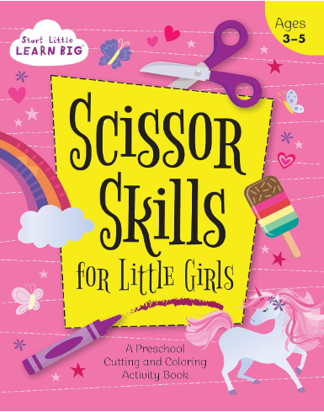
Title: Carson Dellosa Scissor Skills Activity Book for Kids Ages 3-5, Colorful Animals, Shapes, and Line Formation Cut and Paste Activities, Kids Craft Book With Incentive Chart and Stickers, PreK+
Price: $4.18
Monthly Sold Units: 227
Monthly Revenue: $949
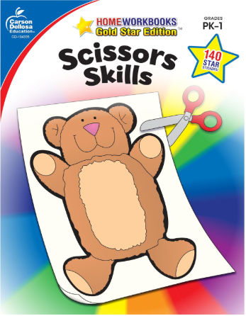

Title: Learn Scissor Skills! (Includes Safety Scissors!)
Price: $4.99
Monthly Sold Units: 173
Monthly Revenue: $863

