

Marketing Campaign 2026 to highlight new incoming capablity and technology:

Doosan SMX2100STB 5 axis Mill-Turn machining center
&
Robojob Turn-Assist

Here are some key highlights that my customers could see as beneficial to them:
- Complete complex parts in a single setup – Benefit: Tighter tolerances, improved consistency, and fewer opportunities for error
- Faster Lead Times: Simultaneous milling and turning reduces total cycle time. Benefit: Shorter turnaround times and quicker delivery on critical parts.
- Lower Total Cost: Fewer setups equal less labor and handling. Reduced scrap and rework. More efficient production for complex geometries. Benefit: More competitive pricing, especially on intricate components.
- Complex Parts Made Simple – True 5 axis capability allows for machining of difficult angles and contours. Ideal for parts that previously required multiple vendors or specialty setups. Benefit: Expanded design possibilities and fewer design compromises.
- Improved surface finish & quality – Advanced tooling paths and fewer handoffs between machines. Reduced vibration and repositioning errors. Benefits: Better finishes, improved performance, and less secondary work.
- Lights-Out automated capability- Compatible with Robojob automation. Enables unattended machining/production hours. Benefit: Increased capacity and reliable delivery schedules.
- Greater capacity for your projects: High-performance spindle and robust build for demanding materials. Handles both short and large prodution runs. Benefit: Sacalable manufacturing from prototypes to full production.
Possible Headline Ideas:
“From Raw Material to Finished Part in One Operation”
“Faster. More Precise. More Efficient.”
“Advanced 5-axis Mill-Turn Capability – Now Available”
“Next Level CNC Capacity”

Closing Message Ideas:
Our investment in the Doosan SMX2100STB reflects our commitment to delivering higher precision, faster turnaround times, and greater value to our customers. This technology allows us to take on more complex work while maintaining the quality and reliability you have come to expect from Envision Tech Inc.
Images: I am only showing examples but feel free to find more exciting images of the same equipment on-line.
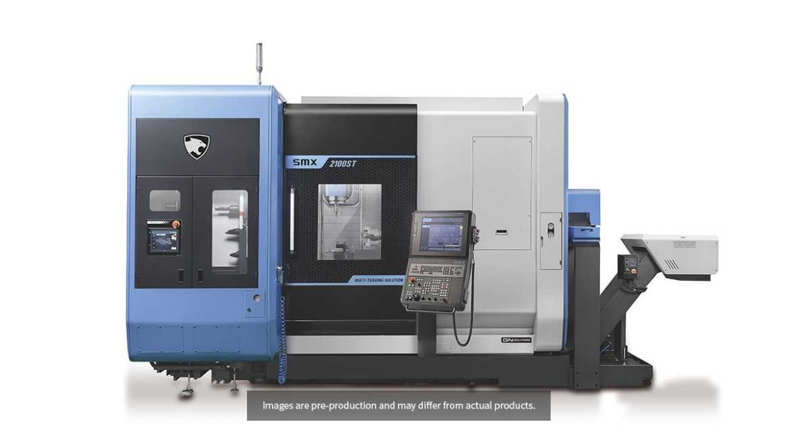
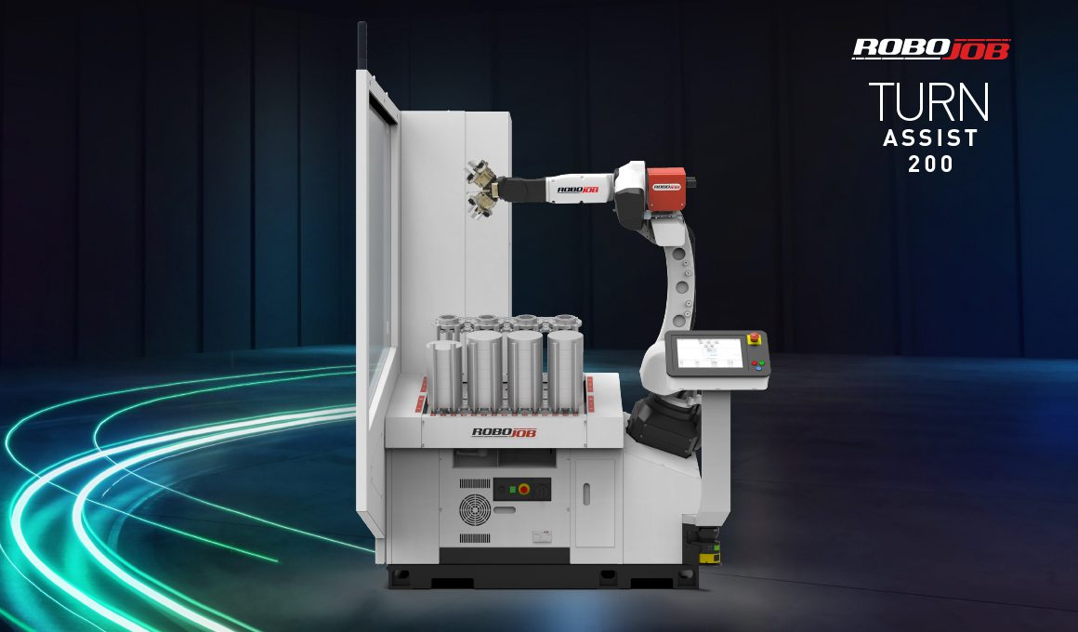

Customers want to know how our new offering will benefit them. Most buyers are not that technical, so listing all the specs would not necessarily benefit them. Buyers are more concerned with “how will this help me and what exactly does this mean to me?

