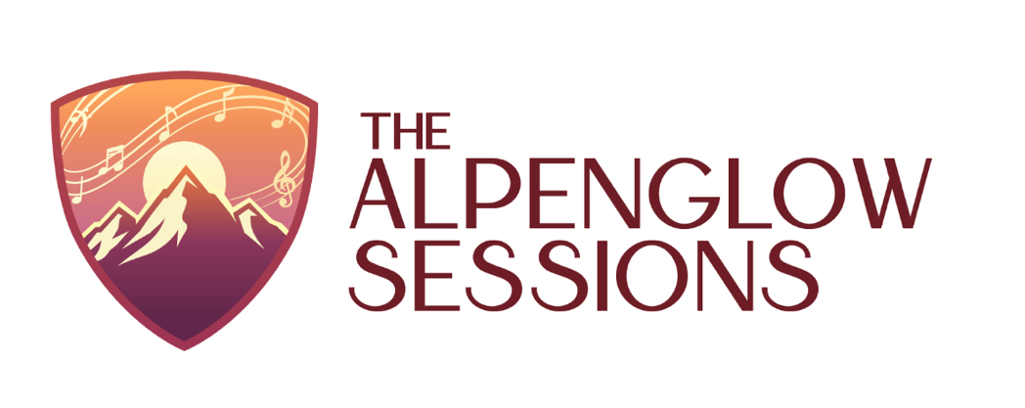

I’m delighted to announce the launch of The Alpenglow Sessions: Intimate concerts in Denver’s North End.

Inspired by the quiet radiance that settles over the mountains at dusk, The Alpenglow Sessions is a new living room concert series devoted to attentive listening, artistic depth, and shared musical experience. Hosted in my home in Denver’s North End of Central Park, these gatherings will bring folks together for evenings of warmth, nuance, and connection.

With an audience of just 25–40 guests, each concert is designed to foster closeness between performer and listener. Expect thoughtful, engaging performances — music that glows in the quiet.

This series is built on a simple conviction: extraordinary music does not require a grand hall. It requires space, intention, and a community willing to listen.

Our inaugural concert date and artist lineup will be announced soon. Seating will be limited, and reservations will be required.

I hope you’ll join us as we begin this new chapter together.

