Home page redesign Instruction.
Existing Homepage > Sandhurst Consulting – Leadership & Emergency Management Experts
Everything in blue is direction to you. Everything in black is copy.
Where there is no copy, but needs copy, use ‘lorem ipsom” to fill space.
Check these website competitors out to ensure your design stands out from the rest
Emergency Response Planning - Black Gold Emergency Planners like this homepage example
BEHR Integrated
Trace Associates | Environmental Science and Engineering Advisory
H2Safety | Comprehensive Safety & Emergency Management
Home - First Response
The audience are Emergency Management Professionals, Decision Makers for Large Industry, Community Leaders, Government, Native American Indians, Oil & Gas, Chemical Facilities, Rail, Airline, Ship
Brand Guidelines
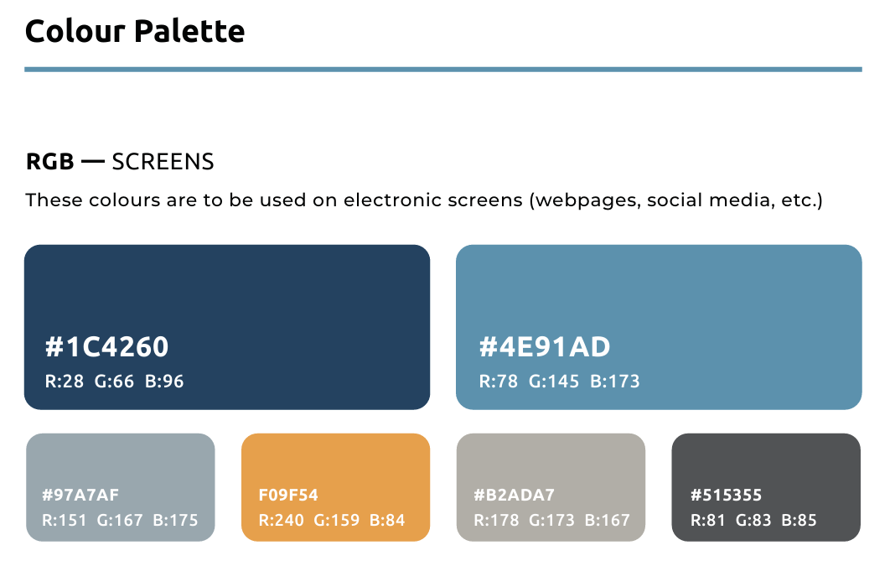We don’t want the brand colours to dominate the page.
Embed colourful images where appropriate and a create bold striking design that is memorable and demonstrates professionalism, confidence and experience while being progressive through the latest website features.
HEADING 1 Calibri Bold (22pt)
HEADING 2 Calibri Bold (18pt)
HEADING 3 Calibri Bold (14pt
BODY Calibri Light (12pt)

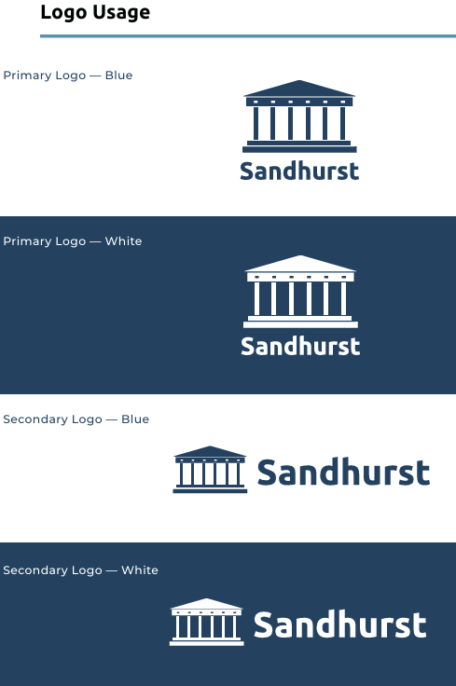

HOMEPAGE
Banner image examples –
find 3-5 video images of crises underway that rotate, showing something like:
- a burning large business building and people on the streets looking up,
- a major flood with cars floating in the water and people on rafts,
- a standoff with police and a bank in a busy street
- a plane that has landed but disabled on the runway with crews all around
- a train derailment with emergency responders everywhere
- A strike where workers are blocking entrance to a company
All must be north American in nature but not showing Canada or Us flags.

Animate Words arriving in one after the other across banner image in this order:
Minimize Risk (1), Mitigate Loss (2)
Command Chaos with Confidence(3)
Intro under Banner that tells them what you solve.
When incidents happen, your plans have to work in real time—not just on paper. The Sandhurst Consulting team understands the practical realities that unfold with emergencies having come from distinguished roles in the military, police, firefighting and paramedic fields. This experience has evolved their collective knowledge and education to prepare high risk organizations with clear strategies, operationally realistic plans, and training that builds true capability.

Why Choose Sandhurst Consulting

Get ready to navigate future challenges with confidence—before an incident, during response, and throughout recovery.


Our emergency management team brings 450+ combined years of proven boots on the ground front-line, leadership, and emergency management experience, supporting high risk industries, communities and the public sector.
Lorem Ipsom quote that lines up next to photo
Lorem Ipsom Lorem Ipsom Lorem Ipsom
Lorem Ipsom Lorem Ipsom Lorem Ipsom
Lorem Ipsom Lorem Ipsom Lorem Ipsom

You won’t find a more dedicated, passionate and experienced team that is driven to amplify your readiness and create confident capable leaders for any event that comes your way.
Paul Flavell, MA, President

Trust Signals
12 years 150 clients 5600+ ICS certifications

Trusted by the following Industries and Brands > design animated way to showcase client logos without showing all at once. At the end of the rotation of logos > create link to our Industries & clients webpage under About Us.



Our Emergency Management Solutions that Address Your Current Priorities.
Leave room for 2-3 sentences of subtext next to each. Create an interesting layout of services.

- Emergency Management
- Leadership Development
- Crisis Communication Strategy
- Fire & Life Safety
- Risk Assessment and Mitigation
- Business Continuity Preparation
- Safety Management
- Security Management
- Training & Simulation Events
- ICS 100, 200, 300 and 400 Certification

Our Work

Feature 3 Case Studies – that lead to more with arrow > animate 3 case studies loading in with the first one much larger than the others, and when you hover over the others, they become the largest in the visible row. Each should feature a large picture with a sentence below that describes each case.

What our Clients are saying:
Show 3 Testimonials boxes with arrow leading to more. The design of boxes should be different from the Our Work section.
These case studies will also be housed individually on service pages and linked from here.

FAQs
Create drop downs under each question for more content.
- How do you assess and mitigate risks ?
- Do you provide onsite crisis support?
- What technologies do you leverage in emergency management?
- Do you provide post-incident reports and analysis?
- What is your fee structure?
- Do you provide crisis communication training?
- What are high risk industries?
___________________________________________________________________--
Site Map – with links to each webpage
Link to Google My Business – Toronto + Calgary Offices
Social Media LinkedIn
2026 All rights reserved

