Ridge Fitness - Web Site
www.ridge-fitness.com

Design a 3 page web site for Ridge Fitness, a small local fitness center that provided cardio and weights only (machines and free weights). There are no classes or other services offered at this facility. Ridge Fitness is an affordable alternative to the big box, expensive fitness centers. It is small, local, convenient and a community oriented place to work out.
web site can be clean, simple and communicate basic information about the company and membership offers. Although the branding is black, orange and gray, the web site colors should be soft, light and neutral colors that will appeal to both men and women.
Text: Input generic text during design for each text area that will be modified later during the coding phase. The selected designer is expected to code the site and deliver all compressive files (images, files and code) for an unrestricted hand off and full ownership of all content by the client for future modifications by others.

Images
Images used can be generic royalty free images of people working out, on cardio machines, lifting on universal equipment, stretching or lifting weights or images with out people i.e a yoga mat, free weights, a row of cardio machines etc. This is an adults only facility - images can be a mix of men and women and of diverse multi ethnic backgrounds. Image of the actual gym are included below but should NOT be used on the web site.

Branding - See attached for vertical and horizontal logos for Ridge Fitness. These can be used in any way and should be incorporated into the web site

WEB SITE OUTLINE
THREE web pages - Pages can be individual pages clicked through to each page from a navigation area but ALSO pages can be “blend together” into one long scrolling “home” or primary landing page.
1) Home Page with basic information
2) Membership Page (to be later integrated with ABC fitness software to show changing membership specials). - see example below - all text will change later


3) contact page - address - telephone number - google map directions
www.ridge-fitness.com
Address:
Located in Limerick Ridge Square
222 W. Ridge Pike, Suite 217, Limerick PA 19468
Tel: 484-984-3354


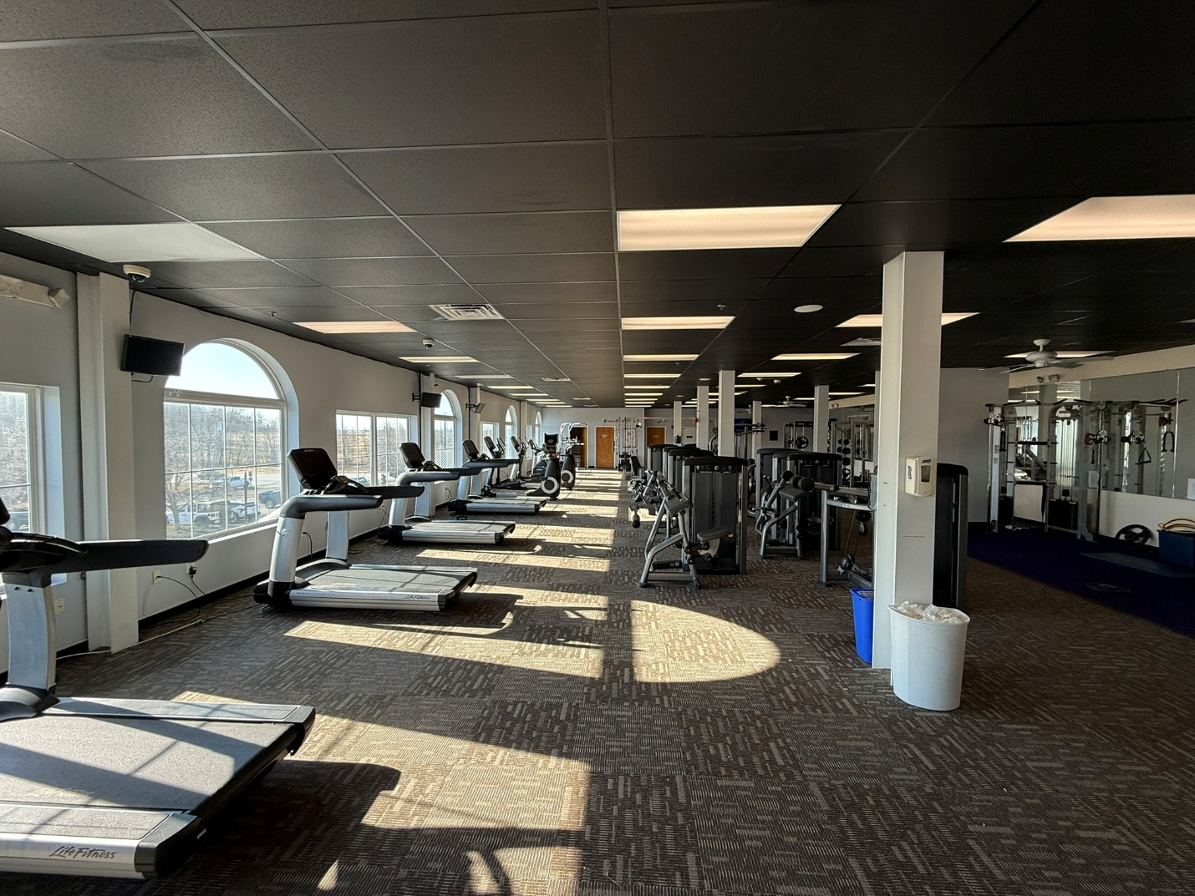

FOR INFORMATION ONLY - EXISTING GYM PRIOR TO RENOVATION – DO NOT USE ON WEB SITE
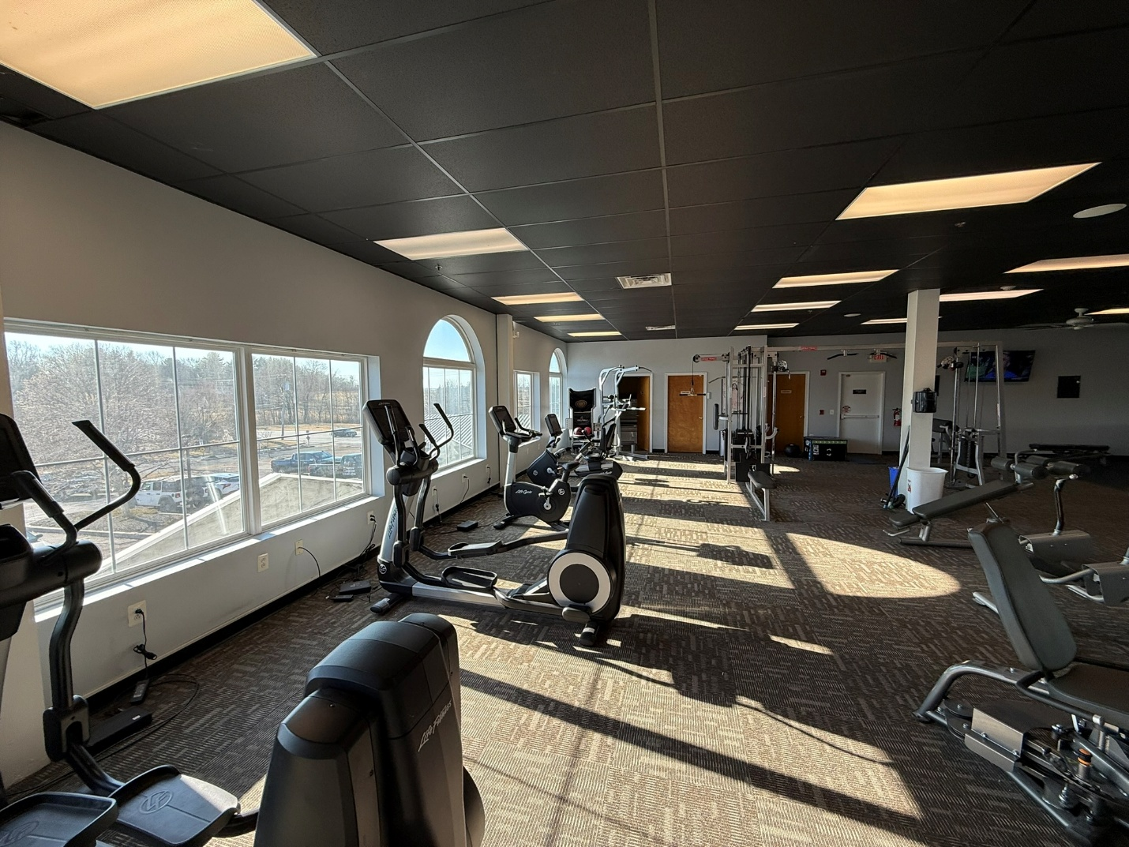

FOR INFORMATION ONLY - EXISTING GYM PRIOR TO RENOVATION – DO NOT USE ON WEB SITE
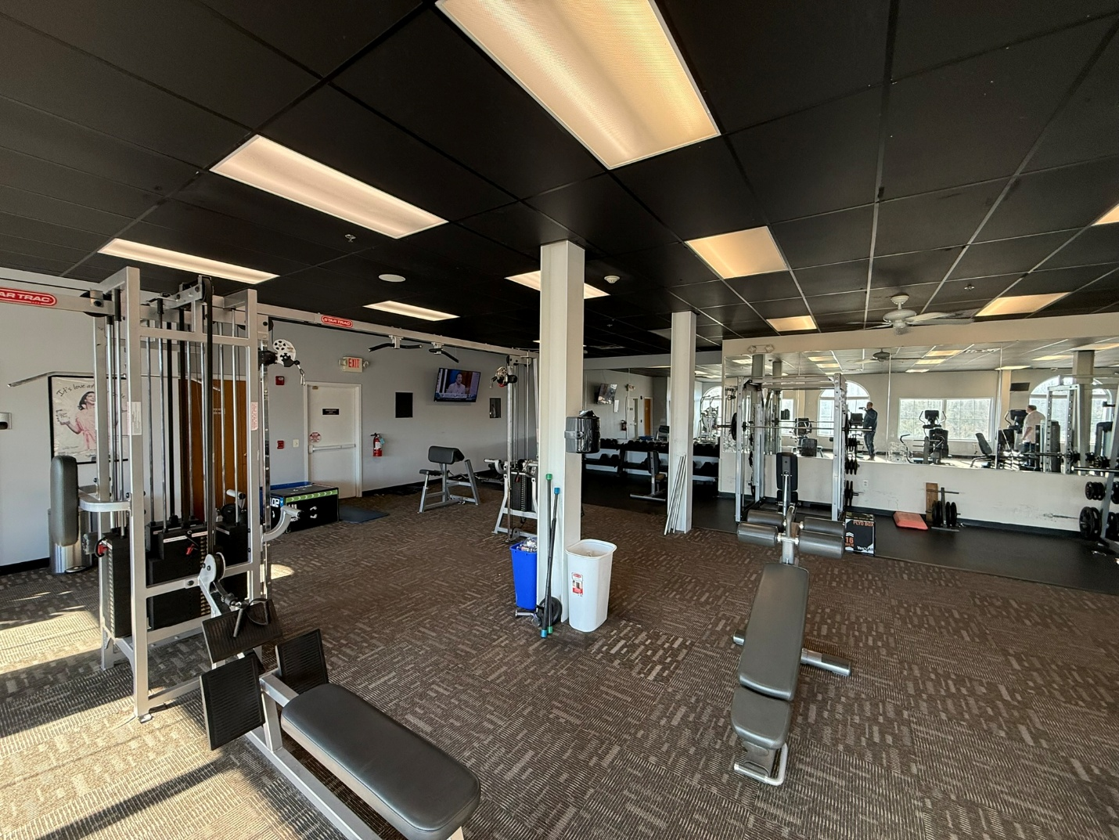
FOR INFORMATION ONLY - EXISTING GYM PRIOR TO RENOVATION – DO NOT USE ON WEB SITE

