

Stop Iron Before It Stains
Metal Monster targets both forms of iron that cause pool and spa headaches—dissolved (ferrous / “clear-water” iron) and particulate (ferric / “rust” iron).
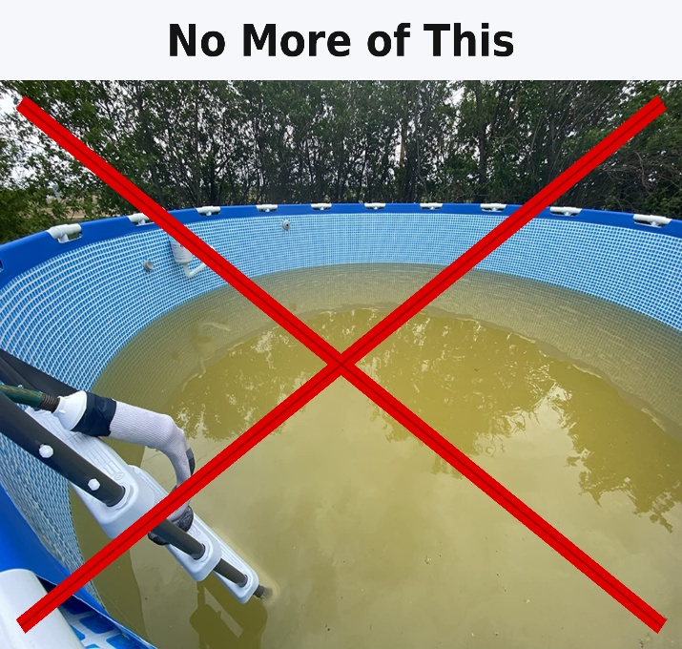
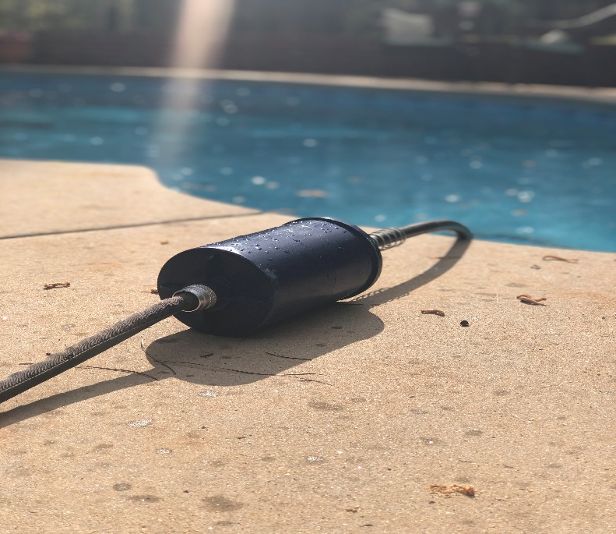
Iron-related discoloration can begin at ~0.1 ppm after shocking or a high chlorine dose—and becomes increasingly likely as levels rise.

Installation & Use
Simple in-line use: Connect Metal Monster in-line with any standard garden hose when filling or topping off your pool or spa.
Mounting options: Mount near an outdoor faucet or by the pool equipment pad using the included bracket.
Service life: Rated for up to 20,000 gallons. One filter typically covers a full season of refills/topping-off; initial fills may use most of the capacity in one use.
First use flush: Run water through the filter for 2 minutes before filling to clear any air or shipping residue.
End of life: When flow noticeably drops or after a season, replace the cartridge. Reuse the bracket next season.
Support: Customerservice@poolhealth.com
Spec | Pool Health Group Metal Monster | X10 Spa filter | Boogie-Blue Plus | Pool Pure | EcoOne | Grow Rite | FreshWater (WatkinsWellness Hydropure Technologies
Total Product Weight | 51 oz | 25 oz | 27.7 oz | 22 oz | 19.6 oz | 20.8 oz | 48.6 oz
Filter Media Weight | 36.32 oz | 15 oz | 24 oz | 10 oz | — | — | 26.7 oz
Breakdown of Media | Carbon Blend, KDF 85, Resin Blend | Carbon, KDF 55 | Carbon, KDF 55 | Carbon, KDF 55 | Carbon, Rocks (yes rocks) | — | Carbon (Impregnated)
Flow Rate | 1 GPM | Max Flow Rate 2 GPM | .5 gpm | — | — | 2.5 GPM Max | —
Capacity Gallons | 20,000 | 10,000 | 45,000 | 8000 | 40,000 | 40,000 | 5000 gallons
TDS Reduction | Yes | No | No | No | No | No | No
Length | 10 | 11.825 | 12 | 10.5 | 10 | 9.875 | 19.5
O.D | 4.6 | 2.48 | 2.49 | 2.41 | 2.5 | 2.45 | 2.37
Total Cubic Inches | 166.1 in3 | 57.1 in3 | 58.4 in3 | 47.9 in3 | 49.1 in3 | 46.6 in3 | 86 in3

Metal Monster vs. Other Hose Filters
Why Metal Monster Wins:
Most filter media: 36.32 oz (2.4× vs 15 oz, 2.7× vs 13.5 oz, 3.6× vs 10 oz).
Largest internal volume: 166.1 in³ (~3× typical).
Only product listed with TDS reduction = YES.
WHY THIS MATTERS – Our filter will remove even the ferrous iron that has become completely water soluble
Most complete media blend: Carbon + KDF + Resin.
We use KDF 85 instead of KDF 55 – KDF 85 is a better filtration media for removing ferrous and ferric iron but its more expensive so were the only ones who use it.
