PRICE LIST

CORE LUXURY RANGE
Poured into beautiful, statement vessels, the Core Luxury Range features timeless jars designed to bring warmth, calm, and quiet luxury into your space.
Diamond Monaco – Luxury Jar – 400g — $50
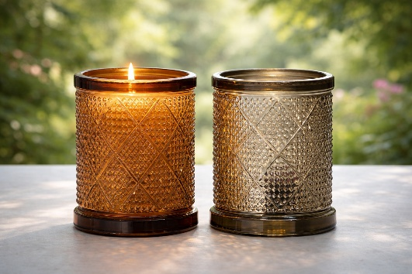

SIGNATURE INSPIRATION RANGE
More than a fragrance, these candles are quiet reminders—of your worth, your strength, and the power of choosing moments that truly nourish. Each one is created to support presence, self-connection, and intentional living.
Cambridge Amber Jar – Bamboo Lid – 295g — $30
Pearl Crown Jar – 200g — $40
Amber Jar – 150g — $20
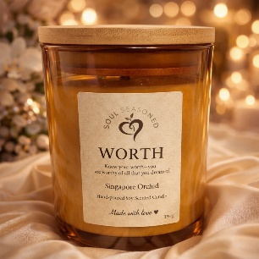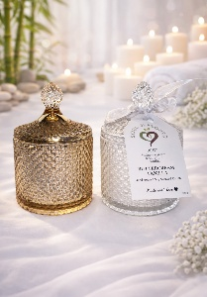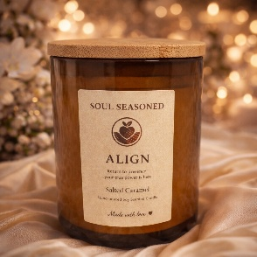
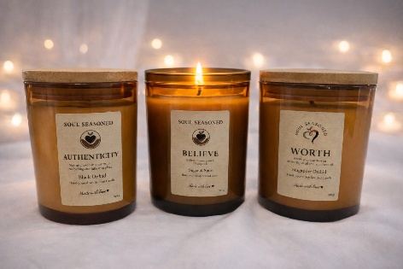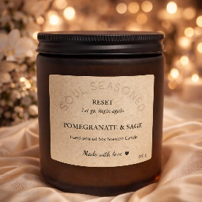

CANDY LANE RANGE
A deliciously indulgent collection that looks almost good enough to eat and smells absolutely divine. The Candy Lane Collection fills your space with rich, comforting fragrance — a sweet sensory escape.
Strawberry Milkshake – 235g — $35
Decadent Chocolate – 235g — $35
Caramel Popcorn – 295g — $30
Iced Coffee – 295g — $30
Café Latte – 295g — $30
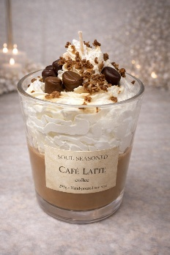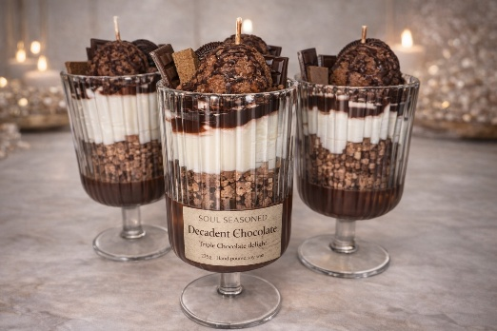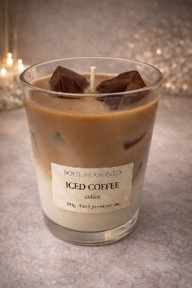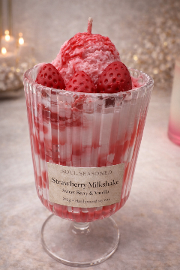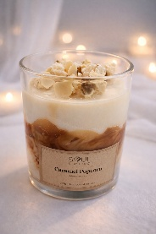

BABY & KEEPSAKE RANGE
Created to celebrate new life, this range is a soft welcome into the world. Gentle, meaningful candles designed to honour love, beginnings, and the light each little soul brings.
Welcome, Little Soul – Cambridge Bowl Candle — $55
Welcome, Little Soul – Cambridge Large Jar – 400g — $40
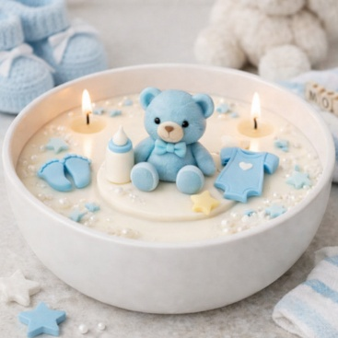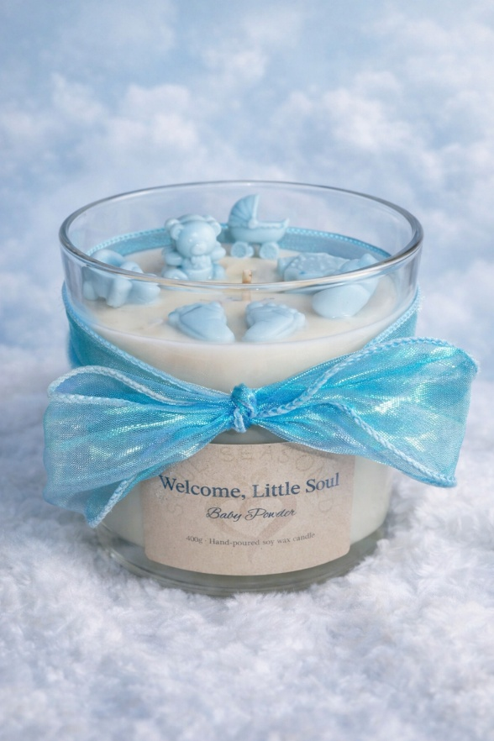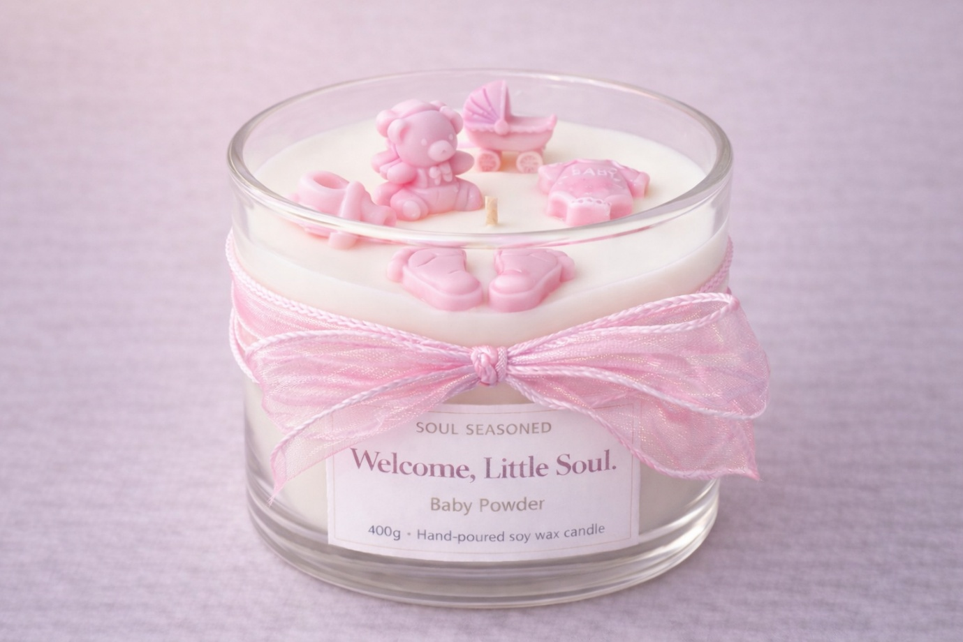

LIMITED EDITION RANGE
Small-batch candles released in limited numbers and available for a short time only.
Sweet Hearts – 200g — $30
Love Always – Limited Edition – 400g — $40
Teddy Bear Lane – Cambridge Bowl Candle — $55
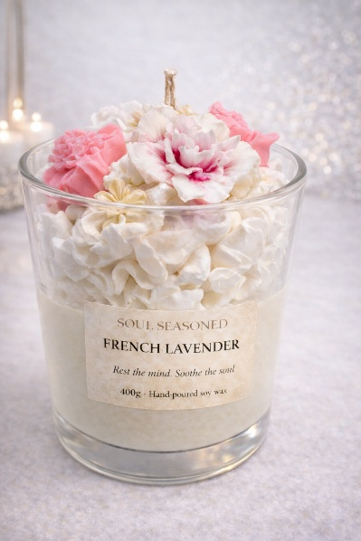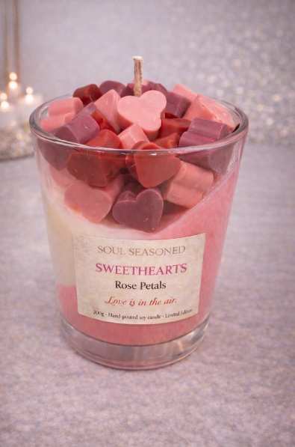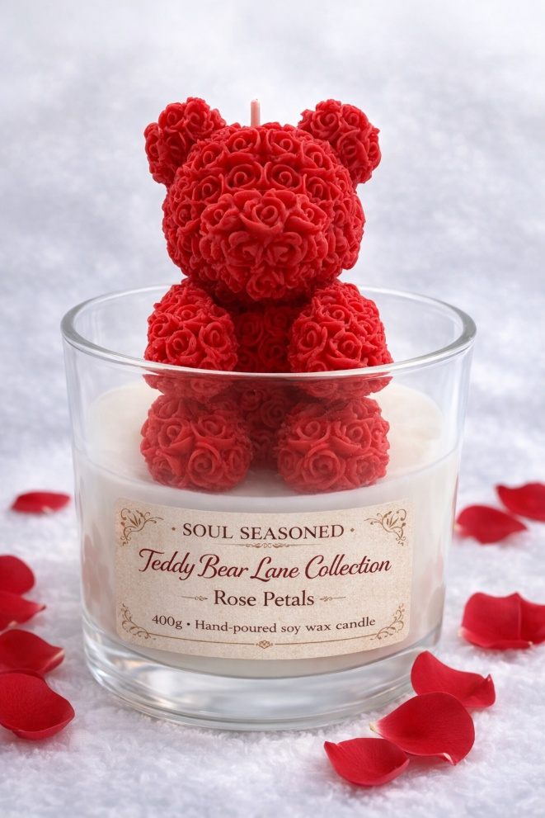

Soul Seasoned is an evolving collection. New candle creations are introduced regularly, and this price list may be updated to reflect new offerings and limited releases.
Each Soul Seasoned candle is poured slowly and mindfully, with intention at its core — because what we bring into our homes, and into our lives, truly matters.

Our website is currently being built. Online ordering will be available soon. In the meantime, all orders can be placed by contacting us via email at soulseasoned@outlook.com.

