A&P Brand Sheet

Atlas & Perpetua Healthcare Consulting, LLC
www.Atlas & Perpetua.com

BLUE #382D5E
RED #C84449

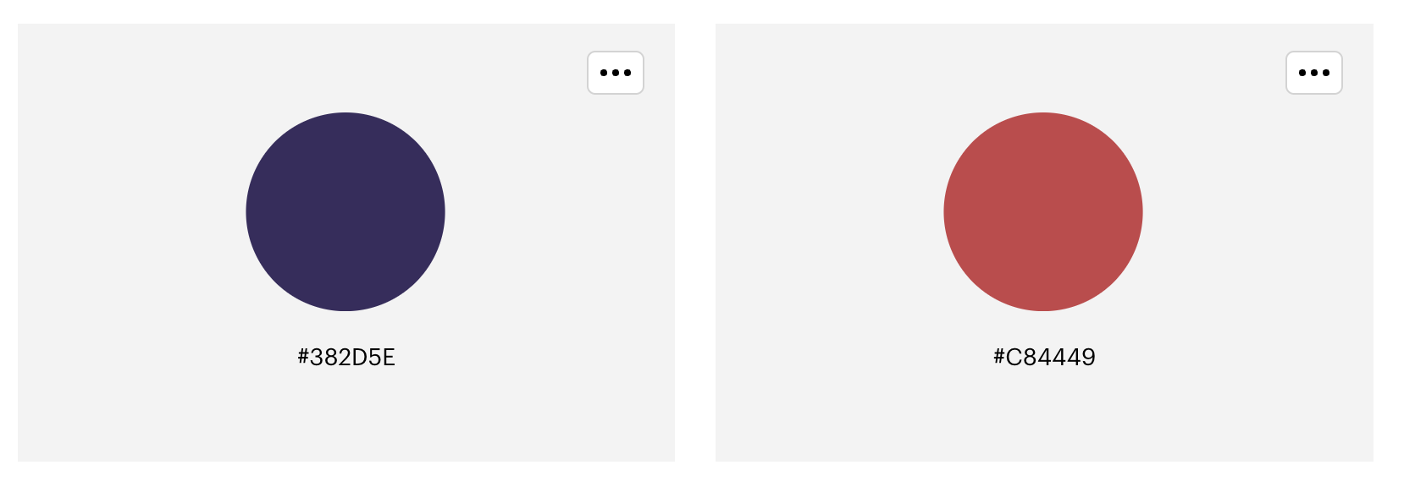

Logo Fonts
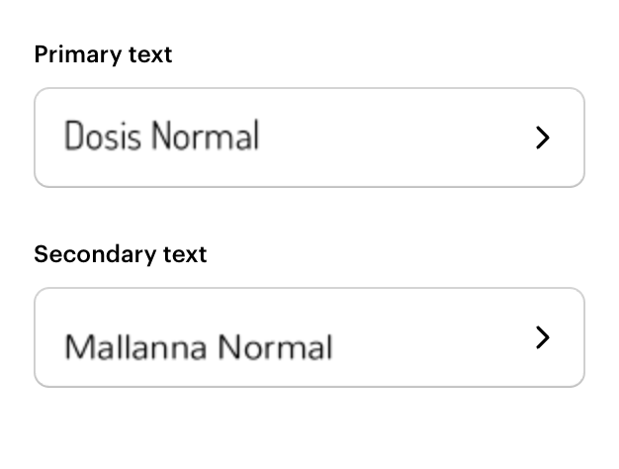
Text/Body/Headline Fonts

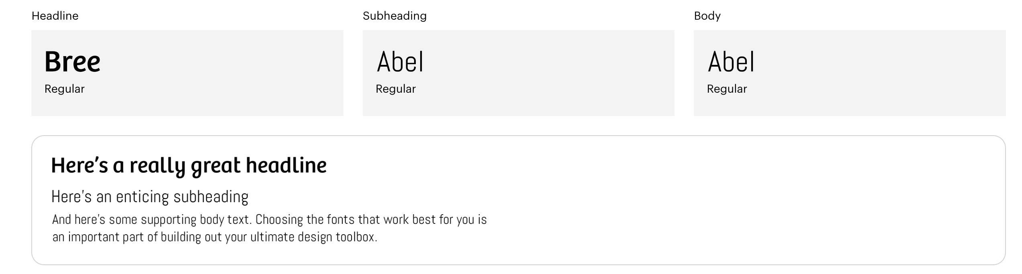

Alternative Fonts
Aptos (Body)
Calibri (Light)

