From Paper-Heavy to AI-Ready: A Practical Path to Modernising Your Organisations forms
Free your people to do what matters most
Streamline administration. Reduce risk. Unlock the value of your data through fast, affordable forms modernisation for not-for-profits.
We digitise paper, automate manual work, and turn data into insight so your team spends more time on your mission — not admin.

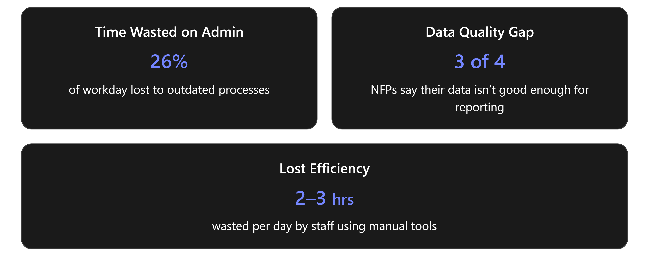

Service overview
Our Forms Modernisation service replaces paper forms, manual workflows, and ad hoc spreadsheets with secure, low-code solutions built on Microsoft 365 and the Power Platform.
In a short, affordable engagement, we:
- Map your priority processes
- Design simple Power Apps or Microsoft Forms
- Automate approvals and notifications with Power Automate
- Store trusted records in SharePoint or a Microsoft Fabric Data lake.
The result is repeatable, auditable processes, fewer errors, and clean data that feeds Power BI reporting and future AI initiatives.

1. Why forms modernisation matters for not-for-profits
Not-for-profits often spend precious time on manual, paper-based tasks — re-keying forms, chasing approvals, and searching for the right document. That time is better spent on mission delivery.
By digitising forms and automating workflows, you can:
- Reduce time spent on admin — staff can focus on program delivery
- Eliminate information silos — one reliable source of truth for clearer reporting
- Reduce operational risk — accurate, validated data captured at source
- Improve data quality — enabling better, faster decision-making
- Ensure continuity and recovery — protect data with proper backup and governance
- Create a foundation for AI and reporting — clean data enables future automation and insight
Many small not-for-profits still rely on paper, email chains, and spreadsheets.
Forms modernisation is one of the simplest, highest-impact steps to efficiency.

2. What we offer
Forms modernisation services
We build low-code and no-code solutions using Microsoft Power Platform and SharePoint, supported by a managed service approach.
Services and features
- Process discovery workshop
Identify high-value manual processes and priority forms. We assess effort, risk, and impact.
- Design and build
Create solutions using Power Apps, Microsoft Forms, Power Automate, and SharePoint, including custom forms with data validation at capture.
- Workflow automation
Automate approvals, notifications, and document routing.
- Integration
Connect forms to other systems such as CRM, finance, fundraising, or property platforms via our Integration Hub.
- Data and reporting
Centralise captured data in SharePoint lists or a data lake and visualise insights with Power BI.
- Governance and backup
Implement best-practice governance and controls, including AvePoint data protection and clear backup and recovery for Microsoft 365 content.
- Managed service and continuous improvement
Ongoing support, enhancements, monitoring, and user assistance — so your solutions continue to evolve.

3. Benefits and outcomes
What your organisation will gain
- Faster processing times (approvals, applications, incident reporting)
- Lower operating costs and reduced staff and volunteer burnout
- Higher-quality data for grants and reporting
- Stronger governance and reduced risk of data loss or accidental sharing
- A clear path to adopting AI once data is clean and accessible
Measured impact
- Less time spent on admin tasks — measurable hours saved each week
- Fewer data entry errors and improved compliance
- Faster, auditable approval and review cycles (e.g. policy reviews)
- Consolidated documents and a single SharePoint or intranet entry point
- A secure, practical pathway to meaningful AI adoption — from donor workflows to case triage and reporting

4. Typical processes we automate
Small-to-medium not-for-profit organisations in Australia often rely on manual, paper-based workflows that drain staff time and increase errors. By digitising a few high-impact processes, NFPs can free up resources for their mission, reduce compliance risks, and improve data for decision-making.

Common automation opportunities for not-for-profits include:
- Volunteer onboarding and credential checks
- Client intake and consent forms
- Incident and safety reporting
- Grant and funding application tracking
- Event registrations and attendance management
- Policy review scheduling and version control
- Expense claims and approvals
- Asset and property bookings and inspections
- Donation acknowledgements and receipting workflows
- Referral tracking and case note capture
Each solution is tailored — from a simple Microsoft Form with a Power Automate flow to a Power App that fills gaps in existing systems.

  - Call to action:
Start your forms modernisation pilot — request a free scoping session and receive a tailored pilot plan for your organisation.
1. Faster approvals
Quicker decisions for approvals, applications and incident reports to reduce bottlenecks and speed up outcomes.
2. Lower operating costs
Automate repetitive tasks to cut admin time, reduce volunteer/staff burnout and save measurable hours each week.
3. Improved data quality
Validated, consistent data for more accurate reporting and stronger grant applications.
4. Stronger governance
Secure, auditable forms and workflows to minimise data loss, accidental sharing and compliance risk.
5. Centralised access
A single intranet entry point (Space / SharePoint) for policies, guidance and forms so staff always know where to find what they need.
6. AI-ready infrastructure
Clean, accessible data and secure processes that enable meaningful future AI use — from donor automation to case triage and reporting.

