Just Heat Pumps

Brand Guidelines



Fonts:

On website:

Heading Font: Rubik

Base Font: Karla

Default font color: Grey with a little blue:
262B38

Proposal and marketing fonts used:

Montserrat

Roboto

Colors in original Logo:

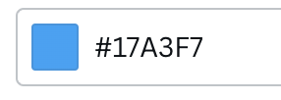
#17A3F7
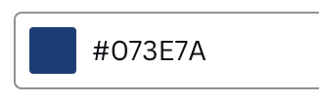
#073E7A
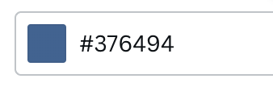
#376494
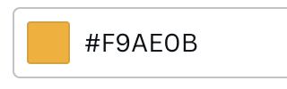
#F9AE0B
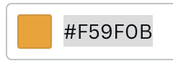
#F59F0B

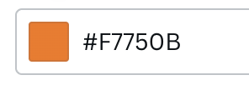
#F7750B

Green button color from website:
#4ea64c

