“The Purest Democracy”
Iwo Jima Eulogy by Chaplain Rabbi Roland B. Gittelsohn

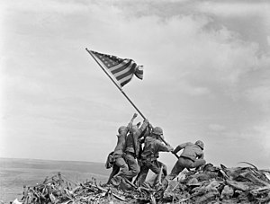
BANNED
Chaplain Mutiny and Conspiracy
The untold story of the first Jewish chaplain to serve in the Marine Corps. Based on discovery of the only known handwritten copy of his “lost” Iwo Jima eulogy.
by Ken Regopoulos

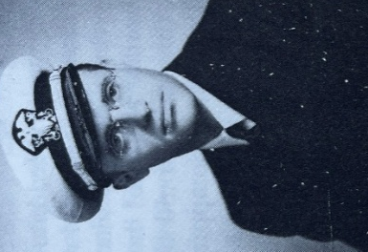

“As the first Jewish chaplain in American history to serve in the United States Marine Corps, during combat on Iwo Jima I witnessed human behavior at its glorious best and ugliest worst. How can such saintly and such beastly conduct emanate from one kind of being? How can men hate, not just the enemy, but each other as they bleed and die in what is hailed as their common cause? How can their religious leaders encourage the nastiest of their prejudice? When – as if by a miracle – a man has survived the most terrifying horrors of hell, what can he do to spare his son and grandson such torment.”

Rabbi Roland B. Gittelsohn

To the reader
This factual historical account is finally being told because of the discovery and research into the only known handwritten copy of Chaplain Rabbi Roland B. Gittelsohn’s “lost” Iwo Jima eulogy. The handwritten eulogy was penned in 1945 by an Army Air Corps CFC gunner on a B-29 super fortress, stationed in Guam during the time of the battle: namely, my father.
Anyone who wants to live in a democratic society should read Rabbi Gittelsohn’s Iwo Jima eulogy: yet most Americans have never heard of the rabbi, his words, or the chaplain mutiny that prevented him from delivering them at the planned interdenominational service to dedicate the 5th Marine Corps Division cemetery on Iwo Jima.
After reading Gittelsohn’s eulogy, we can sense the reasons why, before his death, he looked back on his life wondering where all the hope had gone. The man, his words and story, cannot be forgotten lest we lose the very fabric that makes America. That is why I fell in love with this man, and why I wrote this book.
Ken Regopoulos

“I have often wondered whether anyone would ever have heard of my Iwo sermon had it not been for the bigoted attempt to ban it.”

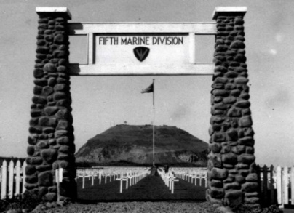
PHOTO: 5th Division Cemetery, Iwo Jima.
(Official United States Marine Corps photo, USMC Archives.)

“The publicity given my cemetery eulogy infuriated the chaplains who had originally objected to my giving it.”

About Rabbi Roland B. Gittelsohn, the first Jewish chaplain to serve in the Marine Corps, and his famous Iwo Jima eulogy, “The Purest Democracy”:

“He would experience dealing with the American military at war… and the impact of racism and bigotry at a time when America appeared to be standing united as a country” - Angela J. Anderson, Director, Marine Corps University Press, in Pacifist to Padre (2021).

“Like hearing Lincoln at Gettysburg” - The Boston Globe, May 29, 2022.

“It is quite a find”- The Jacob Rader Marcus Center of the American Jewish Archives (AJA), email to Ken Regopoulos, April 27, 2022.

“An important document” - National Museum of the Pacific War; Archives and Library, email to Ken Regopoulos, July 6, 2022.

“The import of Gittelsohn’s sermon/eulogy is undeniable” - the National World War II Museum, email to Ken Regopoulos, June 30, 2022.

“Of all the words that aimed to capture the meaning of America’s role in the Second World War and to chart the way for the postwar future, this is the speech for text- books, anthologies, classrooms, recitations, YouTube, memorial ceremonies, and movie scenes” - Donald M. Bishop, “Iwo Jima and The Purest Democracy,” in American Interest, 23 December 2019.

Dedication
“The Purest Democracy” BANNED is dedicated to Rabbi Roland B. Gittelsohn and all military chaplains: be they Christian, Jewish, Muslim, Hindu, Islamic, Sikh, or Lay Person.

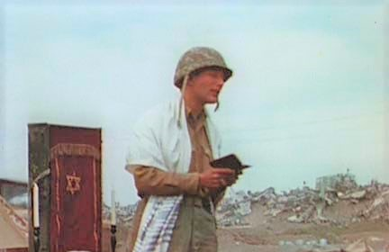
PHOTO: Rabbi Roland B. Gittelsohn on Iwo Jima

Preface
This is a true story about Rabbi Roland B. Gittelsohn, the first Jewish chaplain to serve in the Marine Corps, and prejudice at the hands of Christian chaplains who woke each morning to pray to another Jew, Jesus Christ. It is about the never before disclosed Christian chaplain mutiny on Iwo Jima against their division chaplain, Commander Warren F. Cuthriell; and misleading declarations by the Marine Corps and others that the rabbi had made military history by being the first Jewish chaplain to dedicate a Marine Corps cemetery - even though, in reality, he had been prevented from doing just that.
It is also about the propaganda spread through newspapers, radio stations, books, magazines and various organizations, declaring how the rabbi had stood before the entire 5th Marine Division delivering his powerful words at the cemetery dedication - when he had not. It was a tangled web of deceit, to which even the rabbi contributed in a rather surprising way that has only now been uncovered through research into the recently discovered handwritten copy.
It is especially important today because of the increasing willingness of so many in contemporary affairs to rewrite reality, and to promote Christian superiority, as was done with Gittelsohn’s eulogy in 1945. For 76 years, the American people were told that the rabbi had delivered his eulogy at an interdenominational service before the whole 5th Marine Division; yet it was all a hoax. In fact, he was threatened, the planned interdenominational service canceled, his manuscript stolen, his words altered and entered into the Congressional Record; then he was even investigated as a suspected communist by G-2. His mail was opened, every action of his scrutinized, every meeting and contact considered a possible communist plot. No such evidence was found, but he was drummed out of the service anyway.
That is how this Jewish American hero was treated as the first Jewish chaplain to serve in the Marines. Then it took the Corps fully 76 years before admitting their wrongdoing.
Despite the efforts of the mutiny and the intentional altering of the rabbi’s words, Gittelsohn’s eulogy became famous anyway, and for good reason.
Robert St. John, who had a radio program on NBC, believed that the rabbi’s words invoked true American values and the desperate need to fight for our democratic way of life. Every American needed to hear the rabbi’s speech, he thought: so on Memorial Day, May 31, 1945, he introduced them on a national broadcast.
“I want to read to you a memorial address, delivered over the graves of some Fifth Marine Division dead, on the island of Iwo Jima, by Chaplain Roland Gittelsohn… I think that the words I am about to read to you should be printed in every history book, that millions of copies should be distributed across the land.”
He repeated the eulogy for many years on his Memorial Day broadcasts. It included the following:
When the last shot has been fired, there will still be those eyes that are turned backwards, not forward, who will be satisfied with those wide extremes of poverty and wealth in which the seeds of another war can breed. We promise you, our departed comrades, this too we will not permit.
When the last battle has been won, there will be those at home, as there was last time, who will want us to turn our backs in selfish isolation on the rest of humanity, and thus to sabotage the very peace for which we fight. We promise you who lie here: we will not do that.
When the final cross has been placed in the last cemetery, once again there will be those to whom profit is more important than peace, who will insist, with the voice of sweet reasonableness and appeasement that it is better to trade with the enemies of mankind than, by crushing them, to lose their profit. To you who sleep here silently, we give you our promise: we will not listen.
Thus do we consecrate ourselves, the living, to carry on the struggle you began. Too much blood has gone into this soil for us to let it lie barren. Too much pain and heartache have fertilized the earth on which we stand. We here solemnly swear: this shall not be in vain.
After so many died on Iwo Jima, there were many promises and pledges made to the American people to promote truth and justice and mend wrongs. Where have these gone?

Gittelsohn, Here Am I – Harnessed To Hope, New York; Vantage, 1988, 3.
Gittelsohn, Here I Am, 132.
Gittelsohn, Here Am I – Harnessed To Hope, New York; Vantage, 1988, 142.

