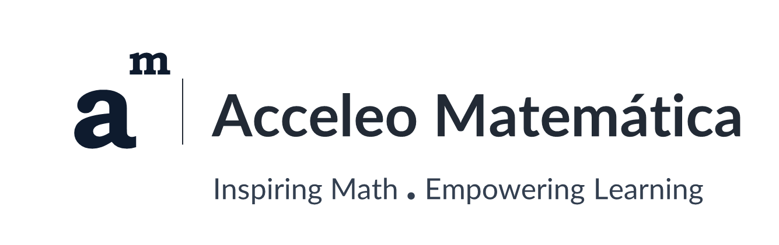

Acceleo Matemática – Additional Content for Presentation Slide Brief

- A Graphic I created
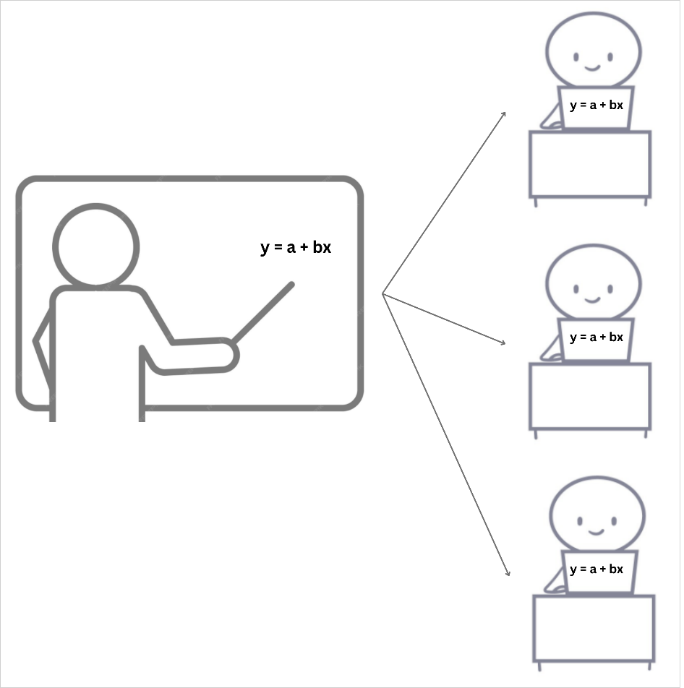
ACCELEO
MATH ACADEMY

- Content could be helpful for the content related to Slide 4: Key Features
Modular Math Lessons

Acceleo Matemática’s lessons/sessions are designed in small, one-and-a-half-hour units, each covering a new math concept that can be taught in twenty minutes. This allows students ample time to practice the newly introduced mathematical skills daily.
This time-tested and proven pedagogical methodology has three pillars: (1) new math skills built on previously taught ones; (2) daily review of earlier math concepts to increase understanding; and (3) frequent, cumulative assessments to ensure students master each math skill as new ones are added.
As a result, our middle school and high school math curricula help students become more confident, more willing to learn math, and ultimately more successful in their educational journeys and lives.

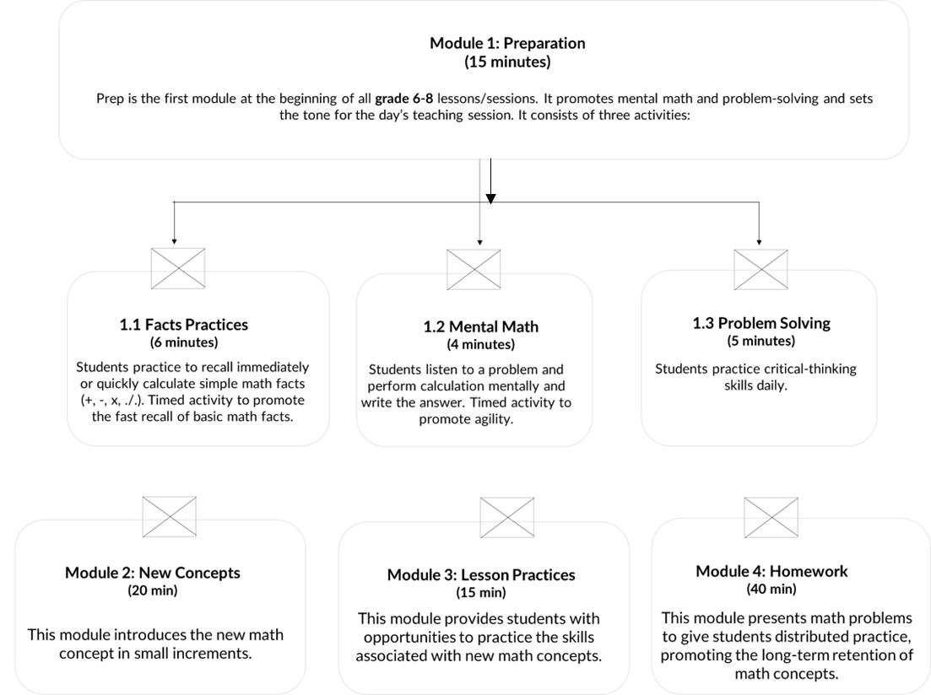

- Content could be helpful for the content related to Slide 5: How It Works

Class Session Schedule

Acceleo Math Academy class sessions are offered Monday through Thursday each week for a six-month term. The school year at Acceleo Math Academy consists of two terms: Term 1, from September to February, and Term 2, from March to August. Students can register for only one term per grade.
Math class sessions are offered in seven different sections or slots per day. These sections are made available on a first-come, first-served basis. Once the first student is registered in a section, that section is open only to 9 more students in the same grade as the first, for a maximum of 10 students per section.
This class scheduling process reinforces Acceleo Matemática’s structured approach for teaching mathematics.

